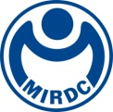
新聞資料NEWLETTER
MIRDC's verification capability assists domestic enterprises in the green transformation to develop sustainable ESG
The Net Zero Emissions policy has become a global trend to deal with the impact of climate change. For most manufacturing industries, the requirement of Carbon Neutral is a test. Faced with the rapidly growing demand for Carbon Footprint Verification in Taiwan and the world, MIRDC has become an inspection agency recognized by the Taiwan Accreditation Foundation under the guidance of the Bureau of Standards, Metrology and Inspection, MOEA, and was recognized by the Environmental Protection Administration as early as this year. It is the first non-profited inspection agency in Taiwan to pass the qualification accreditation of the inspection agency and the Financial Supervisory Commission. MIRDC has provided greenhouse gas inspection services and can assist domestic companies in obtaining independent and impartial third-party inspection statements to complete Carbon Footprint Verification to understand their greenhouse gas emissions and formulate carbon reduction strategies. It can gain international recognition, effectively improve the corporate constitution, reduce operational risks, and meet the challenges of the global trend of ESG.
The Acting President of MIRDC, Chih Lung Lin, stated that MIRDC had become an inspection agency approved by the Environmental Protection Agency of the Executive Yuan to meet market demand. It not only performs Greenhouse Gas inspections of the Environmental Protection Administration, but manufacturers ensure that through third-party inspections like MIRDC, its greenhouse gas inspection report complies with the regulations. With the improvement of environmental protection awareness in various countries, it will be able to respond to the international market and meet the requirements of the supply chain in the future, making enterprises more competitive in the green global market.
In addition, the Water Resources Agency, MOEA, promotes industrial water conservation and implements water justice, encourages sizeable industrial water users to improve the efficiency of water resource recycling, and recognizes MIRDC as an independent third-party inspection agency to perform verification of the Water Resources Agency's water recycling rate. Among them, the manufacturer obtains the verification statement of the water recovery rate issued by the inspection agency. When the water recovery rate reaches or exceeds the industry standard, reduce the water consumption fee preferentially. Through MIRDC's verification, the industry can simultaneously discover water use problems in water management. It can promote the industry's water-saving efficiency and actively improve water resource use efficiency.
In the face of the international trend of sustainable development of ESG enterprises, we must lead the way to green transformation together. MIRDC strives for excellence in the research and development of energy-saving and carbon-reduction technologies and strives for integration and professionalism in product verification and verification services. MIRDC assists the industry, including helping the manufacturers to pass the regulation of wasting recycling product label verification of the Environmental Protection Bureau, Executive Yuan, factory inspection (ISO 17020), various product verification (ISO 17065) and integrated services for management system verification (ISO 17021), greenhouse gas verification (ISO 14065), etc., to ensure that the verification and verification of the company's systems and products meet international standards and national laws and regulations, and obtain international certification simultaneously, helping the industry break through challenges and seize green business opportunities. For more relevant information, please contact Chief Cheng of the Certification Section, Tel 02-27013181, extension 600.
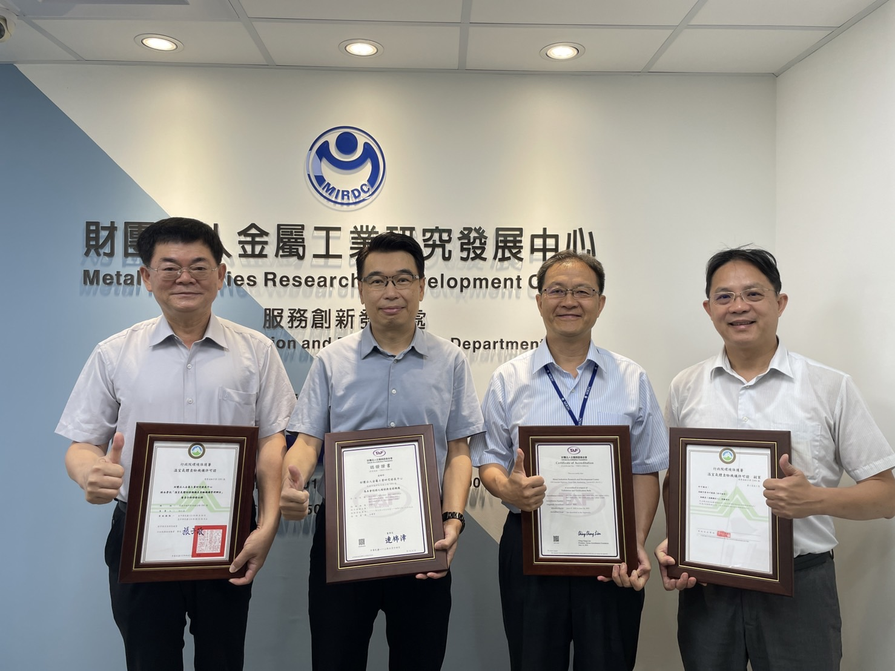
Fig, MIRDC is the first non-profited organsation certified by the Taiwan Accreditation Foundation

