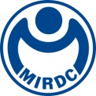
新聞資料NEWS LETTER

MIRDC communicates with the related industries about energy storage verification and risk assessment to ensure the safety of green energy

Because of the frequent occurrence of energy storage system accidents internationally, the safety and risk assessment of energy storage systems is particularly important to move towards large-scale application and popularise it among the people. To assist the industry in developing technologies and products while considering safety and efficiency, MIRDC held the "Energy Storage System Case Study Verification and Risk Assessment Exchange Meeting" in Taichung in mid-December last year (2023). Due to the large number of participants, was held again at the GIS NTU Convention Center in Taipei on January 31, 2024. There are more than hundreds of event participants. In the future, MIRDC will continue to work with various government, industry, academia and research units on issues in the field of energy storage to promote industry exchanges and jointly move towards the goal of sustainable energy development.

In response to international issues such as energy shortage and climate change, the world has long regarded net-zero carbon emissions and a sustainable environment as the core. It continues to invest in developing new products and technologies, and clean energy is one of the key development projects of various countries. The 28th Conference of Parties (COP28) of the United Nations Framework Convention on Climate Change (UNFCCC), held at the end of last year, also announced its commitment to tripling the world's renewable energy sources (to at least 11,000GW) and improving energy efficiency by 2030. 2 times (increased from 2% to 4%). Furthermore, considering the intermittent nature of renewable energy and the rising demand for electrification and carbon-free transportation, the importance of building an "energy storage system" has also emerged. In recent years, Taiwan has also actively promoted the development of the energy storage industry. According to the latest "2022 National Electricity Resources Supply and Demand Report" released by the Ministry of Economic Affairs, as of the end of 2022, Taipower's cumulative capacity in energy storage auxiliary services will be approximately 150MW (including self-built and outsourced), it is expected to reach 1,000MW in 2025 and ultimately hopes to achieve the goals of power independence, energy transformation, and carbon emission reduction.

It has been more than a year since the Bureau of Standards, Metrology and Inspection (BSMI) announced the "Outdoor Battery Energy Storage System Site Verification System", whether the SAT on-site acceptance test at the transitional site or the complete "Outdoor Battery System" covering design review. MIRDC has completed inspection capabilities for energy storage system case studies and Voluntary Product Verification (VPC) review. MIRDC has assisted more than 35 energy storage companies in conducting case site verification. During the process, more companies face risk assessment and fire protection facilities. Prepare for the challenge. The reason why the exchange meeting was held was not only to explain the relevant specifications of "field verification of outdoor energy storage systems" but also to invite experts from critical domestic risk assessment units, including Hy-Consulting Limited Company and Cheng Si Technology Corporation Ltd. System Standard (IEC/CNS)" and "Fire Protection and Fire Risk Assessment" were explained to help allow the domestic industries to have a better understanding of relevant specifications and systems and to assist the development of China's energy storage industry from a pragmatic perspective. In the future, we look forward to jointly promoting the development of Taiwan energy storage industry through communication and collaboration among industry, academia and research.

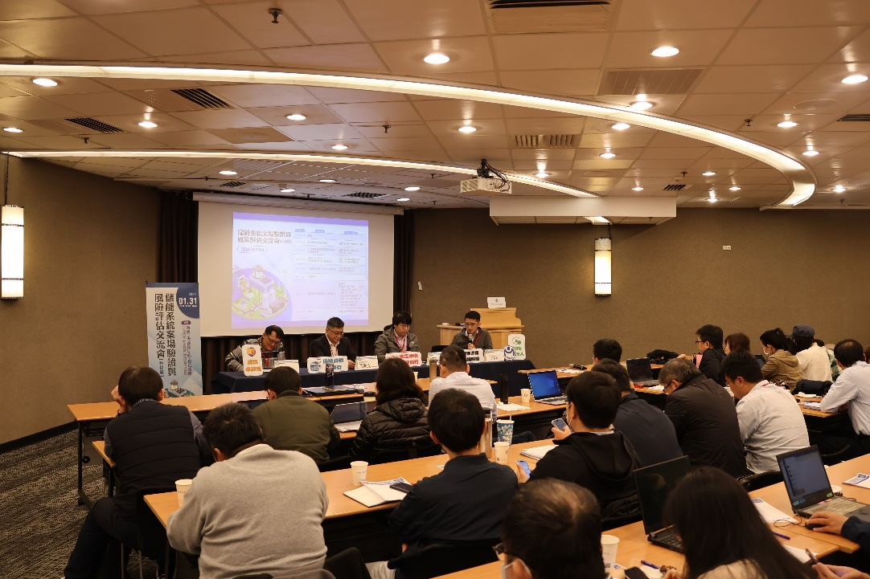

Fig1, “Energy Storage System Case Study Verification and Risk Assessment Exchange Meeting” was held by MIRDC.
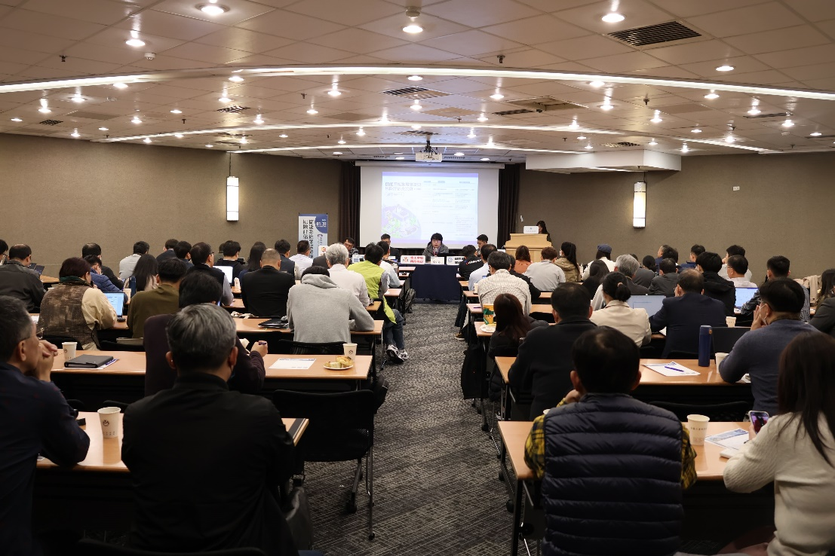

Fig2, The participants of the exchange meeting participated actively.

