新聞資料NEWS LETTER
MIRDC takes home 5 medals at the 8th National Industrial Innovation Awards

The Ministry of Economic Affairs (MOEA) held the 8th National Industrial Innovation Award (NIIA) ceremony on May 15th. The NIIA is mainly to reward enterprises, academia, and research institutions for integrated innovation in Taiwan. MIRDC wins Outstanding Innovation Award for Academic and Research Institutions of Organization Category, and two teams win Innovative Trailblazer Team Award for the Development of key technologies for intelligent orthopedic surgery assistance system and Continuous Heat Treatment System Equipment for Micro Components. In addition, the chief Shin-Hung Kuo and deputy supervisor Chia-Hung Huang wins 2 Awards respectively for the Youth and Individual in the individual category. That's quite an achievement.

Regarding the Award for Academic and Research Institutions of Organization Category, MIRDC promotes forward-looking R&D technology, leading industries to achieve innovation and excellence. Since 2019, MIRDC has won 7 the R&D 100 Awards, especially winning 3 awards at the 2022 R&D 100 Awards. Demonstrating MIRDC’s continuous breakthroughs in technological innovation. In addition, MIRDC activates the mode of industry-academia collaborations such as the joint establishment of R&D centers by academia and research institute, thematic cooperation, recruitment of researchers for academia and the institute, and employment of graduate students from academia to participate in research projects. Integrating the capabilities of academia-research, jointly increasing the competitiveness of industries, and promoting the innovation mode of leading the small by the big, which is the dominant manufacturers lead the supply chain manufacturers to develop new materials, new products, and new markets, leading the transformation and upgrading of the industries in the local industry cluster. In addition, the Innovation Value-added Center of Traditional Industry provides services with innovative product development, and it assists with the rapid mock-up of customized products to enter the international market. The scientific research results were dedicated to social benefits, such as assisting manufacturers to build face mask production lines to increase manufacturing capacities during the pandemic, fully committed to food inspection of plasticizers for food safety and health, and helping children in remote areas make their new shoes by arch fit technology, and so on. Working hard to assist and solve social or public problems.

For Innovative Trailblazer Team Awards, the Continuous Heat Treatment System Equipment for Micro Components integrates four innovative functions of automatic feeding, automatic monitoring and real-time adjustment of carburizing quenching furnace, innovative oil tank and material collecting module, and intelligent digital services with the collecting rate achieving 100%, the yield rate reaching 99%. And the precision and wear resistance of the products has met international standards. It was introduced to several domestic manufacturers, helping the companies receive orders from international manufacturers. Another award is for the development of key technologies for an intelligent orthopedic surgery assistance system that integrates optical 3D composite tracking, a multi-vertebral image navigation system, the surgical-assisted robotic arm can correct the position of each vertebral segment in real-time during the surgery with the accuracy rate reaching 94%, which effectively shortens the surgery time. The technology has been transferred to many manufacturers in Taiwan and replaced the well-known international tracking system. For the Individual Category, the Chief Shin-Hung Kuo, the prize winner of Youth, designs the only 3D printing & casting laboratory in Taiwan to provide multipoint one-stop casting prototyping services. Assisting more than 120 companies with 3D printing and sand casting systems and domestic sand materials and resins for 3D printing. And the assistant chief Chia-Hung Huang, the prize winner of Individual, overcame obstacles of heat treatment for micro components and had the patent for heat treatment material receiving devices. It has been applied in the supply chain production of major international manufacturers, assisting manufacturers enter the high-value product market.

The Acting President of the MIRDC, Chih -Lung Lin stated MIRDC will continue working hard on the 2050 Net-Zero Emissions, Six Core Strategic Industries, and other national development policies. MIRDC plays a key role in connecting academia and research institutes with the goals of "Innovation, Sustainability, and Globalization," to accelerate industrial innovation with critical developments to help industries boost their growth and resilience to consolidate Taiwan's position in the global supply chain. MIRCD also implements CSR and continues building friendly working environments.

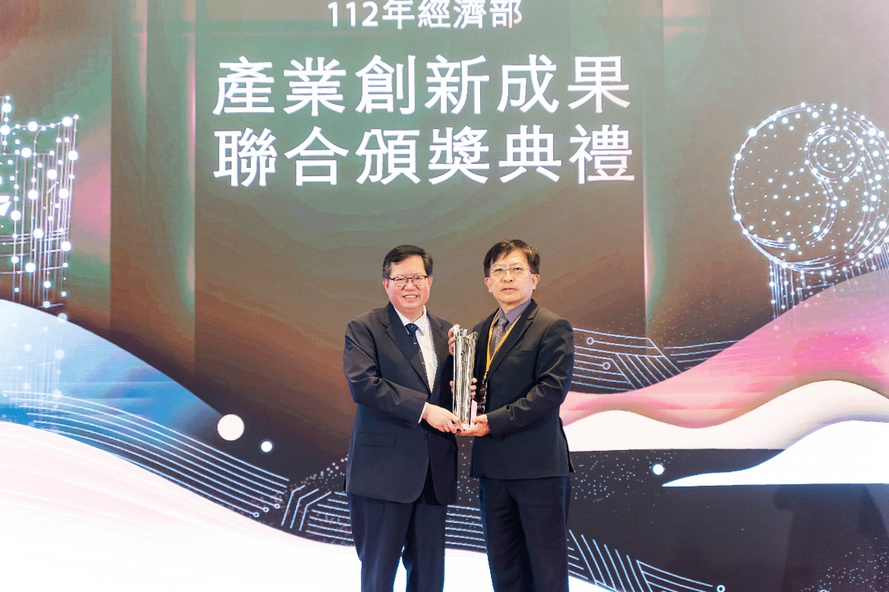
Picture 1、The Acting President of MIRDC, Chi-Lung Lin accepts the award (on the right), the other is the Vice Premier of Taiwan, Wen-Tsan Cheng (Photo Credit: NIIA) 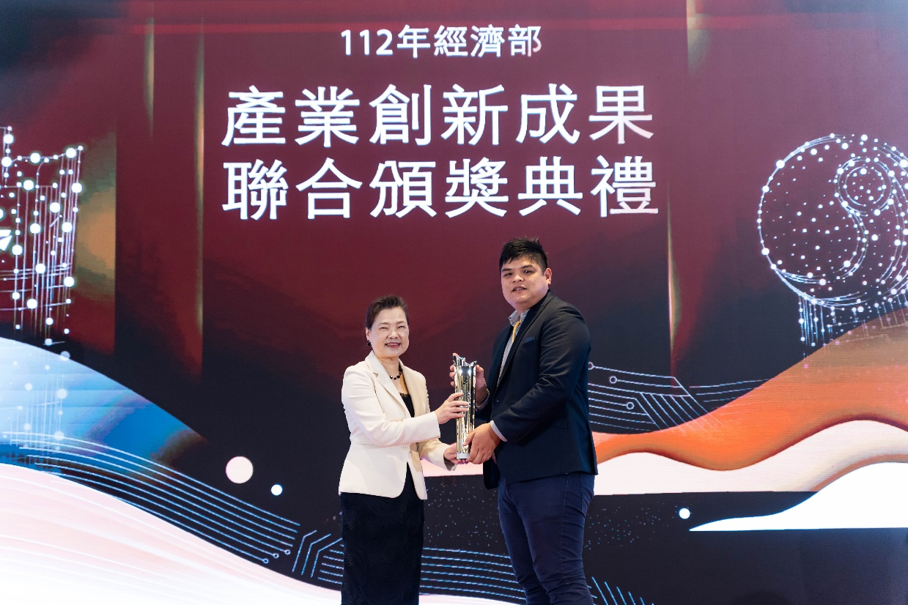
Picture 2、The Chief Shin-Hung Kuo accepts the Award of Youth (on the right), the other is the Minister of Economic Affairs of Taiwan, Mei-Hua Wang (Photo Credit: NIIA) 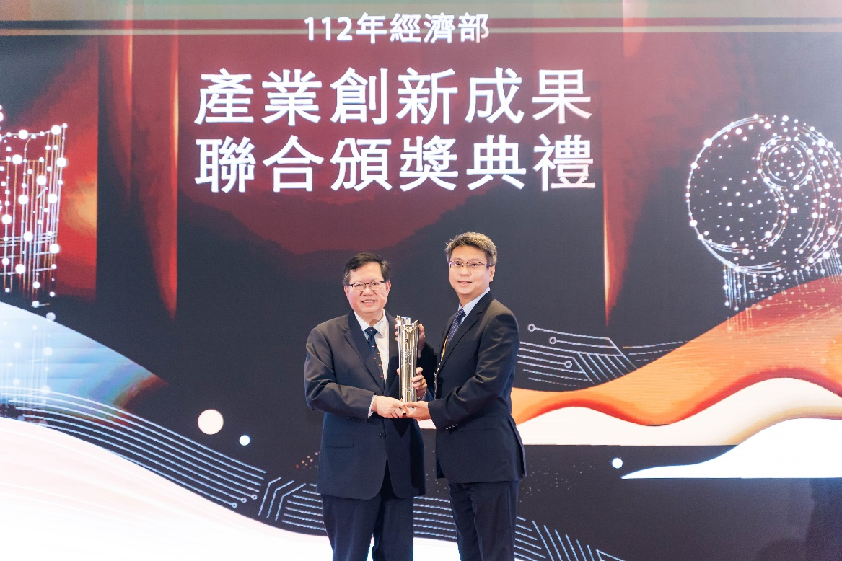

Picture 3、The Assistant Chief Chia-Hung Huang accepts the award of Individual (on the right), the other is the Vice Premier of Taiwan, Wen-Tsan Cheng (Photo Credit: NIIA)

