NEWS LETTER

MIRDC Boosts Taiwan’s Industrial Technological Capacities byReceiving Equipment Donations from Manufacturers
MIRDC is committed to developing and introducing advanced foreign manufacturing and processing technologies to support Taiwan’s manufacturing industry in order to enhance the technological capabilities of the manufacturing industry. Over the past 60 years, MIRDC has grown with many domestic manufacturers and formed a close industrial link. In order to serve the related industries more efficiently, MIRDC, the equipment donors, and the Taiwan Metal Heat Treatment Society jointly held the “Equipment Donation and Industry Technology Deepening and Application - Cooperation Promotion Ceremony” on 4/21(Fri).

Among the equipment donations were digital display micro hardness testing instruments, metallographic microscopes, brine spray testers, fully automatic metallographic mounting machines, metallographic grinding and polishing machines, automatic metallographic cutting machines, and fully automatic metallographic cutting machines provided by Taiwan Nakazawa Corporation; deep cooling furnaces provided by Kin Yuan Dar Metal; carbon and sulfur analyzers provided by Mei Kwang Heat Treatment Co. and the mirror polishing machine provided by SLS CNC. The donated equipment is of the latest and highest grade, with a total value of more than $7.1 million. In addition to helping to conduct relevant academic research, the donated equipment will be used to accelerate the application and promotion of industrial technology in cooperation with the Taiwan Metal Heat Treatment Society in order to expand technological upgrading in the industry.

President Chih-Lung Lin stated that MIRDC has been cooperating with manufacturers in the fields of stainless-steel corrosion resistance and surface hardening technology, micro parts heat treatment technology, vacuum high-pressure gas quenching technology, surface hard coating technology, etc. To take the stainless-steel corrosion resistance and surface hardening technology as an example, the surface of stainless steel is modified by gas activation to increase the hardness of the surface. The hardness of stainless-steel surface is elevated to over HV 1,200, which is much higher than that of general carbon steel and does not damage the original corrosion resistance characteristics, and can be applied to fasteners, jewelry, and accessories, among others. In terms of heat treatment technology for micro parts, the technology allows for custom design, analysis, assembly, testing, and related equipment development, and is suitable for precision heat treatment of micro parts with flesh thickness≦2mm and size≦ 0mm. These two technologies have also been recognized by the international award R&D 100. In part of vacuum high-pressure gas quenching technology, it has the advantage of small workpiece quenching deformation and clean surface, which is suitable for high precision molds and workpieces; and in the surface hard coating technology, we can provide various kinds of suitable coatings for different applications, and we have many applications in the aerospace and precision processing fields.

MIRDC’s heat treatment and surface treatment development team has decades of research and development experience in heat treatment and surface treatment equipment and process, and will continue to work in this field and actively cooperate with manufacturers and serve the industry to continue to accelerate Taiwan’s technology upgrading in this field.
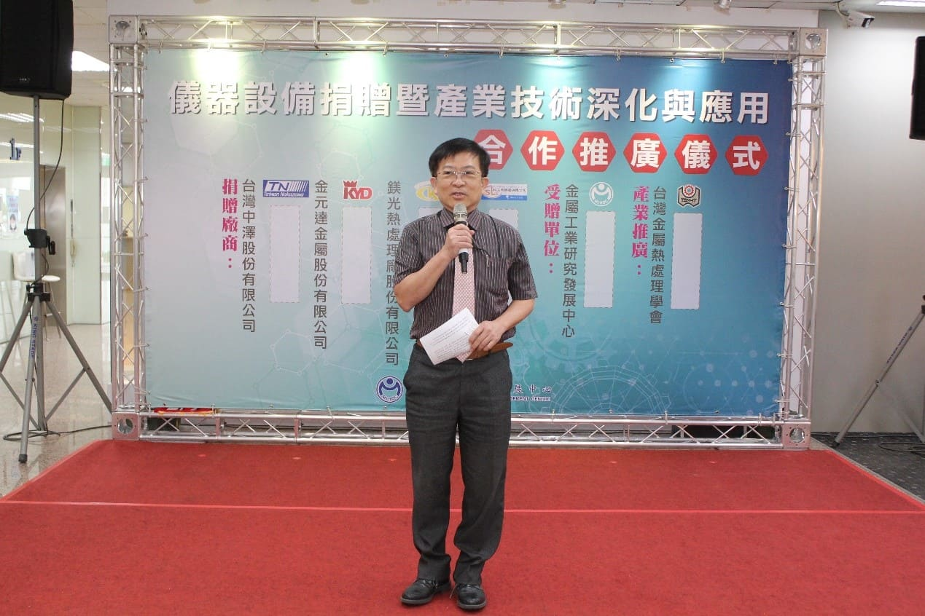

Figure 1: Address by Dr. Chi Lung Lin, the Acting President of MIRDC
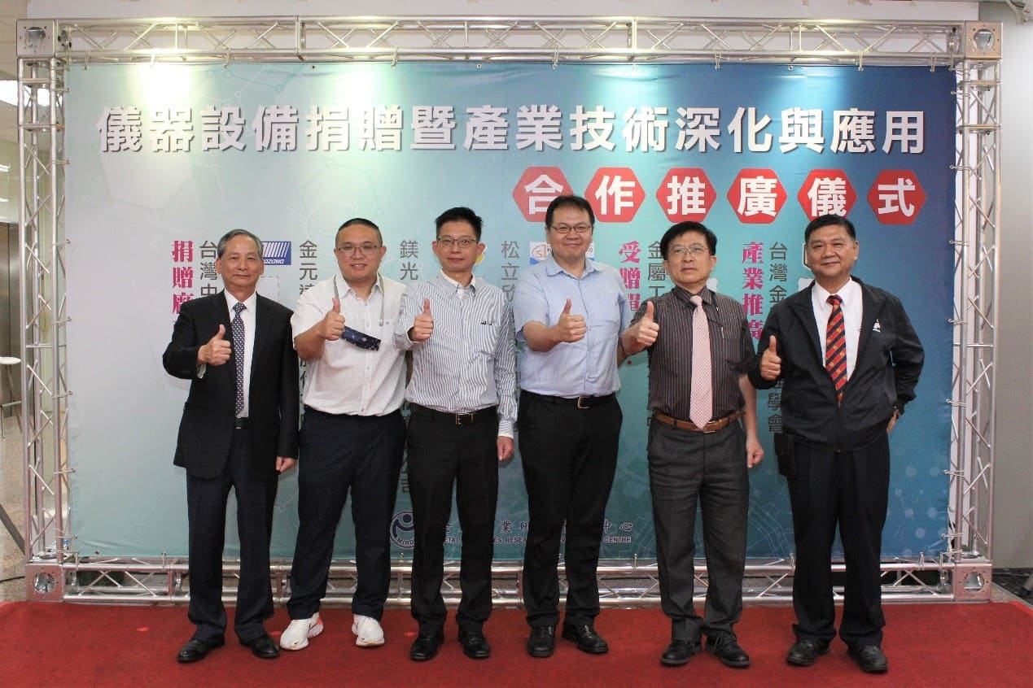

Figure 2: Representatives of the participating companies and societies. From left: Mr. Chou-Yu Hung, Chairman of Taiwan Nakazawa Corporation; Mr. Chih-Ta Tseng, Vice President of Kin Yuan Dar Metal Enterprise; Mr. Chien-Ku Chen, President of Mei Kwang Heat Treatment Co.; Mr. Cheh-Ming Hsu, President of SLS CNC Co.; Dr. Chih-Lung Lin, the Acting President of MIRDC; and Mr. Kuo-Chen Tsai, Director of Taiwan Metal Heat Treatment Society.
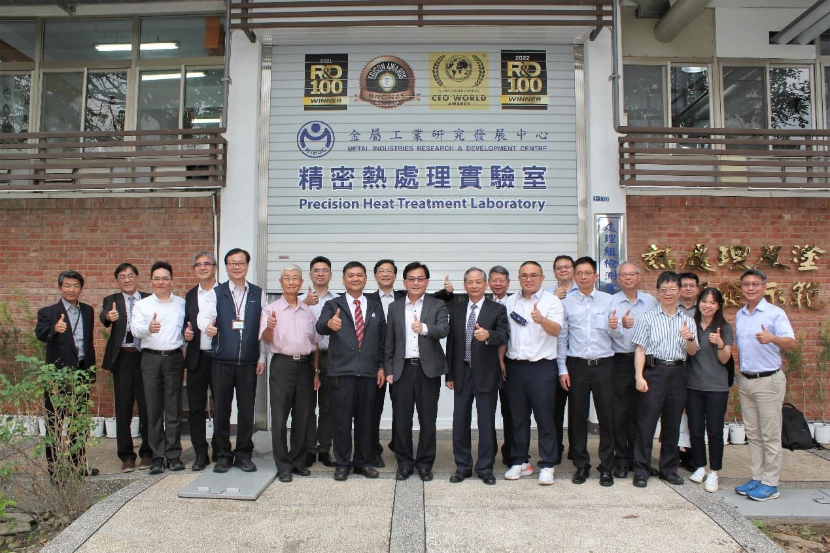
Figure 3: Group photo of all guests at MIRDC - Precision Heat Treatment Lab

