新聞資料NEWLETTER
Save lives. Race against time.
MIRDC joins hands with the National Fire Agency to strengthen information and communications in disaster prevention and the applications of digital technology

With the open mountain and forest policy and the outdoor activities getting popular, the number of hikers significantly increases in Taiwan. Hiking accidents have also inevitably increased in recent years. To improve rescue efficiency, MIRDC and the National Fire Agency (NFA) held a "Memorandum Of Understanding (MOU) Signing Ceremony," witnessed by the Administration for Digital Industries (AFDI) at the Dapinglin Office Building of the NFA in Xindian on 9th June. MIRDC and the NFA will combine 5G communications and drone equipment to strengthen the system for mountain search and rescue in the future, making comprehensive emergency management for mountain disaster relief, boosting our rescue capabilities of disaster response, and improving the efficiency of search and rescue operations as the goal to demonstrate Taiwan’s overall disaster relief capacity.

The 2023 governing objective and strategy of the NFA is to improve disaster relief workers’ equipment and techniques by improving the disaster prevention and rescue system, strengthening information and communication in disaster prevention, and protecting firefighters' care and rights. When mountain accidents occur, it would be more difficult to search and indirectly endanger firefighters’ lives due to bad weather, large areas covered by forests, and when the casualties are located in the lower valleys. The NFA cooperated with MIRDC to combine the application of human and drones interaction and technologies of synergistic cooperation, strengthening the search and rescue module in mountain accidents and solving the delay in rescue caused by casualties' inaccurate information of their location, which can not only enhance rescue workers’ safety but also casualties’ survival rate in distress.

The AFDI, which witnessed the signing ceremony, is tasked with the promotion of applications relating to digital competency and continues to aid the digital transformation of Taiwan’s industries in response to challenges and opportunities that come with the era of the digital economy. MIRDC Chairman Jen-Yi Lin stated that MIRDC has invested in the technology R&D of unmanned aerial vehicles (UAV) in recent years, the purpose of the development is to fulfill high-load, high-stability, and combine with innovative applications in the field—the implementation of UAV applications including agriculture, inspections, pelagic fisheries, etc. Facing the lack of communication infrastructure in the mountainous environment, we hope to promote the application to the field of fire and disaster relief through cooperation with the NFA and to accelerate the support to the industry to promote more diverse applications of UAVs, which drive domestic key components (such as motors, drives, composite material processing, etc.), and SI industry to participate in. We look forward to integrating 5G communications and human-machine interface to bridge the gap in Taiwan's mountain rescue system and achieve precise disaster relief and protect lives and properties and improve the safety and well-being of the people.

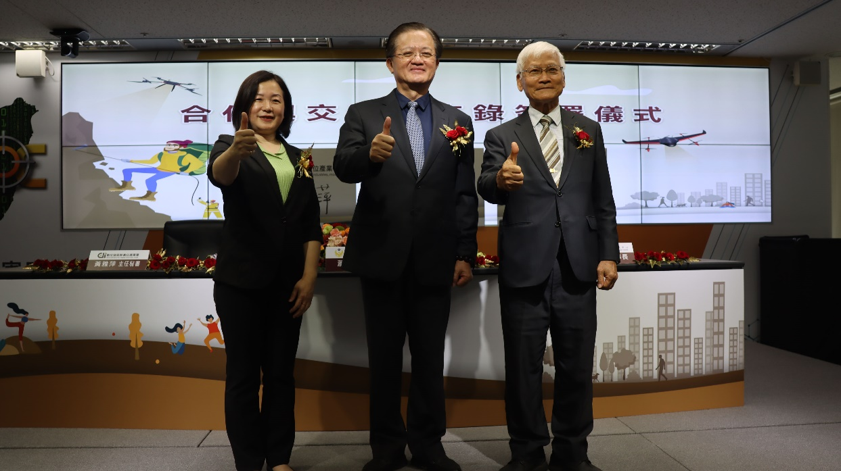

Picture 1、The picture from left to right are Chief Secretary Ya-Ping Huang of the Administration for Digital Industries, Director General Huan-Chang Hsiao of the National Fire Agency of the Ministry of the Interior, and Chairman Jen-Yi Lin of the MIRDC, attending the signing ceremony of MOU.

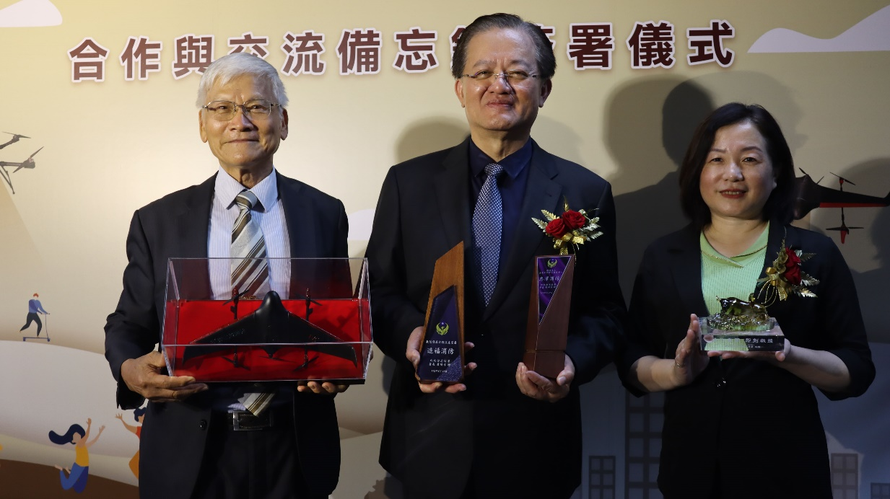

Picture 2、 Chairman Jen-Yi Lin of MIRDC, Director General Huan-Chang Hsiao of the National Fire Agency of the Ministry of the Interior, and Chief Secretary Ya-Ping Huang of the Administration for Digital Industries, exchange gifts at the signing ceremony.
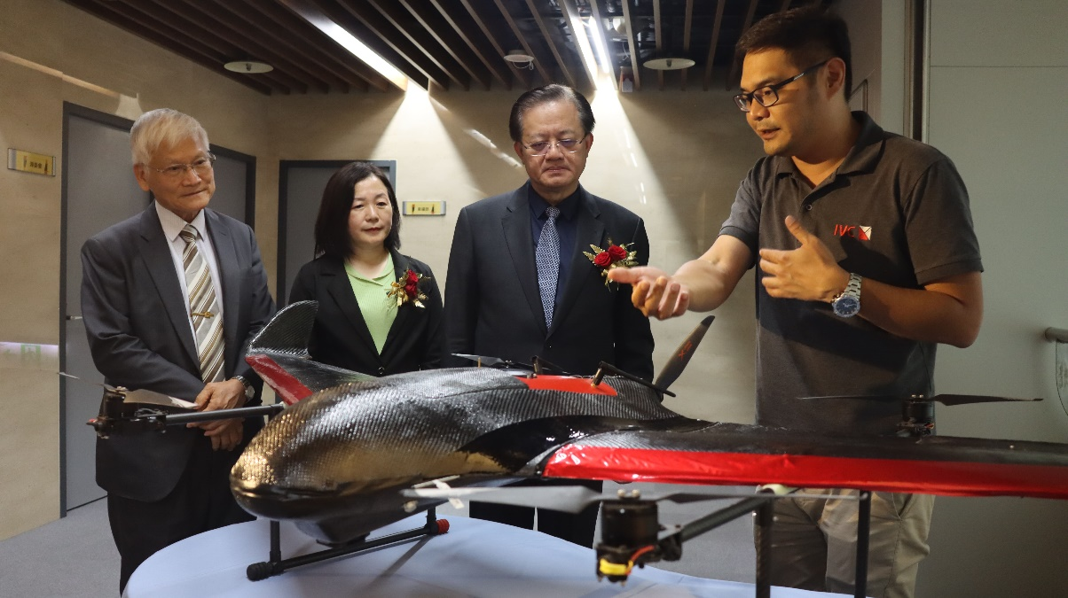

Picture 3、 The Chief Kuang-Shine Yang of the MIRDC (first one from right), explaining the characteristics of UAVs.

