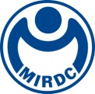
新聞資料NEWS LETTER
MIRDC Showcasing Strong Mold Technology
TAIMOLD 2023 Achievements Zone Launched
The "TAIMOLD 2023 Mold Technology Development Programs Achievements Zone" will be exhibited from August 23rd to August 26th, 2023. The exhibition will be held on the 4th floor of Hall 2 at the Taipei Nangang Exhibition Center. The zone will showcase a total of 16 advanced mold production key technologies. By establishing high-value technological capabilities in digital design, rapid, efficient, and precise manufacturing for the mold industry, it has successfully assisted domestic companies in the mold industry in winning orders from Bombardier Inc., Denmark’s leading wind turbines company, and other international enterprises.

To help mold manufacturers enter high-value-added supply chains, the Department of Industrial Technology, Ministry of Economic Affairs has been investing in the development of digital design, rapid, efficient, and precise manufacturing technologies required in the mold sector through MIRDC for nearly 4 years. This initiative aims to lead the transformation and upgrade of the mold industry in the traditional manufacturing sector. Highlights of the technological achievements in this zone include independently developing the first domestic gravity casting mold digital assistant design system, which can significantly reduce casting mold design time by more than 40%. The first domestic integration of cutting force mechanics models and real-time machine processing data, reducing EDM processing time from 12 hours to less than 4 hours. Innovative 3D sand mold waterway mold rapid prototyping technology can shorten the prototyping schedule by more than 44%. Last, the pioneering mold steel surface hardening technology in Taiwan, increased mold lifespan by more than 2 times.

MIRDC Vice President Jun-Jie Wang stated that mold technology has successfully assisted the industry to enter the supply chain of international enterprises and obtained substantial orders. Yeong Chen Asia Pacific Co., Ltd. introduced a gravity casting mold digital assistant design system and received the order for the foundation of the wind turbine from one of Denmark’s leading companies. New Kailung Gear Co., Ltd. introduced 3D sand mold waterway mold rapid prototyping technology, to develop aluminum alloy gearbox parts and gained orders for Bombardier Inc. ATV/UTV parts. The robust optimization decision support system for casting modification has been introduced to Oscar E.D.M. Company Ltd. to assist this company in establishing automatic production lines in the domestic aerospace industry. The technology was transferred to a well-known domestic medical material manufacturer's mold steel case hardening technology and used in high-hardness titanium alloy aggregate products. The relevant technical achievements have earned recognition from the industries. In the future, MIRDC will continue to comply with government policies, deepen the development of critical technologies in the mold industry, and actively cooperate with the industries to accelerate Taiwan's upgrading and transformation in the field of mold-related technologies.
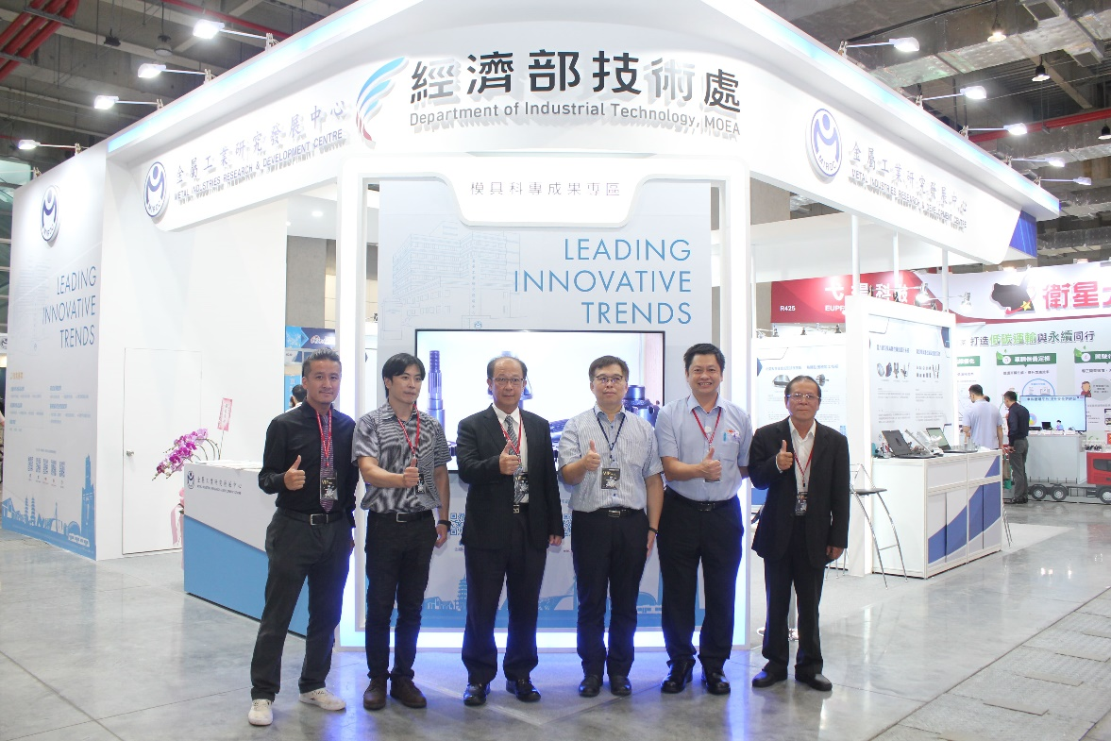

Photo 1、TAIMOLD 2023 Achievements Zone VIPs group photo (from left to right:Senior Manager Jin-Tsan Ho of Oscar E.D.M. Company Ltd., Innovation Manager Chi-Wen Fan of Comptake Technology Inc., Vice President Jun-Jie Wang of MIRDC, Department of Industrial Technology, Technical Specialist Wun-Sheng Lee of Ministry of Economic Affairs, Senior Manager Shi-Hong Liu of Yeong Chen Asia Pacific Co., Ltd., and Director Yin-Jie Lin of MIRDC)
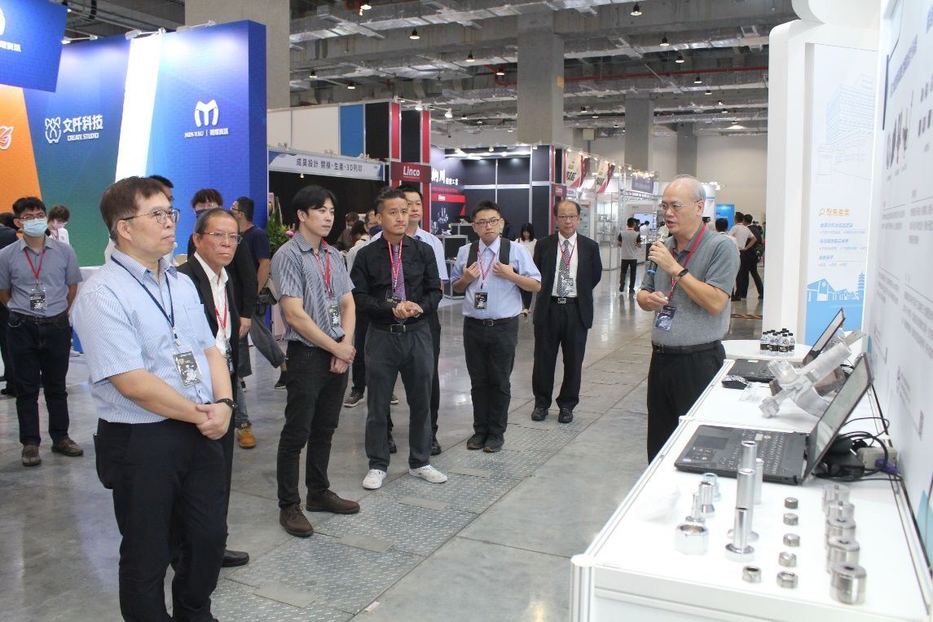

Photo 2、MIRDC VIP tour for the technologies achievements

