
新聞資料NEWS LETTER
Taiwan takes the lead in the global digital transformation of medical technology, shining on the APEC international stage.

MIRDC hosted the "APEC Telemedicine: Beyond Boundaries, Leading Digitally International Forum" in Taipei and Tainan on November 16 and 17 respectively. With the global COVID-19 pandemic and advancements in AI technology, smart telemedicine has become a focal point in global medical technology development. The advancement of smart telemedicine is crucial for human health and well-being. Taiwan, as a vital player in the semiconductor international supply chain, has been leveraging technology since the 1990s to drive a series of transformations in medical digitization and integration. This has led Taiwan's healthcare service model to rank first globally for eight consecutive years. This forum aimed to showcase the achievements of Taiwan's dental medical materials and medical institutions in digital transformation, with representatives from over six APEC member economies attending to discuss smart and telemedicine-related technologies, research capabilities, policy experiences within APEC economies, and interact with each other to build digital medical capabilities.

Chien-Cheng Tai, a Senior technical specialist at the Department of Industrial Technology, Ministry of Economic Affairs, stated that through Technology Development Programs for research institutes, they assist businesses in adopting electronic information technology and advanced manufacturing technology. This not only reduces cumbersome traditional processes but also decreases time and costs. In the past, traditional metal implants and oral prosthetics were not always aesthetically pleasing or functionally ideal. Today, through the adoption of digital dental solutions and 3D printing technology, dental restoration procedures have evolved into "precision dental prostheses." This includes customized absorbable oral bone defect restorations designed for oral bone defects, as well as root portions that mimic natural tooth structures and immediately implant teeth, enhancing stability and aesthetics. Digital dentistry not only drives the transformation of the dental medical materials industry into precise oral prosthetics and digital dental materials but also significantly enhances product-added value and competitiveness. Chien-Cheng Tai elaborated on Taiwan's response to the differing distribution of medical resources by presenting comprehensive smart medical system solutions tailored for urban, rural, and village communities.

Yung-Hsiang Lai, President of MIRDC, expressed that APEC is one of the most important multilateral official economic cooperation forums in the Asia-Pacific region. The Policy Partnership on Science, Technology, and Innovation (PPSTI) serves as a vital platform for technology policy and substantive technology exchange. With the support of the Department of Industrial Technology, Ministry of Economic Affairs, they have facilitated medical materials and technology companies' entry into the international CDMO supply chain, organized domestic and foreign medical material channel opportunity matching meetings, and practical workshops, and led companies to participate in international professional contract manufacturing or specialized medical exhibitions, effectively building international cooperation and business opportunities, and expanding international markets. In the future, they will continue to cooperate with government policies to assist Taiwan’s southern region in creating a digital transformation research and innovation hub, driving regional industrial technological improvement, and promoting diverse innovative medical industry services. MIRDC centered on telemedicine and proposed solutions applied to the "Integrated Software and Hardware for Digital Dental System" as a case to PPSTI by the Department of Industrial Technology, Ministry of Economic Affairs.

The conference also invited speakers from member economies such as the United States, Peru, Japan, Thailand, and Malaysia to share the current development status of medical technology digital transformation in their respective countries. Through this APEC international exchange dialogue, Taiwan aims to raise awareness of its overall development in digital medical technology, showcasing its industry-leading capabilities to APEC economies such as Chile, Peru, the Philippines, Thailand, and Japan, and gaining recognition and favor. Companies like Chung-Chun Hsu from Compal Electronics, Inc. shared their application of information and communication technology in the medical industry; Biomdcare Corporation introduced their "Osteoporosis Image Screening Solution," which can accurately output T-Scores and risk assessments within 6 seconds, effectively reducing testing manpower and time costs. Inteware co. ltd shared their application of AI and cloud technology in digital orthodontics and dentures, achieving precise and telemedicine goals; and The Dentall Taiwan incorporated AI technology into dental treatment, generating dental charts with a single click, providing clinical treatment suggestions, and health insurance code inquiries, promoting treatment quality and medical communication efficiency.

The conference arranged a visit to Advantech's Intelligent Medical Technology Park in Linkou, Taoyuan on November 16, Advantech provides one-stop integrated smart medical solutions, including operating rooms, smart wards, smart consultation rooms, smart medication, real-time location systems (RTLS), and telemedicine applications. On November 17, a visit to Ardenta, in the Southern Taiwan Science Park. Ardenta introduced comprehensive digital dental services, including digital counterfeit restoration design, digital invisible braces, and digital surgical guides, providing clinicians and patients with more comprehensive treatment options. Through sharing Taiwan's medical digitization, it is hoped that future cross-border cooperation can assist APEC member economies in achieving smart medical goals.
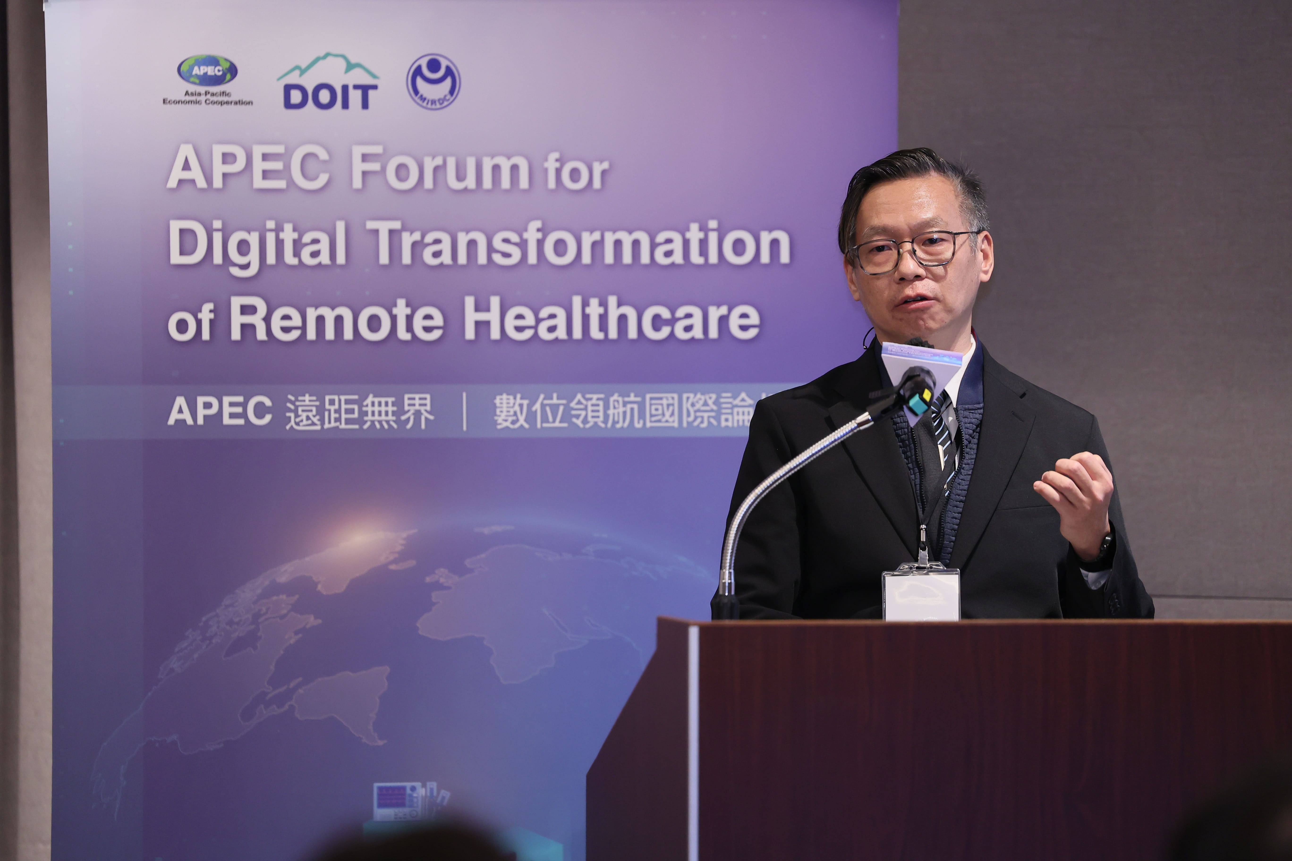

Pic 1、Speech by Chien-Cheng Tai, a Senior technical specialist at the Department of Industrial Technology, Ministry of Economic Affairs

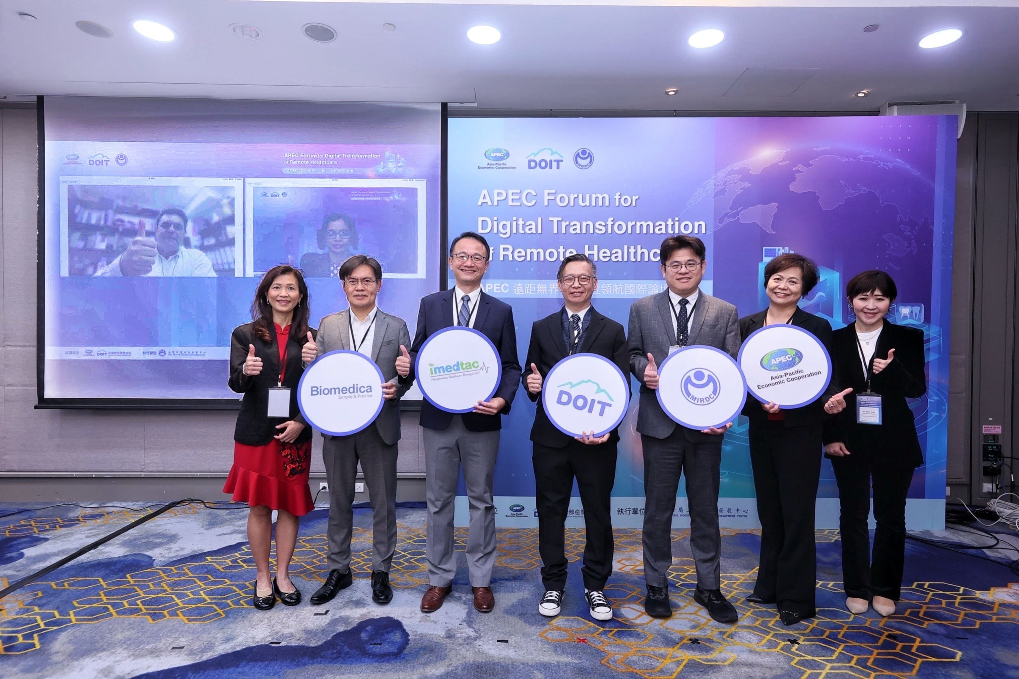

Pic 2、Group photo (from left to right: Professor Dr. Seow Liang Lin from International Medical University Malaysia, Vice President Lin Mingxiang from Biorepro Corporation, CEO Yu Jinshu from Hui Cheng Intelligent Medical Corporation, Chien-Cheng Tai,Senior technical specialist at the Department of Industrial Technology, Ministry of Economic Affairs, Deputy Director Huang Bo-Wei from the MIRDC, General Manager Chen Huiling from Fezzimedical Information Corporation, Associate Professor Dr. Maiko Iwaki from Tokyo Medical and Dental University)
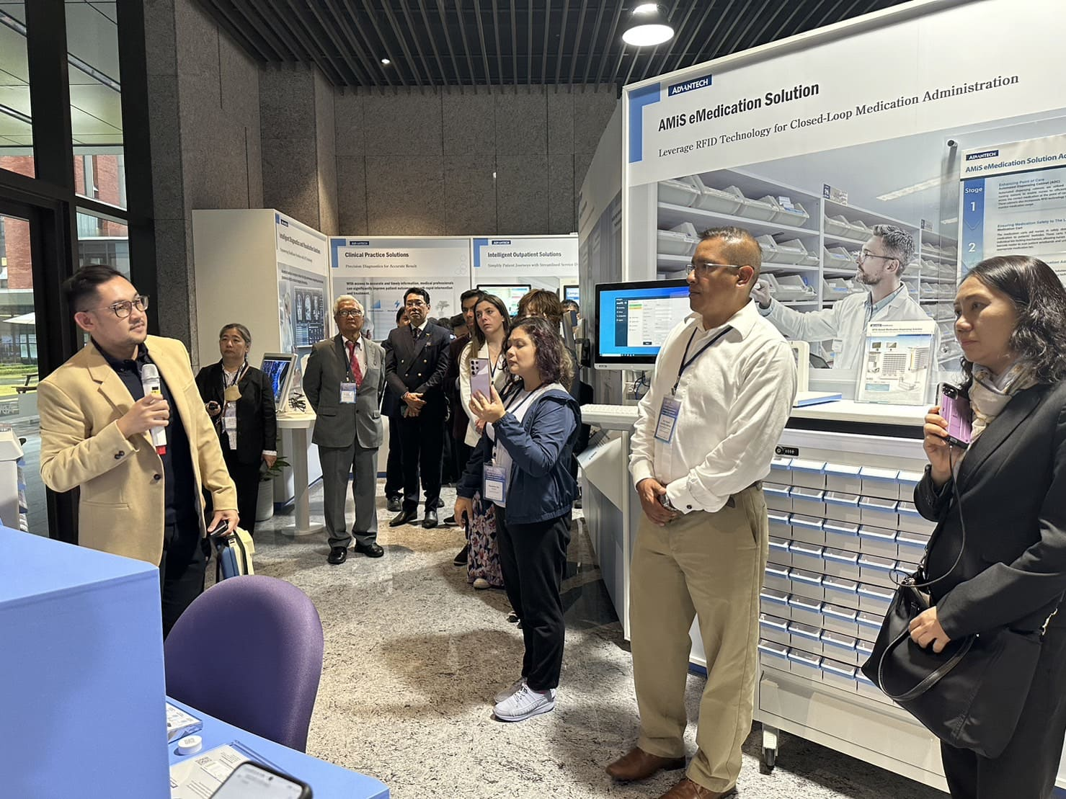

Picture 3、a visit to Advantech's Intelligent Medical Technology Park in Linkou

