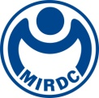
新聞資料NEWS LETTER

MIRDC’s guidance on the intelligent healthcare and medical materials industry has achieved remarkable results

To develop Taiwan's AI and intelligent medical care and introduce information and communication technology in the medical and health field, the Industrial Development Administration, Ministry of Economic Affairs entrusted MIRDC to hold the "2023 Digital Medical Industry Development and Cross-domain Promotion Plan Results Presentation" and "2023 Medical Device Industry Technology Guidance and Promotion Plan Results Presentation" at the Taipei Nangang Exhibition Center (TaiNEX) on December 1st , 2023. MIRDC implements the "Digital Medical Industry Development and Cross-Domain Promotion Plan" and the "Medical Equipment Industry Technology Guidance and Promotion Plan" of the Industrial Development Administration, Ministry of Economic Affairs, through technological upgrading, regulatory strengthening, cross-field talent cultivation and international promotion. MIIRDC assisted 13 domestic manufacturers in upgrading their products through other methods with fruitful and eye-catching results. MIRDC has successfully promoted the domestic medical equipment industry, increased the added value of Taiwan's medical equipment products, and promoted BIO-ICT cross-industry and cross-domain cooperation.

There were 13 manufacturers invited to the presentation, including bestcom/ IMVITEC CORPORATION, melten/ PHYSIOLGUARD BIOTECHNOLOGY INC., Physiolguard Corporation Ltd, BROADSIMS Inc., DIGIBIONIC LIFESTYLE CO., LTD, MediVisionTech Co., Ltd., Eclatorq, T-ACE Medical Co., Ltd., MajorMedLeague Co., Ltd., A-Tech System, and Renorigin Innovation Institute. During the presentation, many achievements in medical materials were displayed, successfully expanding product visibility and establishing public trust in domestic products. It also makes the superb strength of Taiwan's medical materials visible to more people. These include the clinical diagnosis and treatment image prediction and evaluation system for brain radiation therapy (AVM cerebral arteriovenous malformation), the AI thermal imaging patient bed detection system, the home heart failure intelligent detection platform, and the medical station manager's physiological information critical early warning indicator system, smart hearing aid remote testing and control verification, nasogastric/intestinal tube observation auxiliary system, digital torque tool for dental implants, submucosal injection for endoscopic resection surgery, medication auxiliary for infection control breathing tube, sterility Closed-loop immune cell culture bags and lactoferrin nasal spray, etc.

Technical Specialist Chia Hao Li of the Industrial Development Administration, Ministry of Economic Affairs, stated that digital medical consultations can be paid at your own expense or included in health insurance benefits in the coming year, an important milestone. And will help promote digital medical treatment in the future. The Vice-President of MIRDC, Chih Lung Lin, stated that through Myra Yu, Managing Director (Asia Pacific) of Teladoc Health's keynote speech and multiple achievements, intelligent medical care is the ultimate goal of achieving universal health. According to the WHO report, most countries' investments in competent healthcare include mobile healthcare, telemedicine, electronic medical records and online learning. Through the coaching resources and tools provided by the government, MIRDC has gradually positioned the core technologies of the entire medical industry chain and pooled the energy of industry, government, academia, and medical research to create more new business opportunities. This presentation will showcase the government's efforts in guiding the medical sector through a presentation of results.
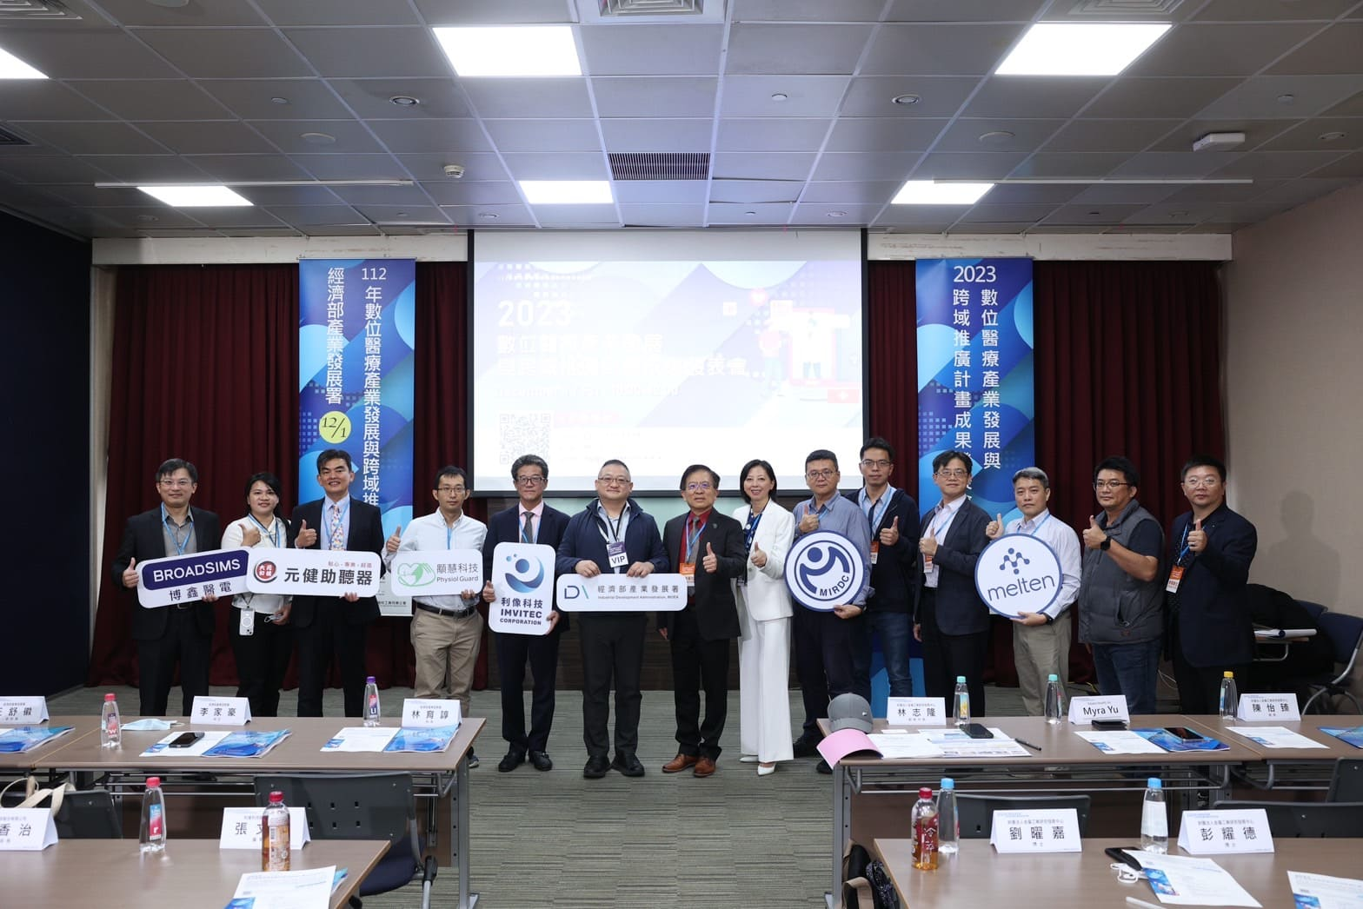

Fig1, Witnessed by Technical Specialist Chia Hao Li (the sixth from left) of the Industrial Development Administration, Ministry of Economic Affairs, the Vice President of MIRDC, Chih Lung Lin, invited Myra Yu, Managing Director (Asia Pacific) of Teladoc Health for the topic speech and led R&D engineers and those mentored manufacturer representatives to showcase the results of the digital medical industry development and cross-domain promotion plan.
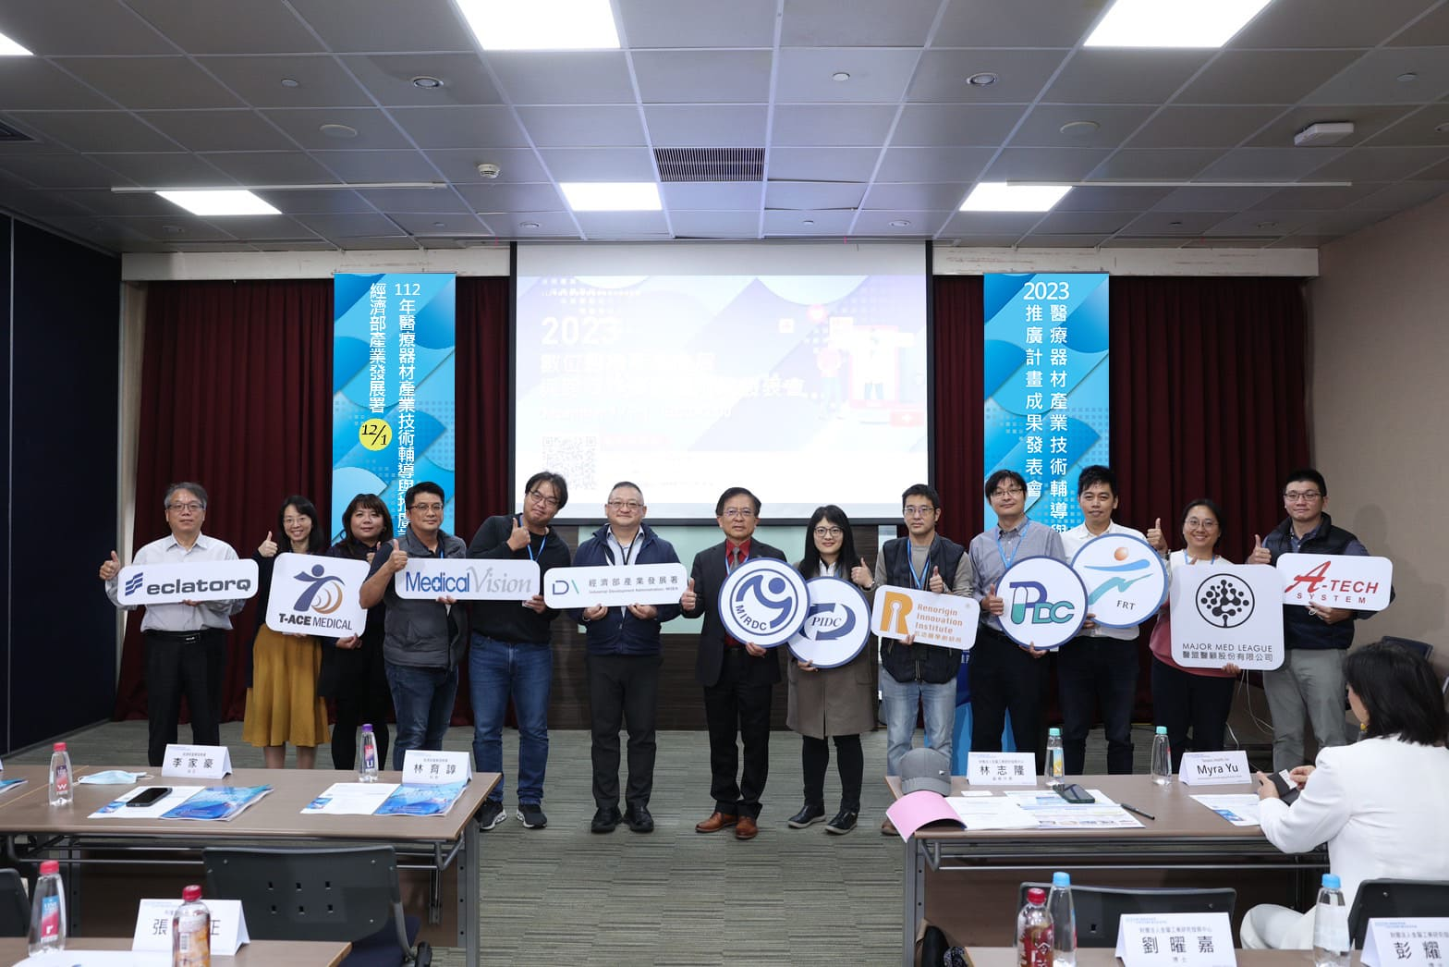

圖二、Witnessed by Technical Specialist Chia Hao Li (the sixth from left) of the Industrial Development Administration, Ministry of Economic Affairs, the Vice President of MIRDC, Chih Lung Lin, led R&D engineers and those mentored manufacturer representatives to showcase the results of the digital medical industry development and cross-domain promotion plan.

