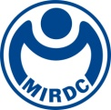新聞資料NEWS LETTER
TASS 2023 Sustainable Taiwan Expo drew to a close
MIRDC showcased 18 technological achievements to deliver sustainable development!

MIRDC participated in the TASS 2023 Sustainable Taiwan Expo at the Kaohsiung Exhibition Center on November 22 to 24, focusing on the theme of "Low-Carbon Regenerated Recycled Aluminum, Cross-Industry High-Value Applications," showcasing 18 technological achievements. It actively assists industries in increasing the use of scrap aluminum and improves the processability of recycled aluminum. It is expected to increase the processing capacity of domestic recycled aluminum by 36,000 metric tons per year. It will independently supply recycled aluminum materials to the domestic aluminum industry chain, replacing imported primary aluminum materials and promoting the aluminum industry to reduce carbon emissions by 300,000 metric tons.

Ren-Yi Lin, Chairman of the MIRDC stated that 18 technological achievements were exhibited this year. Under the guidance of the Department of Industrial Technology, MOEA, government resources, and research institutes’ R&D capabilities were combined to promote implementation in the industry. The "Circular Aluminum Material Innovative Application Process Technology Development Program" is implemented for aluminum recycling and reusing in bicycle components, including international brands (such as Decathlon), and implements the use of low-carbon materials in the bicycle industry. Speaking of the past, domestic construction formwork was mainly wood formwork, which was not easy to reuse (0 to 5 times) and easily caused a large amount of construction waste. Now we are cooperating with ALFORMER Industrial Co., Ltd in green processes application, which reduces manufacturing costs and scales down the felling of 40,000 trees to improve environmental sustainability. The ocean is also an issue that cannot be ignored. We use waste oyster shells and waste stones to develop "regenerated diverse conversion materials". Now in cooperation with the Taiwan Eco Angels Environmental Conservation Association, it is pointed out that the coral bases produced can allow coral seedlings to grow and thrive directly on them. It is not only non-toxic but also more resistant to the impact of seawater. Many restoration results have been successfully implemented on the north coast of Keelung.

At the opening ceremony on November 22, Ren-Yi Lin, Chairman of the MIRDC, and Shun-Chin Lee, Chairman of CPC Corporation, Taiwan also signed an MOU, declaring the joint promotion of hydrogen transportation and storage safety inspection and verification technology, and providing a valuable addition to Taiwan’s hydrogen energy industry. In addition, to assist the industry in building carbon inventory capabilities, Chih-Lung Lin, Vice President of MIRDC, and Fa-Shyang Chang, Chief Risk Officer of Cathay United Bank, signed an MOU to jointly promote the financial sector to support industrial carbon reduction. In addition to new energy development, the exhibition also featured the "Porous Coated High Thermal Heat Pipe" developed by MIRDC through the implementation of the "Industry Led Specialized Material Development and Application Program." Unlike domestic heat exchangers that use smooth pipes as the main heat transfer pipe, this innovation can increase efficiency by 2 to 5 times, and reduce energy loss. This demonstrates a significant contribution to new energy and industrial energy conservation.

As the demand for low-carbon materials and green energy gradually expands, there is a growing emphasis on playing an important role in balancing industrial development and environmental protection. Therefore, a "Low-carbon circular aluminum materials seminar" was held, inviting experts to share industry trends. The active participation of industry players indicates the low-carbon transformation trend is imperative. In the future, MIRDC will continue to develop low-energy, high-recovery, high-quality process technologies, providing the industry with robust technical support. And it hopes to achieve mutual prosperity with industries and move towards a sustainable new future.

MIRDC exhibited three highlight technologies at TASS2023

1. Promoting aluminum recycling and reusing in the bicycle components industry
Assisting industry players in developing refined technologies for high-percentage recycled aluminum, allowing the reuse of recycled aluminum in production (about 600 tons/year). This is applied to manufacturing bicycle frames or components, including international brands (such as Decathlon), resulting in a reduction of at least 90% in carbon emissions per ton of recycled aluminum.

2. Green process application of MIT aluminum formworks
Assisting ALFORMER Industrial Co., Ltd in adopting friction stir welding technology, overcoming the limitations of the extrusion width of aluminum alloy formwork to achieve the welded manufacturing of an engineered formwork system. The carbon footprint of materials and processes can be reduced by over 60%. Compared with traditional wood formwork, significantly reducing the installation manpower for formworks. The formworks are also reusable (over 200 times), effectively reducing costs for construction waste and the construction industry. Providing significant improvements in environmental protection and ESG.

3. Waste utilization to create new materials for marine conservation
Utilizing environmentally friendly natural renewable materials to create hard lucky grass-shaped coral bases. Corals are directly planted on these bases, allowing coral seedlings to grow directly and thrive, eliminating the need for subsequent transplantation. The base surroundings also provide habitats for more marine life.

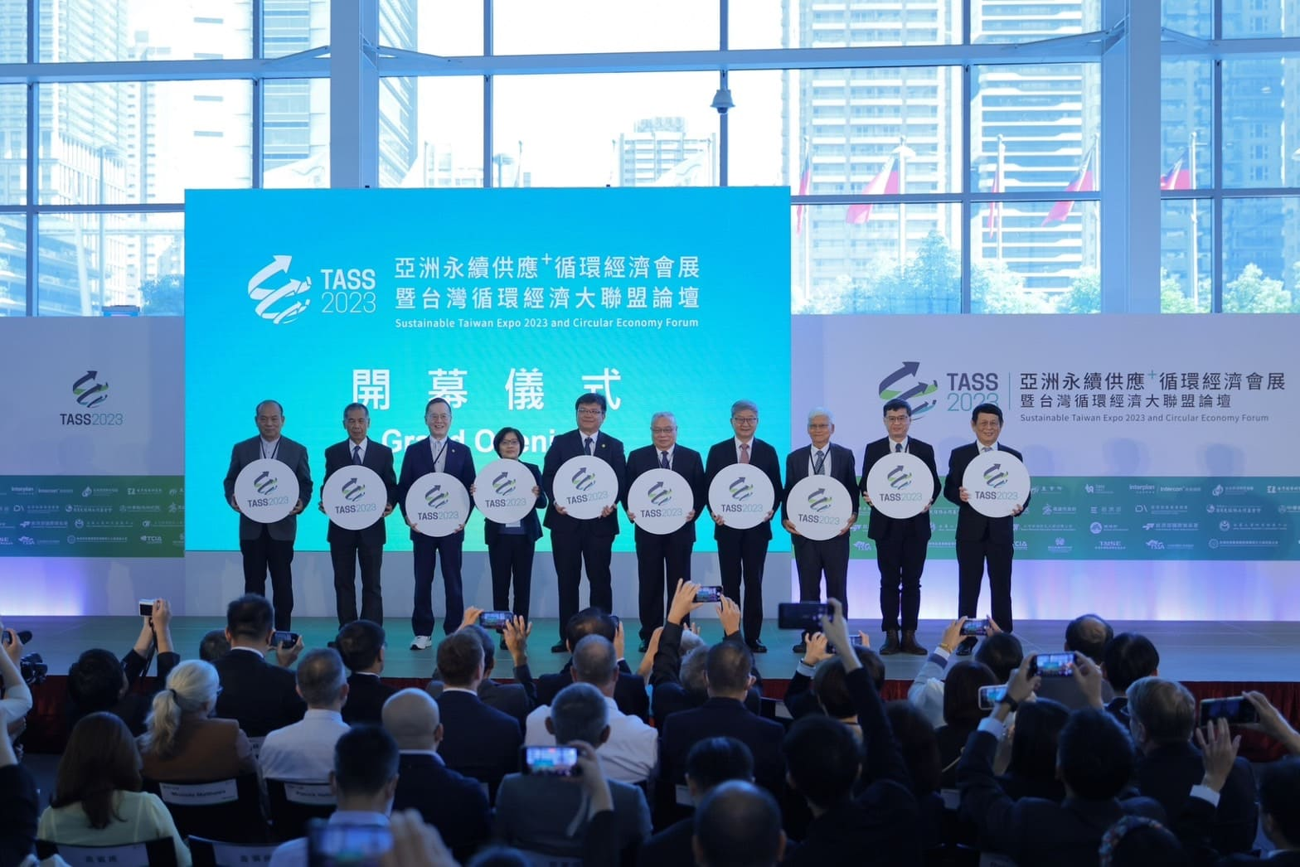

Picture 1. Guests were invited to attend the opening ceremony of the exhibition.
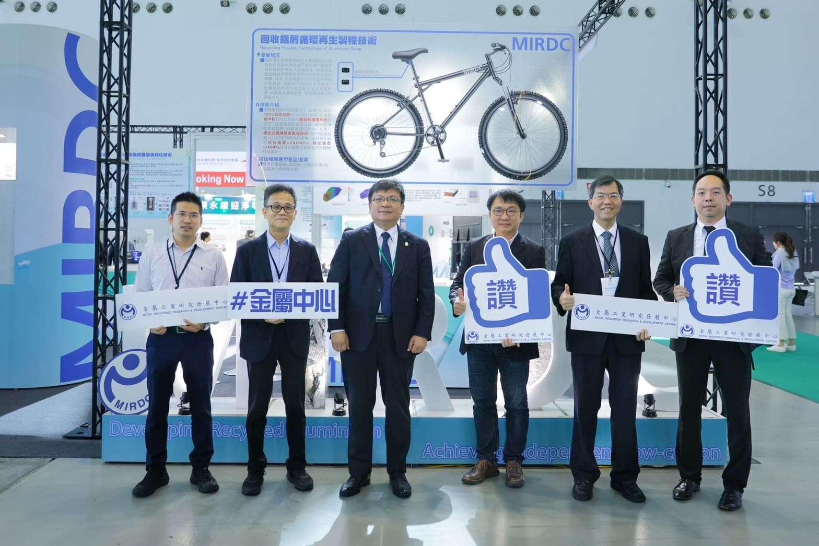

Picture 2. After the opening, distinguished guests visited MIRDC’s booth. The third one from the left is Wen-sheng Tseng, Deputy Minister of the Ministry of Economic Affairs, and the fourth one from the left is Hsiang-Wei Ho, Section Chief of the Department of Industrial Technology, Ministry of Economic Affairs.

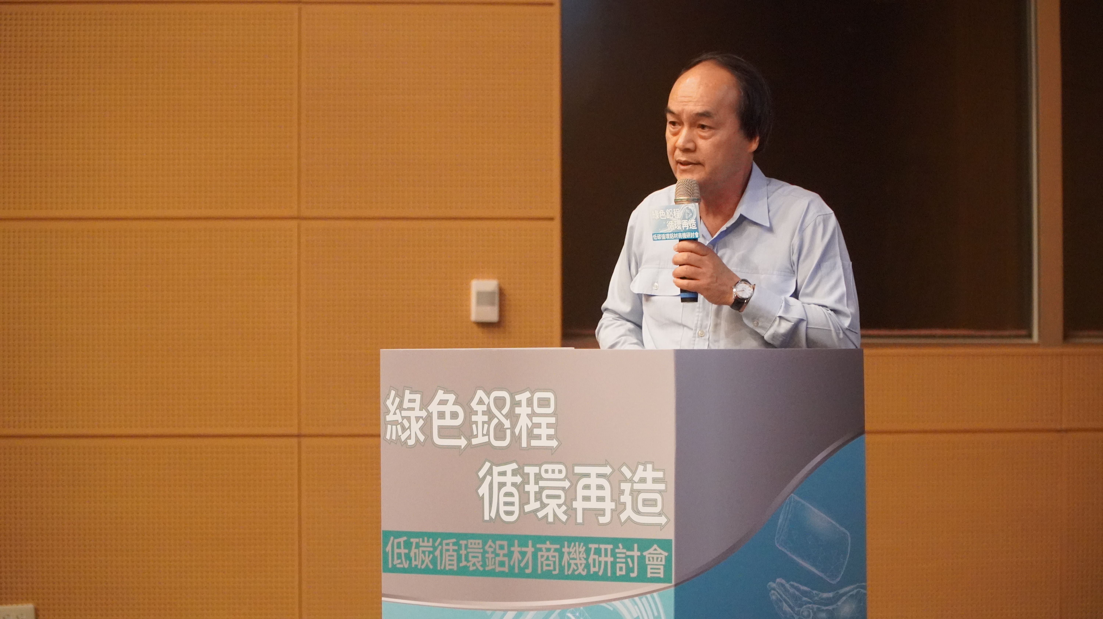

Picture 3: The "Low-Carbon Circular Aluminum Materials Seminar" was held, Chih-Che Chang, President of C.S. Aluminium Corporation was invited to share how to work together with the industry to upgrade and improve the recycling aluminum industry chain.
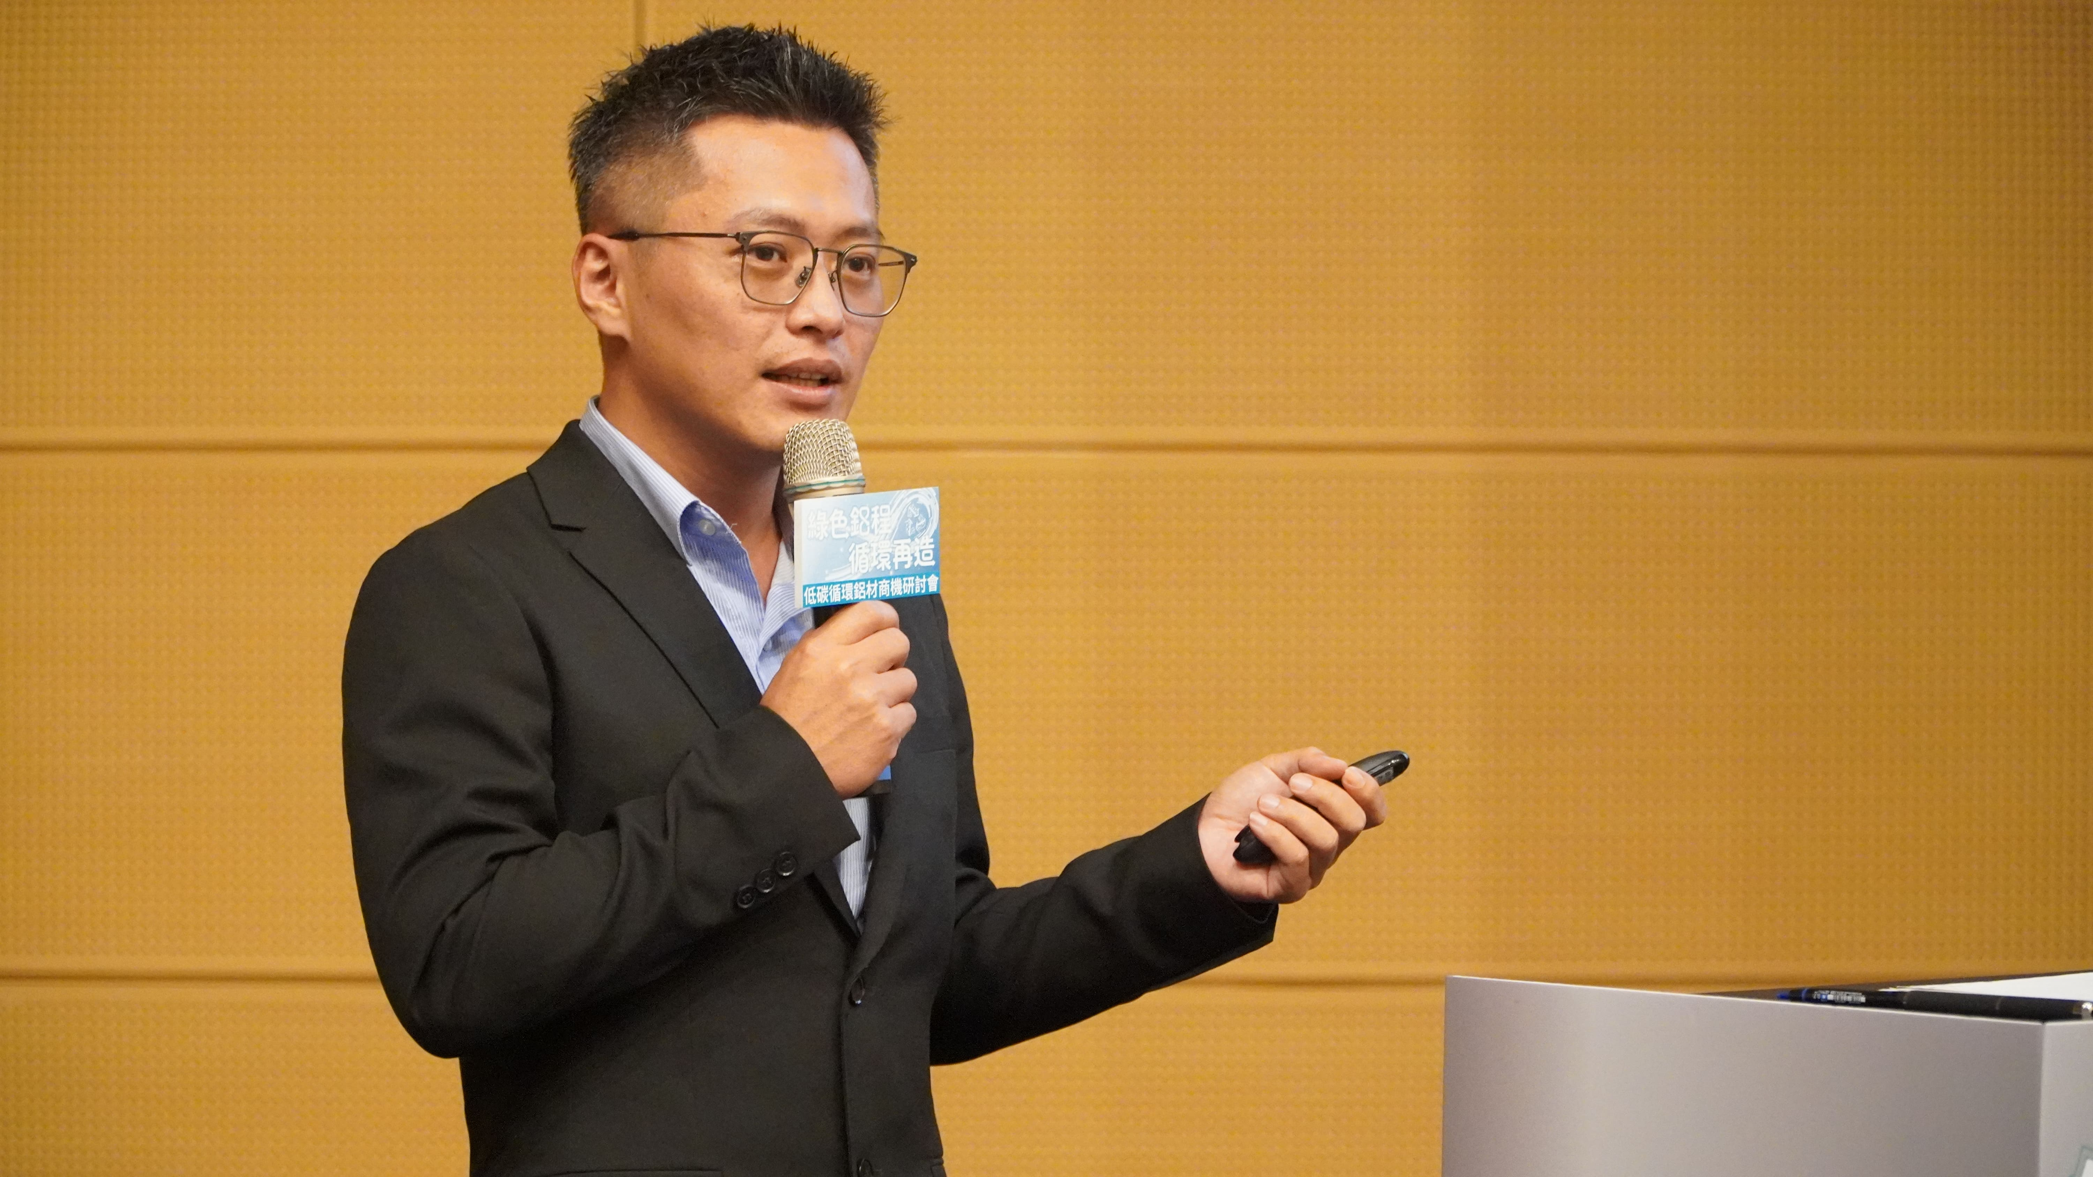

Picture 4. Chun-Yi Chan, General Manager Assistant of ALFORMER Industrial Co., Ltd was invited to share the cross-domain application of aluminum to create market opportunities.

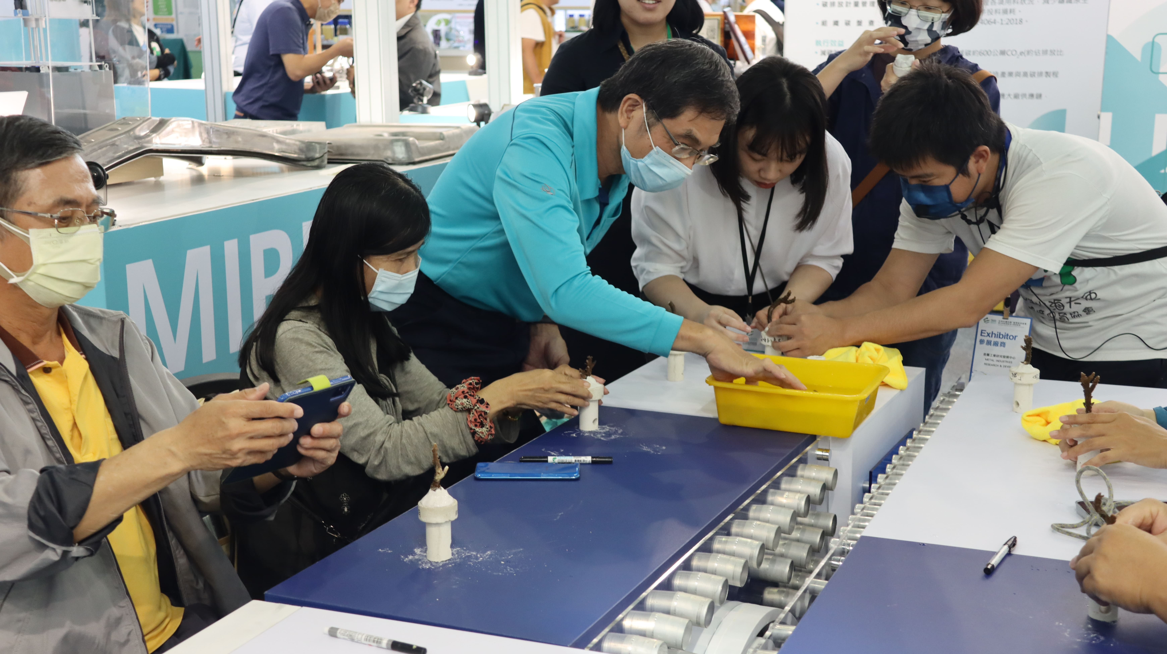
Picture 5. Pavilion Tour and Experience Activity, inviting people to come to the booth to get a taste of the technique. Under the guidance of experts from the Taiwan Eco Angels Environmental Conservation Association, they used regenerated diverse conversion materials to plant corals by hand and do their part for marine rehabilitation.

