伴
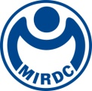
新聞資料NEWS LETTER
MIRDC and Cathay United Bank sign a letter of intent for collaboration, joining forces towards net zero carbon

During the opening ceremony of the "TASS 2023 Sustainable Taiwan Expo," MIRDC and Cathay United Commercial Bank signed a letter of intent for collaboration on November 22. The agreement was signed by Chih-Lung Lin, Vice President of MIRDC, and Fa-Shyang Chang, Chief Risk Officer of Cathay United Bank. This marks the first collaboration letter of intent between MIRDC and a banking institution. Cathay United Bank is the first bank in Taiwan to voluntarily adhere to the United Nations "Principles for Responsible Banking," actively promoting green finance both domestically and internationally. MIRDC, serving as a key driver for the government's efforts towards achieving net-zero carbon, provides essential support in assisting industries in carbon footprint verification, introducing carbon reduction technologies, and facilitating industries in obtaining government assistance resources. Both entities bring comprehensive expertise and experience to the collaboration.

Chih-Lung Lin, Vice President of MIRDC stated that MIRDC is honored to cooperate with Cathay United Bank. In the past, MIRDC has assisted industries in carbon footprint verification, it has also used its accumulated technical energy to assist industries in achieving net-zero carbon through intellectualization and low-carbonization. And simultaneously provided relevant information on industrial green finance and sustainable finance. Fa-Shyang Chang, Chief Risk Officer of Cathay United Bank stated that he hopes both parties will jointly establish a sustainable carbon reduction collaboration program to guide the industry to respond to climate change, reduce greenhouse gas emissions, and initiate low-carbon transformation in the future to strengthen the climate resilience of the industry and promote the diversified application of sustainable financial instruments, support industries in obtaining financing services for the carbon reduction process, and promote industry green competitiveness.

Then on November 23rd, both parties jointly held a green finance forum, hosted by Cathay United Bank and MIRDC respectively, focusing on “The Impact of Global Decarbonization on Enterprises - Assessment, Response and Green Financial Innovation Solutions” and “Carbon Footprint Verification and Carbon Reduction Technology Application in Metal Industry” that two issues are explained. In the future, the direction of cooperation includes assisting the industry in building carbon footprint verification capabilities, providing carbon reduction technology improvements through corporate visits and in-factory diagnostic consultation, providing counseling suggestions, and evaluating project finance related to sustainable finance. The project evaluation will promote the green competitiveness of the industry through incentives that will assist companies with substantial carbon reductions obtain preferential financing rates. Both will also work together to cultivate net-zero carbon reduction talents and cultivate carbon management talents to build carbon footprint verification capabilities. And improve net-zero professional knowledge and skills, accumulate a sustainable talent pool, promote sustainable concepts and improve net-zero professional knowledge and skills, accelerate the industry's net-zero carbon reduction transformation, and jointly assist Taiwan's industries to move towards the 2050 net-zero goal.
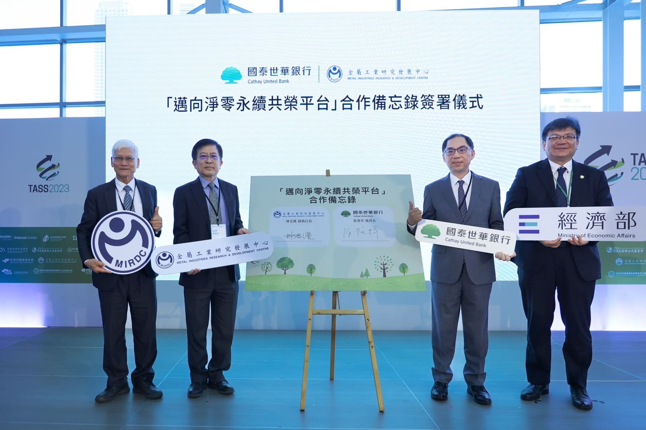

Picture 1. MIRDC signed an MOU with Cathay United Bank. From left to right are Ren-Yi Lin, Chairman of the MIRDC, Chih-Lung Lin, Vice President of MIRDC, Fa-Shyang Chang, Chief Risk Officer of Cathay United Bank, and Wen-sheng Tseng, Deputy Minister of the Ministry of Economic Affairs.。
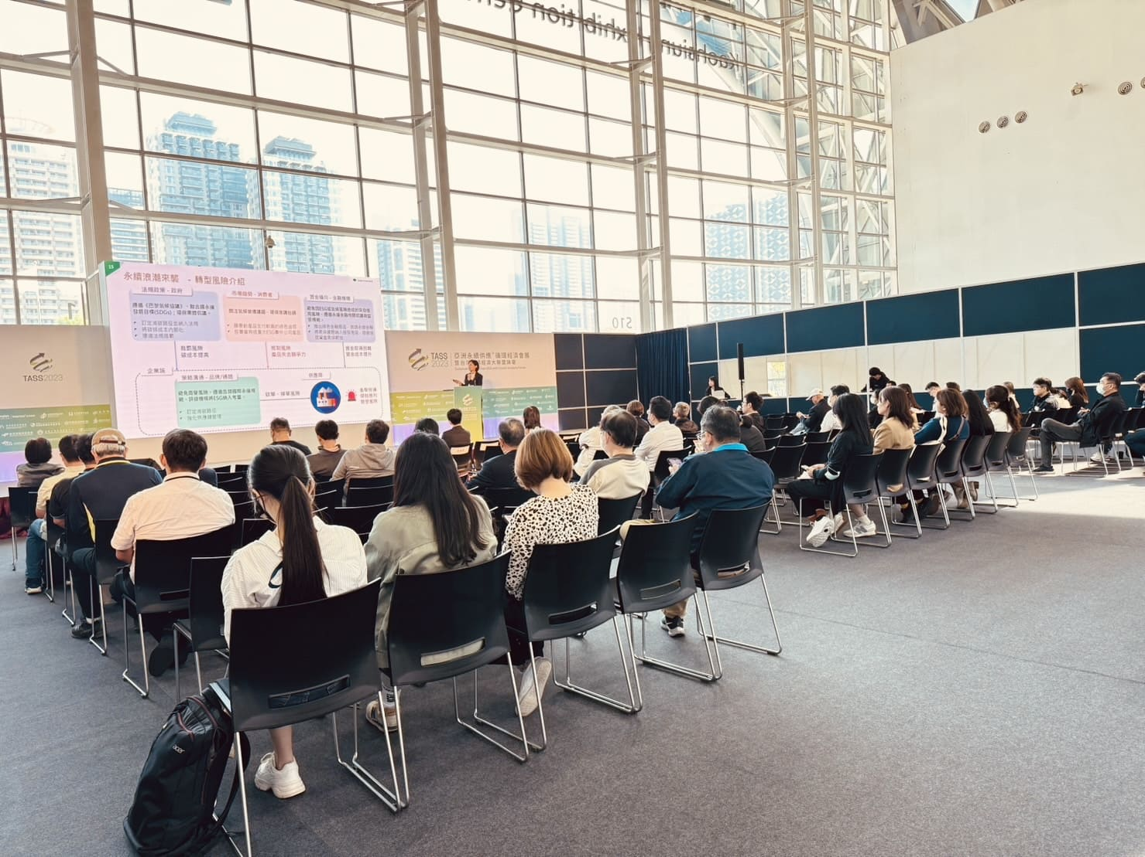

Picture 2. MIRDC and Cathay United Bank jointly held a green finance forum.

