NEWS LETTER

Businesses in the Airline Industry from Taiwan and Europe Collaborate to Move Forward
Airbus gathers its suppliers to visit Taiwan for the first time for business collaboration

Due to the efforts that were devoted by the Industrial Development Bureau, the Metal Industries Research & Development Centre (MIRDC), and China Airlines, from Nov. 7 to Nov. 9, ten suppliers under Airbus, including Rockwell Collins Interior System, Thales, Safran Landing Systems, EATON Aerospace, and NORDAM, visited businesses in Taiwan. They went to Aerospace Industrial Development Corporation, Drewloong Precision, Inc., Magnate Technology Co., Ltd., Aero Win Technology Corporation, Topkey, Fu-Chi Textile Co., Ltd., National Aerospace Fasteners Corporation, as well as China Airlines. This is the first time that Airbus gathered its suppliers, purchasing agents, and outsourcing departments to visit Taiwan for business opportunities. It is hoped that, by doing so, Taiwan and France’s bilateral collaboration in the airline industry will be further promoted and therefore the cooperation between industry, government and academia will be strengthened as well. As a result, both Taiwan and France’s airline industry will be capable of entering the global market and enhancing its efficiency.

On the 7th, Director General of the Industrial Development Bureau, MOEA, Jang-Hwa Leu; Director General of the Economic Development Bureau, Kaohsiung City Government, Tseng Wen Sheng; Chairman of the Board of Metal Industries Research & Development Center, Ren-Yi Lin; as well as senior officers of Taiwan airline industry welcomed guests from afar in the welcome banquet for Taiwan-France Aviation Industry Partnership Conference. According to Director General of the Industrial Development Bureau, MOEA, Jang-Hwa Leu, it is hoped to enhance the collaborative connection between Taiwan and France's airline industry through the exchange activities held this year. The collaboration would start from the production of aircraft structural components and engine modules, and then expand to the production of aircraft landing gears, built-in systems, as well as aircraft maintenance. In addition to that, Taiwan will also assist in producing high-valued sub-systems and system modules. Because of these collaborations, Taiwan will become the best partner for Airbus and its suppliers in Asia-Pacific Region.
Echoing the government’s push for aerospace and defense technology development under the Five Industrial Innovation Plan, Chairman of MIRDC, Ren-Yi Lin indicated that MIRDC will continue to encourage and guide Taiwanese industries to delve into the development of advanced aircraft structural subsystem components and engine modules. As aerospace industry is highly integrated, relative industries in the South will be able to stay rooted in Taiwan and generate more job opportunities domestically.
Certified by national and international aerospace quality system standards and product certifications, aerospace industry in Taiwan is technically capable of producing, repairing and modifying aircraft structural components, engine modules, aerospace electronics and components of other systems. Close partnerships have also been established with the world’s most prestigious companies including The Boeing Company, Airbus, GE and Pratt & Whitney. The visit is expected to facilitate collaborations on innovative projects and to further enable the industrialization of advanced technologies in Taiwan to enhance the foresighted technical momentum in Taiwan’s airline industry.

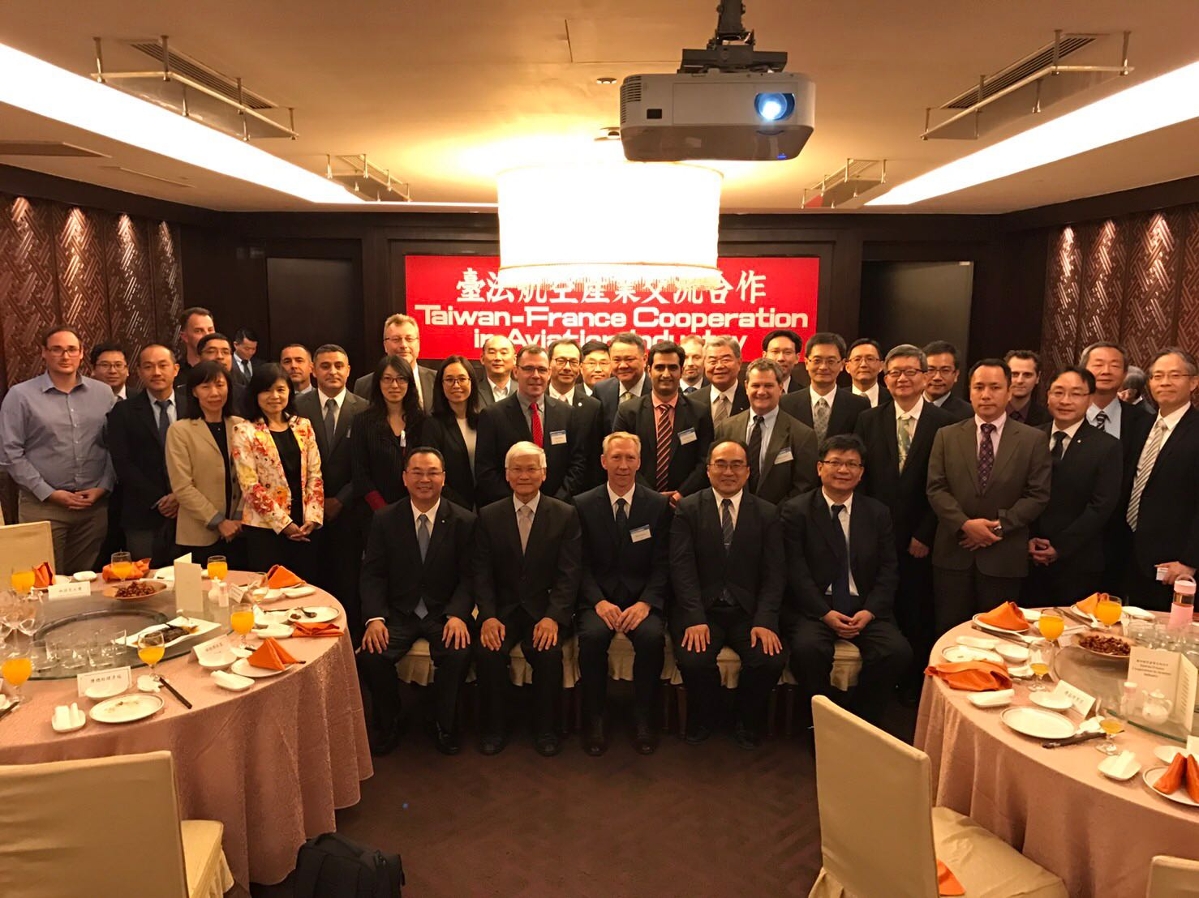
Group Picture of Businesses in the airline industry from Taiwan and Europe in the welcome banquet
(Starts from the first one from the left in the front row: General Manager, Kaohsiung Branch Office, China Airlines, Li I-Chou; Chairman of MIRDC, Ren-Yi Lin; Airbus International Business Department Director, Mr. Remy Moreau; Director General of the Industrial Development Bureau, MOEA, Jang-Hwa Leu; Director General of the Economic Development Bureau, Kaohsiung City Government, Tseng Wen Sheng)

