
新聞資料NEWS LETTER
MIRDC and AI HAYABUSA (Japan) Signed MOU to Explore New Opportunities for International Cooperation in the Application of Natural Plant Extraction Technology

On June 17, Ren-Yi Lin, Chairman of the Board of MIRDC, led an MIRDC team to Hokkaido for the formal signing of a memorandum of understanding (MOU) with partners from Japan and Taiwan. Participants from Japan included leaders and experts from industry, government, academia, and research, such as the Hakodate Research Center for Fisheries and Oceans, the Hokkaido Industrial Technology Center, Hakodate's city government, the Hokkaido Bureau of Economy, Trade, and Industry, and Hokkaido University. This cooperation focuses on two key areas: the application of natural plant extracts and the utilization of Hokkaido marine resources. It signifies the shared commitment of Taiwan and Japan to promote industrial upgrades, local innovation, and sustainable development.

In 2024, when MIRDC planned to establish the Artificial Intelligence System Laboratory, it actively connected with international technical resources and successfully developed a close collaboration with AI HAYABUSA, a leading Japanese AI technology company. During this period, numerous exchanges and mutual visits took place.AI HAYABUSA President Hiroaki Muramatsu visited the Chiayi Industry Innovation and Research Center, where he learned about the MIRDC's advanced capabilities in developing high-value natural products. This experience sparked his interest in potential collaboration, leading to the facilitation of this opportunity for cooperation. The Chiayi NPiL team is working on a project called "Natural Product Innovation Application Technology," which will leverage Hokkaido's abundant marine resources. This includes focusing on high-value natural products, such as kelp. By combining this with MIRDC's extensive expertise in natural product extraction and application technology, the aim is to create complementary advantages and showcase a strong synergy in transnational research and development integration.

MIRDC has partnered with domestic industry leaders Huiying Biomedical and Future AI Technology Co., Ltd. to establish a robust cooperation framework. By leveraging their respective strengths in research and development, manufacturing, and market access, a comprehensive value chain that encompasses raw material development, product design, and brand marketing can be created. This initiative will not only diversify and modernize Hokkaido's fisheries industry but also accelerate the entry of natural plant extract products into the international market, creating more global business opportunities. Additionally, it will enhance Taiwan’s understanding of Hokkaido's current situation regarding the use of marine resources, the development of natural products, and the promotion of related industrial policies. This foundation will support future bilateral cooperation in technology research and development, technology transfer, and international market expansion.

Ren-Yi Lin, Chairman of the Board of MIRDC, stated that signing this MOU represents a significant milestone in the cooperation of industrial innovation between Taiwan and Japan. MIRDC will strengthen its partnership with Hokkaido's industry, government, academia, and research sectors, working together to develop a global application model that integrates natural plant extracts with smart technologies. MIRDC looks forward to continued exchanges between both sides to foster a sustainable future marked by friendship and innovation between Taiwan and Japan.

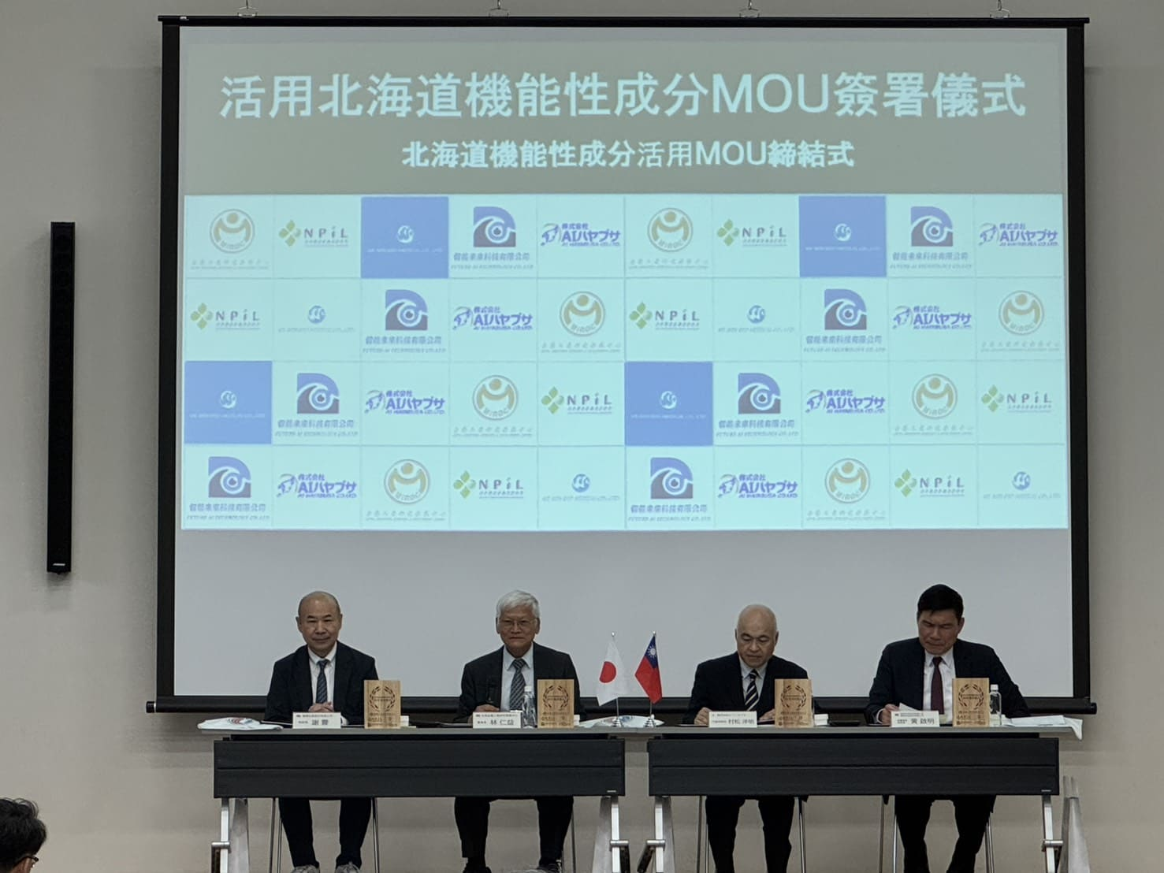

Photo 1. The signing ceremony for the MOU on the utilization of functional ingredients from Hokkaido. (Pictured from left to right: General Manager Chien Hsieh of Huiying Biomedical, Chairman Ren-Yi Lin of MIRDC, President Hiroaki Muramatsu of AI HAYABUSA, and Vice Chairman Chi-Ming Huang of Future AI Technology)

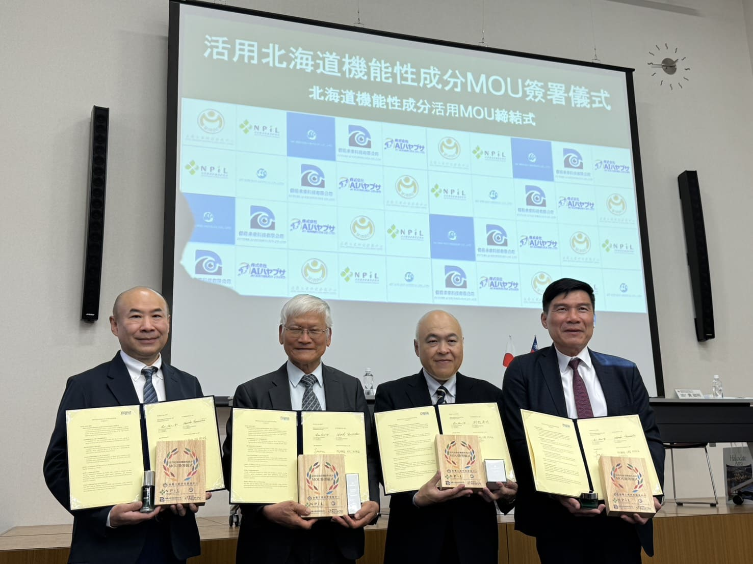

Photo 2. A group photo taken after the signing of the MOU. (Pictured from left to right: General Manager Chien Hsieh of Huiying Biomedical, Chairman Ren-Yi Lin of MIRDC, President Hiroaki Muramatsu of AI HAYABUSA, and Vice Chairman Chi-Ming Huang of Future AI Technology)

