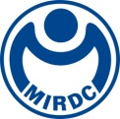
新聞資料NEWS LETTER
MIRDC Collaborates with CETIM to Accelerate the Cultivation of Hydrogen Energy Talent

To support the government's goal of achieving net-zero emissions by 2050 and accelerate technological innovation in Taiwan's hydrogen energy industry to become aligned with international standards, Metal Industries Research & Development Centre (MIRDC) is accelerating the development of core technologies and talent cultivation with support from Department of Industrial Technology, Ministry of Economic Affairs. MIRDC and Centre Technique des Industries Mécaniques (CETIM) co-organized Enlightening H₂: A Taiwan-France Masterclass from September 1st to 5th, improving MIRDC’s understanding of hydrogen energy materials, industry trends, and testing and certification standards, which will enhance its capabilities to serve Taiwan's hydrogen energy industry in the future.
MIRDC is actively engaging in R&D of high-pressure hydrogen storage material, testing, and combustion technologies. To ensure that hydrogen energy technology is in line with international standards and to deepen international cooperation, President Yung-Hsiang Lai personally traveled to France to sign a memorandum of understanding with CETIM in March this year, deepening international cooperation and laying the foundation for in-depth cooperation between Taiwan and France in the field of hydrogen energy technology. In addition, CETIM plays a crucial role in the hydrogen energy ecosystem of France and even all of Europe with its outstanding expertise in materials engineering, testing, and verification. It is not only a key institution driving technological innovations in hydrogen energy in France, but is also on numerous European committees setting standards and specifications for the hydrogen energy industry. MIRDC partnered with CETIM to focus on high-pressure hydrogen material testing and certification, development of next-generation thermoplastic composite material for hydrogen storage cylinder, and joint cultivation of high-level talent, providing excellent support for MIRDC to drive the development of Taiwan's hydrogen energy ecosystem.
MIRDC specially invited two senior experts to participate in the masterclass in Taiwan to provide guidance and engage in technical exchanges. Another five experts shared their professional experience on specific topics online. The masterclass covers two main themes: the current status of the hydrogen energy industry in Europe and France and future technological trends, as well as lectures and case study related to the hydrogen energy transmission and storage standard ASME B31.12. The masterclass provided MIRDC’s technical team with insight into international market trends and direction of regulatory development, ensuring that Taiwan's hydrogen energy technology and products meet global standards, so that they can successfully enter the international market.
President Yung-Hsiang Lai said that talent is the most important key in the development of hydrogen energy technology. MIRDC is collaborating with CETIM with the goal of deepening R&D and broadening the professional horizons of senior talent. MIRDC is gradually developing related capabilities, such as hydrogen energy material development, transmission and storage systems, mixed hydrogen combustion technology, and testing and certification through its connections with domestic industries and networking with international partners, gradually becoming aligned with international standards and specifications. MIRDC provides comprehensive technology R&D and consulting services, and works with industries to jointly move towards Taiwan’s goal of net zero emissions by 2050.
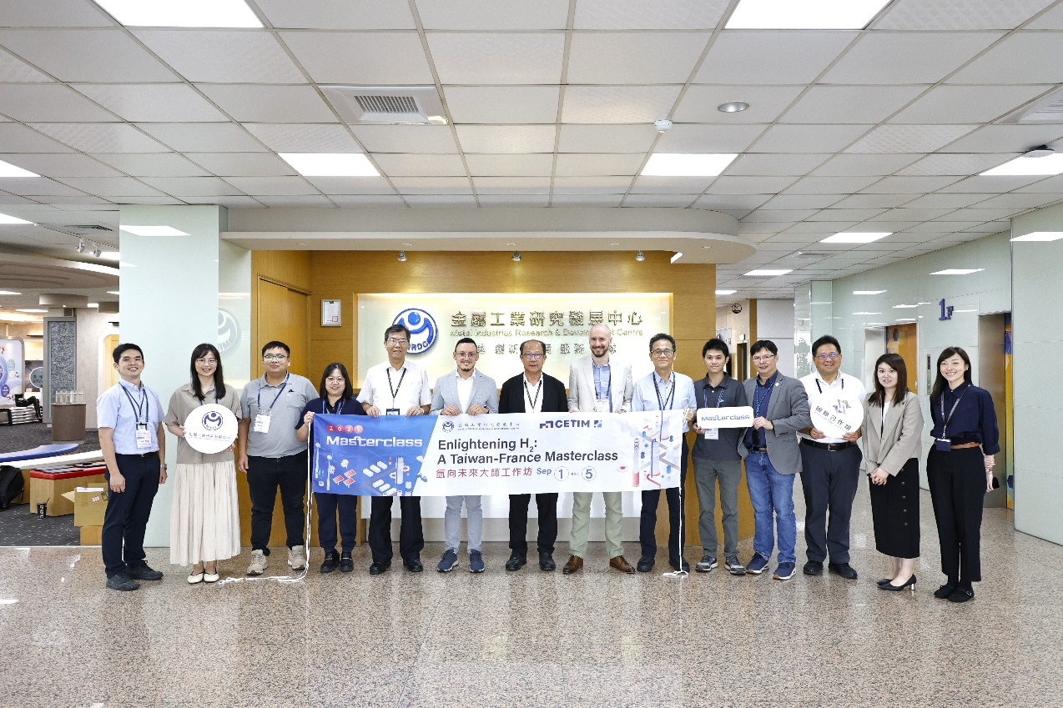
Photo 1. MIRDC and CETIM co-organize Enlightening H₂: A Taiwan-France Masterclass (Group photo of distinguished guests: 7th from the left is Chun-Chieh Wang, Vice President of MIRDC, 6th from the left is Ayoub EL MOUTAOUAKKIL, R&D Project Manager of CETIM, and 7th from the right is Phillipe ROHART, Senior Expert of CETIM)

