
新聞資料NEWS LETTER
MIRDC Launches AI Courses for Training Talent in Plumbing and Fastener Industries, Realizing MOEA’s AI Pilot Production Line Policy to Support Industrial Upgrading

To address the challenges posed by international trade, the Ministry of Economic Affairs (MOEA) has launched 50 AI pilot production lines through various research-based organizations under its jurisdiction. These lines are designed to help companies quickly develop and verify high-value-added products, such as prototype development, trial production, and testing. This initiative aims to help domestic industries overcome high verification thresholds, trial production costs, and the need for equipment resources. Through this pilot program, companies can train employees to operate AI equipment and enhance the development of AI talent in the industry. These production lines will also support the upgrading and transitioning of Taiwan's industries.

Recently, Director General Chao-Chung Kuo of the Department of Industrial Technology, MOEA, along with representatives from the Taiwan Mold & Die Industry Association, the Taiwan Transportation Vehicle Manufacturers Association, China Steel Corporation, and EJEE, visited the pilot production line equipment at MIRDC. Director General Kuo emphasized that, due to global uncertainties, Taiwan's industries can maintain their competitiveness only by increasing value and reducing costs. To support this goal, AI pilot production lines will introduce the latest AI smart machinery in various fields, making them available to the industry for developing innovative products. Additionally, industry employees can operate the smart machinery on-site and participate in hands-on training, enhancing their understanding of AI applications and helping them develop valuable skills. If the companies find the trial production process practical, they can implement AI-based experiences and technical modules in their own companies to quickly replicate applications.

Yung-Hsiang Lai, President of MIRDC, announced that MIRDC has assessed its internal capabilities and has launched seven AI pilot production lines across various application areas, including mold & die, fasteners, plumbing, hand tools, vehicles, medical device, and food industries. For instance, in the AI smart stamping die trial production field, servo-press forming simulation and analysis aligns with actual tryout scenarios. This approach reduces the error rate in mold & die development, enhancing design efficiency and lowering development costs. The high-end manufacturing trial production field for metal fasteners offers customized proofing and trial production services encompassing design, manufacturing, and quality verification. This helps companies respond quickly to customer orders. Utilizing AI for mold & die design, material stress simulation analysis, integrated proofing, and trial production guidance software, MIRDC provides optimized design services to address common mold & die issues, such as poor thread design. The AI trial production and testing verification process for plumbing utilizes a comprehensive database of gravity casting process parameters and AI machine learning models. This approach will provide one-stop trial production services, which include essential copper alloy smelting parameters for gravity plumbing casting, design specifications for casting molds needed for rapid production, casting formation parameters, and digital simulation technology for predicting casting defects. Additionally, AI-driven microbial testing and detection services are available to help companies ensure their products comply with international standards. This method reduces the need for repetitive testing, thereby minimizing costs.

In addition to providing high-end equipment for trial production, MIRDC actively cultivates AI talent through industry-specific training programs. Two programs are currently underway: the AI process transition program for the Plumbing Industry and the AI applications Training Program for Fasteners. Additional training courses for AI talent in areas such as molds and hand tools will follow. MIRDC, in collaboration with the Plumbing Association of Taiwan, conducted a 30-hour training course focused on AI process transition for the plumbing industry. This course taught participants how to use AI to identify plumbing products effectively. Through practical lessons, students learned to train AI models to automatically differentiate between good and defective products, eliminating the need for manual and visual inspections. The training attracted participants from various plumbing manufacturers, including Long Tai, Globe Union, and Taiwan Shin Jhin Lih. Chia-Lieh Chang, the Chairman of the Plumbing Association of Taiwan, encouraged plumbing companies to enhance their factories' digital capabilities and continue integrating AI technology to maximize their benefits. The on-site AI training for fasteners began on May 14. The program is designed to help participants master the practices of transitioning to smart manufacturing. It aims to establish a foundational understanding of AI and provide insights into its application within the fastener industry. The training also covered various topics, including introducing smart design, smart scheduling, smart die adjustment, smart sensing, and smart light inspection. Numerous companies, such as Chen Nan, Top-Green Fastener, and Easylink Industrial, have engaged in this initiative.

MIRDC has established seven AI pilot production lines across various application fields to help the industry minimize the risks and costs associated with digital transition through AI parameter optimization, process simulation design and analysis, rapid trial production, and defect-recognition and inspection. Also, MIRDC offers talent training and practical guidance to accelerate technology adoption. In the future, MIRDC will expand its service modules and collaborate with other institutions, academia, and research institutions to develop more cross-domain applications, creating a powerful engine for the digital transition of Taiwan's industries.

🔗 The training courses for pilot production lines in fasteners, plumbing, and hand tools are expected to continue in June. For relevant registration information, please visit MIRDC's website: https://www.mirdc.org.tw/

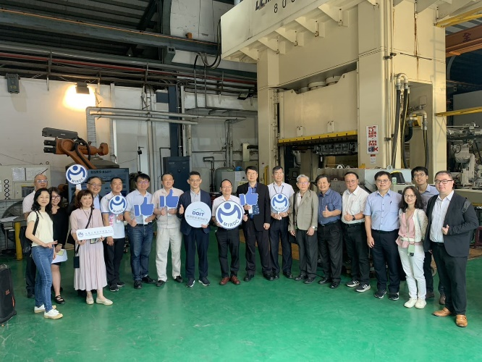
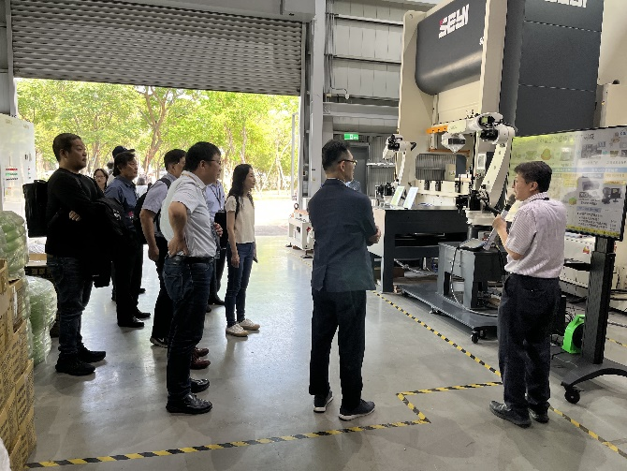
Photo 1 | Photo 2

Photos 1 and 2: Director General Chao-Chung Kuo of the Department of Industrial Technology, MOEA, and company representatives visit MIRDC's AI pilot production lines

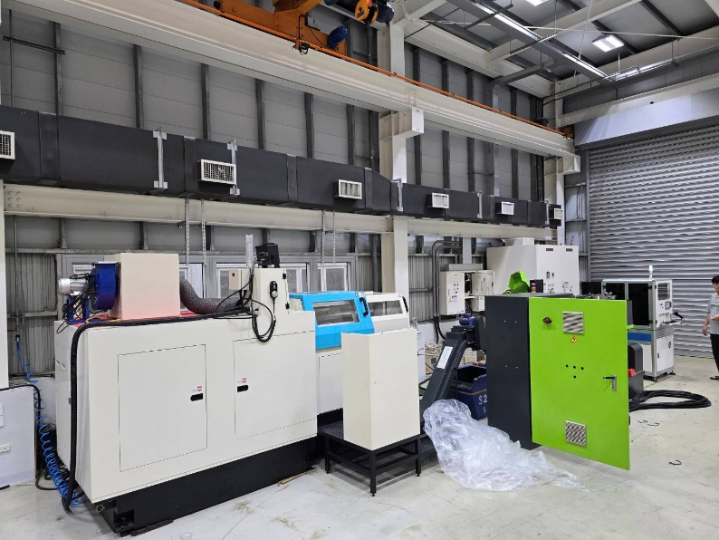
Photo 3: High-speed molding machines
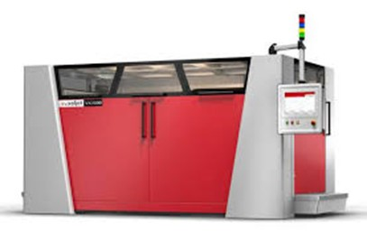
Photo 4: 3D printing equipment for casting molds
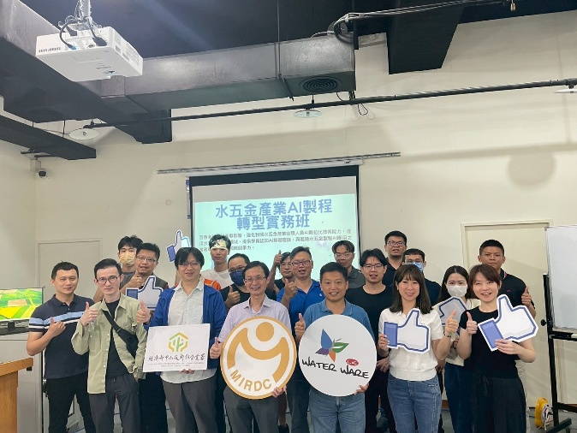
Photo 5: Chia-Lieh Chang, the Chairman of the Plumbing Association of Taiwan (third from the right), participates in the AI process transition training for the plumbing industry

