NEWS LETTER
MIRDC “Regional Industries Moving Towards Carbon Reduction Transition and Sustainability Layout”
Experts Seminar Launched
The Executive Yuan passed the amended draft of the “Climate Change Response Act” on April 21st this year. In face of the European Union’s (EU) Carbon Border Adjustment Mechanism (CBAM) and the carbon tax collection mechanism of various countries subsequently being rolled out, it is necessary to accelerate the promotion of carbon reduction transition measures. The purpose is to increase industry competitiveness. To enable businesses in the southern part to understand net zero carbon reduction promotion method, the Metal Industries Research & Development Centre collaborated with the Taiwan Alliance for Sustainable Supply, TASS on June 27th in organizing the experts seminar titled “Regional Industries Moving Towards Carbon Reduction Transition and Sustainability Layout” at the Garden Villa Kaohsiung.

The seminar has invited the Taiwan Alliance for Sustainable Supply (TASS), Advanced Semiconductor Engineering (ASE) Group and China Steel Corporation (CSC) to share their experiences in net zero carbon reduction. The Export Processing Zone Administration (EPZA), Ministry of Economic Affairs (MOEA), Kaohsiung City Government, Pingtung County Government, National Kaohsiung University of Science and Technology (NKUST), and National Pingtung University of Science and Technology (NPUST) were invited to the event. Various industries from southern part were also invited, including the steel industry, metal products manufacturing industry, aerospace industry, motor vehicles and parts manufacturing industry, agriculture and livestock industry, and financial industry to join the seminar. Experts from industry, government, academics and research discussed the possible impacts of carbon reduction transition that might have on the regional industries, covering the four major aspects from legal, green supply chain, green finance and circular materials.

The EPZA of MOEA expressed that the Technology Industrial Park has already cooperated with the government to assist industries for net zero transition by 2050 and the industrial clusters of the industrial park as the major promotion targets. Assistance is provided to businesses to construct carbon inventory mechanism and to increase the overall carbon reduction capability. To resolve the difficulties in the talent shortage for promoting energy conservation and carbon reduction of the manufacturing industry in the industrial park, collaborations between the park and the various academic research units nearby have been established, driving regional low-carbon transition.

The Economic Development Bureau, Kaohsiung City Government representative explained that recently the government has established the “2050 Net Zero Pathway Release and Industrial Net Zero Alliance” and have announced the net zero pathway. Concurrently, established the net zero city management autonomous regulations for close collaborations in fulfilling ESG, assisting more enterprises in the transition. The Department of Urban and Rural Department, Pingtung County representative explained that at this moment, they are conducting guidance and audits on the basics of energy saving, energy research, citizen participation and energy education promotion. There are also local energy conservation plans and the building of rural hazard prevention renewable energy micro-grid.

The Taiwan Alliance for Sustainable Supply, TASS, Executive Director Shu-Hsin Lai shared the international net zero emissions trends, and introduced the currently available government energy conservation carbon reduction policy tools and projection service for carbon emissions calculations. ASE Group Director Ping-Shuo Su shared the electronics industry promoting supply chain system energy conservation and carbon reduction measures execution, and how the company drives the industrial supply chain’s green competitiveness. China Steel Corporation Deputy Director Shih-Hsien Liu shared the short, medium, and long term strategies and pathway in carbon reduction of the steel industry, and the blueprint for net zero carbon reduction.

The Metal Industries Research & Development Centre Vice President Dr. Chun-Chieh Wang expressed that in the future MIRDC will guide industries in upgrading through net zero carbon reduction technologies, and to provide consultation to industries. The purpose of this seminar is also to listen to everyone’s advices, to understand the needs of the industries apart from inviting various industries to share their experiences. It is in the hope that the subsequent execution of carbon reduction process for the industries can be smoother, realizing energy transition and industrial policy. There are anticipations that the future will become the new driving force for industry development and enable domestic enterprises to become more competitive internationally.
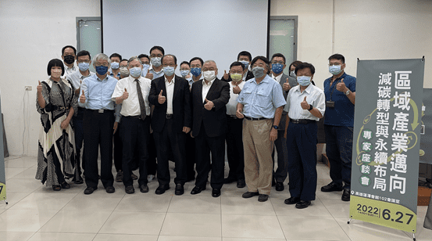
Figure 1. Guests group photo (From left to right: ASE Group Director Ping-Shuo Shu (second left), EPZA of MOEA Secretary General Te-Chang Wu (third left), MIRDC Vice President Dr. Chun-Chieh Wang (fourth left), TASS Executive Director Shu-Hsin Lai (third right), CSC Project Deputy Director Shih-Hsien Liu (second right)

