新聞資料NEWS LETTER
The Result of Ministry of Economic Affairs’ Project “Advanced Coating,” Helps Win International Orders for Aerospace Composite Material Machining Industry

Boeing’s Commercial Market Outlook estimated 44,000 new airplanes are needed worldwide between 2019 and 2038, a total gross output of $6.8 trillion. On the other hand, lightweight, high-strength composite materials are used extensively for energy efficiency in new airplane in international market. It is estimated that more than 50% of materials used to produce new passenger planes are composite. The production, machining and manufacturing of composite materials have decisive influence on whether the aerospace industry can win international orders. Taiwan-based companies, including AIDC, Vision Wide, Gongin and Mirle, recently joined force to secure orders worth billions of NT dollars for aerospace composite material processing. However, such material is known to be difficult to work on, and the cutters used for processing often suffer significant wearing. The result is the staggering costs of machining tools. For this, people are looking vigorously for a solution to improve the service life of tools and minimize wearing in them.

Thanks to the support from the Department of Industrial Technology（DoIT）, Ministry of Economic Affairs, the Metal Industries Research and Development Centre (MIRDC) succeeded in the development of “multi-Al-Cr-alloy coating for composite material processing tools,” consisting of several sophisticated processes from alloy powder manufacturing, target source design to final coating. This is a solution for many bottlenecks in alloy production from smelting, powder making to process, as well as for problems in the formulation and coating of multi-Al-Cr-alloy target materials.

The development result has been incorporated into a cooperation project with AIDC who that has performed a series of tests on the coated tools. With sophisticated machining parameters, the multi-alloy coated scale-shaped milling cutters exhibit 35.8% more service life in machining carbon fiber composite materials than uncoated cutters; for drill bit testing, the coated cutters again perform better by improving the service life by 73.2 % on machining carbon fiber and copper film composite materials; considering the price of tools and coating process costs, the C/P values are improved by 33% and 71%, respectively, a significant improvement of application efficiency for industrial mass-production.

Apart from composite material processing, the multi-alloy coating has extreme potentials in other difficult-to-process materials, such as super alloys. MIRDC will keep working together with machining tool manufacturers to promote the latest technologies across the industry and provide them better tools in order to improve the international competitiveness of Taiwan’s aerospace material processing and tool manufacturers.
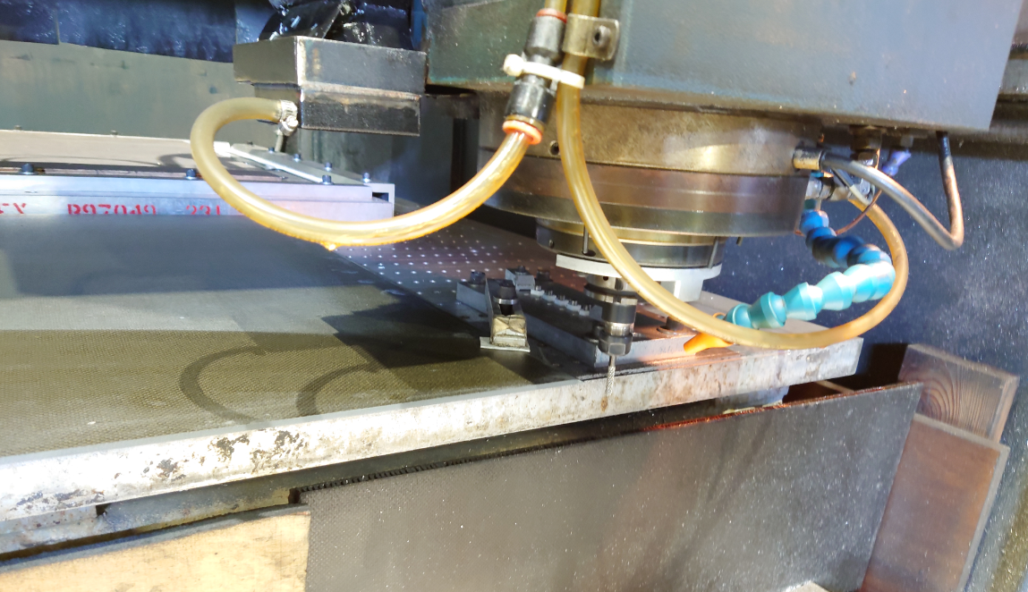
Figure 1 Milling test on carbon fiber composite material at AIDC using MIRDC’s coated scale-shaped milling cutter
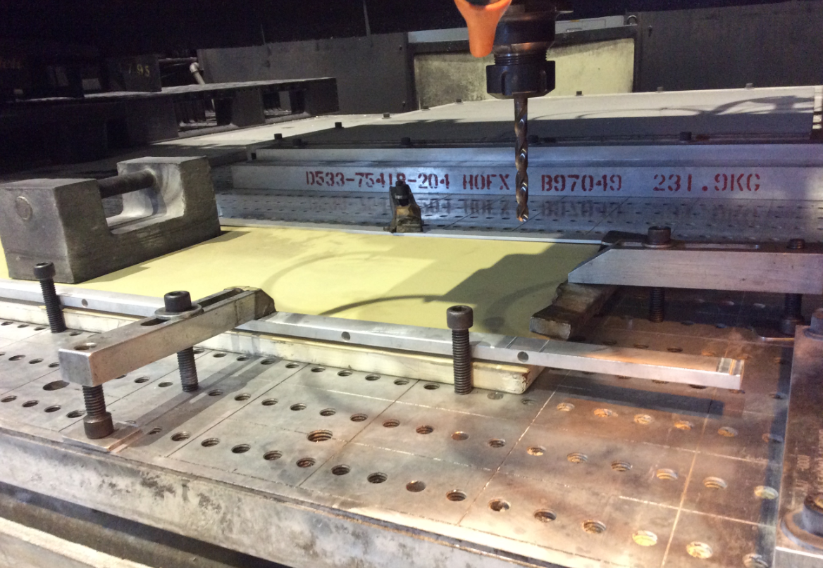
Figure 2 Drilling test on carbon fiber and copper film composite materials at AIDC using MIRDC’s coated drill bits

