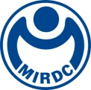
新聞資料NEWS LETTER
Employment in Wind Energy Industry Aligns with International Standards, Production and Training Integrated, Boosting Competitiveness
The Metal Industries Research & Development Centre (MIRDC) is now enrolling for its second round of wind energy employment training courses!

The Maritime Technology Innovation Center (MTIC), managed by the MIRDC on commission by the Energy Administration under the Ministry of Economic Affairs, is a training base for offshore wind energy and maritime engineering professionals in Taiwan. It has long been committed to fostering practical links between the green energy sector and international professional certifications. Since the opening of the Offshore Wind Energy Employment Training Course in 2020, the courses have built extensive experience across multiple rounds and have earned a good reputation. Over the years, it has achieved a peak employment correlation rate of 81%, demonstrating its high alignment with industry needs and the effectiveness of its training.

This year's first round achieved fruitful results. Industry visits and matchmaking interviews received overwhelmingly positive feedback
In the first round of courses, which began in April 2025, multiple professional training and industry connection activities were organized, including a visit to Siemens Gamesa Renewable Energy’s wind turbine nacelle factory to gain a deep understanding of the internal structures and assembly processes of turbines. On the final two days, one-on-one corporate matchmaking interviews invited companies from various sectors of the wind energy industry chain for on-site recruitment interviews with participants, fostering job placement opportunities. Many trainees received interview opportunities before the training ended. They expressed their high praise for the course: “The visits and interviews helped us not only to learn but also to enter the workplace earlier.”

The course covers GWO international certification, fully tailored to meet industry needs
Different from many experience-based short courses, this training course includes five GWO (Global Wind Organization)-certified basic safety modules: work at heights, sea survival, manual handling, fire awareness, and first aid. These certifications comply with international offshore wind farm safety standards. Trainees who pass the assessment during training can directly obtain international certification, which greatly improves their competitiveness in the workplace and lays a solid foundation for entering the wind energy industry.

Those eligible will receive full subsidies, allowing young people to enter the industry without financial barriers. The time to enroll is now!
Any young person of Taiwanese nationality who is aged between 18 and 29, currently unemployed, and not a daytime student can apply for 100% tuition subsidies. Recipients only need to pay an attendance deposit in advance, which will be fully refunded after the course ends if the attendance and assessment standards are met. During training, various employment guidance services are provided, including English resume reviews, mock interview drills, industry lectures, and corporate matchmaking interviews, which help trainees seamlessly transition into the wind energy workplace.

The second round of courses will officially begin on June 9, and enrollment will end after the first 30 spots are filled!
The second round of the course runs from June 9 to July 1, with a total training time of 144 hours. Course content will cover: Wind energy industry development & career analysis, wind turbine system technology, wind energy marine engineering and operation and maintenance, GWO Basic Safety Training (BST) international certification, English resume reviews and interview skills enhancement, industry expert lectures and matchmaking interviews. Only 30 spots are available (minimum enrollment:8). Registration ends on May 23. Young people who are interested in joining the offshore wind energy industry are welcome to seize this opportunity.

Many past students who were not eligible for subsidies (such as being over 30 years old) still chose to pay the NT$100,000 at their own expense to participate in the full course. After completing the course, those students successfully entered wind energy and related workplaces and are now working at the forefront of the industry. The course also welcomes those paying out of pocket to register, work together to thrive in the green energy sector, and reach new career heights!

📞 Course inquiry: Ms. Yen, MIRDC (Maritime Competency Technology Development Section) 07-6988899 Ext. 7232
📧 Registration mailbox: ireneyen211@mail.mirdc.org.tw
🔗 Taiwan Jobs course page: https://elite.taiwanjobs.gov.tw/ClassSearch/Detail?UUID=F5C9C5E153814D3A8D222CCF078C842E&SOURCE_TYPE=ELIT

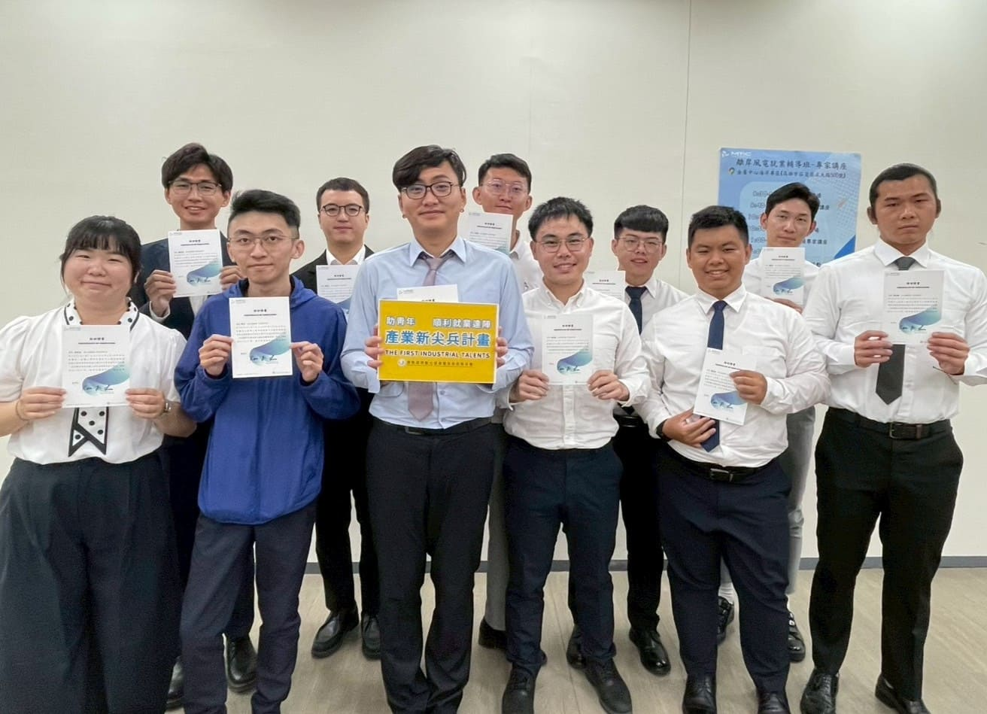
Photo 1. Offshore Wind Energy Employment Training Course—Graduates of the first round receive certificates
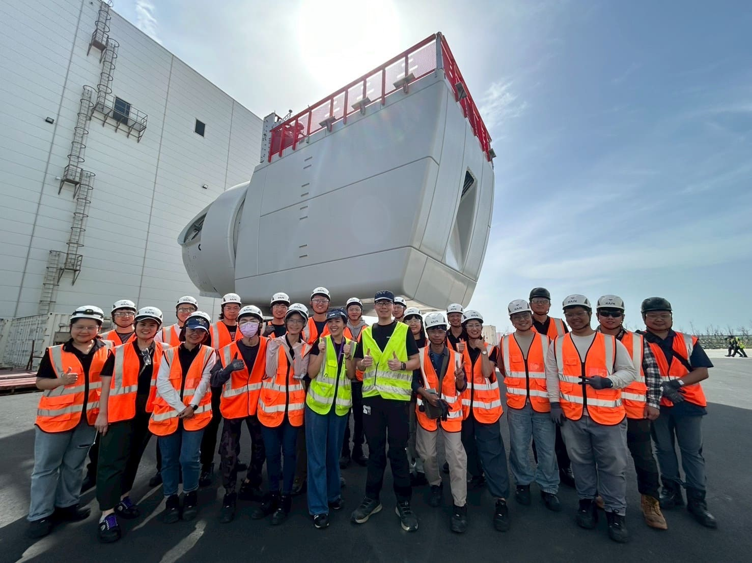
Photo 2. Offshore Wind Energy Employment Training Course—Field visit to Siemens Gamesa Renewable Energy’s Taichung Port Nacelle Factory

