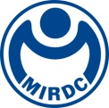
新聞資料NEWS LETTER
New Opportunities from AI Smart Manufacturing in 2025, MIRDC Highlights Innovative Tech Prowess

The Metal Industries Research & Development Centre (MIRDC) participated in the 2025 Tainan Automatic Machinery & Intelligent Manufacturing Show, marking its third consecutive year of participation. To date, tens of thousands of people have visited the show, a lively event that has promoted the upgrading of local industries and driven business exchanges in the machinery sector. MIRDC is deeply involved in the machinery and automation industry fields. In recent years, with the rapid development of AI, global sustainability and carbon reduction, labor shortages, and other issues, the industry has faced several challenges. The Centre has been actively developing innovative technologies for smart manufacturing, energy saving, and carbon reduction to help solve industry pain points—achieving outstanding results in supporting industry transformation. By participating in trade shows, MIRDC broadens its perspective, shares valuable expertise, fosters connections and collaboration, and remains at the forefront—actively listening to industry needs and serving as a steadfast partner for transformation.

MIRDC showcased 33 technologies and services under the theme of “Tune the future to more pleasant era,” including those recognized by the 2024 R&D 100 Awards —often referred to as the “Oscars of Innovation”—and the prestigious Edison Awards, drawing widespread attention throughout the venue. 2024 R&D 100 Awards - Enduring-High-Efficiency Combustion System for Industrial Furnace (EHE Combustion System). Developed for medium- and high-temperature combustion industrial furnaces at 550–950℃, the EHE Combustion System provides long-lasting, efficient, and energy-saving combustion. By dynamically adjusting the air-fuel ratio, the system can achieve up to 80% waste heat recovery, ±3℃ temperature uniformity, 25% energy savings, 30% carbon reduction, and maintain over 95% heat exchange efficiency. Another highlight was the Compact and High-Performance Welding Cobot, winner of silver in the 2025 Edison Awards. The cobot can instantly capture the topography of multiple welds, generate reference coordinates, and enhance the flexibility, efficiency, and accuracy of welding. It has been successfully applied to the large-scale shipbuilding industry and is set to be expanded to offshore wind turbines, bridges, buildings, railways, and other fields. Another silver-winner, the EDM for Aerospace Applications Based on AI Optimization combines Big Data, AI computing, and domain knowledge to enable remote data monitoring, online quality prediction, and real-time feedback compensation optimization. It improves machining accuracy and efficiency and optimizes production management, providing innovative solutions for aerospace component processing.
MIRDC also held the 2024 R&D Results Presentation on April 25, in which it spotlighted the two major areas of “smart manufacturing” and “medical devices.” It announced 7 forward-looking R&D results, displayed more than 100 applicable patents and opened up technology transfers and MIRDC Membership recruitment, driving technology adoption and strengthening industrial chain integration. This year, in response to the impact on the industry from technological development in AI, MIRDC planned a keynote speech on the topic “Innovation and Development of AI Applications in the Metal Industry.” The session explored how AI can optimize processes, enhance product performance, and reduce manufacturing costs — helping Taiwan’s manufacturing industry transition towards intelligent and high value-added products. The presentation was met with enthusiastic feedback from attendees.
Ren-Yi Lin, Chairman of MIRDC, said that amid a rapidly evolving global and domestic industrial landscape, MIRDC is actively developing and sharing several metal material, processing, and process technology optimizations. By integrating these with cutting-edge AI tools and innovative applications, MIRDC is actively driving the growth of domestic metal and related manufacturing industries while expanding into such fields as medical devices, energy, and aerospace. Aligned with the move toward net-zero carbon emissions, MIRDC is spearheading industry progress toward smart technology and sustainable development through innovative R&D.

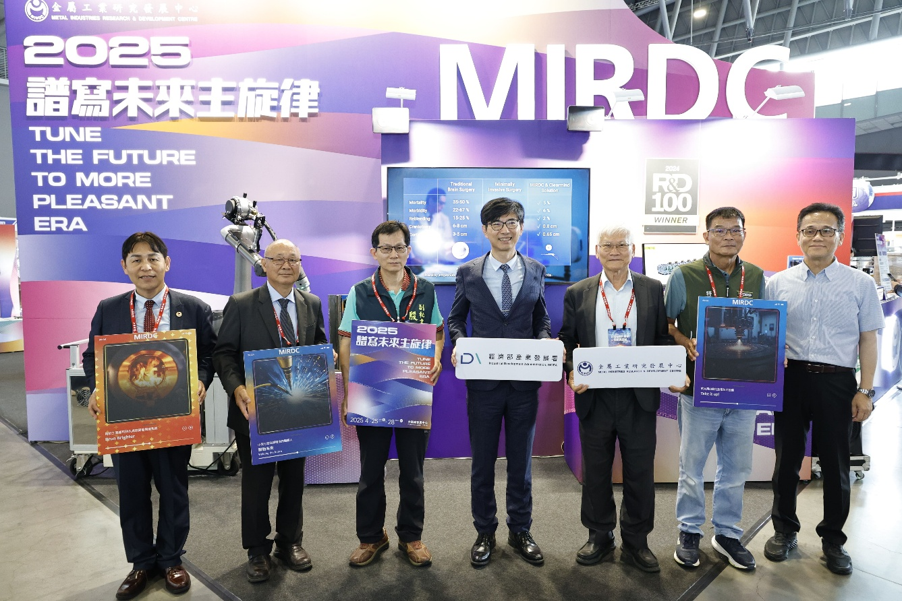
Photo 1. Director General Chyou-Huey Chiou of the Industrial Development Administration, Ministry of Economic Affairs (4th from left) and Deputy Secretary General Shi-Xi Yin of the Tainan City Government (3rd from left) led distinguished guests to visit the MIRDC exhibition venue at the 2025 Tainan Automatic Machinery & Intelligent Manufacturing Show. They were received by MIRDC Chairman Ren-Yi Lin (3rd from right) and took a group photo.

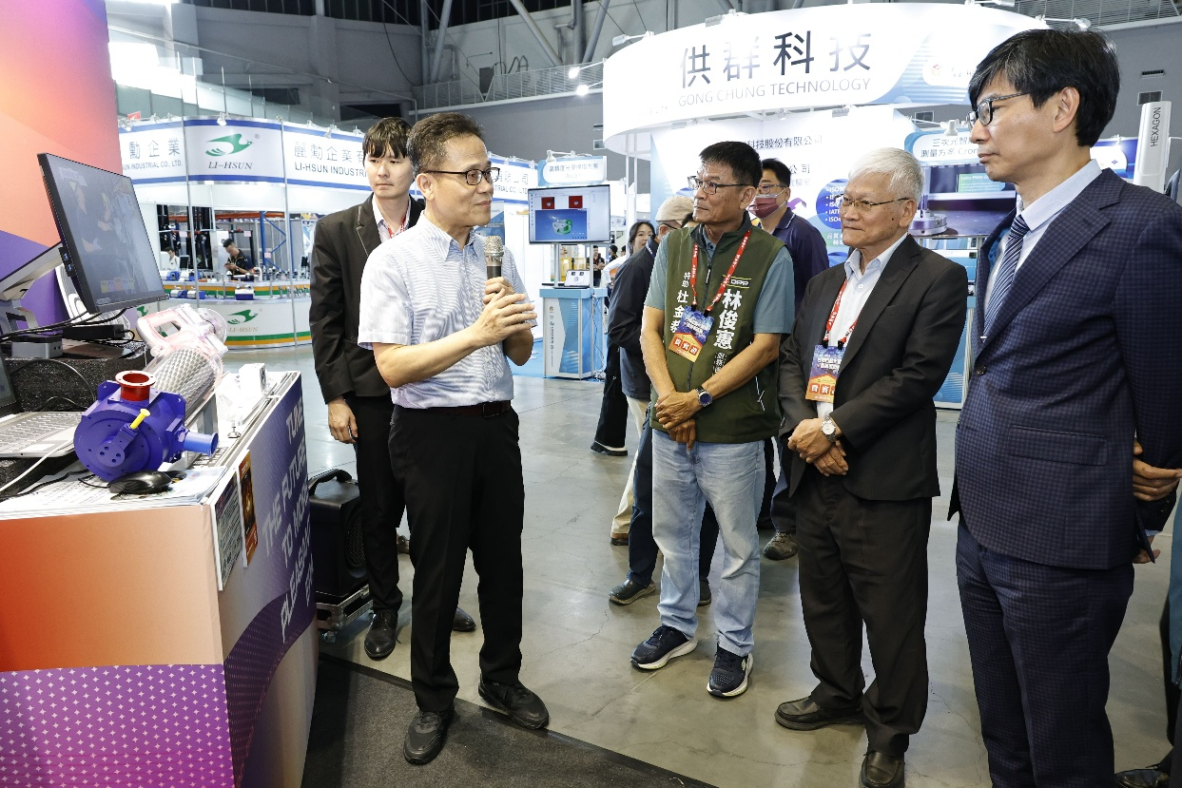
Photo 2. Director General Chyou-Huey Chiou of the Industrial Development Administration, Ministry of Economic Affairs (1st from right) led distinguished guests on a tour of the 2025 Tainan Automatic Machinery & Intelligent Manufacturing Show. They were received by MIRDC Chairman Ren-Yi Lin (2nd from right) and heard explanations of the MIRDC's technologies that had won the R&D 100 and other international awards.

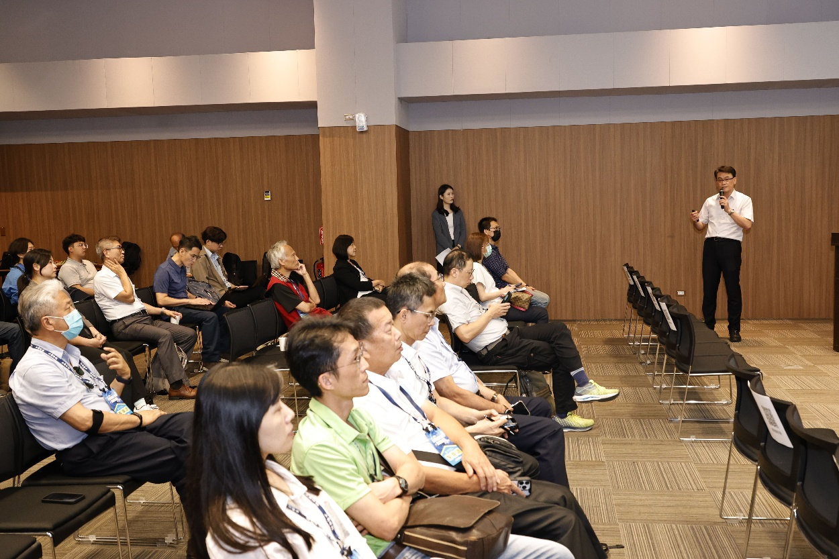
Photo 3. MIRDC also held the 2024 R&D Results Presentation at the show.

