
新聞資料NEWS LETTER
Kaohsiung Maritime Technology Innovation Center Adds Key Facility – Taiwan's First 10-Meter Deep Pool Officially Opens

The grand opening of the "Kaohsiung Marine Technology Innovation Center – Offshore Engineering Center" was held today (15th). The center was planned and established by the Metal Industries Research & Development Centre (MIRDC) backed by the Energy Administration, Ministry of Economic Affairs. Numerous distinguished guests attended the ceremony, including Director-General Chun-Li Lee of the Energy Administration, Deputy Mayor Ta-Sheng Lo of Kaohsiung City, Chairman Chia-Ju Liu of the MIRDC, and distinguished guests from internationally renowned marine technology research institutions, such as MARIN in the Netherlands and SINTEF in Norway, jointly witnessing a key step forward in Taiwan’s maritime technology development.

The Maritime Technology Innovation Center is planned as three centers, namely the Marine Technology Engineering Talent Training and Certification Center, the Marine Technology Industry Innovation R&D Center, and the Offshore Engineering Center. These three centers complement each other to form a complete industry service system. The official opening of the Offshore Engineering Center completes the last piece of the puzzle of the "three centers." In the future, it will provide one-stop service from marine talent cultivation, technology R&D, to design verification. Distinguished guests were also invited to visit the deep pool, which is capable of highly realistic simulations of wind, waves, and currents, allowing attendees to personally experience the highly realistic marine environment, and demonstrating Taiwan's advanced technological capabilities for providing a marine environment for testing.

Chairman Chia-Ju Liu of the MIRDC said that the world has been facing the growingly severe impact of extreme weather events, and that the marine environment has been changing rapidly in recent years. The Offshore Engineering Center's deep pool has the equipment to simulate complex conditions, such as wind, waves, and currents of varying levels and intensities, which can help the industry more realistically test the performance of underwater structures and equipment. This testing and verification method allows problems to be discovered in advance so that designs can be optimized, improving the overall reliability and safety of marine technology. This will allow Taiwan to be fully prepared when facing climate challenges, and will also help Taiwan steadily accumulate R&D capabilities in the fields of renewable energy and marine technology.

The Offshore Engineering Center features a world-class deep pool measuring 36 meters in length, 30 meters in width, and with an adjustable water depth from 0 to 10 meters. It provides a highly realistic marine environments for testing. In the future, it will be able to support scale model verification, underwater vehicle operation training, and the R&D and application of underwater instruments and structural equipment, becoming an important base for key technology verification and talent cultivation for offshore wind power and marine engineering in Taiwan. The opening of the Offshore Engineering Center is expected to drive Taiwan’s industry to develop from OEM to ODM, and ultimately to the establishment of domestic brands (OBM), symbolizing a new milestone in the independent R&D of marine technology.
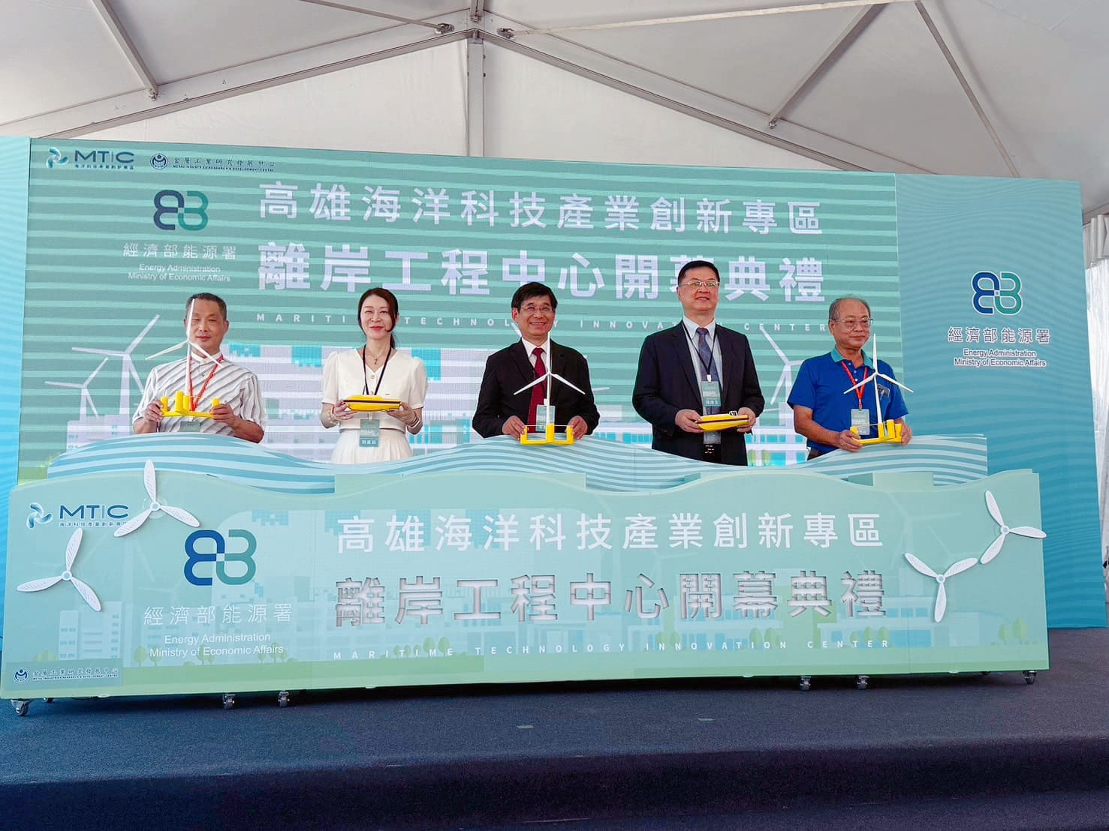

Photo 1: Group photo at the opening ceremony of the Offshore Engineering Center (from left to right: Chairman Chao-En Huang of Xing An, Chairman Chia-Ju Liu of the MIRDC, Director-General Chun-Li Lee of the Energy Administration, Deputy Mayor Ta-Sheng Lo of Kaohsiung City, and Chairman Ming-Shan Chen of Sui Chang)
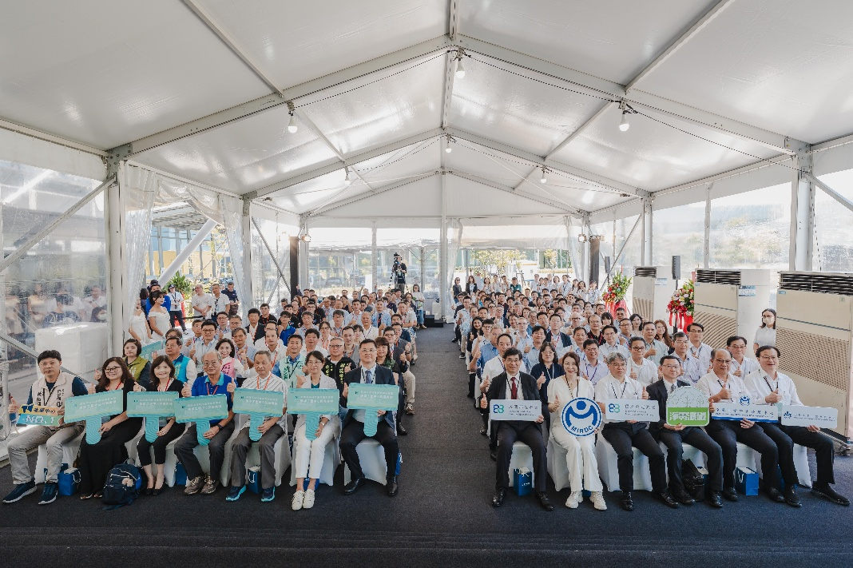

Photo 2: Group photo of all distinguished guests at the opening ceremony of the Offshore Engineering Center
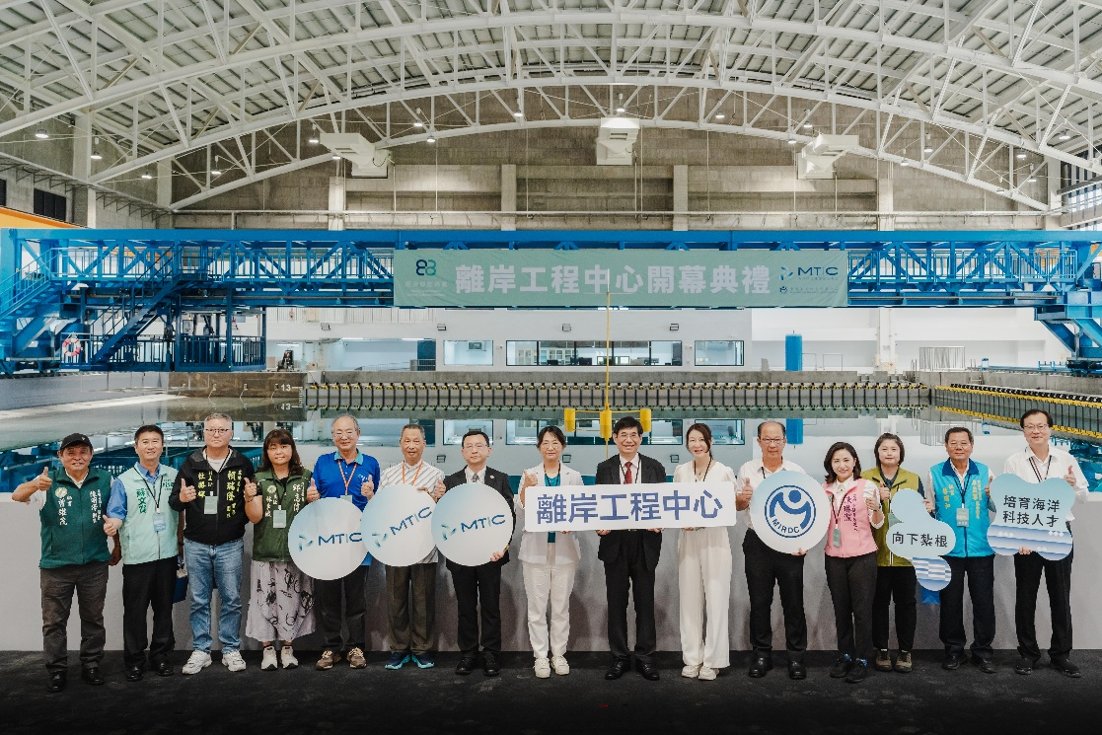

Photo 3: Group photo by the pool at the opening ceremony of the Offshore Engineering Center

