新聞資料NEWS LETTER
Intelligent Drones Technology to the Rescue
In recent years, the rapid change of climate has created endless natural disasters all over the world; locating on the seismic belt, Taiwan also gets sudden earthquakes in addition to hard rainfall within a short time, strong winds, and man-made fires and explosions, devastating the livelihood of people. And thus how to increase the rescue capacity against disasters and enhance the efficiency of search and rescue operations have become the major concerns of our country. Taiwan Fire Academy in Zhushan (TFAZ) has exhibited a series of intelligent firefighting applications yesterday (6/14), including how to use drones to broadcast, search for fire source/survivors, and put out fire with fire hose nozzles in a simulation of fire. A great number of government officials have attended the event, including Director General Huan-Chang Hsiao of the National Fire Agency, officials of the Ministry of Foreign Affairs, and foreign ambassadors.

Taiwan Fire Academy in Zhushan (TFAZ) is not only the largest training base for firefighting and disaster prevention & rescue in Taiwan but also the third largest in the world as well as the largest in Asia. In addition to providing professional firefighting training for fire fighters, National Military personnel, and students of Central Police University and Taiwan Police College, it is also the training site of government agencies and civil rescue groups for drills of disaster prevention and rescue. A variety of drills were exhibited yesterday, such as the Special Rescue Squad drill for the exhibition of equipment for international humanitarian aid (including search cam, life detector, and seismic monitoring device), the search dog drill (such as remote controlling, long tunnels, horizontal ladders, and bark box), the fire rescue scenario drill (including remote controlling drones for reconnaissance, suiting up fire equipment, fire drills for motorcycles parked under pedestrian arcades, and cradle carry), new methods of rope rescue, and rescues for petrochemical disasters, presenting the overall rescue powers of our country.

The Department of Industrial Technology, MOEA has devoted into the development of drones technology in its technology project titled “Development and Verification Plan for Highly Stable Weather-resistant Collaboration Vehicle”; with high load, high stability, and innovative field application as its development theme, the project plans to apply drones in the field of firefighting and rescue from the current agricultural use, patrolling, and support for offshore fishery operations, accelerating the promotion of the industry in the application of drones in more fields. The MIRDC (Metal Industries Research & Development Centre) has developed drones technology for years. The highly stable collaborative rescue rotorcraft exhibited yesterday has used a software that quickly controls the rotorcraft to minimize the spray and recoil, and installed fire hose nozzles onto the rotorcraft to spray water directly on fire, solving the conventional problem of inability to spray water immediately to tall buildings. Comparing to the traditional method of using high pressure water guns, using fire hose nozzles to spray water provides better cooling and fire extinguishing effects. Meanwhile, the fire fighters have used a high-speed frequency hopping for anti-interference technology for communications, so even in strong winds of level 7 or an unstable current, the fire fighters are still able to perform their duties and transmit the images back to the command center. By analyzing the images with AI and collects data on a full scale, the commanding personnel are able to make immediate decisions to prevent fire fighters from entering danger zones and save more rescue time to increase the efficiency of the overall rescue operation, opening a new horizon in technology rescue.
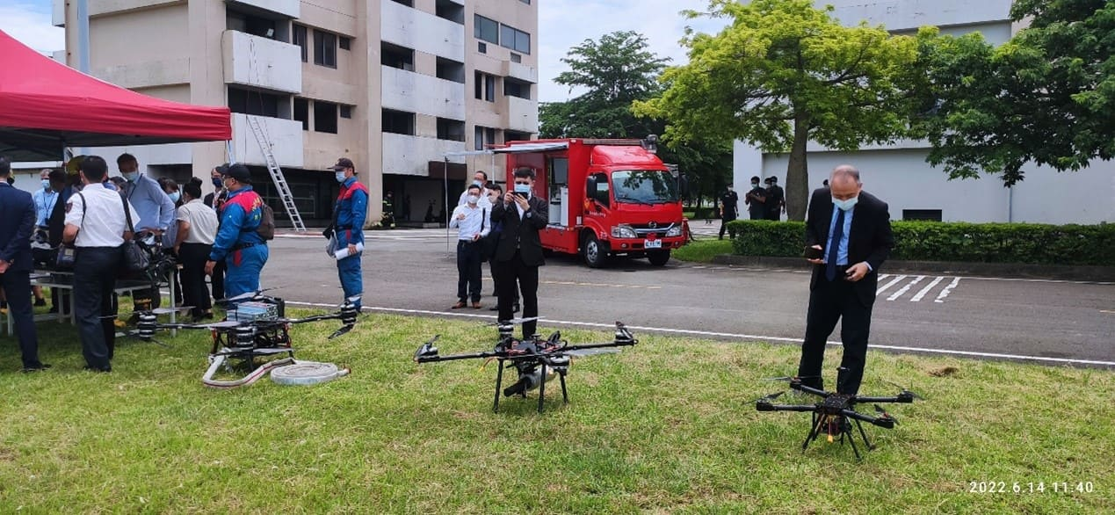
Figure 1. Taiwan Fire Academy in Zhushan (TFAZ) exhibiting a series of highly stable collaborative rescue rotorcraft.
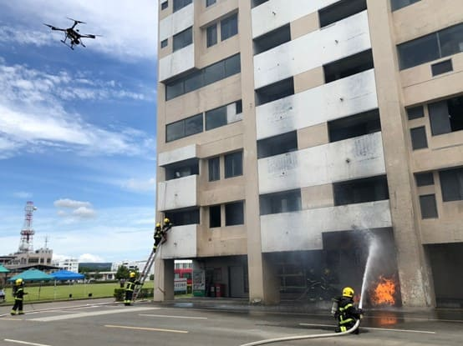
Figure 2. Simulation of the fire site Command Center using drones to broadcast and monitor for the search of fire source/survivors.

