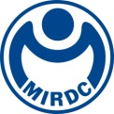
新聞資料NEWS LETTER
MIRDC partners with industry to launch six technologies that support seniors to enhance their quality of life

Taiwan is on the brink of becoming a super-aged society. In response to the increasing health needs of the elderly population, the Metal Industries Research & Development Centre (MIRDC), with support from the Department of Industrial Technology, MOEA, recently participated in the 2nd Healthy Ageing Tech Show held at the Taipei World Trade Center. At this event, MIRDC showcased six innovative senior-friendly technologies that incorporate smart assistive devices, digital platforms, and AI applications to build a healthy, independent, and dignified lifestyle for elders.

MIRDC’s Smart Solution for Oral Care and Swallowing Empowerment was recognized with a Top 10 Age-Friendly Technologies Award at this year's show. President Lai personally presented the award to MIRDC Chairperson Chia-Ju Liu. This recognition highlights that MIRDC’s technologies not only meet industry needs but also provide practical solutions to real challenges faced by elders. The solution effectively combines AI and non-contact detection technologies to provide functions such as plaque detection, oral hygiene guidance, swallowing training, and gamified rehabilitation systems. This comprehensive approach safeguards seniors' oral health while promoting their engagement in self-care. The relevant technologies have been transferred to Formosa Heavy Industries and Formosa Biomedical, and further integrated with the resources of Colgate and Beishin Information for deployment in long-term care institutions.

MIRDC has partnered with several companies, including imedtac, aiFree Interactive Technology, Mobisnet, Chiun Mai Communication Systems, and DIGIBIONIC, to showcase innovative technologies. These advancements include the Smart Solution for Oral Care and Swallowing Empowerment, smart care operation systems, hearing aids, cognitive and muscle training devices, and care robots. Through these partnerships between industry and research, MIRDC is actively developing a systematic ecosystem for the senior health industry.

Chairperson Liu expressed her heartfelt gratitude to the MIRDC team for their dedication and commitment to technological research and development. She acknowledged that the recognition received affirms the value of MIRDC’s efforts. She emphasized her hope that, with the policy guidance of the Department of Industrial Technology, MIRDC will continue to integrate resources across various sectors to enhance the practical applications of gerontechnology, ensuring that technology truly serves as a caring companion in the daily lives of seniors.
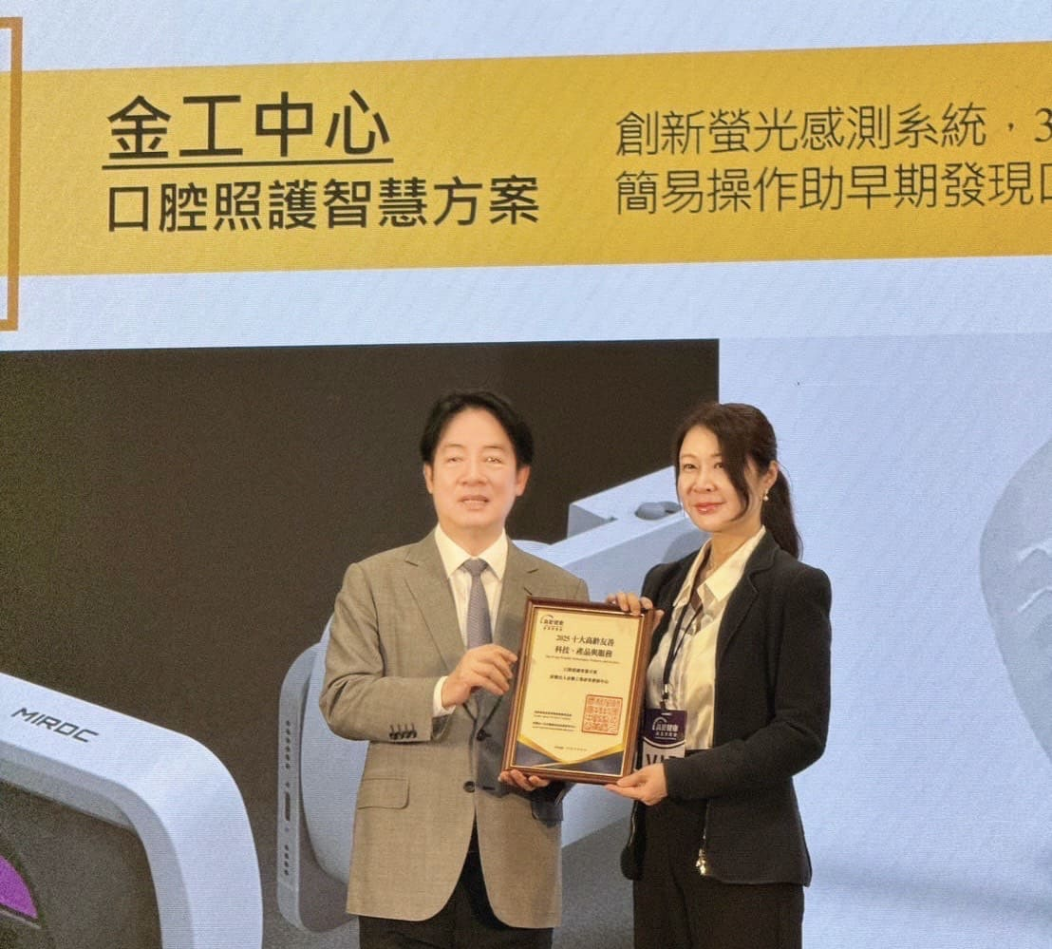

Photo 1: MIRDC’s Smart Solution for Oral Care and Swallowing Empowerment was recognized with a Top 10 Age-Friendly Technologies Award at the 2025 Healthy Ageing Tech Show. President Ching-Te Lai pictured with Chairperson Chia-Ju Liu

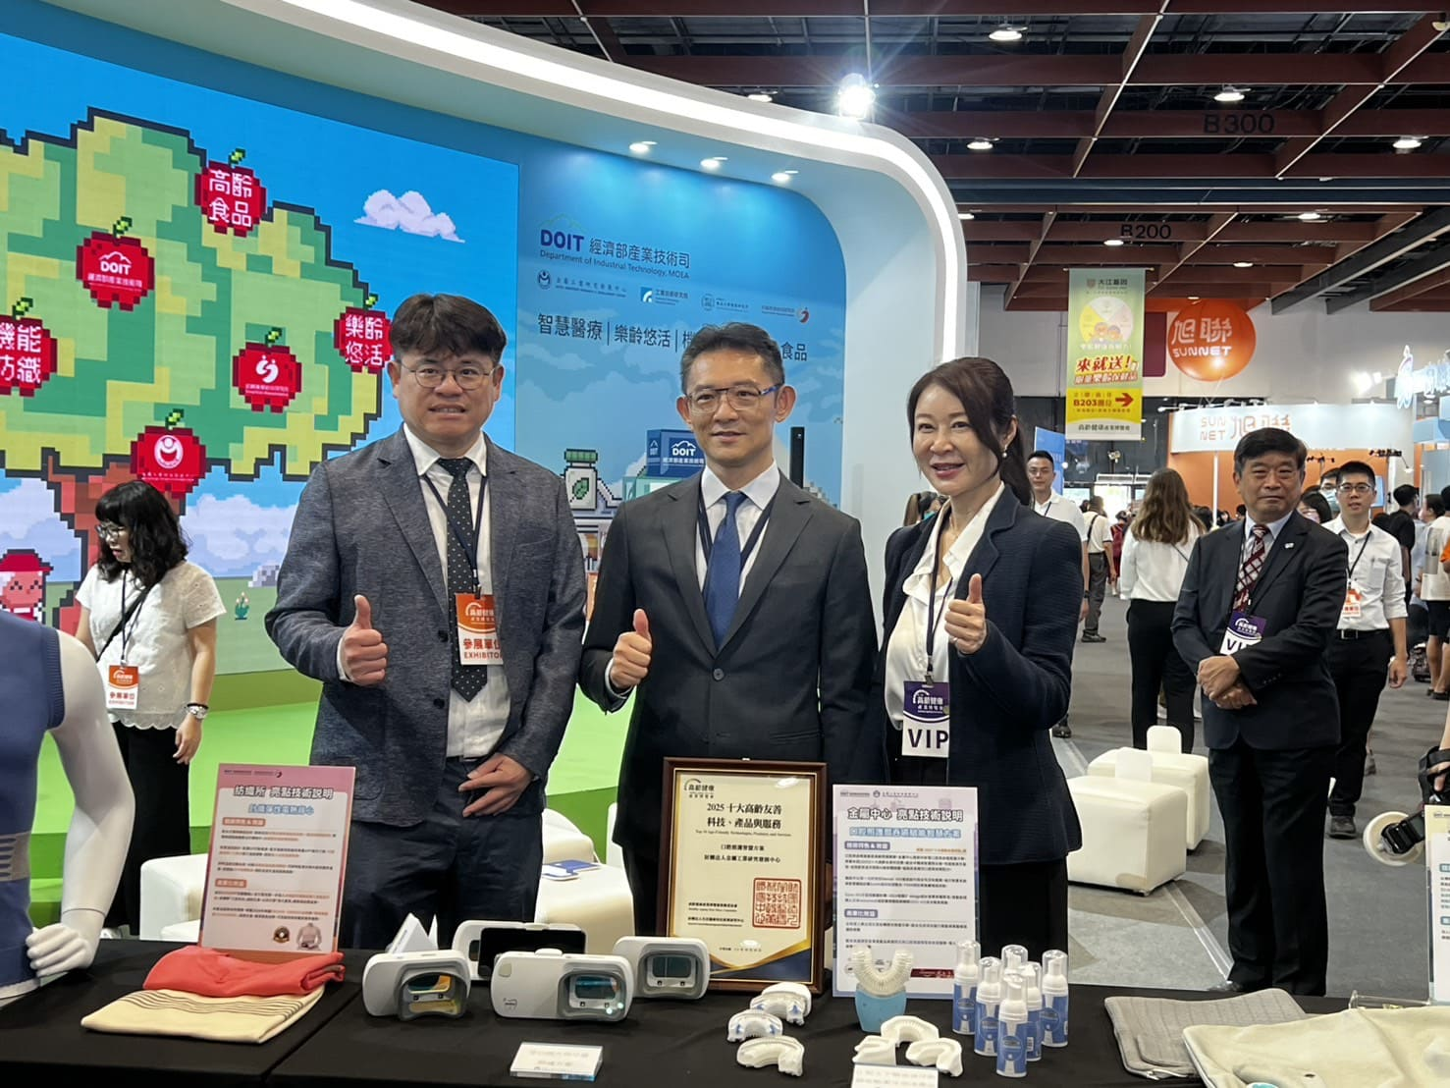

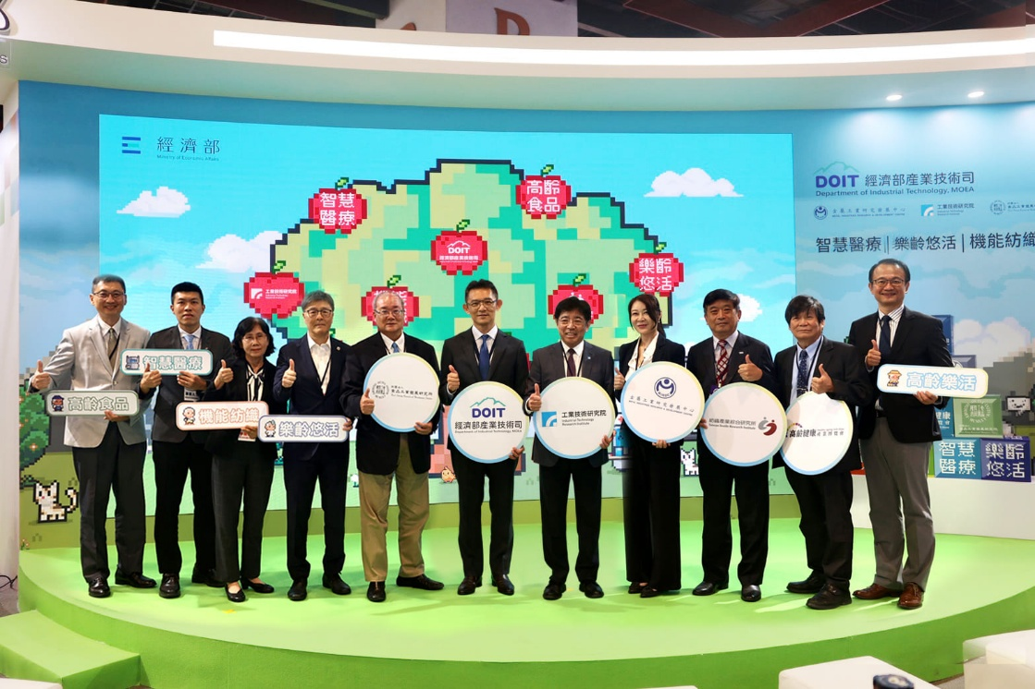
Photo 2: MIRDC’s Smart Solution for Oral Care and Swallowing Empowerment was a featured highlight at DoIT’s pavilion. From right: MIRDC Chairperson Chia-Ju Liu, Director General Chao-Chung Kuo of the Department of Industrial Technology, MOEA, and MIRDC Engineer Boi-Wei Huang

Photo 3: The Department of Industrial Technology’s pavilion at the 2nd Healthy Ageing Tech Show kicked off today with an opening ceremony at the Taipei World Trade Center Hall 1. From left: Chimei’s R&D Division Assistant Vice President Bu-Lun Chen; Formosa Heavy Industries Specialist Jen-Bang Cheng; Pailung Manager Jui-Wen Shih; Mymate General Manager Li-Fu Yu; Deputy Director General Binghuei Barry Yang of the Food Industry Research and Development Institute; Director General Chao-Chung Kuo of the Department of Industrial Technology, MOEA; ITRI President Wen-Hsiung Liu; MIRDC Chairperson Chia-Ju Liu; President Kuei-Chi Lee of the Textile Industry Research Institute; Chairman Yao-Chang Qiu of the Taiwan Oral Care Association; and imedtac General Manager Chin-Shu Yu
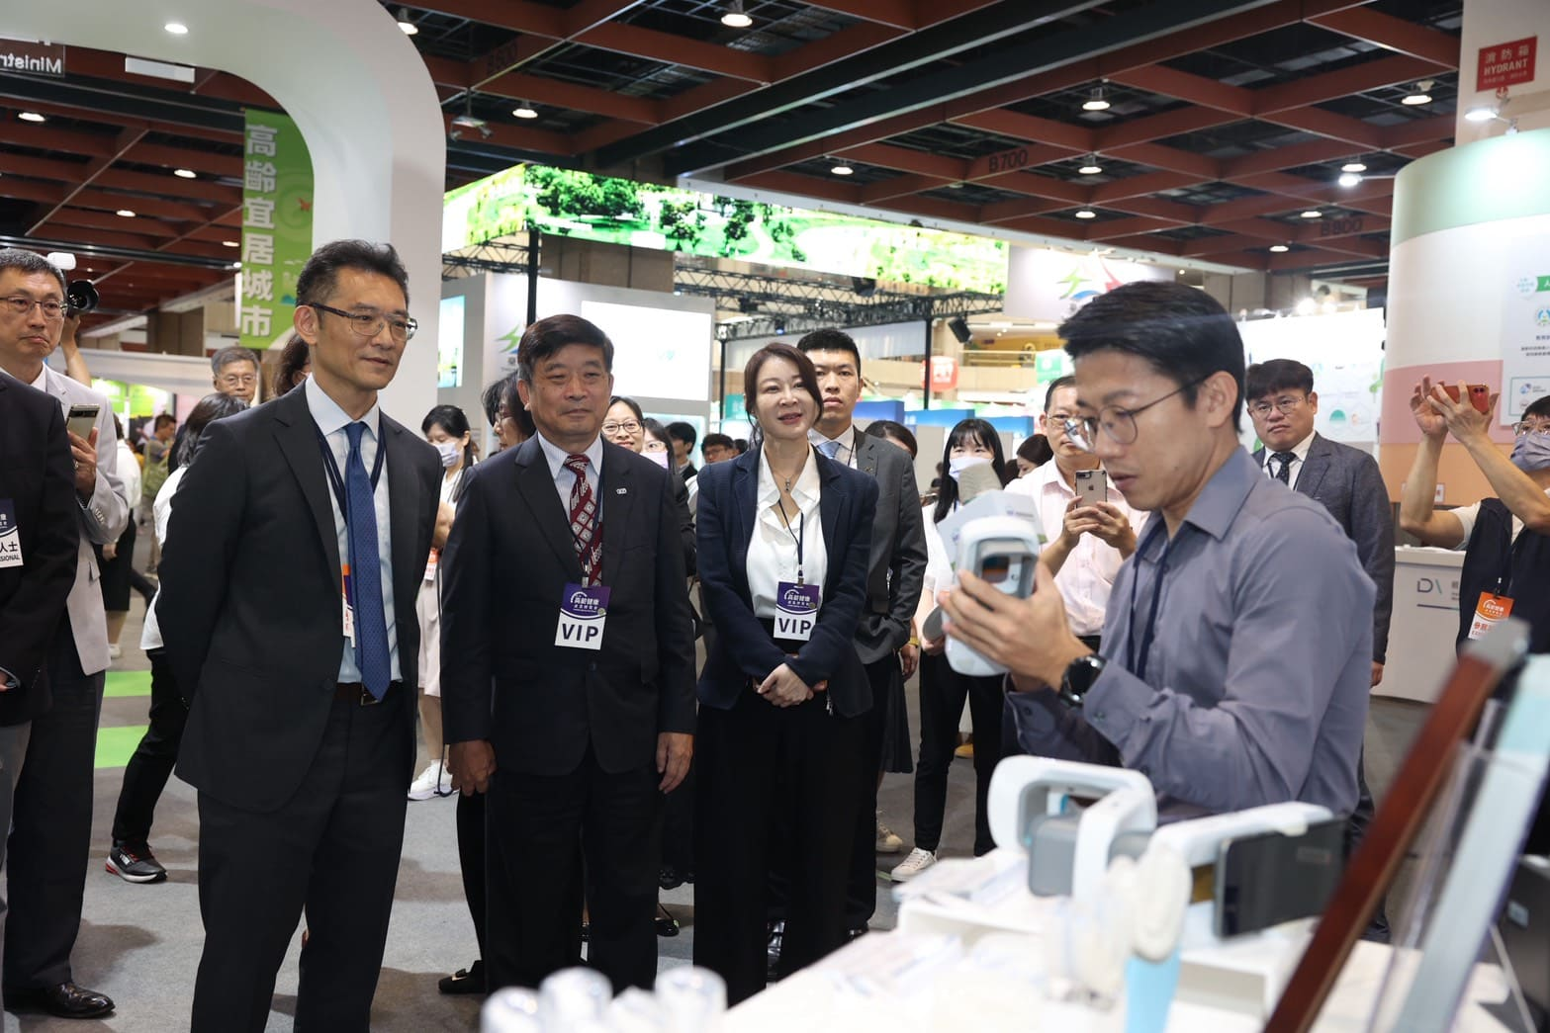

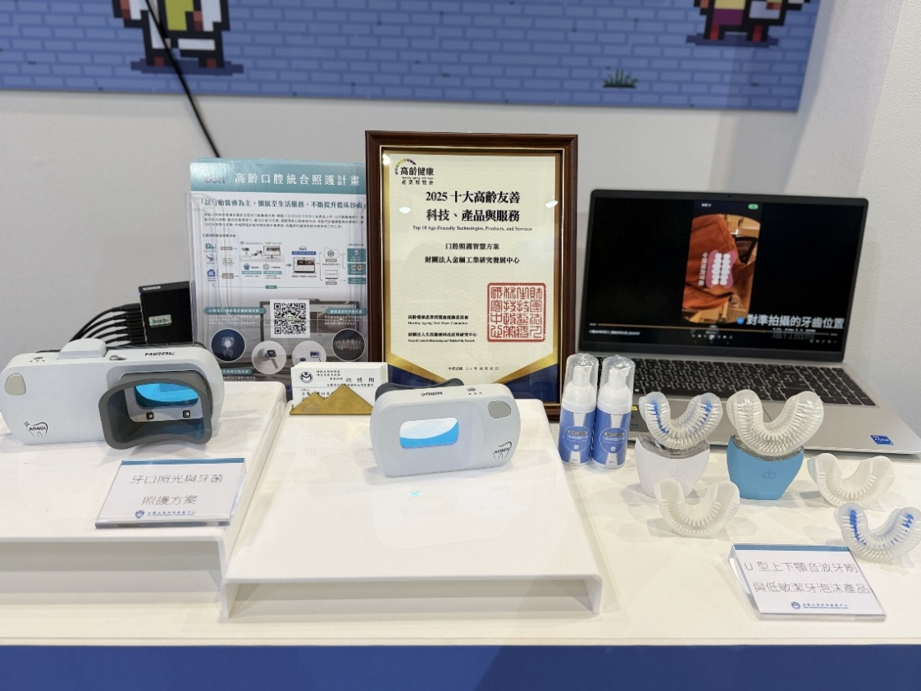
Photo 4: Director General Chao-Chung Kuo visited the Smart Solution for Oral Care and Swallowing Empowerment highlight showcase

Photo 5: MIRDC’s Smart Solution for Oral Care and Swallowing Empowerment combines AI and non-contact detection technologies to provide plaque detection, oral hygiene guidance, swallowing training, and gamified rehabilitation systems to safeguard seniors' oral health comprehensively

