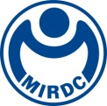
新聞資料NEWS LETTER

MIRDC as Winner of Multiple International R&D Awards, It Again Received R&D 100 Awards, Oscars of Technology Industry

Taiwan's R&D capabilities are gradually making a mark on the global stage. "R&D 100 Awards" is an internationally renowned technology innovation award. Every year, 100 commercial technologies with major innovative significance and profound impact on human life are selected from thousands of innovative technologies around the world. This year is the 62nd year of the award, which has been an important indicator for identifying revolutionary and new technologies in the market. Products such as fax machine (1975), LCD screen (1980), Nicoderm nicotine patch (1992), Taxol cancer drug (1993) and
high-definition television (1998) were selected as year's best products of R&D 100 Awards for significant impact they had on human life and for their indispensable part in our lives.

With support of Ministry of Economic Affairs, MIRDC (Metal Industries Research & Development Centre) is assisting the government in enhancing the research capabilities needed for industrial transformation and upgrading, and it is promoting the development and growth of Taiwan's next-generation industries. This year, MIRDC was once again recognized by R&D 100 Awards, for its "Enduring-High-Efficiency Combustion System for Industrial Furnace" (EHE Combustion System) technology. The system is equipped with self-preheating burners and intelligent burner operating principle (IntelliBurn). Heat exchanger within self-preheating burner will gradually decline in energy-saving efficiency due to issues such as material degradation from thermal shock, carbon accumulation and other problems. Under the IntelliBurn computational framework, combined with a high degree of control over the health of the self-preheating burners, MIRDC has solved the degradation problem of energy-saving efficiency of existing burners. By dynamically adjusting the air-fuel ratio and leveraging the interplay of switching times and modes, the energy efficiency of industrial furnaces has been restored. Because of that, for EHE Combustion System, its waste-heat recycle is at most 72%, and its temperature uniformity is within ±3°C, and energy savings is up to 25%. Furthermore, heat exchange efficiency is maintained at over 95% of initial capability of heat exchangers.

Yung-Hsiang Lai, President of MIRDC, pointed out that the Centre continues to help manufacturers achieve energy saving and carbon reduction while satisfying their requirements of high average temperature. Therefore, its tool base has low deformation and meets accuracy requirements for precision machining, giving Ying Chien Foundry an edge in the high-end market. The technology is also introduced to Taiwell Aluminum Corporation, which has an annual output of 100,000 tons of aluminum sheets, helping it in heat treatment of 190 tons of large aluminum flat ingots. The single furnace helped Taiwell achieve an annual reduction in carbon of 270 tons, and there are now multiple furnaces being introduced. The carbon reduction effect is expected to be great, and their introduction will bring substantial and significant solutions to the industry. In the future, MIRDC will continue to put its efforts behind perfecting the technology and introducing it to more Taiwanese industries.

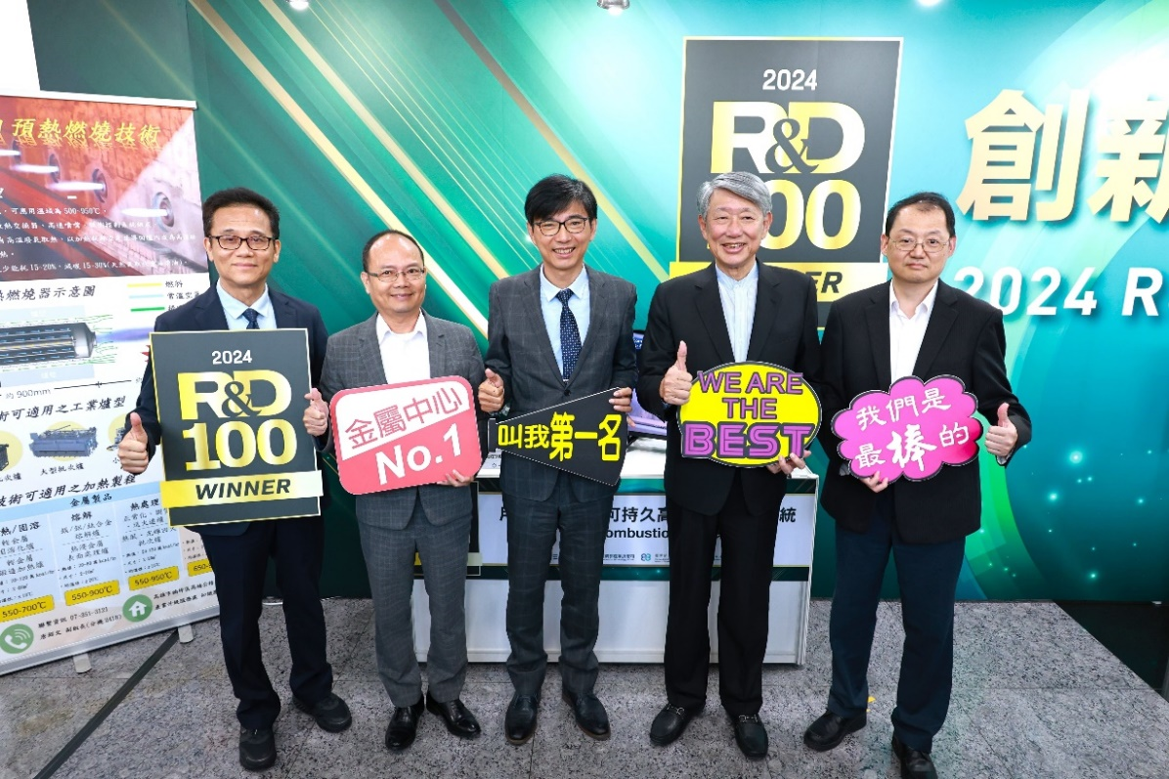
Photo 1. Jyh-Huei Kuo, Minister of Ministry of Economic Affairs (second from right), Chyou-Huey Chiou, Director General of Department of Industrial Technology (third from the right), and Chih-Wei Wu, Deputy Director-General of Energy Administration (first from the right) visited MIRDC for its award-winning EHE Combustion System and took a group photo with Yung-Hsiang Lai, President of MIRDC (second from left) and
Heng-Yu Lin, Director General of MIRDC (first from left)

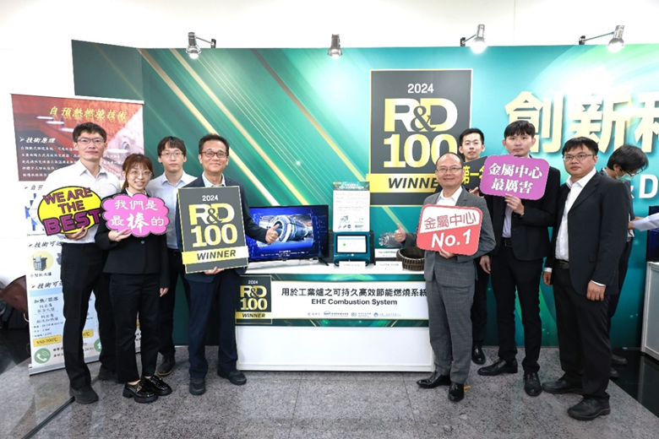
Photo 2. Yung-Hsiang Lai, President of MIRDC (fourth from right) and Heng-Yu Lin, Director General of MIRDC (fourth from left) took a group photo with technical team

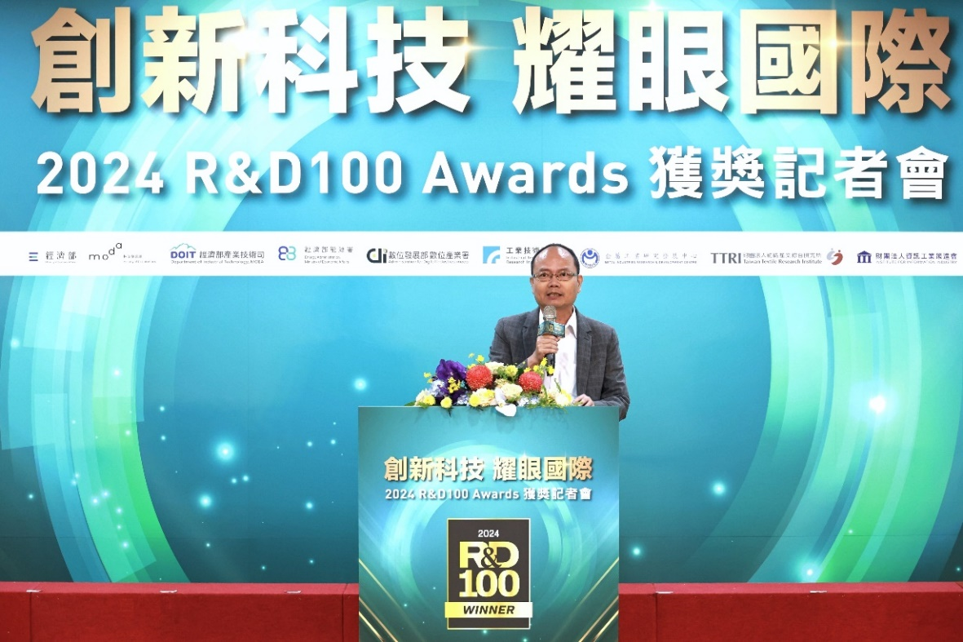
Photo 3. Speech by Yung-Hsiang Lai, President of MIRDC

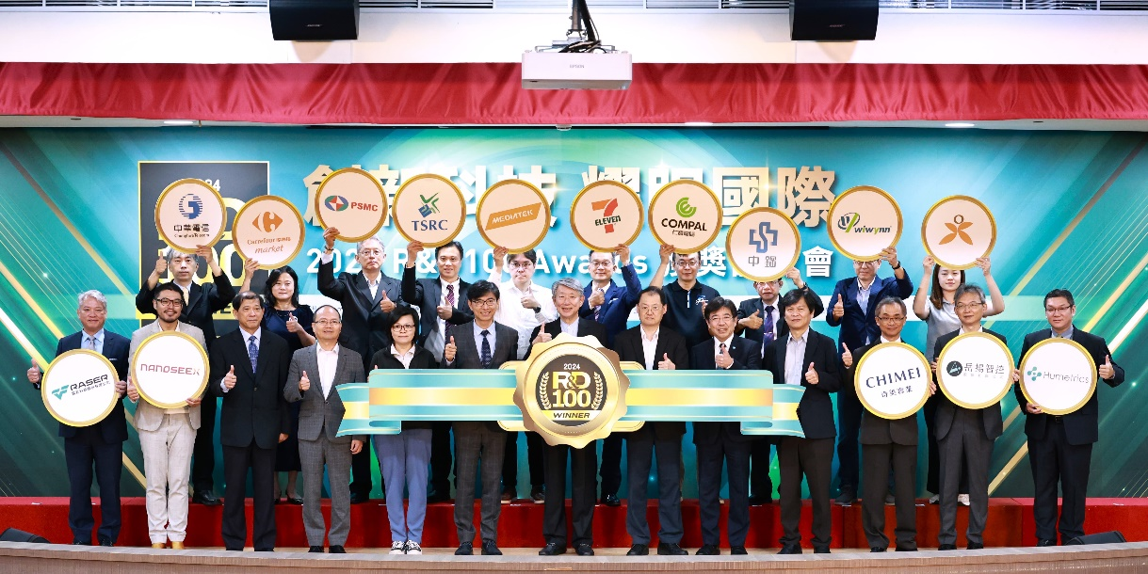
Photo 4. Group photo of distinguished attendees of the conference

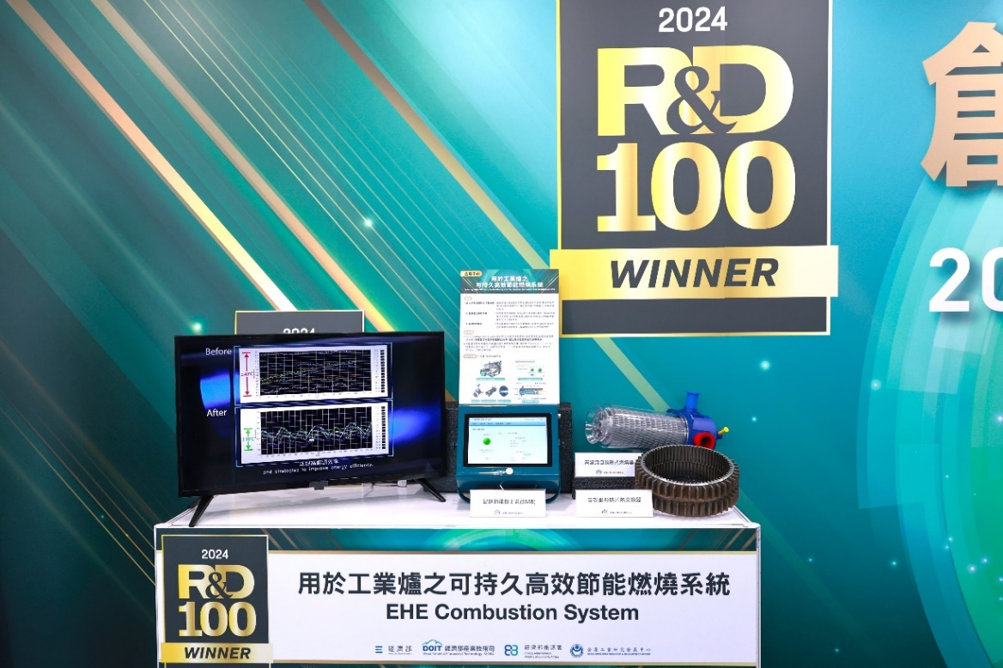
Photo 5. MIRDC’s EHE Combustion System, award-winning technology of
2024 R&D100 Awards

