
新聞資料NEWS LETTER
MIRDC Partners with National Cheng Kung University for Better Positioning in the Geothermal Energy Industry and to Expand into New Energy Fields

The Metal Industries Research & Development Centre (MIRDC) held an exchange meeting with the Department of Resource Engineering, National Cheng Kung University (NCKU) to review the results of their cooperation over the years, and also engage in in-depth discussions on geothermal technology and future energy development. Both parties emphasized that they will build on their current foundation by expanding into carbon sequestration, hydrogen energy, circular economy, and metal recycling, showing the determination of academia and research institutes to jointly develop green energy. Both parties will jointly host an international conference on geothermal technology in October, to create an international exchange platform and jointly promote Taiwan's geothermal industry.

Chairman Chia-Ju Liu of the MIRDC pointed out that geothermal energy is a crucial part of Taiwan's path to net zero emissions. Under the leadership of Director Hun-Yu Lin, the MIRDC’s geothermal team has been honing its expertise for the past decade, starting with the Zhiben Hot Spring demonstration project in Taitung, the team has made numerous technological breakthroughs, such as the acid-alkali separation design and the localization of pipes that meet international API standards, with the support of the Technology Development Program of the Energy Administration. This has successfully attracted China Steel Corporation, Chung Hung Steel, and Chuan Yang Geothermal to make investments and gradually formed an industry chain, demonstrating the R&D capabilities of corporations and the results of collaboration with the industry. In addition, the team developed acid-resistant titanium alloy/steel composite pipes for harsh acidic geothermal environments, and completed dynamic laboratory and field tests, which attracted more than 10 companies to join the industry alliance, injecting new momentum into the development of geothermal energy at Datun Mountain in northern Taiwan.

Hsing-I Hsiang, Director of the Department of Resources Engineering at NCKU, said that NCKU has a solid foundation in energy research, geological science, and numerical simulation, and has established a comprehensive experimental and monitoring platform, accumulated years of research results, and maintained close communication with industries and expert teams in Taiwan and overseas. The capabilities of academia combined with the MIRDC’s engineering application and industry chain integration capabilities, are expected to create synergies in geothermal power generation, carbon sequestration, and metal recycling.

Looking towards the future, the MIRDC and NCKU will continue to deepen their cooperation, take the lead in the development of Advanced Geothermal Systems (AGS), and engage in the R&D of deep geothermal horizontal pipeline coatings, geological simulation, and economic models. Both parties hope to utilize academia and industry as dual driving forces to assist in the implementation of government policies and the establishment of supply chains, pushing Taiwan's geothermal industry onto the international stage, and injecting new momentum into the transition to green energy.
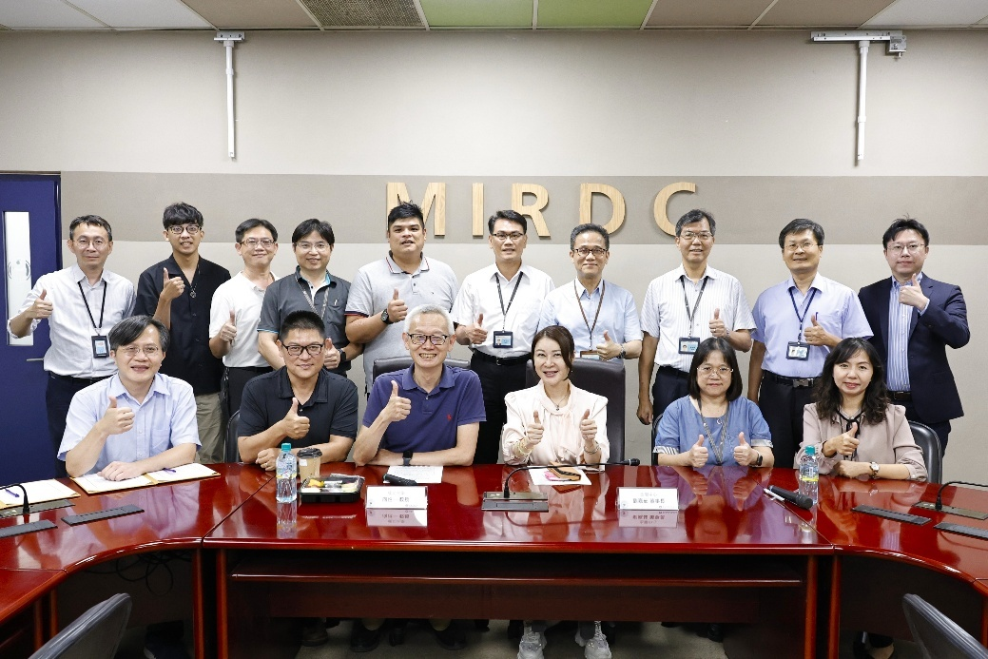

Photo 1. Group photo of the MIRDC and Department of Resources Engineering, NCKU at the exchange meeting

