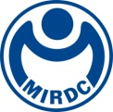
新聞資料NEWS LETTER

MIRDC Applies Self-preheating and Indirect Heating Technology to Continuous Heat Treatment Furnace

In view of the global carbon reduction and net-zero emission trend, it is important for Taiwan to establish effective energy-saving technology because enhancing energy efficiency will strengthen international competitiveness for its industries. The Energy Administration, Ministry of Economic Affairs, provides subsidies through the Technology Development Program to the Metal Industries Research & Development Centre (MIRDC) in 2024 to help develop an intelligent self-preheating and indirect heating system. This is to establish an optimum energy-saving technology for metal industry by using waste heat, and it is for medium-high heating process ranging from 500℃ to 950℃. MIRDC collaborated with Ming Shyr Metals International, a renowned heat treatment manufacturer in Taiwan. The proprietary self-preheating and indirect heating technology is integrated with radial pipes, and which is applied in continuous carburizing heat treatment furnace with a maximum processing capacity of 0.9 ton of objects per hour. For medium-high heating process, the cooperation is an energy-saving and carbon reduction case study with optimization of energy consumption. Therefore, a technology conference about this topic was held on December 17.

The technology conference invited Zhong-Chun Wu and Kuo-jen Tsai, Chairman and Honorary Chairman of the Taiwan Society for Metal Heat Treatment, Shih-Tsung Huang, Director General of the Taiwan Industrial Fasteners Institute as special guests, as well as over 40 guests from academia, and enterprises from relevant fields. The conference focused on the application of self-preheating combustion system and radial pipes on indirect heating of the carburizing heat treatment process. By integrating fin type heat exchanger, efficiency of the heat exchange exceeds 65%. In addition, adjustable multiple pulse control technology is able to prevent concentration of hot points on the radial pipes, thereby effectively increasing temperature uniformity and useful life of the radial pipes. Meanwhile, adoption of intelligent burner-operating-principle (IntelliBurn), and monitoring and diagnostic technology is able to further up energy saving by 3%. In particular, the self-preheating and indirect heating system is introduced into the continuous carburizing heat treatment furnace, and manufacturers provide heat-treatment-process requirements of metal fasteners and screws. Therefore, it meets requirements of heat treatment curves of fasteners and ±10℃ uniform temperature inside furnace, and which achieves energy saving and carbon reduction efficiency by more than 20%.

Yung-Hsiang Lai, President of MIRDC, pointed out that MIRDC received 2024 R&D 100 Awards, and it is also the Platinum Award Winner of 2024 Taiwan Innotech Expo Invention Awards. This showcases MIRDC’s achievement in promoting high-efficiency and energy-saving technology, and its concrete results in helping industry meet targets of energy conservation and emissions reduction is also demonstrated. In the future, MIRDC will continue to integrate innovative technology and industry needs to create more value for the metal industries, helping Taiwan move toward sustainable green manufacturing.

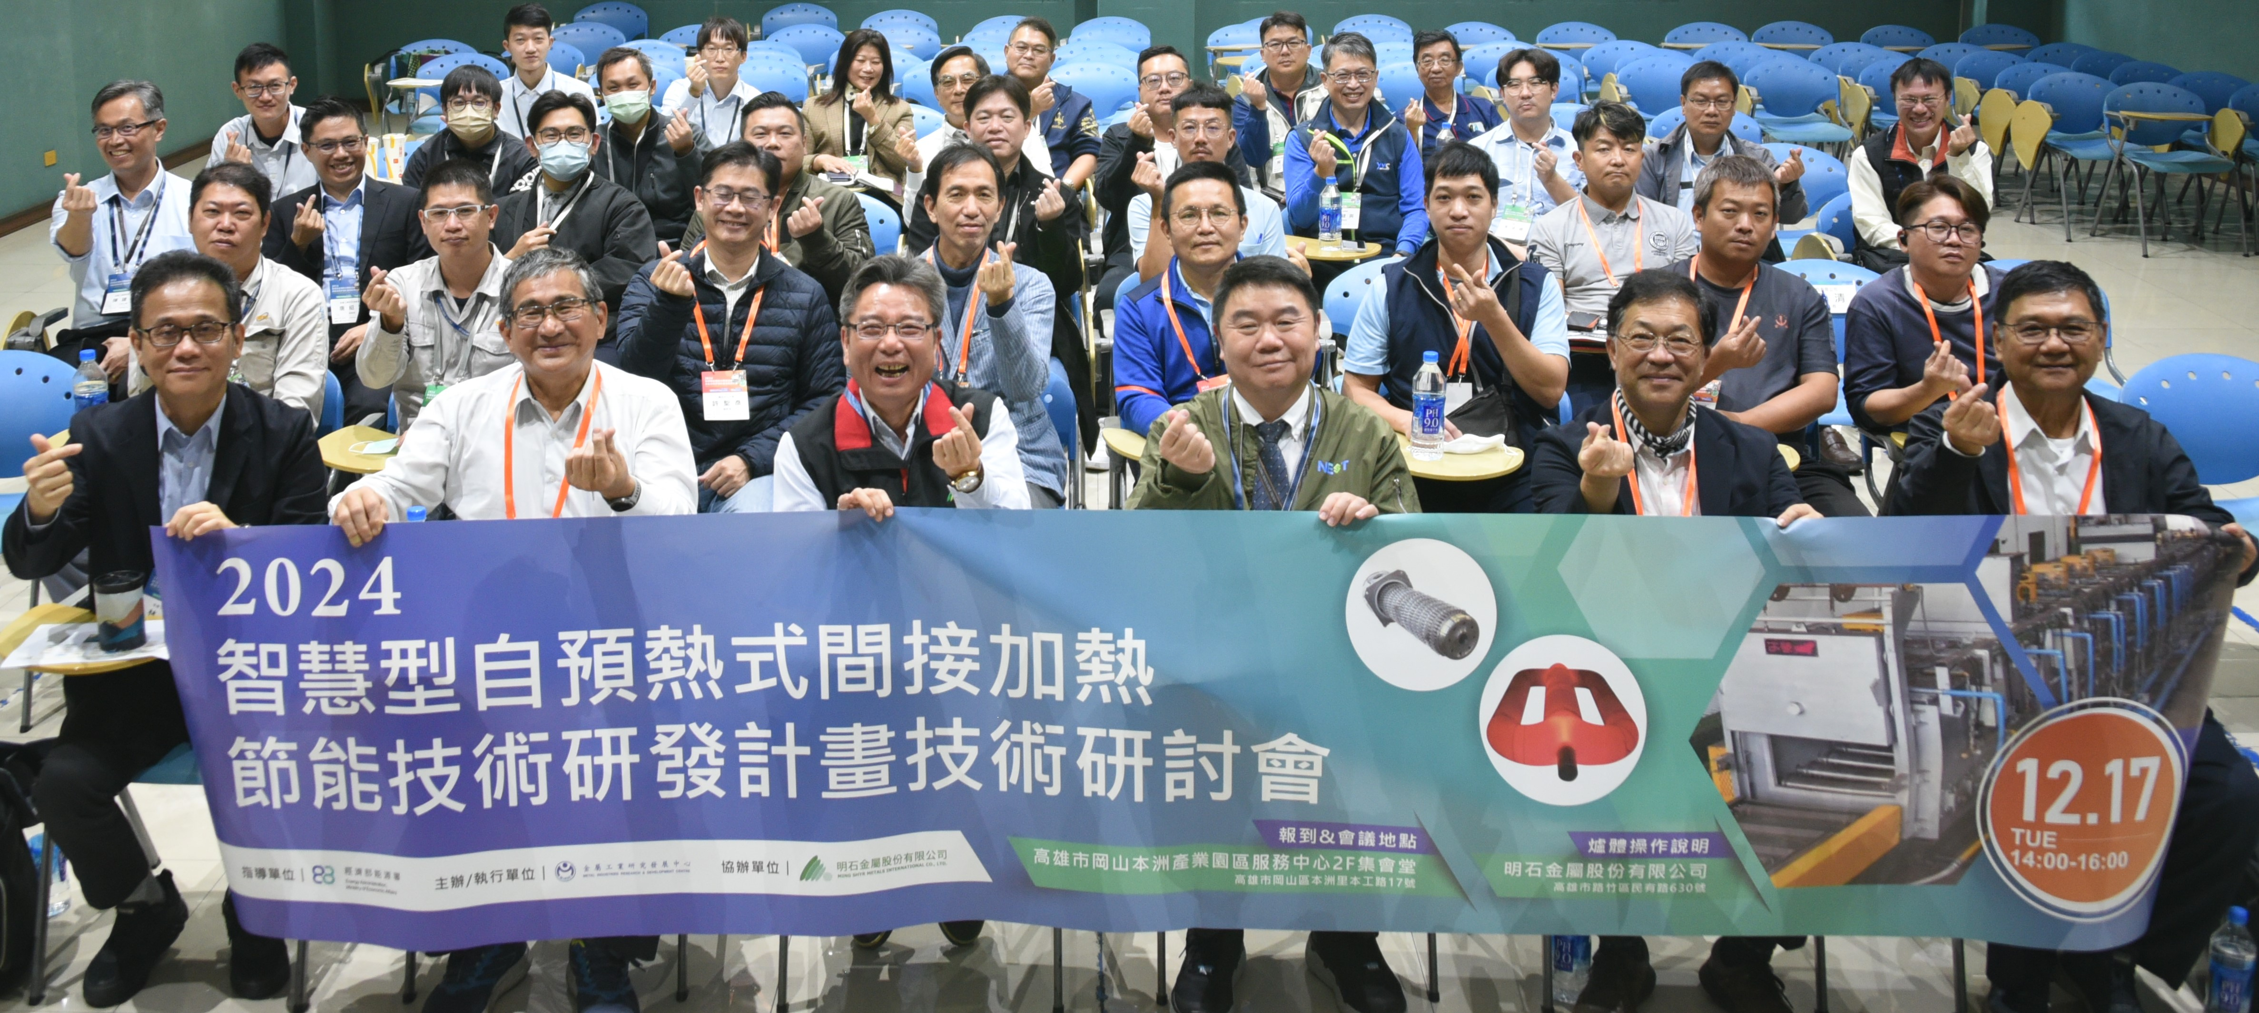
Photo 1. MIRDC hosts the technology conference for the intelligent self-preheating and indirect heating system.
Caption: Front row from the left, Hun-Yu Lin, Director of MIRDC, Shih-Tsung Huang, Director General of the Taiwan Industrial Fasteners Institute, Qiu-Sheng Chen, Chairman of Ming Shyr Metals International Co., Ltd., Wei-Hung Wu, Vice President of MIRDC, Zhong-Chun Wu and Kuo-jen Tsai, Chairman and Honorary Chairman of the Taiwan Society for Metal Heat Treatment.
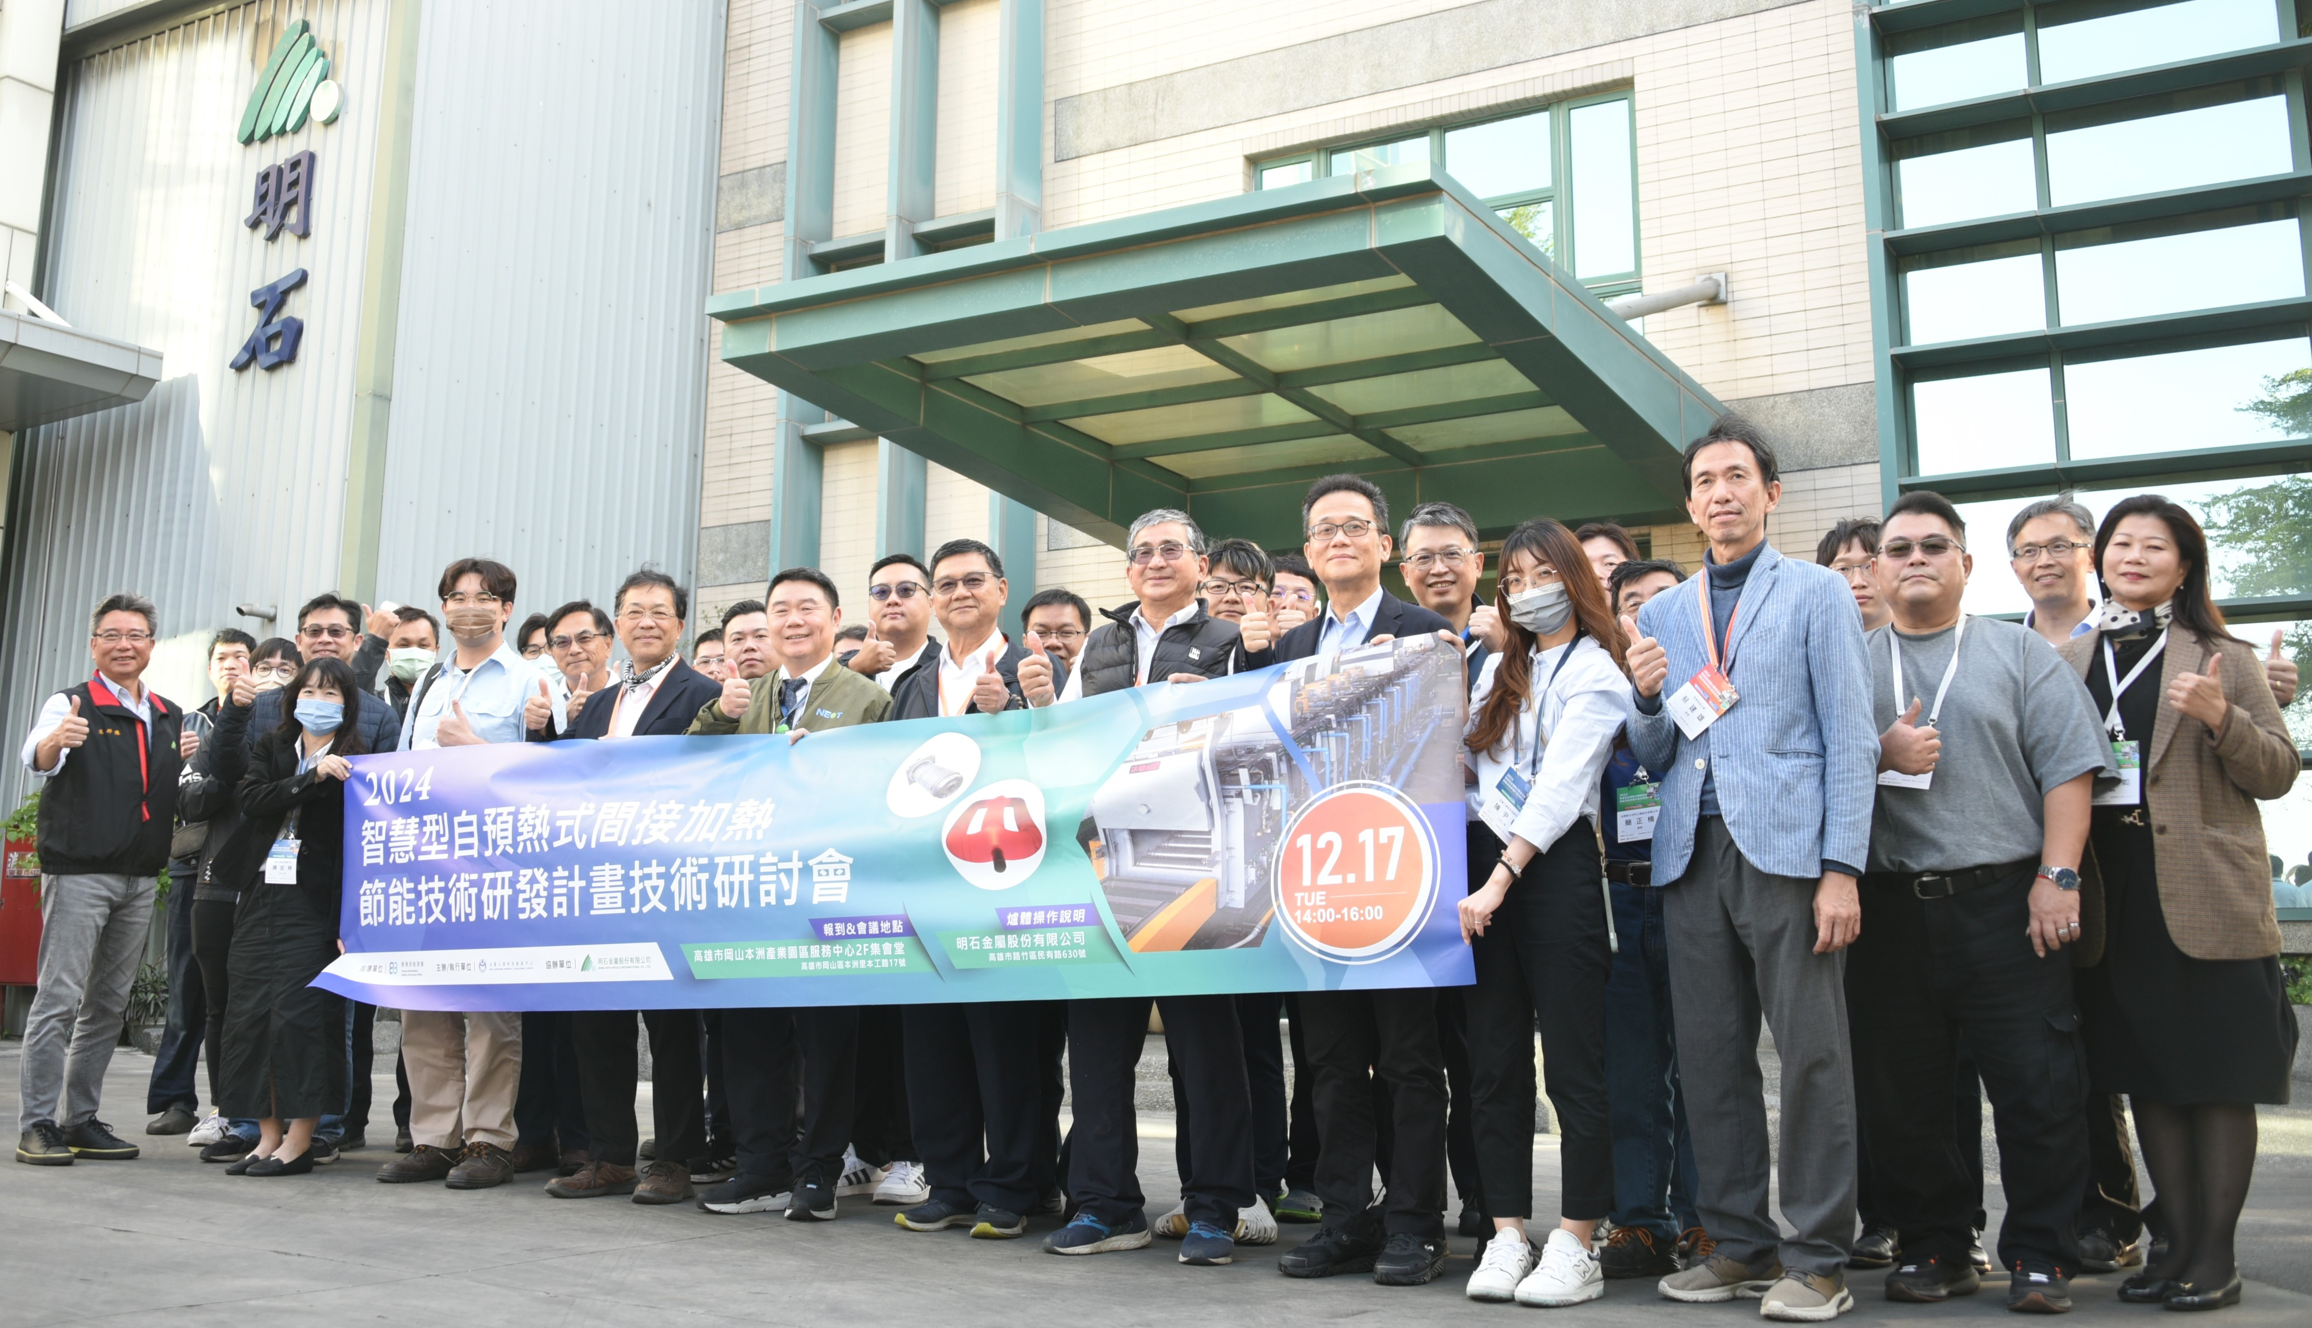
Photo 2. Guests at Ming Shyr Metals International.
Caption: Hosted by Wei-Hung Wu, Vice President of MIRDC, and the technical team leads guests to visit Ming Shyr Metals International and introduces operation of furnace.

