
新聞資料NEWS LETTER
Creating an Industrial AI Application Ecosystem: MIRDC Presents Talent Training Results for AI Pilot Production Lines

In response to President Ching-te Lai's policy and vision for creating an ecosystem of industrial AI applications, the Metal Industries Research & Development Centre (MIRDC) actively engaged in the promotion of AI pilot production lines and talent cultivation together with 14 R&D institutions to support government policy. MIRDC on the 12th held "Talent Training Results Sharing Session of AI Pilot Production Line" in the NTUH (National Taiwan University Hospital) International Convention Center. Government representatives (including Director-General GJ Lee of the Small and Medium Enterprise and Startup Administration, Ministry of Economic Affairs, Director Chao-Chung Kuo of the Department of Industrial Technology, and Section Chief Feng-Chi Yen of the Industrial Development Administration) along with representatives of associations and R&D institutions (including Chairman Tai-Li Chuang of the Taiwan Association of Machinery Industry, Chairman Shen-Teng Chen of the Taiwan Machine Tool & Accessory Builders’ Association, Chairman Chia-Lieh Chang of the Plumbing Association of Taiwan, and Chairman Chung-Chun Wu of the Taiwan Society for Metal Heat Treatment) jointly witnessed the practical results of introducing AI into the manufacturing industry and new opportunities for industrial transformation.

Yung-Hsiang Lai, President of MIRDC, said that MIRDC is one of the core legal entities promoting AI applications in the manufacturing industry, and has completed 9 AI pilot production lines for molds, fasteners, plumbing hardware, hand tools, casting, welding, automotive stamping parts, medical devices, and food industries, and which are aligned with the three major strategies of "practical implementation, verification by companies, and talent deployment." MIRDC took the lead in offering 7 courses on 3 pilot production lines for fasteners, plumbing hardware, and hand tools, with 73 participants completing training and serving 60 companies. The pilot production site not only introduces high-end equipment, but also integrates AI models and real-time inspection technology to help companies verify product design and process quality in advance. The results of the pilot production lines have been widely praised by the industry.

During the sharing session, MIRDC showcased the results of courses on AI pilot production lines for fasteners, plumbing hardware, and hand tools. A detailed introduction was provided to explain MIRDC’s complete process of AI course design, production line introduction, and practical application, indicating MIRDC’s specific practices and unique features in driving the implementation of AI technology in practice. To provide a better demonstration of practical results, MIRDC also invited Jien Chang Co., Ltd., a model company that was among the first to introduce AI collaboration, to share its experience during the session. With MIRDC's assistance, the company established a forging and forming force database and utilized AI computing models to successfully provide optimal parameter recommendations for the threading process, reducing the number of single sample runs to 4 times and under, and lowering overall production costs by over 25%. This successful case fully shows the benefits provided by AI applications in traditional manufacturing processes.

MIRDC hopes that the presentation of pilot production line results and sharing of implementation cases will deepen the industry's understanding of AI applications in practice, as well as the benefits they provide. Looking ahead, MIRDC will continue to deploy AI pilot production lines, accelerate the cultivation of AI talents, assist industries in steadily moving towards smart manufacturing and higher value, and become an important driving force for Taiwan's ecosystem of industrial AI applications.

For more information on AI pilot production lines, please contact:
Contact person: Ms. Ou 0800-005-288
https://service.moea.gov.tw/EE514/tw/aiip/437.html
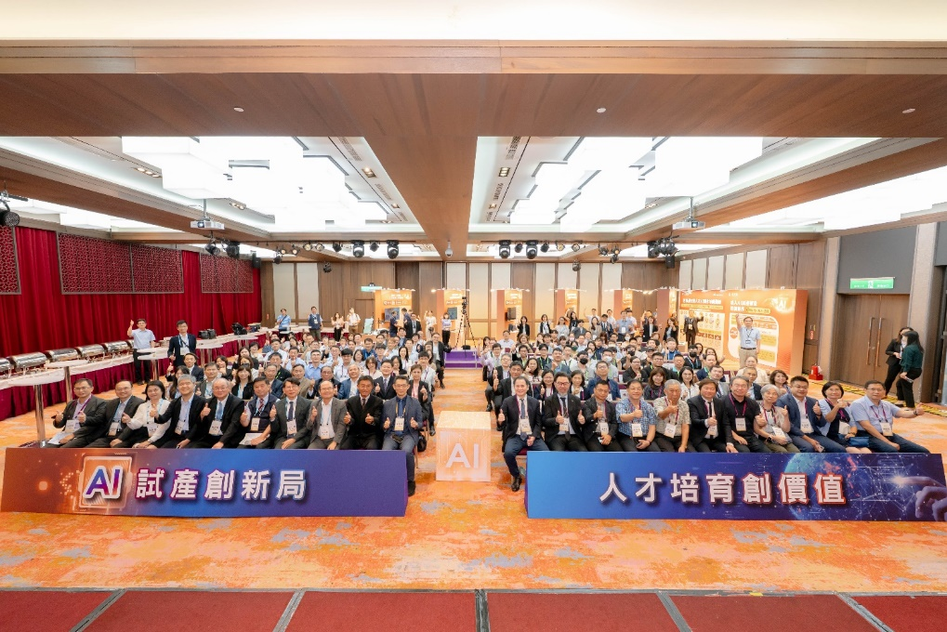

Photo 1. Group photo of all attendees at "Talent Training Results Sharing Session of AI Pilot Production Line"

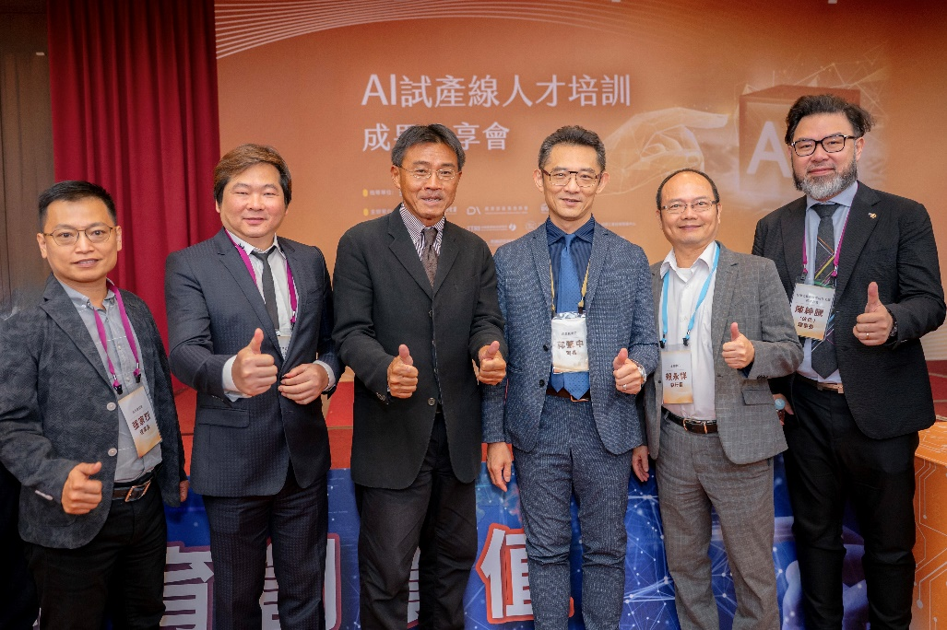

Photo 2. President Yung-Hsiang Lai of MIRDC (second from the right) exchanged views and took a group photo with Director Chao-Chung Kuo of the Department of Industrial Technology, MOEA (third from the right), Director-General GJ Lee of the Small and Medium Enterprise and Startup Administration (fourth from the right), Chairman Shen-Teng Chen of the Taiwan Machine Tool and & Accessory Builders’ Association (first from the right), Chairman Chia-Lieh Chang of the Plumbing Association of Taiwan (first from the left), and Chairman Shih-Yu Chang of the Precision Machinery Development Association (second from the left) during the meeting.

