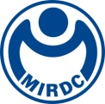
新聞資料NEWS LETTER

MIRDC Collaborates with Greek Company Theon Sensors to Promote the Localization of Key Technology Industries for Night Vision Devices

To comply with the government's "Five Trusted Industries" policy and strengthen the independent research and development and manufacturing capabilities of Taiwan’s defense industry, the Metal Industries Research & Development Centre (MIRDC) and Theon Sensors S.A., the Greek optoelectronic technology company for defense applications, officially signed the “Memorandum of Understanding (MOU) for Promoting the Localization and Industrialization of Key Technologies for Night Vision Goggles.” This collaboration stems from the results of MIRDC’s implementation of the National Defense Advanced Science Technology Research Program, Office of Science and Technology Policy’s (OSTP), National Science and Technology Council (NSTC), and integrates MIRDC’s long-term practical experience in the defense industry. The two parties will jointly promote local research and development and the industrialization of the core technologies for night vision devices, work together to drive industrial upgrades with innovative technologies, and enhance Taiwan’s national defense independence and industrial resilience.

This collaborative project includes four major items, and they are "evaluating the feasibility of local development of key technologies for night vision devices," "promoting the industrialization of key technologies for night vision devices," "expanding domestic and international market opportunities for night vision devices," and "exploring collaboration opportunities in complementary technology fields." The aim is to build an industrial environment for continued development and innovation. The signing ceremony was held on June 9, and the "International Business Opportunity Development and Exchange Seminar for Night Vision Device Sub-systems" was also held on the same day. The event was attended by Chen-Hao Chang, Executive Secretary of the OSTP, NSTC, and witnessed by many leading domestic optoelectronics companies and system integration manufacturers. In-depth exchanges were also held on international cooperation and industrial applications, thereby creating new opportunities for cooperation in the future.

Dimitris Papageorgiou, Regional Director of Business Development, Theon Sensors S.A., stated that the company has comprehensive vertical integration capabilities, and its products include military night vision goggles as well as thermal imaging and multi-spectral observation systems. The company’s products have been exported to more than 70 countries around the world, including 26 NATO member states, and it has ample experience in technology transfer and international cooperation. This collaboration with MIRDC will strengthen the technical exchanges and links with Taiwan's industries, so that all parties will be able to work together to explore the international market and create new global business opportunities.

Yung-Hsiang Lai, President of MIRDC, pointed out that optoelectronics and sensing technologies are indispensable to high-value industries, and their fields of application include industrial measurements, aerospace technology, medical equipment, and environmental monitoring. Taiwan has a solid foundation in material processing, coating technology, and terminal applications, and MIRDC has also been actively developing the fields of forming processing technology and surface treatment technology for many years. Therefore, Taiwan can provide key technical support for the development of photomultiplier tubes (PMT), a core component of night vision devices. This collaboration brings Theon Sensors' thirty years of technical achievements and international market experience to the table, which will not only bring key technologies from abroad to Taiwan, but also integrate Taiwan's industry advantages in manufacturing and R&D, thereby jointly accelerating the localization and industrialization of night vision device technology, as well as promoting Taiwan’s independent development of national defense science and technology.
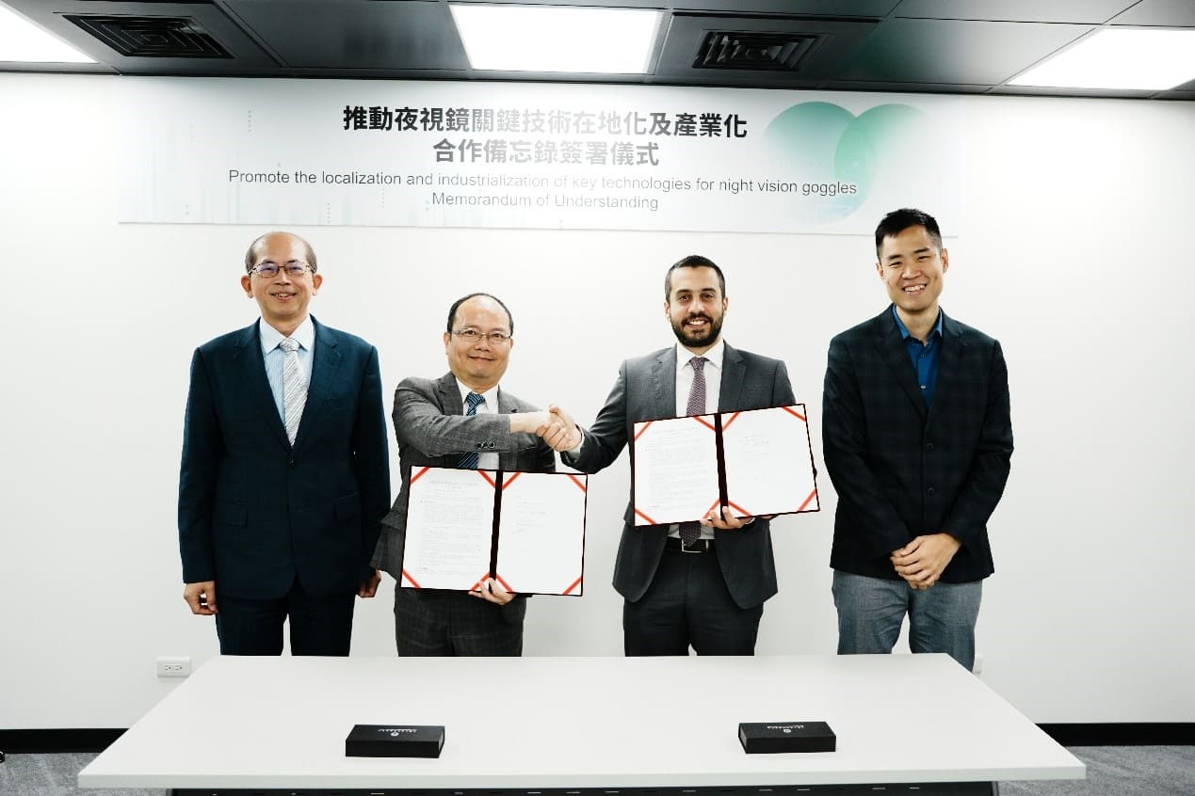

Photo 1. Chen-Hao Chang, Executive Secretary of the OSTP (first from left),
Yung-Hsiang Lai, President of MIRDC (second from left), Dimitris Papageorgiou, Regional Director of Business Development, Theon Sensors S.A. (second from right), and Goh Yang Xuan, Manager at Theon Sensors S.A. (first from right) took a group
photo at signing ceremony of the “Memorandum of Understanding (MOU) for Promoting the Localization and Industrialization of Key Technologies for Night Vision Goggles,”

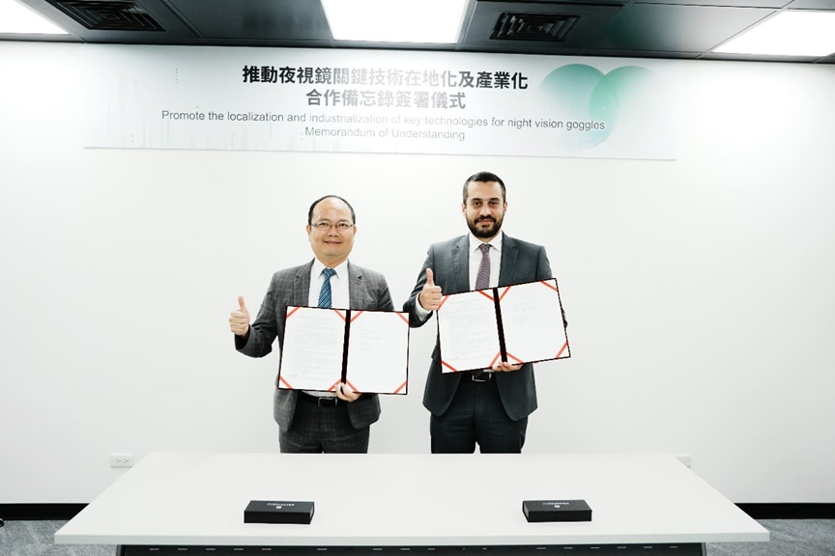

Photo 2. Yung-Hsiang Lai, President of MIRDC (left) and Dimitris Papageorgiou, Regional Director of Business Development, Theon Sensors S.A. (right) at signing ceremony of the “Memorandum of Understanding (MOU) for Promoting the Localization and Industrialization of Key Technologies for Night Vision Goggles.”

