
新聞資料NEWS LETTER
Accelerating Net Zero Transformation! MIRDC Partners with Chunghwa Telecom to Lead Domestic Industries Towards Net Zero Emissions by 2050

In response to the global wave of energy saving and carbon reduction, the government has accelerated the development of green energy. In 2022, the Executive Yuan issued the "Taiwan’s Pathway to Net-Zero Emissions in 2050 Strategy Overview", which is expected to assist the industry's net-zero transition through the model of "supporting major enterprises to lead smaller businesses”, integrating industry associations and supply chain manufacturers, and setting state-owned enterprises as examples. To align with the national energy transition policy, Metal Industries Research & Development Centre (MIRDC) and Chunghwa Telecom signed a "Memorandum of understanding on Promoting Net-Zero Transition Services" at the MIRDC headquarters on April 10. As the "major enterprise" expected to “lead smaller businesses”, Chunghwa Telecom will jointly assist the industry in accelerating net-zero transition and look forward to serving as a model of cross- sector cooperation. Both parties will work together on the testing and verification of green energy products and systems to strengthen domestic industry awareness of net-zero and green energy.

In terms of carbon reduction pathway objectives, Chunghwa Telecom has set a target of 100% renewable energy use in IDC data centers and adopting electric vehicles company-wide by 2030, and full use of renewable energy (RE100) by 2040. In addition, Chunghwa Telecom has become the only telecommunications operator in Taiwan to have made an early commitment to achieve net zero by 2045. As a leading provider of telecommunications services in Taiwan, Chunghwa Telecom has actively expanded its green energy business in recent years, leveraging its physical channels as well as commercial and industrial customer resources to support industries in advancing toward net-zero transition. MIRDC is a non-profit organization recognized by the Bureau of Standards, Metrology and Inspection (BSMI), Ministry of Economic Affairs for voluntary energy storage product certification. It has a track record of testing and verifying many green energy service-related technologies, systems and project sites, as well as renewable energy certificate verification. It is currently assisting in the operation of the newly opened National Center for Energy Storage System Technology under the BSMI located in the Tongluo Science Park in Miaoli, and aims to provide more comprehensive testing technology capabilities.

K.H. Liang, Vice President of Chunghwa Telecom’s Enterprise Customer Division stated that the partnership is an important step in helping Taiwan move towards the country’s net zero goal. Combining Chunghwa Telecom's channel resources with the MIRDC's testing capabilities and expertise, the two organizations are joining forces to lead and accelerate net-zero transition for industries in the future.

Wei-Hung Wu, Vice President of MIRDC stated that the MIRDC’s years of experience in renewable energy, energy storage, net zero and other operations have now combined with the testing capabilities of the National Center for Energy Storage System Technology. This will help Chunghwa Telecom achieve its own carbon reduction goals while enhancing the safety of green energy business development by improving the quality of products, systems and project sites. The current partnership mainly encompasses “raising awareness of net zero and green energy", "integrating net-zero transition capabilities" and "developing markets for green energy applications." It is expected to connect the domestic green energy industry supply chain, expand the renewable energy and energy storage application market, develop customers to establish green energy performance, and contribute to the country's shift towards net-zero emissions targets for 2050.

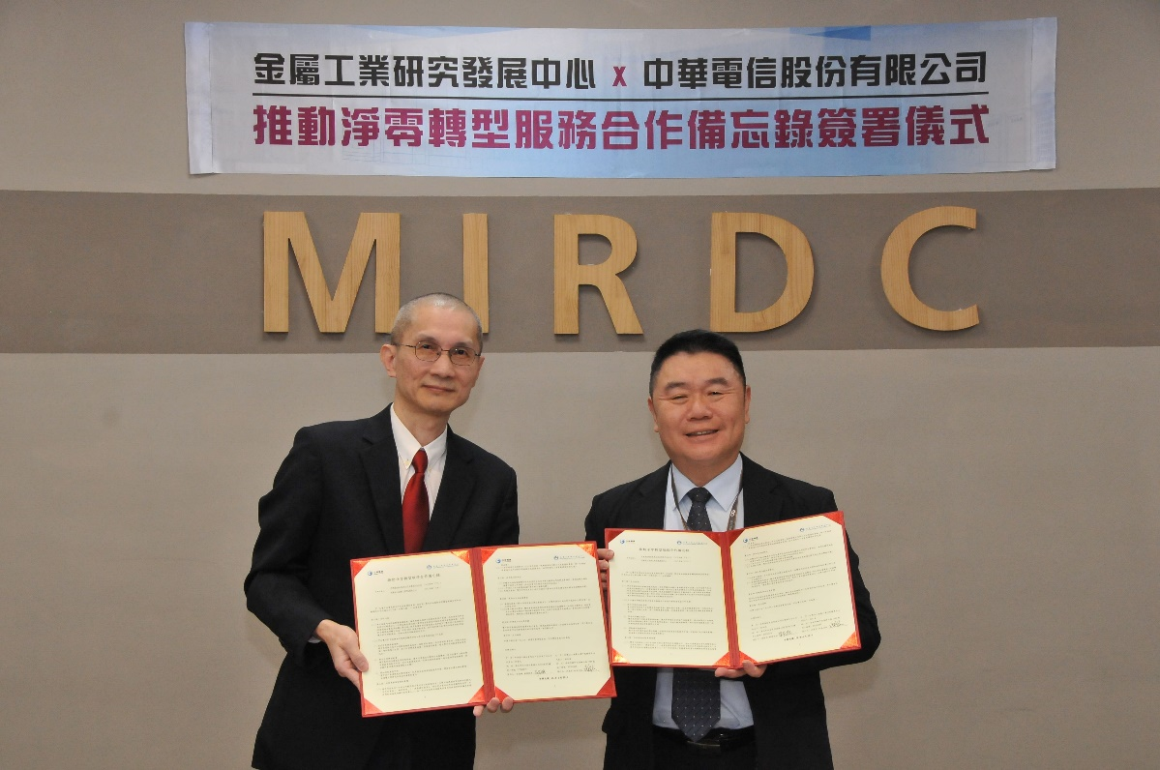

Photo 1. Chunghwa Telecom Enterprise Customer Division Vice President K.H. Liang (left) and MIRDC Vice President Wei-Hung Wu (right) signed a memorandum of understanding on promoting net-zero transition services.

