
新聞資料NEWS LETTER

Leveraging "Green Premium" Seizes New Opportunities of Nickel Industry

Nickel prices have seen violent fluctuations around the world in recent years. Since 2021, average rate of change in nickel prices has varied among 41.6%, -17.9%, and -19.9%, which has significantly affected costs for nickel industry in Taiwan. The nickel industry is still significantly affected by such factors as the interest rate policies of major economies, net-zero emissions trend, and supply and demand imbalances. It is currently in the industrial recovery stage. In that context, MIRDC (Metal Industries Research & Development Centre) held “2024 Symposium on Enhancing Resilience of Nickel Industry” on September 10 in an effort to help the industry get a better grasp of the real-time supply and demand situation and future development trends for nickel. The symposium held exchanges on major issues in Taiwan's nickel metal industry and helped the industry get a handle on new opportunities for industrial upgrading.

Attendees included Taiwan's major manufacturers of stainless steel, special steels, nickel alloys, and battery materials, with a total of 10 senior managers attending. The event opened with MIRDC’s reviewing and sharing industry’s issues of concern, including pricing mechanisms and key indicators affecting nickel prices. The centre also shared the measures taken by Industrial Development Administration, Ministry of Economic Affairs, to promote upgrading and transformation of industries and SMEs, and providing the requisite resources, such as low-carbonization and smartification, which offers benefits to industry players in Taiwan to leverage the "green premium" to make the most of new opportunities in the nickel industry. Stainless steel and nickel alloy operators noted that only a small amount of nickel is used in production for material composition. In view of the severity of recent market conditions and the trend toward net-zero emissions, using scrap steel or scrap materials is far more important than using nickel. Since major manufacturers of electric vehicle (EV) battery materials use high-purity nickel for the main raw material, they are significantly affected by nickel supply and demand and the fluctuations in its price.

Faced with the overall environmental impact on price fluctuations and supply and demand, MIRDC will continue to use this exchange platform on enhancing the resilience of the nickel industry to help industries get a better grasp of price information and real-time supply and demand, thereby promoting the prosperity and development of Taiwan's nickel industry and helping maintain stability in the domestic market.

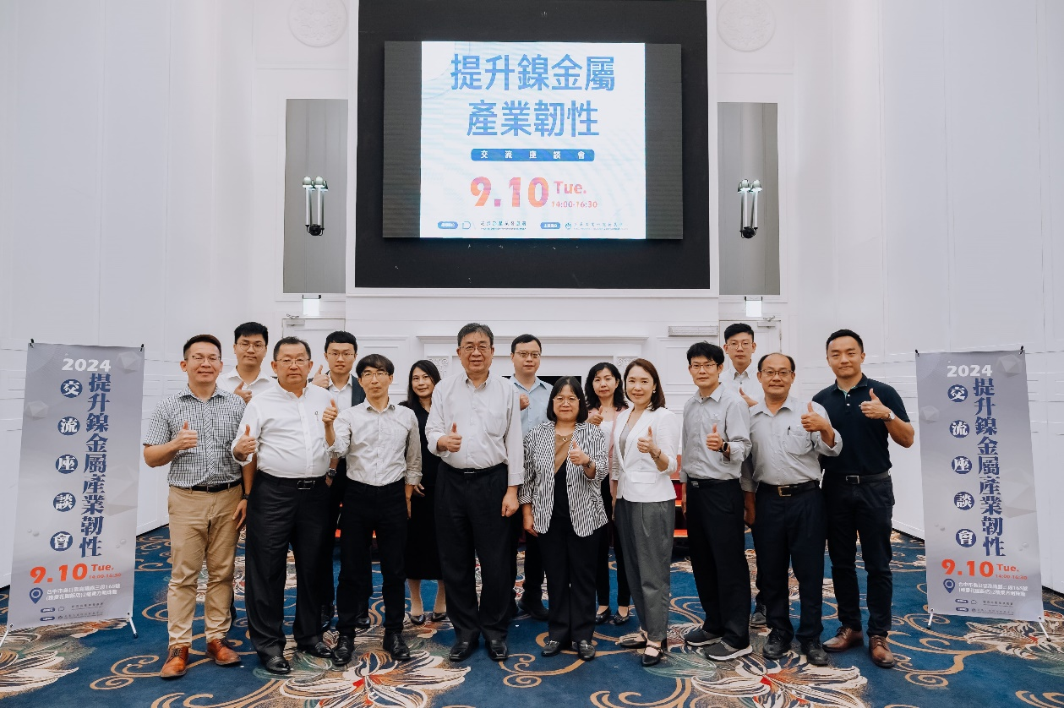
Photo 1. Industry operators in a group photo at 2024 Symposium on Enhancing Resilience of Nickel Industry

