
新聞資料NEWS LETTER

MIRDC Receives Support from Toyo Kenma and SLS. CNC. Machinery to Realize Energy-saving Innovation in Key Heat Treatment Processes!

The precision components market has rapidly expanded following the surge in demand for machinery, electric vehicles, and electronic products. Heat treatment is a key technology in the manufacturing process, but it is a process with high energy consumption and high carbon emissions. Facing this dilemma, effectively shortening processing time, increasing utilization of heat treatment furnace, and reducing energy consumption have become the primary challenges that the industry urgently needs to solve. Metal Industries Research & Development Centre (MIRDC) held “Micro Particle Shot Polish and Vacuum Carburizing Composite Treatment Equipment Donation and Memorandum of Understanding (MOU) Signing Ceremony" on September 13 to help the industry respond to this key issue. The MOU was signed between MIRDC, Toyo Kenma Co., Ltd., (hereafter “TOYO”) and SLS. CNC. Machinery Co., Ltd., the largest distributor of TOYO in Taiwan, to jointly promote energy-saving technology of heat treatment and assist domestic companies with entering international supply chains.

In response to the global trend of energy conservation and carbon reduction, SLS. CNC. Machinery focuses on R&D of Shot Machine A.one Polish (SMAP) technology, and it donated “micro-particle shot polish and vacuum carburizing composite treatment equipment” to MIRDC together with its business partner, TOYO. It looks forward to working with MIRDC and ECM Group from France in promoting applications of micro-particle shot polish technology. The technology introduces a shot polish process before heat treatment, effectively improving carburizing ability and significantly shortening the time of carburizing heat treatment for energy conservation and carbon reduction. In addition, the three parties will also conduct in-depth research on how micro-particle shot polish technology can improve the deformation of workpieces before and after heat treatment to further optimize process quality.

In addition, Taiwan's first "Asia-Pacific Vacuum Heat Treatment Synergy Center" is jointly established with ECM Group from France, and it will act as a trial and demonstration site, where it will test the improvement in vacuum carburizing ability, and also introduce SMAP technology into the domestic industry. In the future, the three parties will focus on developing micro-particle shot polish technology for the surface of thin gears in reducers, shortening the vacuum carburizing process time, reducing energy consumption by about 10%, and increasing energy saving rate by more than 5%. This technology is expected to be further applied in robotics industry and electric vehicle industry. The companies will partner with Sha Yang Ye Industrial Co., Ltd. and Hota Industrial Mfg. Co., Ltd. to enter the supply chain of major manufacturers, such as Tesla, Porsche, and GE, and they will overcome the challenges of heat treatment deformation and energy conservation, and which is expected to bring in purchase orders exceeding NT$300 million.

Ren-Yi Lin, Chairman of MIRDC, said that this cooperation is based on energy-saving technology of heat treatment. The development of product processes through simulation of carburizing process not only shortens product verification time, but also brings local R&D and manufacturing of heat treatment technology to a new level. Going forward, MIRDC will actively promote the application of this technology for energy saving in high-precision manufacturing, such as electric vehicles and semiconductors, helping the industry seize market opportunities while creating growth momentum and new business opportunities.
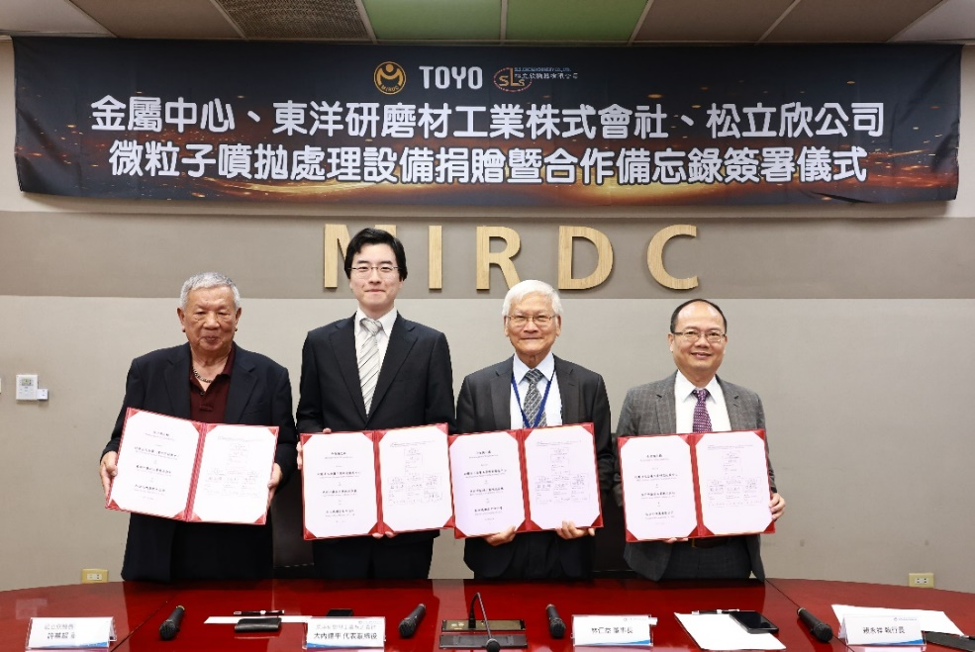
Photo 1. Photo at the signing ceremony. From the left: Chi-Chao Hsu, Chairman of SLS. CNC. Machinery, Tappei Ouchi, Representative Director of TOYO, Ren-Yi Lin, Chairman of MIRDC, and Yung-Hsiang Lai, President of MIRDC.

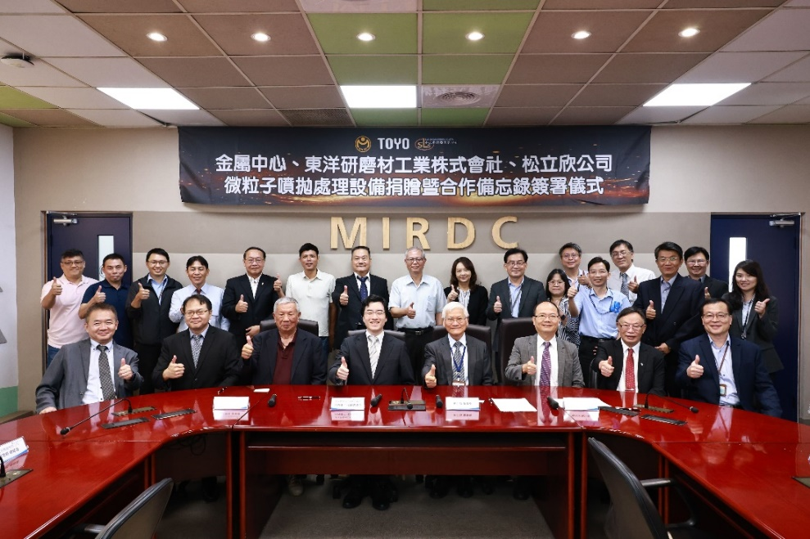
Photo 2. Group photo at the equipment donation and MOU signing ceremony. From the left in the front row: Yung-Sheng Sun, President of Nanolub, Che-Ming Hsu, President of SLS. CNC. Machinery, Chi-Chao Hsu, Chairman of SLS. CNC. Machinery, Tappei Ouchi, Representative Director of TOYO, Ren-Yi Lin, Chairman of MIRDC, Yung-Hsiang Lai, President of MIRDC, F.C. Tsai, Chairman of Sha Yang Ye Industrial Co., Ltd., and Lei-Chuan Lin, Vice President of MIRDC.

