
新聞資料NEWS LETTER
Ørsted’s Offshore Wind Industrial Development Fund will be contributing nurturing talent, technology, and profit to the Taiwan's offshore wind power industry

Ørsted and Metal Industries Research & Development Centre (MIRDC) announced on the 19th of October 2022 that the results of the Ørsted’s Offshore Wind Industrial Development Fund which provided resources and knowledge-sharing to help enhance local sub-suppliers technological capabilities, close the skills gap and nurture talent to sustain the healthy development of offshore wind supply chain in Taiwan.

The gathering invited the representatives of the three companies that received Ørsted’s Offshore Wind Industrial Development Fund to share their stories. Tai-Shing Engineering and Construction Co., Ltd., representing the localization of technology, has accelerated the research and development of remote-controlled welding technology. The help of this fund has improved the quality and the production capacity. Wei Sheng Machinery & Electric Co., Ltd, represented the subsidized company in the training of high-level welding personnel and is committed to building a local high-level welding brand. By receiving the fund and obtaining the first related job in offshore wind power. Ho Lung Power Engineering, which has the highest market share of ultra-high voltage power engineering in China, has nearly 60 employees who completed the GWO offshore wind power basic safety training certification. With the support of Ørsted's Offshore Wind Industrial Development Fund, they will continue to expand the number of wind power talents and strengthen the construction team to cope with wind power projects in the next few years. Nine local Taiwanese companies showed their intentions to invest in the offshore wind power industry during the implementation of the Ørsted's Offshore Wind Industrial Development Fund. With the grants provided for the R&D projects, 82 technicians received advanced welding training, and 108 trainees received international wind energy organizations (Global Wind Organization, GWO) basic safety training for offshore wind power.

The chairman of the board of Ørsted Taiwan, Hsin Chieh Wang, stated that potential Taiwanese manufacturers would use this fund to strengthen their strengths to have the ability to serve the southeast and southwest of Changhua. It is the first stage of offshore wind farms. Meanwhile it can also provide services in other wind farms to help local manufacturers and contractors realize more potential. What Ørsted Taiwan has done is just the beginning, and we hope that the Taiwan government and related industries can work together to build an offshore wind power industry chain through cooperation and cooperation in the future.

The deputy director of MIRDC, Wei Te Chen, pointed out that Taiwanese manufacturers have the strength and their technologies and skills are above a certain level. Ørsted's Offshore Wind Industrial Development Fund helps the Taiwan local suppliers to improve their manufacturing capabilities in facing production challenges and cultivate relevant talents. It can also strengthen the local supply chain capacity and develop Taiwan's offshore wind power supply chain.

Offshore wind power is already indispensable to Taiwan’s energy transition. Ørsted’s Offshore Wind Industrial Development Fund is the company’s contribution to localized development, helping Taiwan companies to obtain business opportunities with the company’s global experience. In the future, it will form a positive cycle, continue to expand the base of manufacturers in Taiwan's supply chain, and work together to advance the business opportunity of 25 years of operation and maintenance.
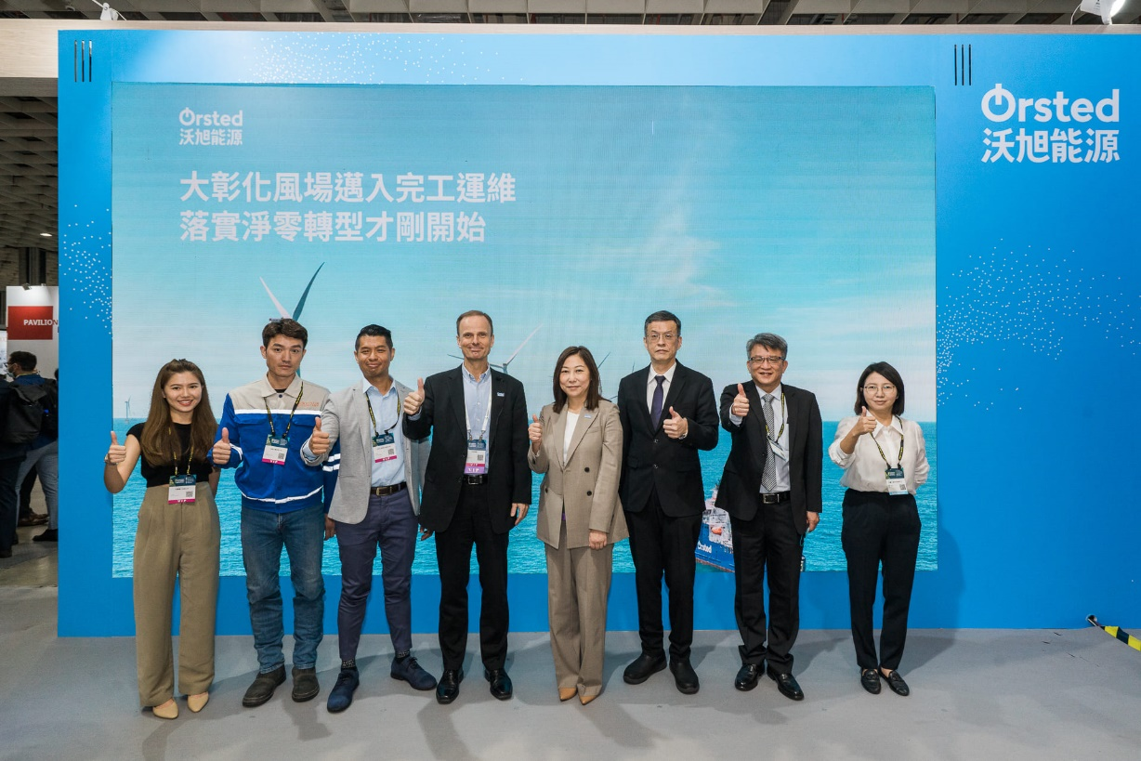

Fig1, a group photo of the honorable guests (from the left to the right included Yi Nien Chen from Ho Lung Power Engineering, Cheng Wei Huang from Wei Sheng Machinery & Electric Co., Chia Chen Wu from Tai-Shing Engineering and Construction Co., Ltd., Per Mejnert Kristensen from Ørsted Asia Pacific, Hsin Chieh Wang from Ørsted Taiwan, and Wei Te Chen and Ya Hui Yu from MIRDC.

