NEWS LETTER

The World’s First
Smart Orthopedic Surgery Aid System - Real-time Positioning Surgery Aid
Receives Dual Recognition from R&D100 and Red Dot

The Metal Industries Research & Development Centre (MIRDC) developed the world’s first “smart orthopedic surgery aid system - real-time positioning surgery aid” with the support of the technology development program of the Department of Industrial Technology, Ministry of Economic Affairs. The system has won the 2022 R&D 100 and German Red Dot awards. The optical 3D complex positioning integrated with the multi-vertebrae image-guided navigation system and surgical robotic arm overcomes deficiencies of the current systems, such as how navigation software regarded visual models as continuous rigid bodies in the past. It is capable of automatic spine segmentation, multiple point position estimation, and image-to-physical image registration with up to 94% accuracy. This effectively reduces surgery time for physicians and delivers enhanced medical quality to patients. It can improve existing surgical systems in clinical settings and solve the problems of obstruction and poor accuracy caused by the excessive size of the positioning target.

As the global population continues to age, the demand for orthopedic medical devices is growing year over year. By 2025, the global orthopedic medical device market is expected to reach a value of US$58.08 billion. Among the devices, the growth for spinal surgery navigation systems and surgical robots is increasing the fastest, and the market is expected to reach US$13.38 billion in 2025. The safety and efficacy of the “smart orthopedic surgery aid system - real-time positioning surgery aid” developed by the MIRDC have been verified through clinical trials on cadavers. The system is about to apply for US FDA510K and Taiwan TFDA licenses, and is expected to be launched in the near future. Its competitive price advantage helps professionals in Taiwan to develop and use this system.

Furthermore, the development of the “smart orthopedic surgery aid system - real-time positioning surgery aid” is not only focused on R&D but also combines technology with aesthetics and the design is user-oriented. The ergonomic interface integration has been enhanced to fulfill operability by the doctor and comply with spatial limitations. It can dynamically track more than three vertebrae and position each vertebrae independently, providing the doctor with real-time information related to the actual condition of the spine. In clinical surgeries, the system can provide more precise, safer, and more efficient multi-vertebrae spinal surgery. In the future, the system will be expanded to cover trauma recovery, the pelvic cavity, the brain and other indications. Moreover, through cooperation with large medical device companies, medical institutions, and academic and research institutions, the MIRDC will continue to offer diverse smart medical solutions to enhance the international competitiveness of Taiwan’s high-end medical devices.

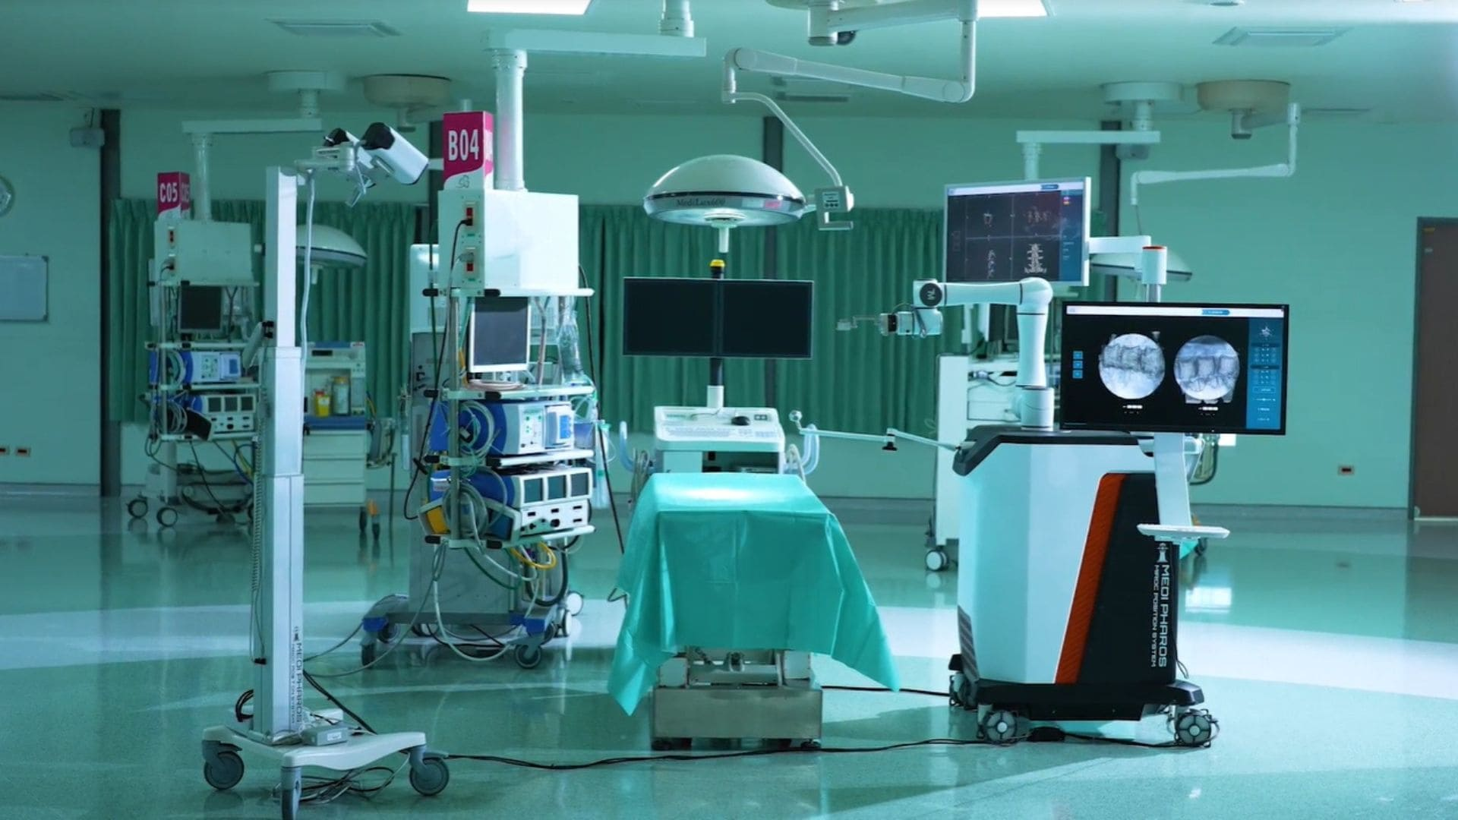
Caption: With the support of the technology development program of the Department of Industrial Technology, MOEA, the MIRDC developed the “smart orthopedic surgery aid system - real-time positioning surgery aid” to provide precise positioning for complex spinal surgeries.

