新聞資料NEWS LETTER

MIRDC Introduces Intelligent Self-Preheating and Indirect Heating System to Wire Coil Spheroidizing Annealing Furnaces to Support Net-Zero in Metal Processing

Amid global efforts to attain net-zero, Taiwan’s metal processing industry faces the dual challenges of energy transition and international competition. To help companies boost energy efficiency and reduce carbon emissions, the Metal Industries Research & Development Centre (MIRDC) successfully implemented its intelligent self-preheating and indirect heating system this year at the demonstration site, San Shing Fastech’s wire coil spheroidizing annealing furnace, with the support of the Energy Administration, Ministry of Economic Affairs, creating an innovative model for energy saving and carbon reduction in medium-to-high temperature processes. A technical briefing and sharing session was also held on December 18 to showcase the retrofit results of the wire coil spheroidizing annealing furnace at San Shing Fastech, along with energy-saving and carbon-reduction case studies. The event specially invited Zhong-Chun Wu, Chairman of the Taiwan Society for Metal Heat Treatment, as a guide, alongside industry, academia, and research representatives to explore the latest progress in self-preheating combustion systems and radial pipe applications for indirect heating to promote technology dissemination and supply-chain connections.

This project integrates several core technologies, including a high-power staged combustion self-preheating burner paired with a large double-P-type radial pipe and staggered fin heat exchanger, achieving a heat exchange efficiency of ≥65%. Simultaneously, design combining low-NOx staged nozzles and an ejector keeps nitrogen oxide emissions <150 ppm, ensuring environmental performance and combustion stability. In terms of control strategy, a dual-drive adaptive control technology for self-preheating indirect heating is introduced. Combined with an AI-based intelligent burner-operating-principle and monitoring and diagnostic system, it delivers an additional 3% energy savings while maintaining equipment health. Overall, the system achieves up to 20% savings in natural gas and 10% reduction in fan electricity consumption, significantly improving energy efficiency, helping companies lower energy costs and reduce carbon emissions, and creating higher added value for metal processing.

Yung-Hsiang Lai, President of MIRDC, stated that these self-preheating energy-saving technologies are globally recognized by the R&D 100 Awards and demonstrate MIRDC’s outstanding achievements in promoting high-efficiency energy-saving and low-carbon technologies. He emphasized that under the leadership of Hun-Yu Lin, Director of MIRDC’s Industrial Upgrading Service Department, MIRDC will continue to integrate innovative technologies with industry demand, deepen cooperation and demonstration applications with domestic manufacturers, and accelerate the metal processing industry to move toward high-efficiency, low-carbon, and high-value-added green manufacturing, thereby enhancing competitiveness and aligning with global net-zero trends.
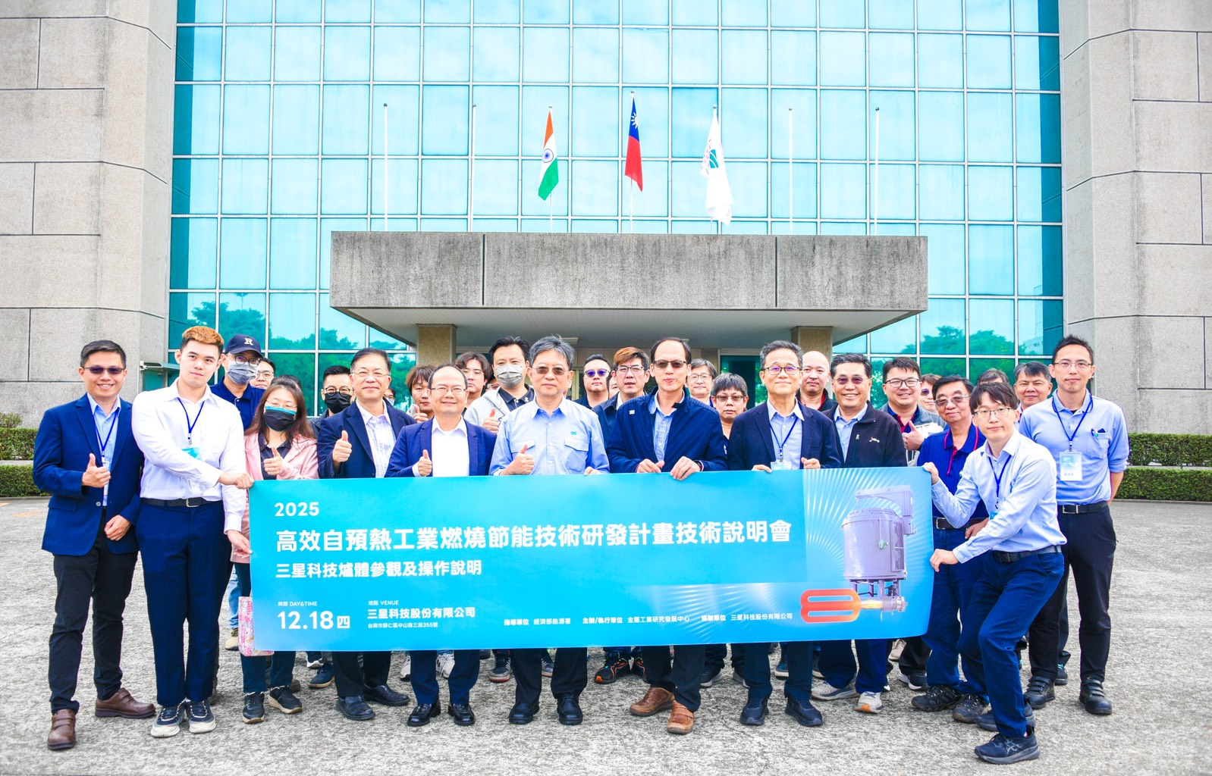
Photo: MIRDC organized a technical briefing session for the R&D project on high-efficiency self-preheating industrial combustion energy-saving technologies. Front row, starting fourth from left: Zhong-Chun Wu, Chairman of the Taiwan Society for Metal Heat Treatment; Yung-Hsiang Lai, President of MIRDC; Hsin-Chih Chen, President of San Shing Fastech Corp.; Tien-Kuei Su, Vice President of San Shing Fastech Corp.; and Hun-Yu Lin, MIRDC’s Director of Industrial Upgrading Service Department.

