
新聞資料NEWS LETTER
MIRDC Collaborates with Toyo Kenmazai, SLS. CNC. Machinery, and Sha Yang Ye to Develop Taiwan’s Green Heat Treatment Capabilities

Taiwan's precision machinery components play a key role in the global supply chain with their high quality and high precision. As Taiwan works towards the goal of net zero emissions by 2050, improving the energy efficiency of key processes, such as heat treatment, has become a top priority for the precision machinery industry to enhance its green competitiveness. Metal Industries Research & Development Centre (MIRDC) signed a memorandum of understanding (MOU) with Toyo Kenmazai Kogyo Co., Ltd. (TOYO) and Taiwan’s leading small gear manufacturer, Sha Yang Ye Industrial Co., Ltd. on August 19, 2025, once again teaming up with partners in Taiwan and Japan. MIRDC also received a new Shot Machine A.one Polish (SMAP) equipment that can handle larger workpieces, the second machine donated by SLS. CNC. Machinery Co., Ltd., TOYO's distributor in Taiwan. The introduction of forward-looking and energy-saving technologies and building local capacity will accelerate the development of Taiwan’s precision machinery industry towards higher value and low carbon emission.

The event began with the signing of an MOU by Chairman Chia-Ju Liu on behalf of the MIRDC with TOYO and Sha Yang Ye Industrial Co., Ltd., witnessed by Hsiang-Wei Ho, Section Chief of the Department of Industrial Technology, Ministry of Economic Affairs. President Yung-Hsiang Lai then accepted the SMAP equipment donated by SLS. CNC. Machinery Co., Ltd. on behalf of MIRDC, witnessed by Chairman Liu. The signing of the MOU and the donation of equipment both show that MIRDC is actively engaging in international cooperation. The cooperation with partners in Taiwan and Japan shows added-value of collaborative development of technologies and applications, and an integrated R&D site in Taiwan that connects materials, equipment, and end applications will significantly shorten the R&D and testing schedule, deeply rooting key capabilities of green manufacturing in Taiwan.

President Yung-Hsiang Lai stated that the application of SMAP will establish a complete process from pre-treatment, heat treatment, to simulation testing. MIRDC integrates equipment introduction, process testing, and application demonstrations. Using the high-end medical device “retinal recognition instrument module” as an example, the dimensional stability and surface quality of the module's transmission structure are crucial to accurate determination. Therefore, the introduction of SMAP pre-treatment before heat treatment can enhance carburizing diffusion efficiency, shorten vacuum carburizing time, reduce surface roughness, and increase workpiece surface hardness. This is expected to increase the service life of key components, such as sliders, by approximately 20%. In addition, carrier feasibility and field testing have been completed.

The European Union's implementation of the Carbon Border Adjustment Mechanism (CBAM) has changed the rules of the global supply chain. Green transformation is no longer optional, but a necessary action for the sustainability of industries. Going forward, MIRDC will build on this foundation and expand the application of energy-saving technologies into high-value industries, such as electric vehicles, semiconductor equipment, and advanced medical devices. This will help industries in Taiwan steadily connect to the global green supply chain, seize opportunities, and generate momentum for a new wave of growth.

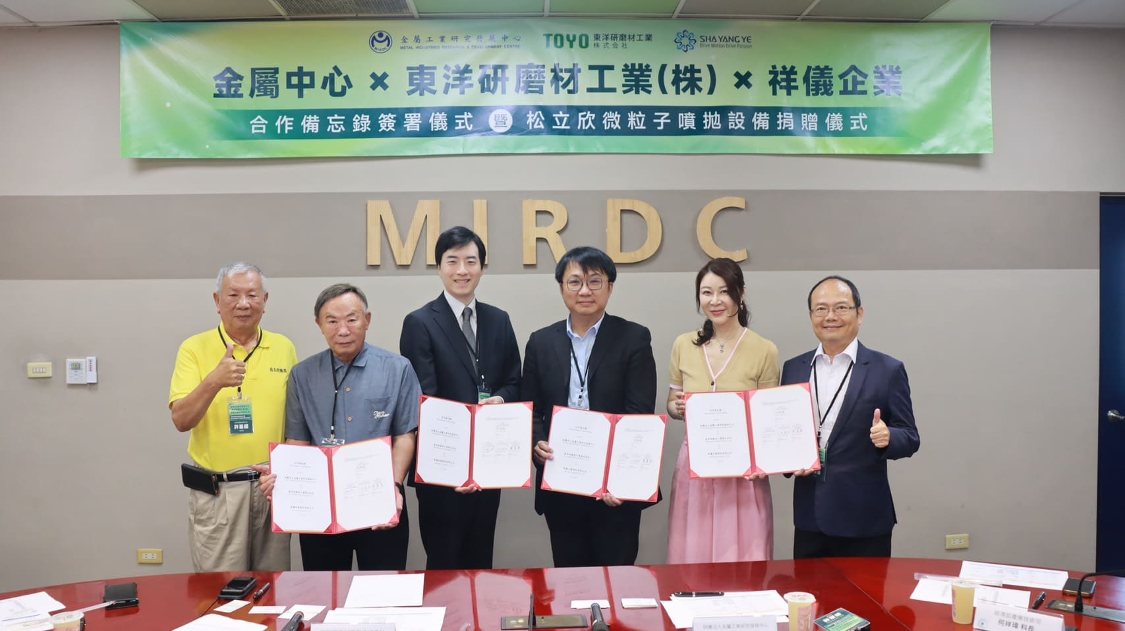

Photo 1. Group photo of distinguished guests at the MOU signing (From the left: Chi-Chao Hsu, Chairman of SLS. CNC. Machinery Co., Ltd., F.C. Tsai, Chairman of Sha Yang Ye Industrial Co., Ltd., Tappei Ouchi, Representative Director of TOYO, Hsiang-Wei Ho, Section Chief of the Department of Industrial Technology, Ministry of Economic Affairs, Chia-Ju Liu, Chairman of MIRDC, and Yung-Hsiang Lai, President of MIRDC)

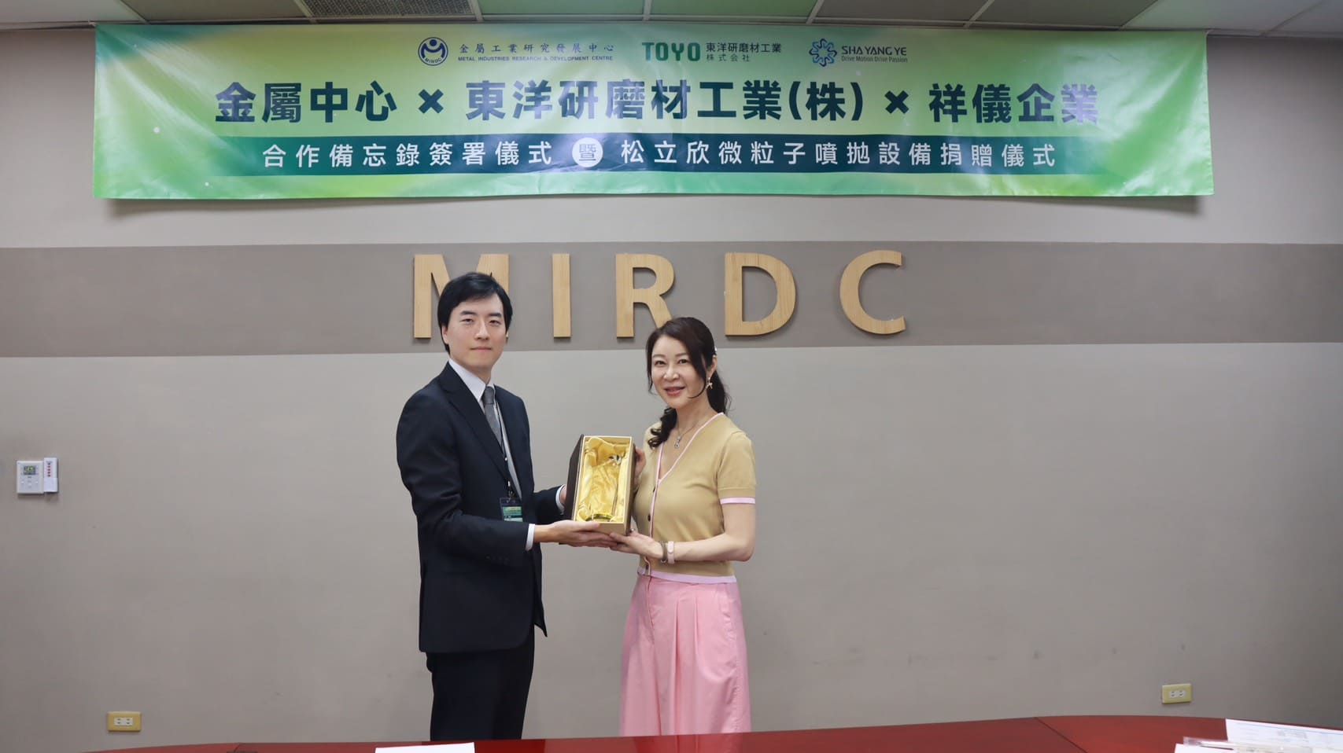

Photo 2. Gifts exchanged between the two parties - Tappei Ouchi, Representative Director of TOYO (left) and Chia-Ju Liu, Chairman of MIRDC (right)

