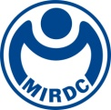
新聞資料NEWS LETTER

MIRDC Works Together with International Experts to Lead the Mold & Die Industry Towards a New Era of Carbon Reduction and Smart Manufacturing

The mold & die industry is a base industry indispensable to the manufacturing industry, and has long played a core role in the mass production and precision processing of products. The global industry has been facing the dual challenges of low-carbon sustainability and smart manufacturing in recent years. Achieving energy conservation and carbon reduction while going through digital transformation has become an inevitable trend in the development of mold & die technology. The Department of Industrial Technology, Ministry of Economic Affairs specially commissioned the Metal Industries Research & Development Centre (MIRDC) to help Taiwan's mold & die industry face these challenges and enhance its international competitiveness, with Principal Investigator Chorng-Tyan Lin leading a team to implement the “Carbon Reduction and Key Technology Development Project for Mold & Die Industry Chain.” MIRDC and Taiwan Mold & Die Industry Association co-organized the “Seminar on Key Technologies of Carbon Reduction and Digital Transformation for Advanced Mold & Die,” on August 22, 2025, and widely invited industry, government, academia, and research institutes to participate, during which they enthusiastically engaged in exchanges.

The seminar brought together domestic and foreign mold & die experts, as well as Japan’s industry representatives, focusing on “Outlook and Proposal for the Future of Press Processing,” “High-Turnover-Rate Smart Mold Optimization Technology,” “Case Study on Realizing Mold & Die Smart Manufacturing and Digital Transformation,” and “Energy-saving and Waste-reducing Advanced Mold Manufacturing Technology.” The keynote speeches and case studies gave a complete picture of the mold & die industry’s forward-looking strategies when facing requirements on low carbon and AI, and provided Taiwan’s industry with insights on the latest technologies and application directions.

Dr. Ryuichi Hattori from Yamada Dobby Co., Ltd. was specially invited from Japan to be the guest speaker at the seminar. Yamada Dobby is a global leader in stamping equipment, and is committed to providing smart manufacturing solutions for achieving zero defects, energy conservation, and carbon reduction. Dr. Ryuichi Hattori has long led the design and R&D team at Yamada Dobby, and has been invited to speak at numerous international conferences. At the seminar, he shared the “Outlook and Proposal for the Future of Press Processing,” covering high-precision servo stamping applications, low-energy consumption methods, and integration strategies for smart production lines. His presentation was praised by the experts and industry representatives in attendance. Dr. Hattori stressed that the future mold & die technologies will focus on not only increase of production efficiency but also environmental sustainability, achieving a win-win situation of reducing carbon emissions and enhancing industrial competitiveness through smart manufacturing.

Yung-Hsiang Lai, President of MIRDC, said that Dr. Hattori's speech not only provided a global perspective, but also deepened the exchange and cooperation between Taiwan and Japan in mold & die technology. In-depth interactions with a leading multinational company will help Taiwan's mold & die industry grasp global trends more quickly, and apply the technologies they learn to upgrade local industries. At the same time, this international exchange created international cooperation opportunities for Taiwanese companies, and expanded new business opportunities in the global market. The project focuses on “driving carbon reduction in industries through technological innovation” and “guiding digital transformation through smart manufacturing.” In the future, MIRDC will continue to work with industry chain partners in developing efficient, low-carbon, and smart mold & die manufacturing processes, and will also help companies apply results in actual production lines, developing an internationally competitive mold & die industry with sustainability values. MIRDC continues to engage in R&D and international cooperation in hopes of leading Taiwan's mold & die industry onto the international stage and become an industry that attaches importance to both sustainability and innovation.
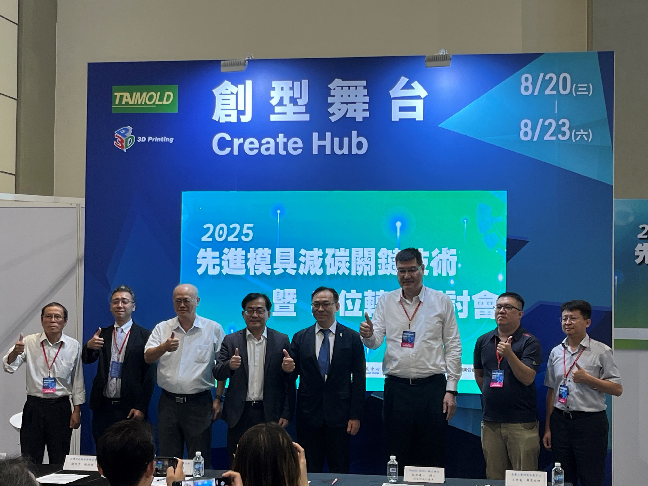
Photo 1. MIRDC partners with domestic and foreign mold experts and Japan’s industry representatives to lead the mold & die industry towards a new era of carbon reduction and smart manufacturing (from the left on the front row: Jack Y. C. Lin, Consultant of MIRDC, Dr. Ryuichi Hattori, Yamada Dobby Co., Ltd., Chi-Ming Hong, Project Manager of MIRDC, Chorng-Tyan Lin, Director of MIRDC, Ho-Ming Chang, Director of Taiwan Mold & Die Industry Association, Shang-Heng Hsieh, General Manager of CIMFORCE International Limited, Shung-Ping Wang, Manager of MIRDC, Fu-Chuan Hsu, Section Chief of MIRDC)

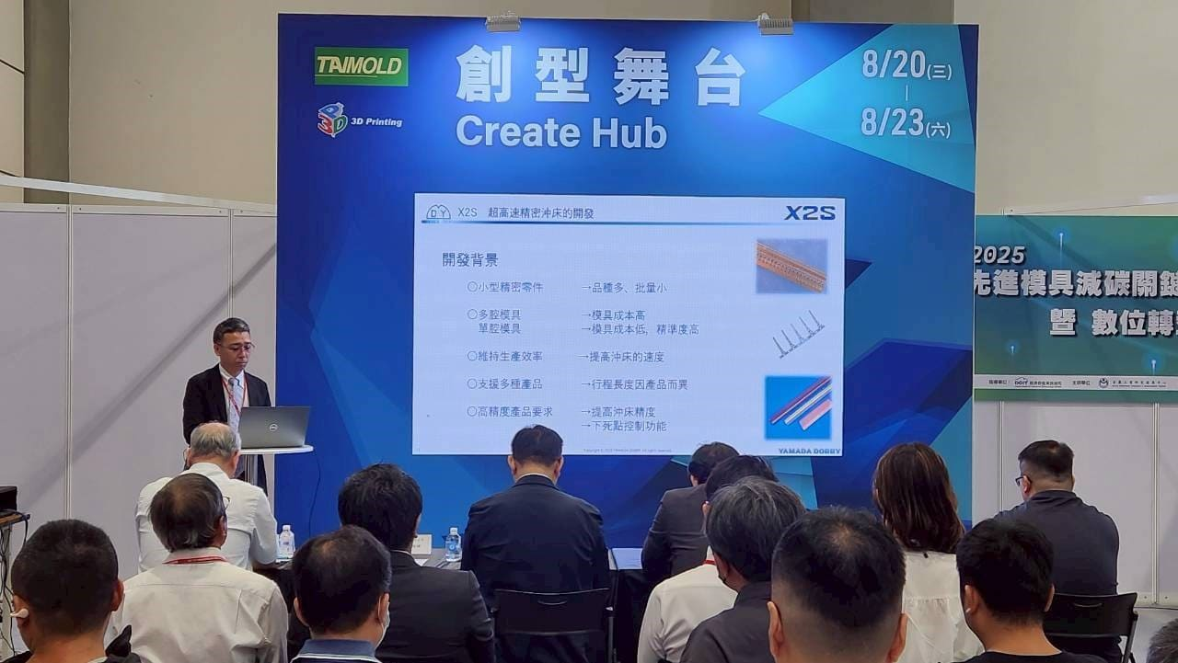
Photo 2. Director Chorng-Tyan Lin of MIRDC giving presentation on “Introduction to International Trends and the Current Situation of the Mold & Die Industry”

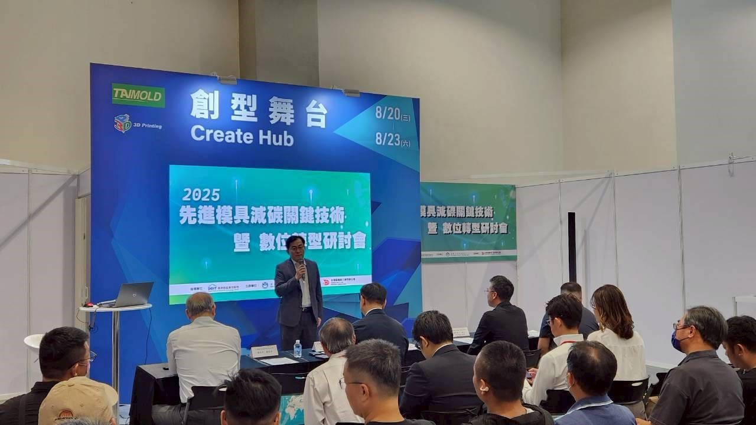
Photo 3. Dr. Ryuichi Hattori of Yamada Dobby giving presentation on "Outlook and Proposal for the Future of Press Processing"

