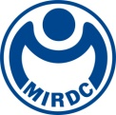
新聞資料NEWS LETTER
MIRDC Organizes Hydrogen Energy Seminar with International Partners

The Metal Industries Research and Development Centre (MIRDC) held the Seminar on Hydrogen Energy Industrial Application and International Cooperation in the Traditional Industries Innovation Centre in Kaohsiung on September 2nd under the guidance of the Department of Industrial Technology (DOIT), Ministry of Economic Affairs (MOEA).

The event focused on high-pressure transmission and storage, as well as the industrial combustion and safety applications of mixed/pure hydrogen. Two senior experts from the Centre Technique Des Industries Mécaniques (CETIM), an international partner of the project, were invited to Taiwan to share the insights on “High-pressure Hydrogen Material Applications and Service Life Analysis” and “Pressure Vessel and Storage Tank Design and Manufacturing.” CETIM is a leading European institution for mechanical and materials technology and a key player in driving hydrogen technology innovation in France. The exchanges provided insights into international experience related to the hydrogen embrittlement and safety applications of materials. Representatives from the Dutch company Bronkhorst also introduced the “Valve Modularization and Precision Control Technology” developed in collaboration with the MIRDC. Bronkhorst is Europe's largest flow control equipment manufacturer and possesses precision control capabilities for industrial applications of hydrogen. The collaboration was a step forward in cross-border technology collaboration that brings local industries in line with current practices and accelerates real world application of hydrogen energy technologies.

Hsiang-Wei Ho, Section Chief at the DOIT, emphasized that hydrogen energy has become an important energy source for the world’s transition to net zero emissions. In recent years, the DOIT has actively promoted the R&D of key hydrogen energy technologies, and is gradually building a domestic supply chain. Partnering with research institutions, industries, and international organizations will not only enhance Taiwan's technological capabilities in hydrogen energy, but also accelerate industrial application and reduce transition costs, thereby enhancing international competitiveness.

Chun-Chieh Wang, Vice President of the MIRDC, noted that hydrogen energy is crucial to carbon reduction in high-carbon emission industries. MIRDC has successfully developed several proprietary core technologies, such as high-pressure transmission and storage and mixed/pure hydrogen combustion, and has collaborated with international partners (such as Bronkhorst, CETIM, and Canada's Powertech Labs) to introduce modular valves, high-pressure transmission and storage, and safety testing technologies, thereby enhancing industrial application capabilities. Hun-Yu Lin, Director of the Industrial Upgrading Service Department of the MIRDC, added that the key technological outputs of the project include a 300-bar high-pressure hydrogen storage tank system and an integrated industrial furnace system with a 0-100% hydrogen burner. All these technologies comply with international standards and lay the foundation for future industrial applications. More than 100 people participated in the seminar, showing the achievements of cross-border collaboration and linking together the industry chain. In the future, the MIRDC will continue to make technological advancements and develop their applications, working together with industry, academia and research institutes to move towards the vision of net zero emissions by 2050.

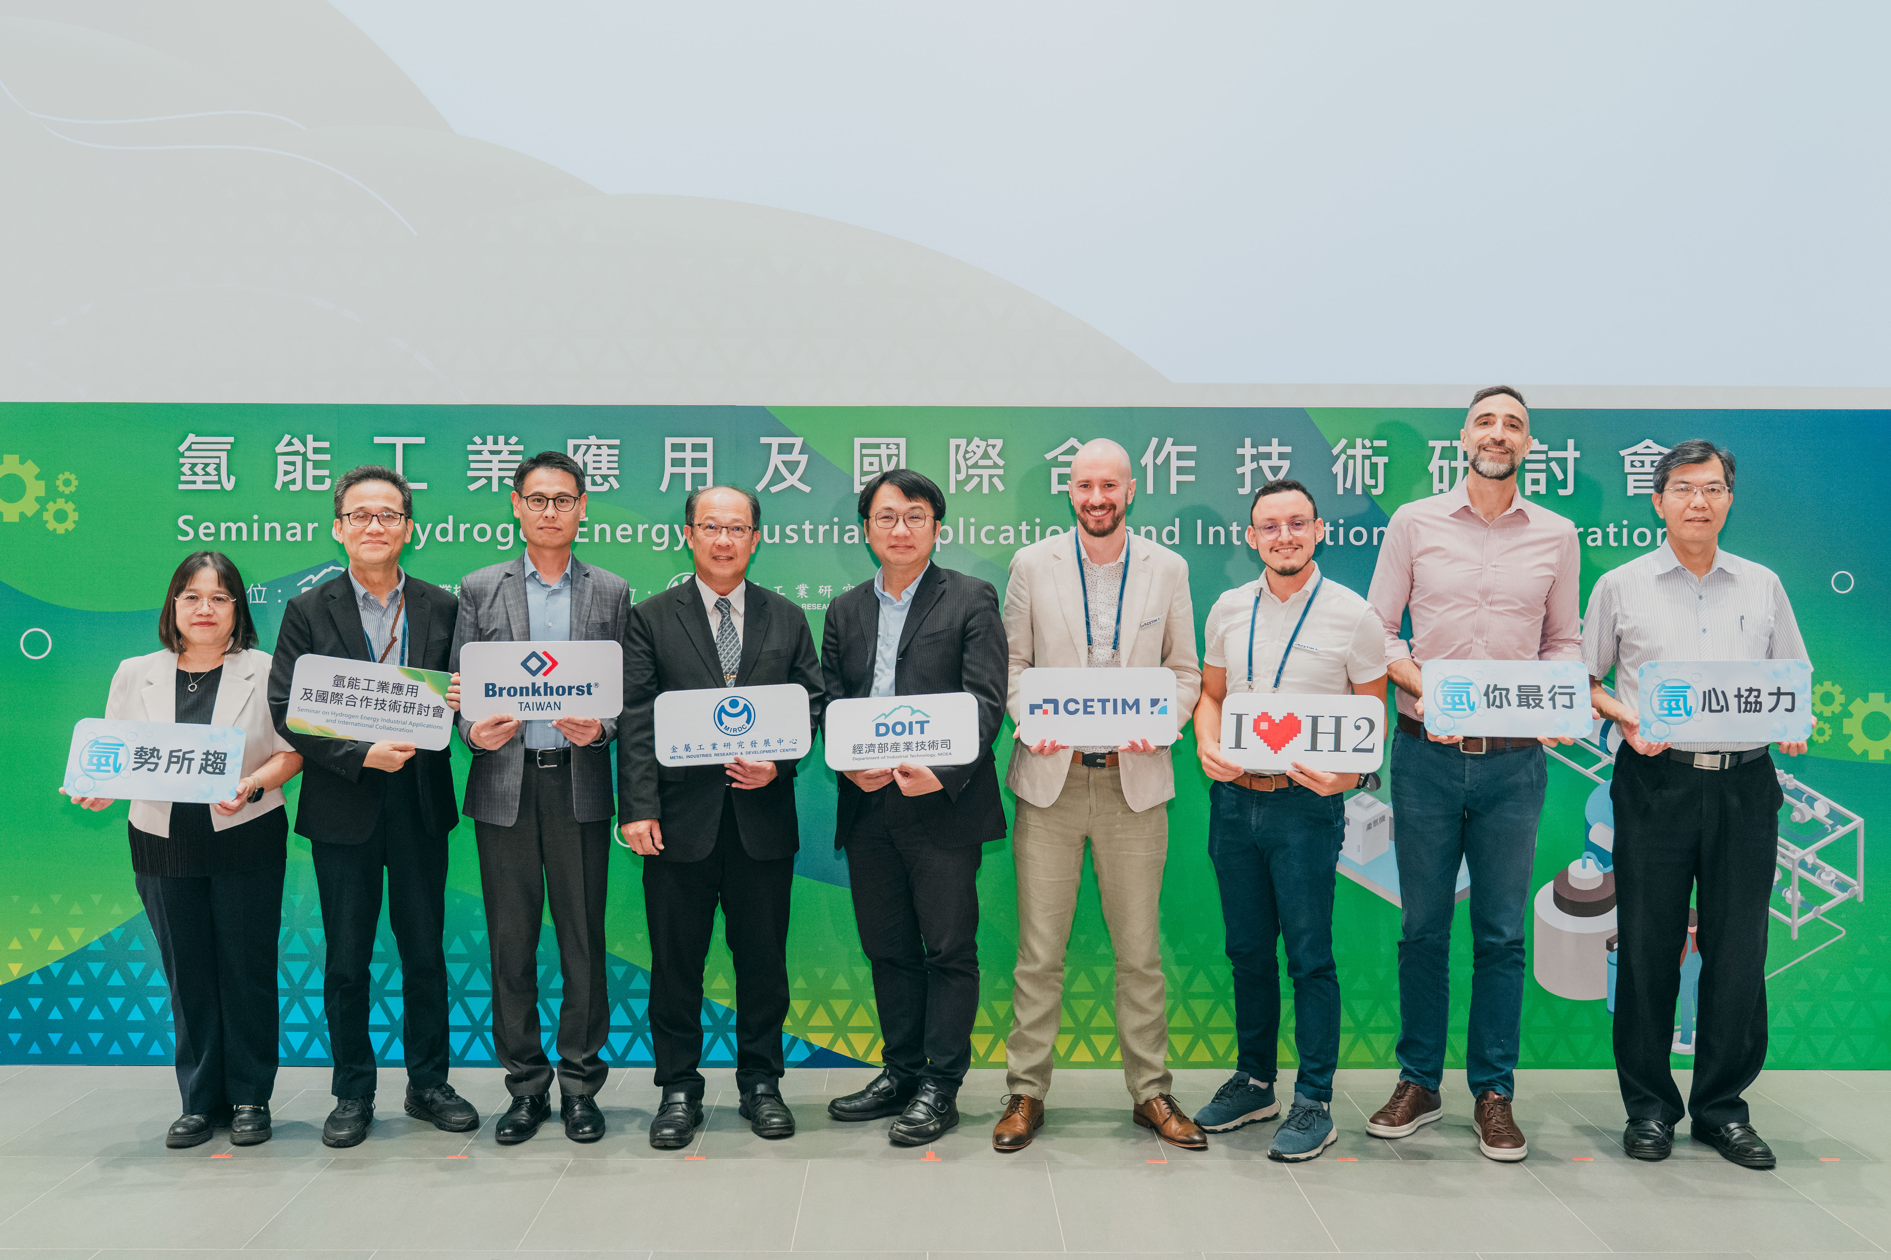

Photo 1. Seminar on Hydrogen Energy Organized by the MIRDC with International Partners (from left to right: Director Yueh-Hsiu Lee of the Planning and Promotion Department of the MIRDC, Director Hun-Yu Lin of the Industrial Upgrading Service Department, President Po-Yang Huang of Bronkhorst Taiwan Co., Ltd., Vice President Chun-Chieh Wang of the MIRDC, Section Chief Hsiang-Wei Ho of the DOIT, Senior Expert Philippe ROHART Cetim, R&D Project Manager Ayoub EL MOUTAOUAKKIL Cetim, Thibaud Brunel TB Solutions, and Director Ping-Kuo Cheng of the Metal Processing R&D Department)

