
新聞資料NEWS LETTER
Taiwan's First ADI Pilot Production Platform Launches New Strategy for High-end Manufacturing

The casting industry's requirements for material performance has become increasingly higher to meet the requirements of precision mechanical components for high precision, high rigidity, and light weight. Traditionally, heat treatment was generally used to strengthen the mechanical properties of cast iron. As the world moves towards net-zero emissions, product development must take into account both process energy consumption and material substitution. Austempered Ductile Iron (ADI) is made using a special heat treatment process that gives both high strength and high toughness to spheroidal graphite cast iron, and which is known as "upgraded version of cast iron." Its average energy consumption is only 30 MJ/kg. Compared with copper, aluminum, and alloy steel, it provides significant carbon reduction benefits and is a low-carbon metal materials that has attracted widespread attention around the world.

The Metal Industries Research & Development Centre (MIRDC) established Taiwan's first "Trial Production Platform of Austempered Ductile Iron" with four innovative designs, including a high-temperature heating furnace, a salt bath furnace, a cleaning machine, and an AI image recognition module, to comprehensively optimize the heat treatment and AI inspection processes. The equipment is able to accurately control furnace temperature within ±6°C and has a maximum processing capacity of 600 kg. The monitoring system monitors the temperature distribution in the furnace in real time, and ensures stable treatment quality by adjusting process parameters through the feedback mechanism. The platform is designed with a bridge mechanism that is able to quickly transfer materials from the high-temperature section to the low-temperature section, shortening the treatment time and maintaining heat treatment effects. The cleaning equipment has a stepped structure to effectively separate and recycle the cleaning medium, reducing the use of consumables and operating costs. The AI metallographic image recognition module is able to quickly analyze the microstructure of materials with a recognition accuracy of over 90%. It shortens the inspection time from the traditional 30 minutes to 10 minutes, helping companies accelerate product development and improve process stability and quality control efficiency.

The platform has been successfully applied to key components of solar panels in the green energy industry, replacing the original aluminum bronze with ADI materials, which increases tensile strength by 60%, reduces production cost to 1/3, and reduces energy consumption by more than 3.5 times. In addition, the platform allows companies to adjust the performance of castings according to the needs of different usage scenarios, and expand its applications to components of agricultural machinery, rail vehicles, and mechanical equipment. After the technology is promoted, it will accelerate the upgrade of materials and optimization of processes for the domestic manufacturing industry, and drive industries to quickly adopt high-strength and low-carbon materials in various industries, further expanding application benefits and improving the self-reliance of supply chains and the resilience of industries.

According to industry survey data, the output value of the global ADI application market is expected to reach US$28.35 billion by 2027, with a compound annual growth rate of approximately 8%, making it an important development trend in low-carbon and high-strength materials. MIRDC continues to utilize Technology Development Program to strengthen the austenite tempering process and application technologies, promote the localization of independent equipment and material technologies, and assist the industry in becoming aligned with the government's 2050 net zero emissions policy and the manufacturing industry's carbon reduction transformation goals. In the future, MIRDC will accelerate the practical application and diffusion of ADI materials upstream and downstream of the industrial chain, and allow Taiwan's manufacturing industry to move towards high value, low carbon, and sustainable development.

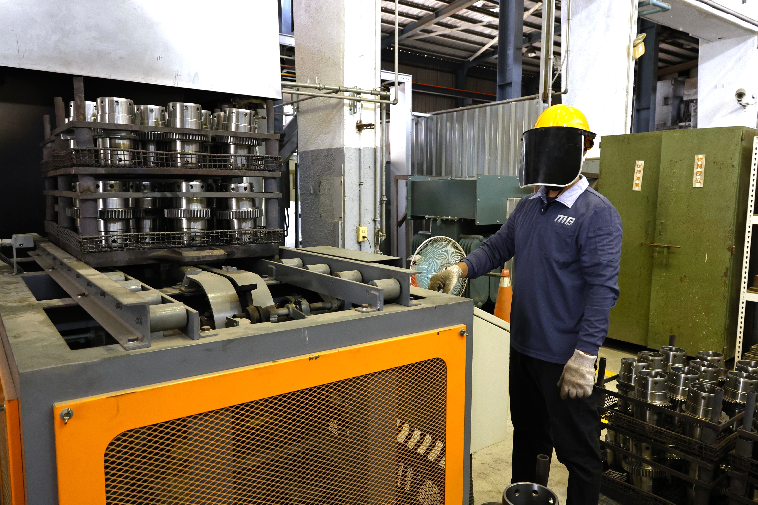

Photo 1. MIRDC established Taiwan's first ADI pilot production platform with smart heat treatment and AI image recognition modules for applications in developing components for green energy, agricultural machinery, rail vehicles, and mechanical equipment.
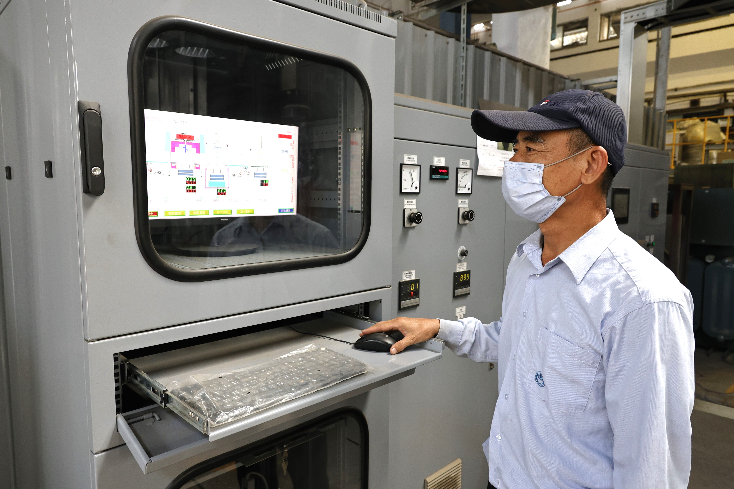

Photo 2. The equipment is able to accurately control furnace temperature within ±6°C. The monitoring system monitors the temperature distribution in the furnace in real time, and ensures stable treatment quality by adjusting process parameters through the feedback mechanism.

