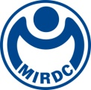
新聞資料NEWS LETTER

MIRDC Attends 2025 Smart City Summit to Tune the Future to a More Pleasant Era Through Innovative Technology

On March 20, the Kaohsiung Smart City Summit & Expo (KSCSE) was held at Kaohsiung Exhibition Center. This year, the summit’s feature theme was “Digital and Green Transformation,” and the Metal Industries Research & Development Centre (MIRDC) presented 33 technologies and services. “Tune the future to a more pleasant era” was the overlying concept throughout all 4 themed areas. For “MIRDC Trend,” MIRDC showcased its award-winning technologies at home and abroad in the past 6 years. “New Knowledge” invited KOLs to present highlights such as R&D stories and applications through video and infographics on social media. "Technology Advantages" showcased products developed in collaboration with member manufacturers using MIRDC’s technologies. Furthermore, “New Stuff” featured an AI-themed experience via AI-generated music and social media voting to connect online and offline digital interactions. MIRDC will continue investing into scientific and technological research in hopes of advancing Taiwan’s society and industries as we strive towards a promising future to solidify Taiwan as a key base of technology research and development in the international community.

One of MIRDC’s most captivating technologies at the summit was the “Enduring-High-Efficiency Combustion System for Industrial Furnace (EHE Combustion System)” which recently earned recognition in the 2024 R&D 100 Awards. Manufacturing processes in the metal industry often require heat treatment to improve the quality and properties of materials, and which has resulted in an ongoing issue of severe waste heat and carbon emissions. This enduring-high-efficiency combustion system developed for medium and high temperature combustion of 550-950℃ is a breakthrough from existing industrial furnaces whose energy saving efficiency only gradually declines. The combination of dynamic air/fuel ratio with time and mode toggles achieve an interaction that has revived energy saving performance in industrial furnaces. The system can recover up to 80% of waste heat, maintain a temperature uniformity of up to ±3°C, save up to 25% of energy, reduce carbon emissions by up to 30%, and maintain a factory heat exchange efficiency of over 95%.

In addition, there are three high-quality technologies that are on a par with those of internationally renowned institutions. The "Compact and High-performance Welding Cobot" effectively solves the technical difficulties of multiple welds. It is equipped with a magnetic base to adapt to multi-directional spatial operations, and has a built-in laser tracking and AI recognition system. It can instantly capture the topography of multiple welds, generate reference coordinates, and improve the flexibility, efficiency, and accuracy of welding. It has been successfully applied in Terminal 3 of Taiwan Taoyuan International Airport, the large-scale shipbuilding industry, and will be expanded to offshore wind turbines, bridges, buildings, railways and other fields in the future.

"EDM for Aerospace Applications Based on AI Optimization" solves the problems of traditional electrical discharge machining, which has complex parameters and relies on manual experience, often facing long processing time, insufficient process stability, and severe electrode wear. The technology establishes smart AI optimization technology capable of analyzing key parameters at microsecond speeds. In addition, trial and error method is mostly used in traditional processing, but its trial production is costly and time-consuming, and it also lacks immediate feedback on processing status. MIRDC’ s technology solves the above-mentioned issues, and it combines big data, AI computing, and domain knowledge with AIoT cloud service architecture to enable remote data monitoring, online quality prediction, optimized real-time feedback compensation to provide industries with an innovative operating model featuring higher performance and greater production stability. This improved machining precision, efficiency, and optimized production management offer innovative solutions for aerospace component processing.

The "3D Magnetic Tracking-guided ICH Surgical Navigation System" proposes a minimally invasive treatment solution for hemorrhagic stroke. The system integrates precise magnetic tracking and a multifunctional flexible endoscope system with preoperative biomedical images to provide precise intraoperative 3D multimodal fusion intracranial navigation. It helps neurosurgeons expand their surgical field of view and positions instruments to the exact depth of bleeding in a single attempt. This reduces internal bleeding and complications caused by blind punctures and avoids secondary surgeries, and achieves surgical navigation operations that are precise, safe, and efficient. It not only reduces the clinical continuous surgical radiographic radiation exposure by 80%, but also improves the effects of treatment. MIRDC has formed a strategic partnership with Clear Mind Biomedical Inc., a medical device manufacturer, to provide safer and more effective options for clinical/medical healthcare.

Ren-Yi Lin, Chairman of MIRDC, stated that MIRDC has long been committed to the intelligent transformation of the domestic metal and related manufacturing industries. In response to the AI trend in recent years, innovative research and development has been expanded in the fields of energy, aerospace, and healthcare. In addition, more scientific resources from government will be used to develop more technologies, and the technologies results will see practical application in various industries as we advance industries towards AI and net zero sustainability goals. Innovation, like the crescendo found in music, grows in strength with the rhythm. As we approach and become closer with industries, we can achieve greater resonance and advance forward at the same frequency.

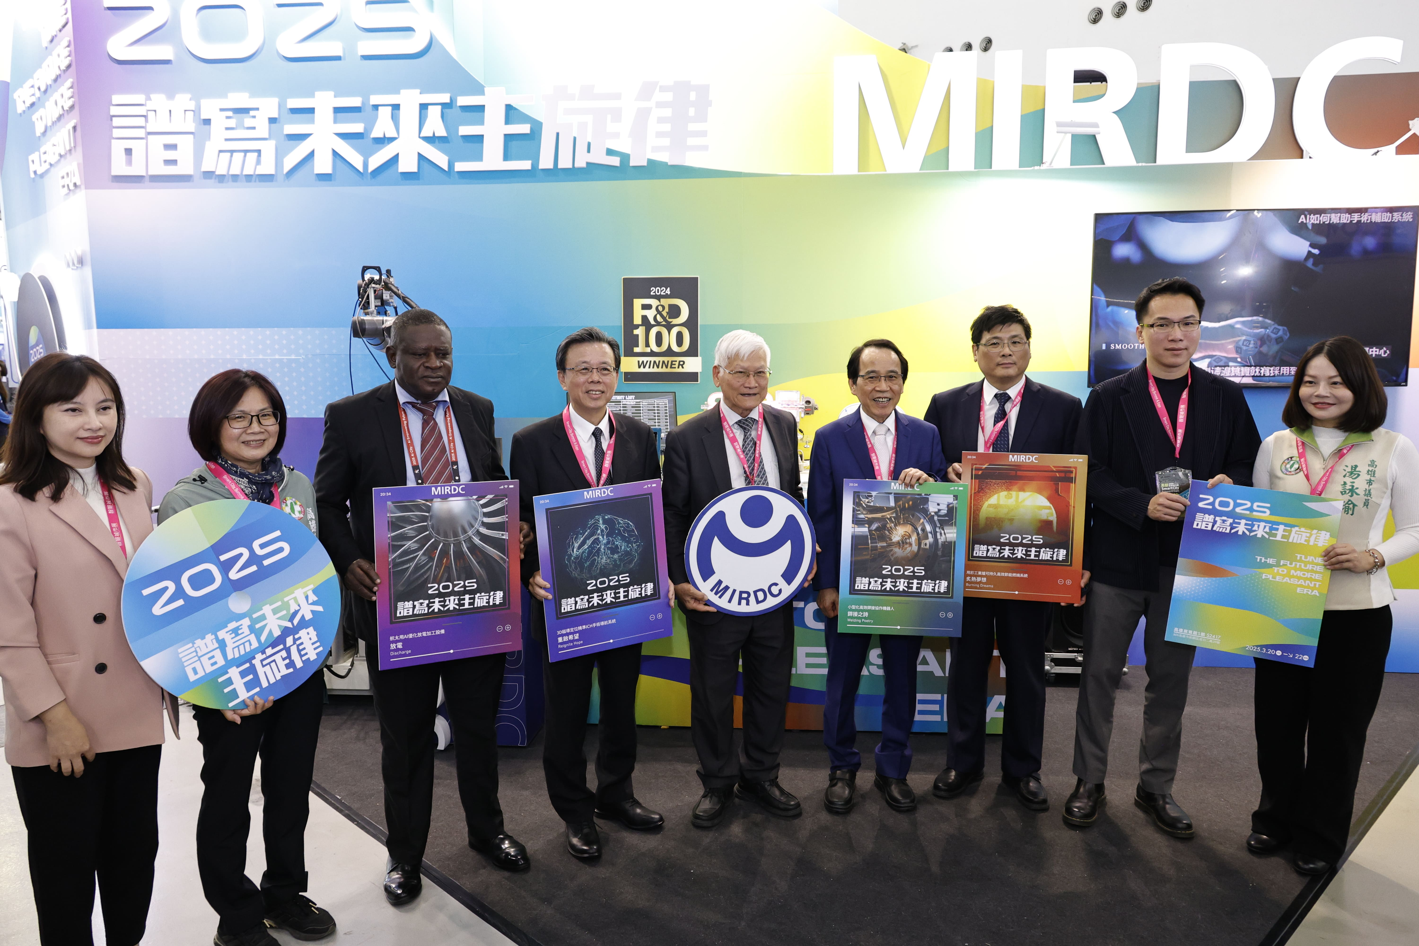

Photo 1. Chin-Rong Lin, Kaohsiung Deputy Mayor (4th from right), lead distinguished guests to visit the MIRDC booth at the 2025 Kaohsiung Smart City Summit & Expo (KSCSE), and Ren-Yi Lin, Chairman of MIRDC (5th from right) received those guests. Together, they experienced the captivating theme of 2025, Tune the Future to a More Pleasant Era.
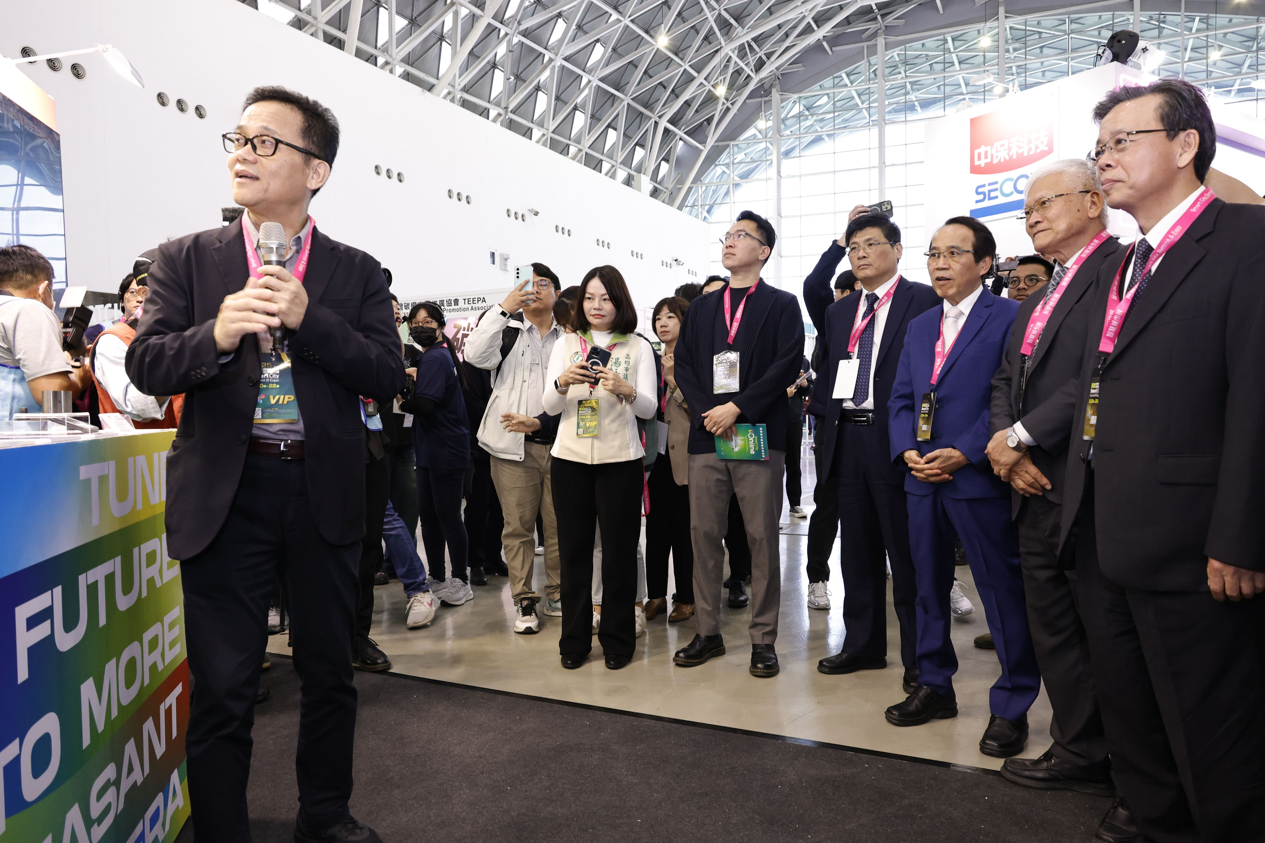

Photo 2. Hun-Yu Lin, MIRDC’s Director of Industrial Upgrading Service Department (1st from left) gave a guided tour to introduce the Enduring-High-Efficiency Combustion System for Industrial Furnaces, the winning technology of the 2024 R&D 100 Awards, to demonstrate new technologies in the field of energy saving AI.

