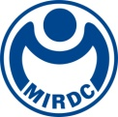
新聞資料NEWS LETTER
MIRDC Partners with France’s Largest Industrial Research Institution, Cetim, to Enhance Taiwan’s Industry Supply Chain Capacity of Hydrogen Energy

As the world moves toward the goal of net-zero emissions by 2050, hydrogen energy has become a key driver of the energy transition. To accelerate the development of Taiwan’s industry chain of hydrogen energy applications, the Metal Industries Research & Development Centre (MIRDC), with the support of the Department of Industrial Technology, Ministry of Economic Affairs, signed a Memorandum of Understanding (MoU) with Centre Technique des Industries Mécaniques (Cetim) on March 4 at JEC World, the world’s largest composite materials exhibition in Paris, France. Ambassador Pei-Chih Hao of the Taipei Representative Office in France attended the signing ceremony, demonstrating the government’s high regard for Taiwan-France technological cooperation.

Cetim is a renowned European industrial research institution providing technical services across the energy, aerospace, and mechanical engineering sectors, with over 8,000 clients worldwide. Cetim is also a key player in the European hydrogen energy industry. To advance France’s hydrogen energy sector, it has invested €25 million in the HyMEET project, focusing on research and development in hydrogen production, storage, transportation, and applications, as well as the establishment of a testing center. Additionally, Cetim actively participates in the Union de Normalisation de la Mécanique and the Association Française de Normalisation, integrating into the European hydrogen energy regulatory framework. Cetim also leads the European Union’s H2Ref-Demo project, focusing on the technology development of hydrogen refueling station to bridge the final gap in hydrogen energy applications. With its extensive technical expertise and industry influence, Cetim has become a major driving force in the European hydrogen energy ecosystem.

Yung-Hsiang Lai, president of MIRDC, stated that as global competition in the hydrogen economy intensifies, and the development of safe and efficient hydrogen energy application technologies is crucial for Taiwan’s success in this field. In recent years, MIRDC has actively promoted the hydrogen energy industry, successfully developing welding processes for anti-hydrogen embrittlement and surface treatment technology for hydrogen-permeation resistance, which are applied in hydrogen transportation and storage devices to effectively reduce leakage risks caused by hydrogen embrittlement. Furthermore, MIRDC has innovatively designed industrial burners with adjustable hydrogen mixing ratios, establishing Taiwan’s first hydrogen-mixed industrial combustion boiler and gradually accumulating core technological capabilities through independent research and development.

To further strengthen Taiwan’s technological foundation, MIRDC is partnering with Cetim to leverage Europe’s experience in the hydrogen energy industry and assist domestic manufacturers in enhancing key manufacturing technologies. This collaboration will focus on the development of next-generation thermoplastic composite material for hydrogen storage cylinder technology. High-pressure hydrogen storage cylinders are one of the core components of hydrogen storage and transportation, but due to the extreme pressure they must withstand, the technical barriers for material processing and bonding are exceptionally high. To address this technical challenge, MIRDC will integrate Cetim’s proprietary automatic winding tape technology to assist domestic manufacturers in enhancing their production capabilities for high-pressure hydrogen storage cylinders, making the cylinder structure lighter and extending its service life. In addition, since hydrogen energy equipment is exposed to high-pressure hydrogen environments for extended periods, metal materials may fail due to hydrogen embrittlement, posing safety concerns. To mitigate this issue, MIRDC will utilize Cetim’s high-pressure hydrogen fatigue testing and material analysis models to help domestic hydrogen energy supply chain develop more durable and safer hydrogen energy equipment and components. This will enhance Taiwan’s independent research and development capabilities in key hydrogen transportation and storage technologies and ensure that products meet international standards.

Cetim and MIRDC share a similar founding background, with strong alignment in technical expertise and research and development fields. Through the signing of this MoU, both parties will focus on research and development of hydrogen energy technology as well as international talent cultivation. In the future, the collaboration will be further expanded to include fields such as metal materials, aerospace, mechanical processing, and new energy, strengthening Taiwan’s industrial supply chain capacity and supporting the domestic hydrogen energy industry’s expansion into international markets.

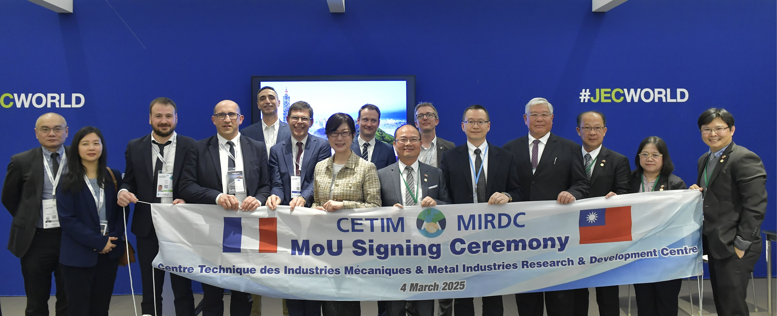

Photo 1. With Ambassador Pei-Chih Hao (front row, sixth from the left) of the Taipei Representative Office in France as a witness, MIRDC President Yung-Hsiang Lai (front row, sixth from the right) and Cetim General Secretary Sylvain Lambert (front row, fifth from the left) jointly signed a MoU.

