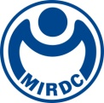
新聞資料NEWS LETTER
Friendly Workplace: A Fresh Start for the Year of the Snake
MRDC Gets a Splash of Color by Presenting Ink Paintings of Local Artist

The Metal Industries Research & Development Centre (MIRDC) invited Kaohsiung artist, Hsiu-Feng Chen, to exhibit her ink paintings at MIRDC’s multi-functional library. The exhibition launch, timed to coincide with the Lantern Festival, aims to highlight MIRDC's recent ESG and sustainability efforts and its commitment to a friendly workplace. Running from February 12 to August 29, 2025, the art exhibition "Golden Snake, Blooming Wealth" explores the four seasons through depictions of flowers, birds, and insects, celebrating nature's beauty and the hope it inspires.

Since last year, MIRDC has actively pursued ESG initiatives, culminating in the publication of its first Sustainability Report (2023) at the end of the year. The report reviews its ESG achievements and sets future goals. MIRDC, the largest non-profit R&D organization in southern Taiwan, also conducted a greenhouse gas inventory, demonstrating its commitment to sustainable operations. Furthermore, MIRDC prioritizes a friendly workplace environment as part of its broader ESG initiatives, and it includes creating various clubs, organizing diverse activities, and implementing convenient mechanisms for its employees during work. These efforts are recognized by Kaohsiung City, and it offered MIRDC “Happy Enterprise Award” of large enterprise section in 2022. In the beginning of the Year of the Snake, MIRDC invites Kaohsiung ink painter, Hsiu-Feng Chen, to showcase her artwork, and which offers its employees a moment of pause by appreciating those artworks.

The artist, Hsiu-Feng Chen, has enjoyed a distinguished career, and it includes Director of the Kaohsiung Museum of History, Chairperson of the Kaohsiung City Documentation Committee, and District Directors of Cianjin, Sinsing, and Cianjhen Districts. She currently chairs the Fly Feng Welfare Care Association and organizes charity bazaars. The "Golden Snake, Blooming Wealth" exhibition at MIRDC showcases 47 paintings celebrating the four seasons. The works, featuring flowers, birds, insects, and Chinese zodiac themes, emphasize nature's beauty and the hope it inspires. Along with New Year's wishes for a good Year of the Snake to MIRDC and the people of Kaohsiung, Hsiu-Feng Chen's exhibition features a series of flower paintings, including depictions of peonies, carnations, frangipani, daisies, and daffodils. A fresh and elegant style with vibrant brushstrokes of those paintings showcases her love for nature and the harmony between people and the environment, echoing MIRDC's efforts to promote a friendly workplace.

Ren-Yi Lin, Chairman of MIRDC, explains that major design concept of MIRDC’s multi-functional library is “user-friendly environment,” and choosing the library as the exhibition location meets this purpose. The vibrant artworks complement the library's collections and create an inviting atmosphere in the newly established meeting and study spaces, enriching the services offered to its employees. In addition, the library holds "New Year Market at the Library" event to celebrate the Lantern Festival and the launch of the exhibition, and which offers its visiting guests a chance to experience both the healing effects from art and the festive spirit of the New Year.

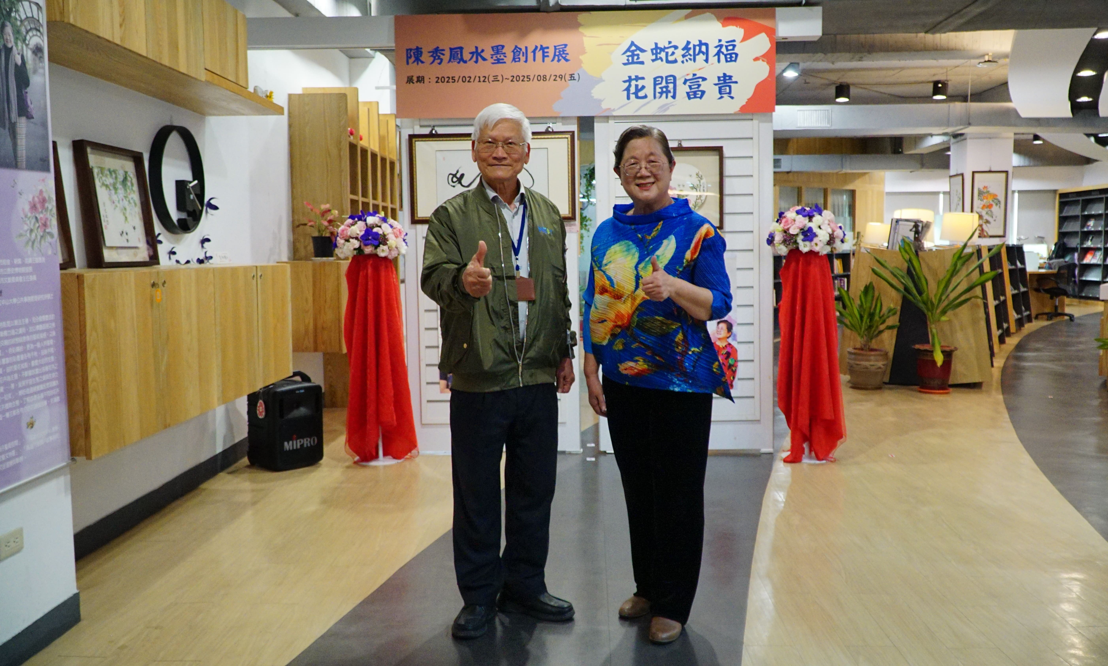
Photo 1. MIRDC collaborates with Kaohsiung ink painter, Hsiu-Feng Chen, to hold the "Golden Snake, Blooming Wealth" painting exhibition
(Left: Lin Ren-Yi, Chairman of MIRDC, right: Ms. Chen Hsiu-Feng, ink painter)

