
新聞資料NEWS LETTER
MIRDC and J.C.Y. Masterpiece Hardware Industrial Co., Ltd. Sign MoU to Promote Development of JIS Testing and Quality Technologies

To help domestic fastener manufacturers secure more international product certifications and expand into international markets, Metal Industries Research & Development Centre (MIRDC) is actively collaborating with J.C.Y. Masterpiece Hardware Industrial Co., Ltd., a major domestic fastener manufacturer. On November 5, 2024, Chairman Ren-Yi Lin of MIRDC and Chairman Yi-Fang Wang of J.C.Y. Masterpiece Hardware Industrial Co., Ltd. signed a Memorandum of Understanding (MoU) in Tokyo. The signing was witnessed by Chairman Wu-Hung Lin of Hosun Universal Co., Ltd., Chairman Chih-Yuan Hou of Home Shine 8 Co., Ltd., General Manager Yuan-Chieh Chang of Yuan Shi Shang Industrial Co., Ltd., General Manager Cheng-Hsueh Li of Cheng Pin Optoelectronics Technology Co., Ltd., and General Manager Hao-Min Chang of Shian Fu Enterprise Co., Ltd. The MoU focuses on conducting in-depth exchanges regarding Japan’s expertise in testing, verification, and quality technologies. This includes standard certification processes, testing plan formulation, and verification applications, all aimed at further advancing breakthroughs and applications in international verification technologies for Taiwan’s fastener products. The key points of the collaboration include jointly exploring the latest verification processes for Japan’s JIS certification and providing technical and testing certification consulting to assist domestic fastener manufacturers in applying for certifications by analyzing Japanese internationals standards. This will facilitate the industry’s expansion into the Japanese fastener market.

Chairman Yi-Fang Wang of J.C.Y. Masterpiece Hardware Industrial Co., Ltd. expressed great honor in partnering with MIRDC. He highlighted that the two parties will deepen cooperation in areas such as technical consultation, international standards, and certification processes. Chairman Wang looks forward to providing testing and verification references to the domestic fastener industry in the future, thereby helping Taiwan enter the Japanese fastener market.

Chairman Ren-Yi Lin of MIRDC stated that MIRDC has a long-standing history of supporting domestic industries in securing international certifications for their products. He noted that the partnership with J.C.Y. Masterpiece Hardware Industrial Co., Ltd. is a significant milestone in advancing international certification developments for fastener products. Through close cooperation between the two parties, MIRDC will not only continue to strengthen its product verification capabilities but also accelerate the alignment of Taiwan’s fastener products with international standards, thereby enhancing their international appeal and market potential. The two parties will embark on a long-term partnership to strengthen Taiwan’s testing capabilities and services for Japan’s product certification mechanisms. Going forward, with increased collaboration in the field of testing, MIRDC will enhance its capabilities in testing technologies for Japanese product certifications, further refining these technologies to help the industry boost its international competitiveness.

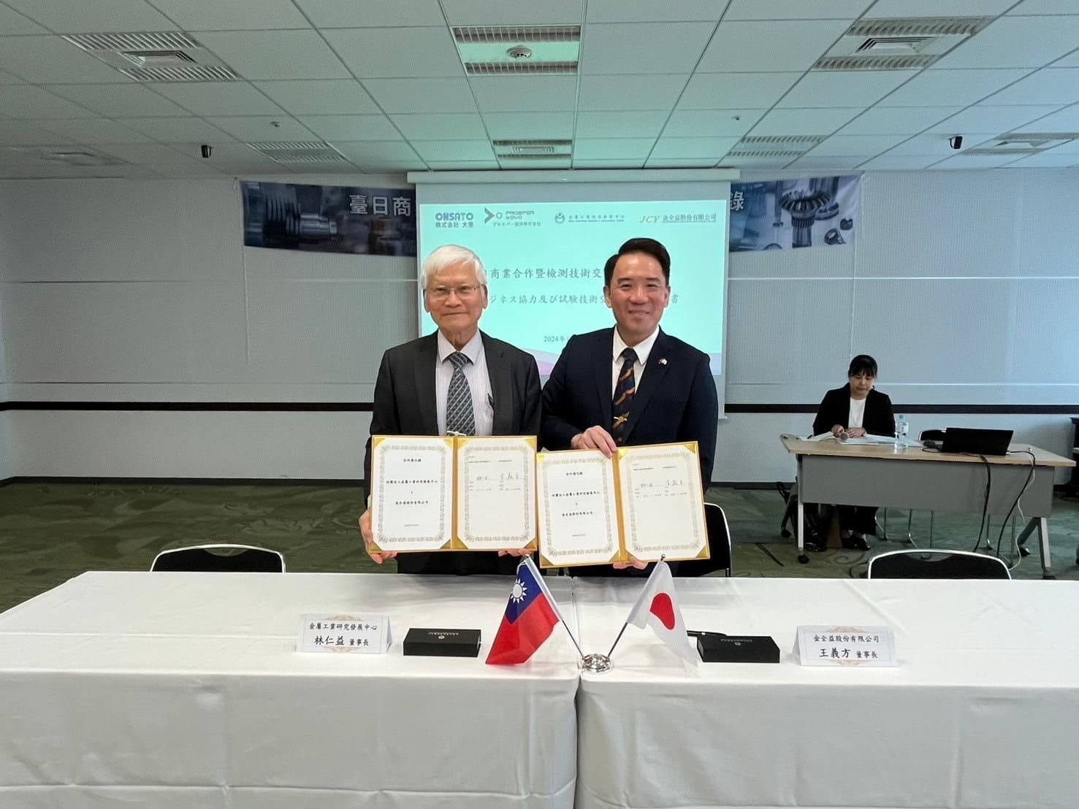

Photo 1. Chairman Ren-Yi Lin of MIRDC (left) and Chairman Yi-Fang Wang of J.C.Y. Masterpiece Hardware Industrial Co., Ltd. (right) signed an MoU

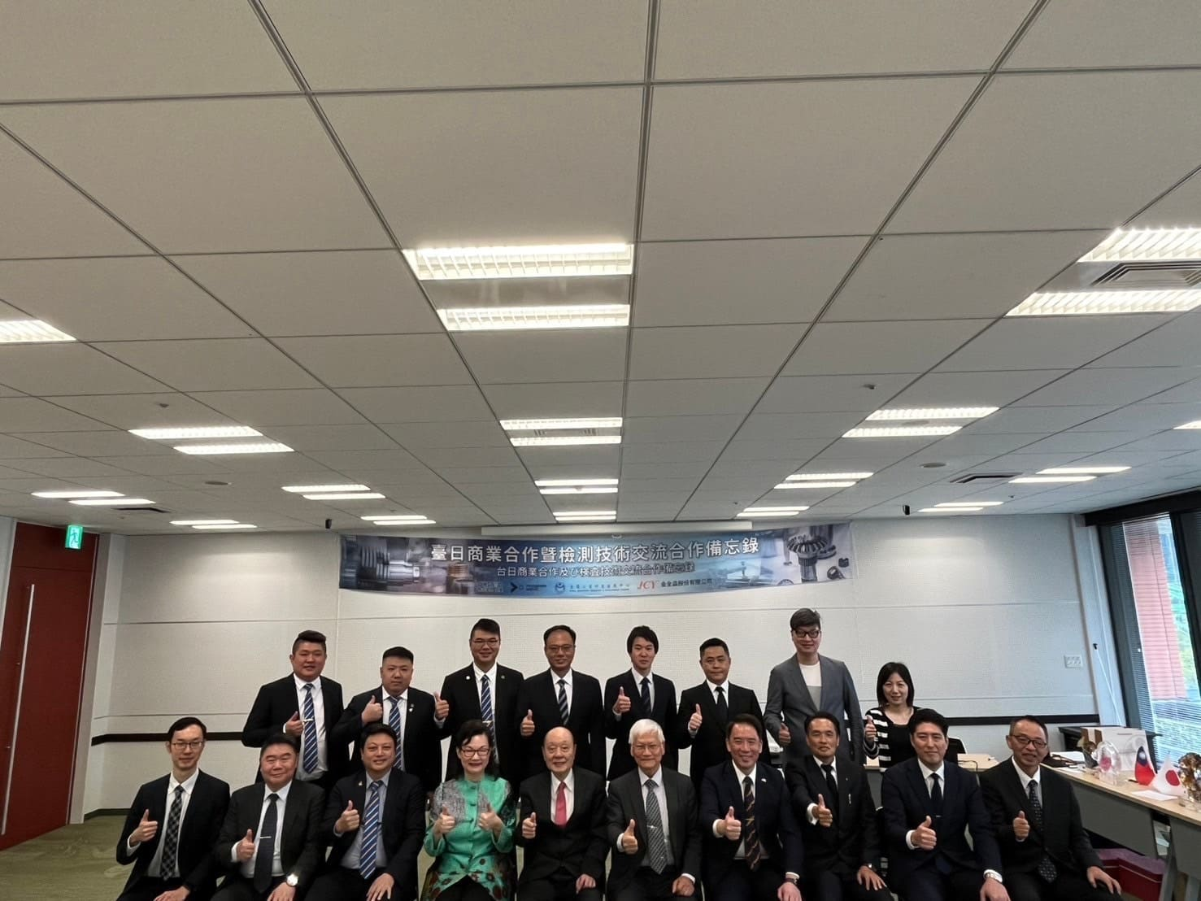

Photo 2. Group photo of distinguished guests at the signing ceremony for the MoU on Taiwan-Japan Business Cooperation and Testing Technology Exchange between MIRDC and J.C.Y. Masterpiece Hardware Industrial Co., Ltd.

