新聞資料NEWS LETTER
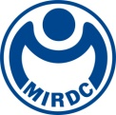
The Only Dual Simulation System of Maritime Engineering in Taiwan Assists Talent Cultivation of Offshore Wind and Vessel Industries

Maritime Technology Innovation Center (MTIC) is established by the Executive Yuan, and Energy Administration, Ministry of Economic Affairs, delegates the Metal Industries Research & Development Centre (MIRDC) to operate this center. MTIC focuses on cultivation of professional talents of offshore wind and maritime engineering fields. After receiving international standard certifications of GWO (Global Wind Organization) and OPITO (Offshore Petroleum Industry Training Organization), MTIC continues to expand its talent training programs of offshore wind, and it has provided over 30 training programs of international certifications. It offers basic level, advanced level, and customized training programs and has trained around 3,000 trainees around the globe. The center has become a renowned professional talent cultivation institute for offshore wind and maritime engineering fields in Asia Pacific region, and it will continuously promote development of Taiwan’s offshore wind industry.

While MITC is upgrading its training capabilities, it also introduces the only dual-simulation operation system in Taiwan for Dynamic Positioning (DP) and Offshore Crane Operation (OCO) related training programs, and it has been certified by Nautical Institute (NI) from the United Kingdom by the end of this year. Because of that, MTIC has become Taiwan’s first institute that provides comprehensive training of maritime engineering simulator and issues certificates to qualified candidates. DP training provides trainees with realistic operation simulation at sea, and it covers practical scenarios such as vessel positioning at sea and port entry and exit. It can also integrate with onboard crane equipment for OCO customized training. For assisting government in strengthening professional skills of Taiwanese crew members, relevant trainings for improving localized self-sufficiency capabilities will continuously be offered via “subsidized training program of Taiwanese crew member,” and which is MTIC’s important milestone for cultivating professional maritime talents. In addition, scenario setting function of dual simulation system enables customized training programs in accordance with industry needs, and which greatly improves trainee’s professional operation capability.

As a leading maritime and energy training center, MTIC will provide diversified and high-standard training programs, and which not only complies with government’s energy transformation policy but also assists realization of 2050 net zero emission target. In the future, MTIC will continue to expand its training resources and capabilities, and further supports talents cultivation of floating wind farm, dynamic positioning, and other forward-looking technologies, enhancing Taiwan’s industry competitiveness and influence of clean energy and maritime engineering in the globe.

For more information, please contact Cheng Chang Wang (Email: scott.wang@mail.mirdc.org.tw / Phone No. 0919828632)
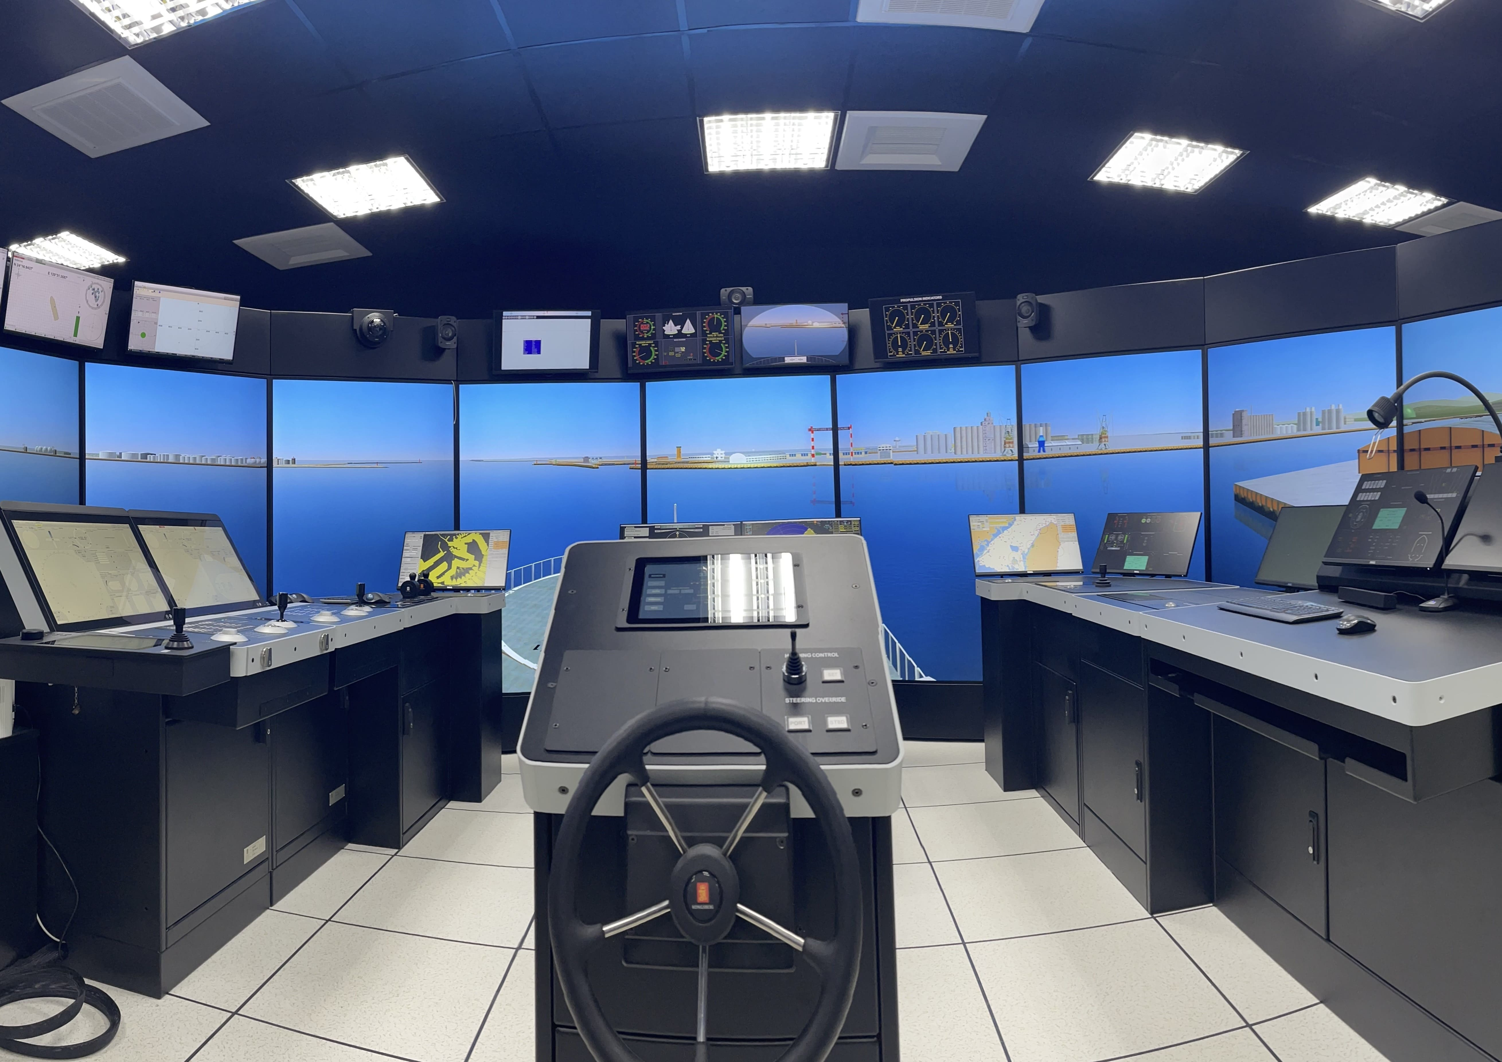

Photo 1. Dynamic Positioning (DP) of MTIC’s dual-simulation operation system
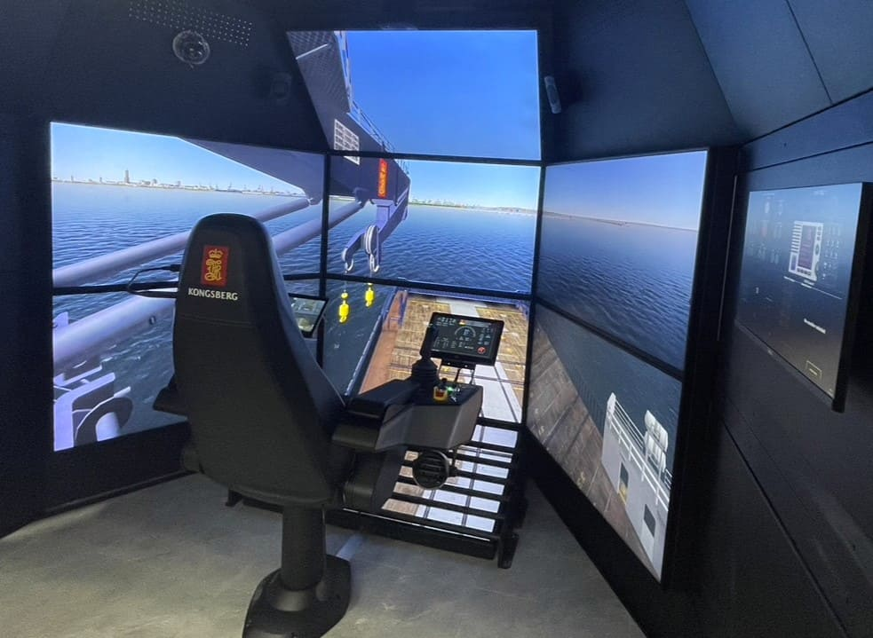

Photo 2. Offshore Crane Operation (OCO) of MTIC’s dual-simulation operation system

