
新聞資料NEWS LETTER
MIRDC Partners with NCSIST to Promote Strategic Technologies for Drone Industry Development

The Metal Industries Research & Development Centre (MIRDC) and the National Chung-Shan Institute of Science & Technology (NCSIST) held a ceremony on December 2 to sign a strategic technology cooperation memorandum for drone industry development, to accelerate the growth of Taiwan’s drone industry and deepen bilateral technological cooperation. This partnership marks a new milestone for Taiwan’s drone industry, particularly in technological research and development, system integration, and supply chain capabilities. By combining R&D strengths and industrial resources, both parties aim to implement a military-civilian dual-use development strategy to advance the development and application of domestic drones, thereby boosting national defense autonomy and enhancing Taiwan’s global competitiveness.

NCSIST plays a vital role in the national drone team as a core technology developer and industry chain integrator, supplying the military with a range of highly specialized drone platforms. With extensive experience in drone system integration, testing, and verification, NCSIST continues to develop and improve next-generation drone products. NCSIST is also committed to partnering with private manufacturers to rapidly produce commercial drones by leveraging existing technologies and production capabilities to meet the armed forces’ needs. MIRDC plays a pivotal role between the government and industry for technological R&D and industry promotion. Moving forward, both parties can leverage their respective strengths and expertise to help Taiwan’s drone industry gain a foothold in the global market.

Chia-Ju Liu, Chairman of MIRDC, highlighted the establishment of the Aerospace Science and Technology Industry Development Department in 2023, created to address Taiwan’s needs in aerospace technology development, with guidance and support from the Ministry of Economic Affairs. Under the leadership of Director General Chih-Wei Chien, the team has systematically developed industrial capabilities encompassing drone materials, full system integration, key module supply chain optimization, and drone application services. Wei-Hung Wu, Vice President of MIRDC, emphasized that, as an essential government-industry think tank, MIRDC will continue to integrate upstream and downstream resources to strengthen Taiwan’s aerospace industry supply chain. This collaboration with NCSIST leverages complementary strengths and joint development across the military and civilian sectors, aiming to bring R&D achievements to the global market.

Building on this partnership, both parties will continue to advance the drone technology strategy and work together to implement highly reliable and highly integrated drone innovations to strengthen Taiwan’s industrial capabilities and set a new standard for a globally competitive drone industry. Looking ahead, this collaboration will focus on military-civilian synergy, independent research and development, technology implementation, and shared industrial prosperity. Both parties will work together to strengthen Taiwan’s drone industry, enabling it to compete effectively on a global scale while also enhancing national defense autonomy and fostering industry advancement.
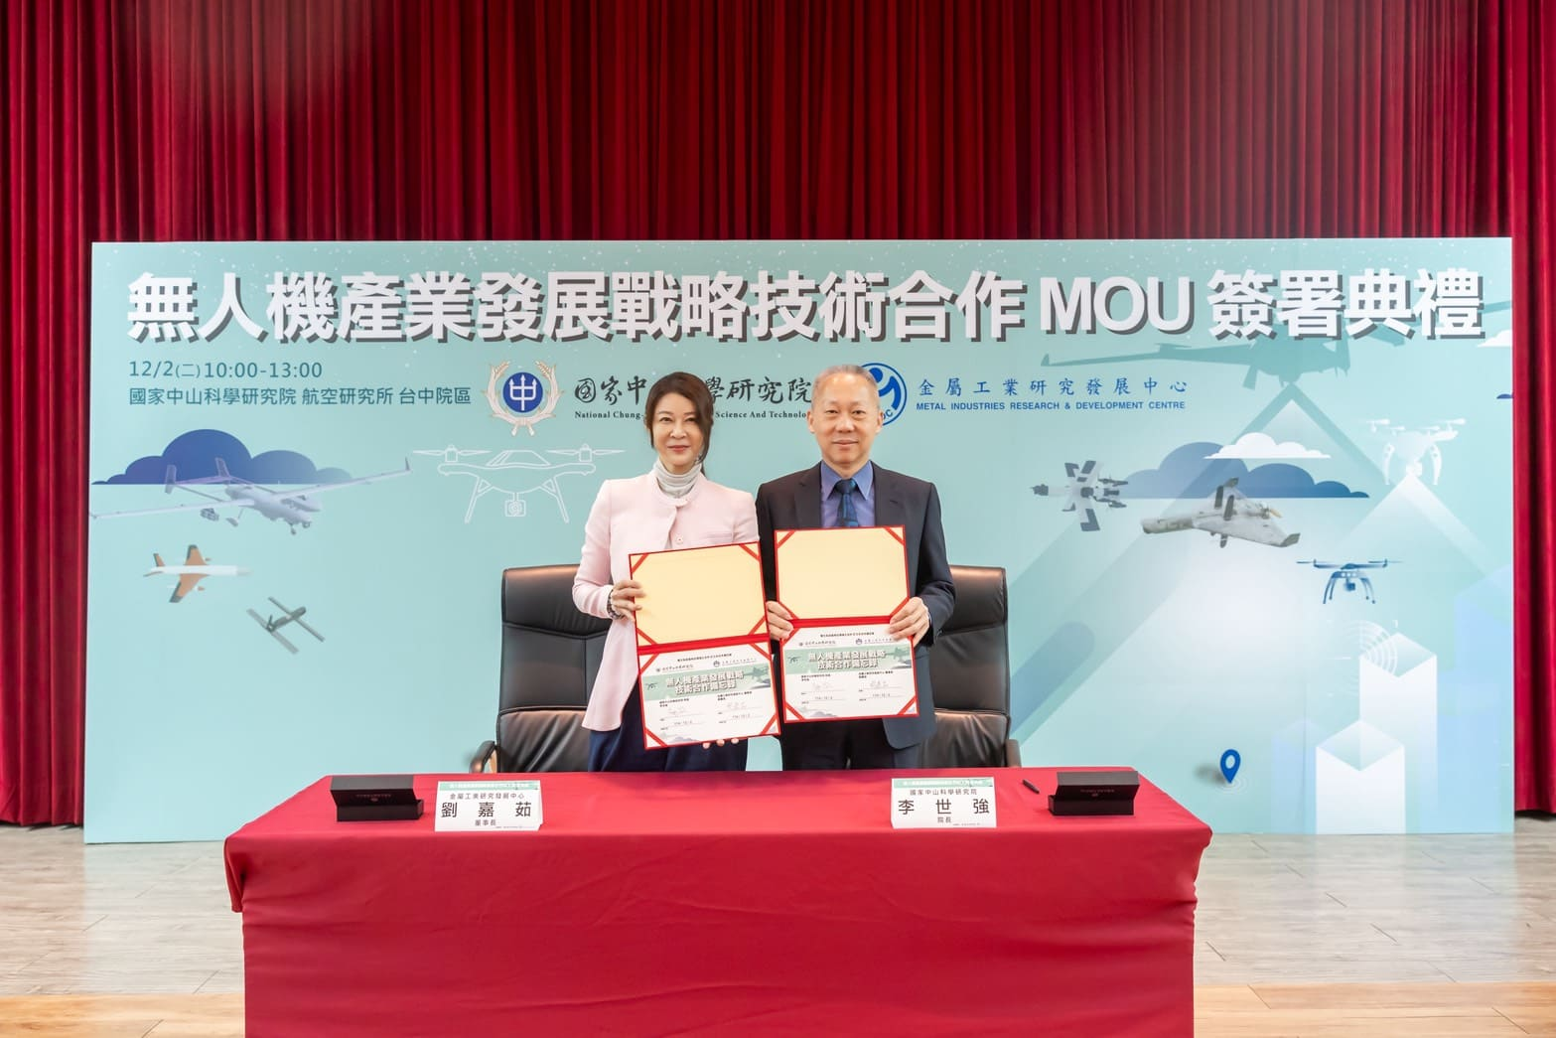

Photo 1. MIRDC Chairman Chia-Ju Liu (left) and NCSIST President Lieutenant General Shih-Chiang Li (right) sign the Memorandum on Strategic Technology Cooperation for Drone Industry Development.

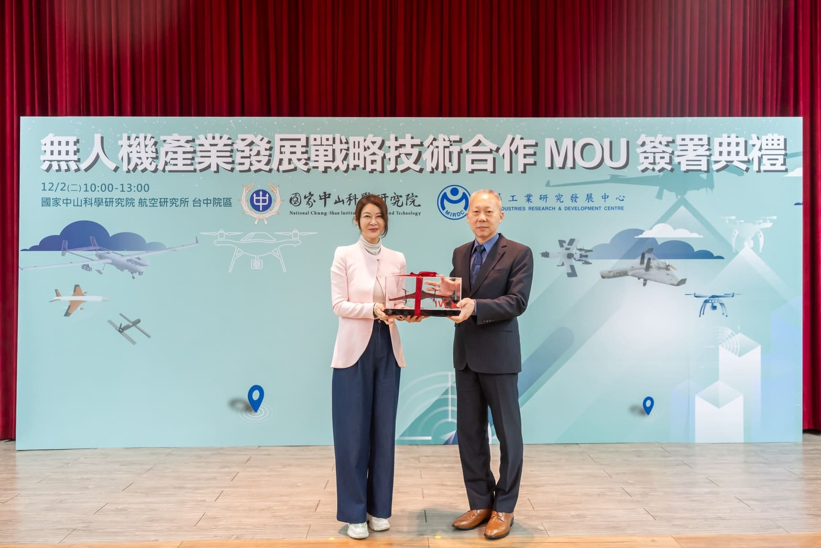
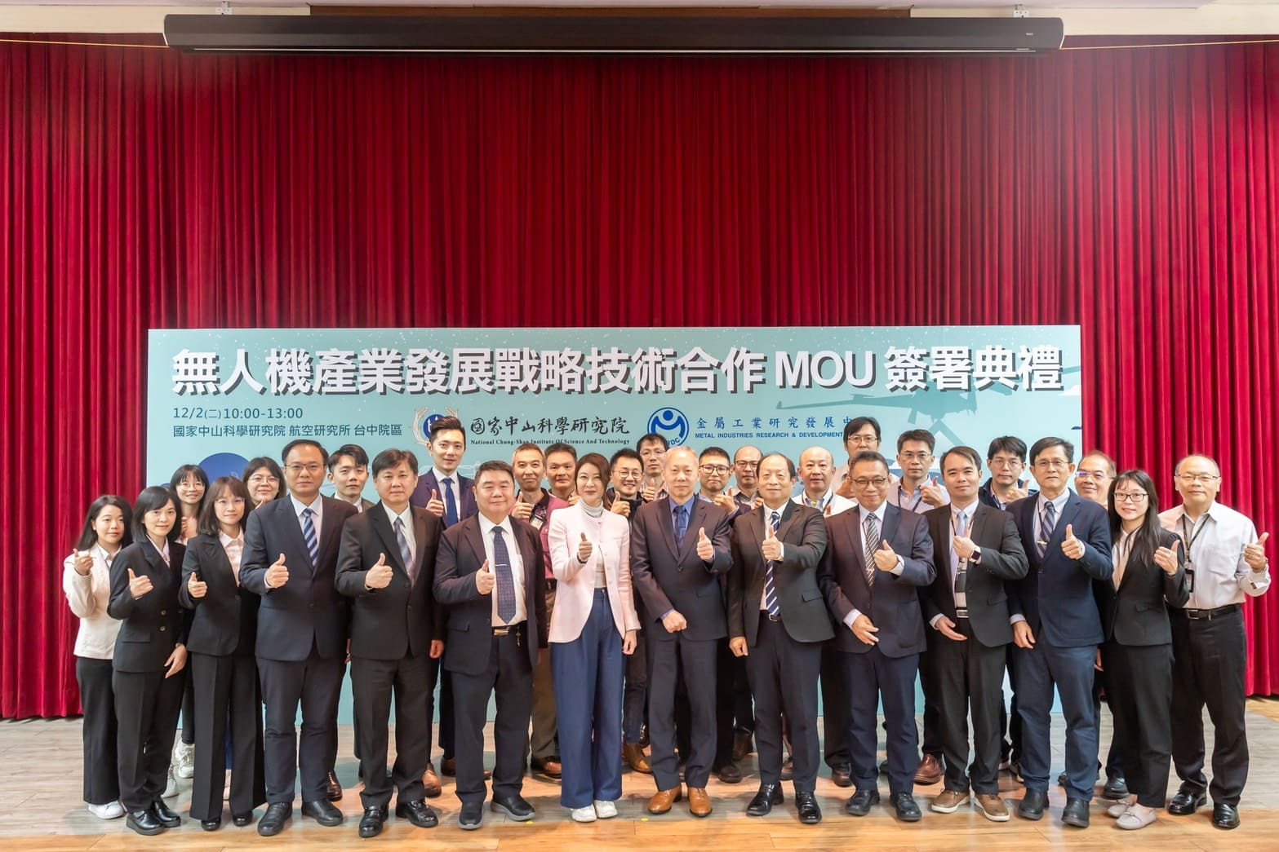
Photo 2. MIRDC Chairman Chia-Ju Liu (left) and NCSIST President Lieutenant General Shih-Chiang Li (right) exchange gifts.
Photo 3. Group photo of the MIRDC and NCSIST teams.

