
新聞資料NEWS LETTER
Geothermal Drilling Goes International! MIRDC Integrates Joint Efforts of Taiwan and Canada in Green Energy with a Focus on the Trillion-dollar Business Opportunity Underground!

Geothermal energy is energy that comes from the earth. It can be stably and effectively output without being affected by the climate, making it one of the most promising emerging green energy sources! The 2025 Geothermal Energy Application Technology Conference organized by the Metal Industries Research & Development Centre (MIRDC) under the guidance of the Energy Administration, Ministry of Economic Affairs (MOEA) was successfully held at the GIS MOTC Convention Center a few days ago. This landmark summit gathered nearly a hundred experts from industry, government, academia, and research institutes, officially launching deeper collaboration between Taiwan and Canada, a powerhouse in geothermal development.

During the exchange conference, Taiwan was represented by Hsiao-Chuan Li, Assistant Chief of the Energy Administration, MOEA, while the Canadian was represented by Ms. Marie-Louise Hannan, Executive Director of the Canadian Trade Office in Taipei, who expressed support for multifaceted cooperation between Canada and Taiwan in the field of clean energy during her speech, hoping to leverage Canada's geothermal development experience and work together with Taiwan towards a green future with low-carbon technology. In addition, Chun-Pin Huang, Secretary-General of Taiwan Geothermal Industry Development Association, voiced the industry's expectations that leveraging Canada's experience in the oil and gas as well as geothermal energy industries will rapidly enhance capabilities of the domestic industry chain to scale up development, which is the only way to meet the technology sector's urgent demand for renewable energy.

Yung-Hsiang Lai, President of MIRDC, stated that the MIRDC serves as the technology leader for the entire industry chain from drilling to power generation. The geothermal team led by Hun-Yu Lin, Director of the Industrial Upgrading Service Department, has actively utilized the MIRDC's strong R&D capabilities in acid-resistant pipes and high-temperature-resistant materials to solve technical barriers for the industry, demonstrating its expertise and dedication to geothermal energy. Going forward, Taiwan will engage in further exchanges and cooperation with Canada to localize the geothermal industry.

During the exchange conference, representatives of leading Canadian geothermal pioneers, including the Canadian Geothermal Industry Alliance (CGIA), Novus Earth, and Remedy Energy, shared efficient drilling technologies and precise exploration strategies under extreme geological conditions. A senior consultant from global energy service giant Halliburton then shared how to use the most advanced drilling communication and connection technologies to find the "key" to the fastest and safest development of advanced geothermal systems.

The 2025 Geothermal Energy Application Technology Conference was a success. It not only built a bridge for the most efficient and direct cooperation between industries of Taiwan and Canada, but also aims to provide the technologies and funding needed to scale up and internationalize Taiwan's geothermal industry.

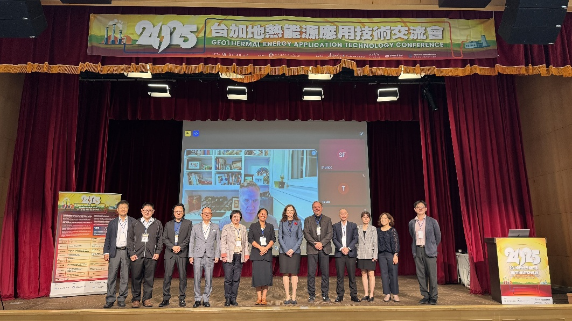

Photo 1. Group photo of guests and speakers

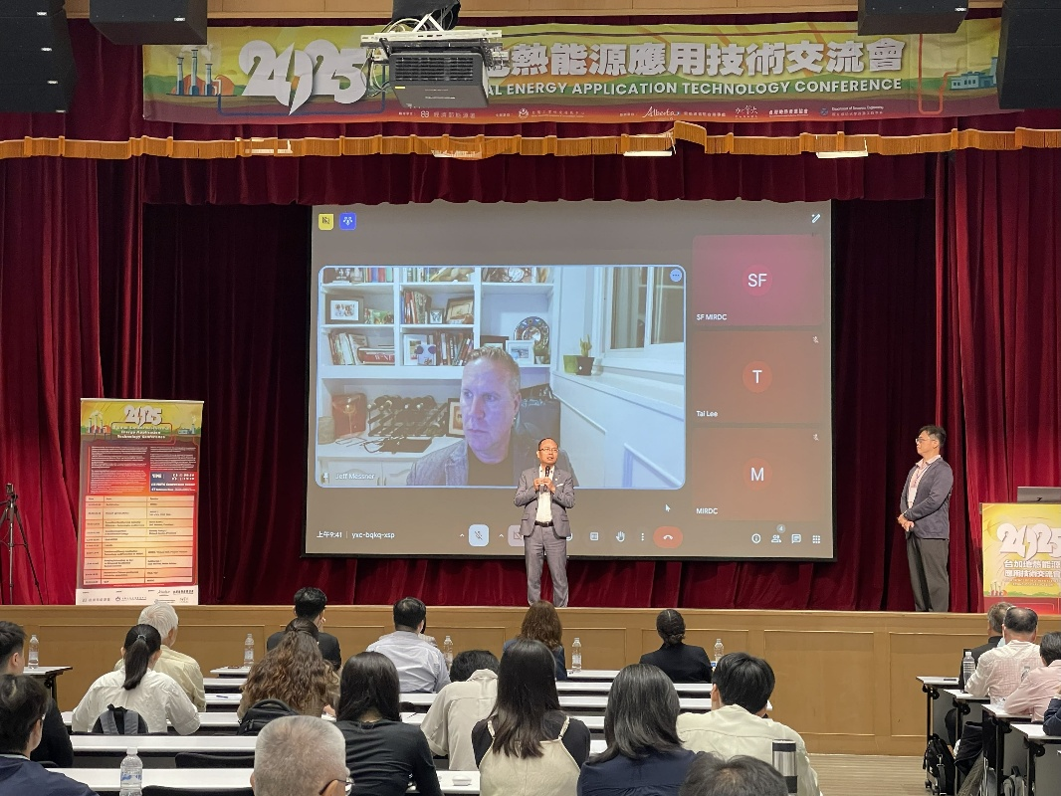

Photo 2. President Yung-Hsiang Lai delivers opening remarks and Canadian speaker delivers online speech

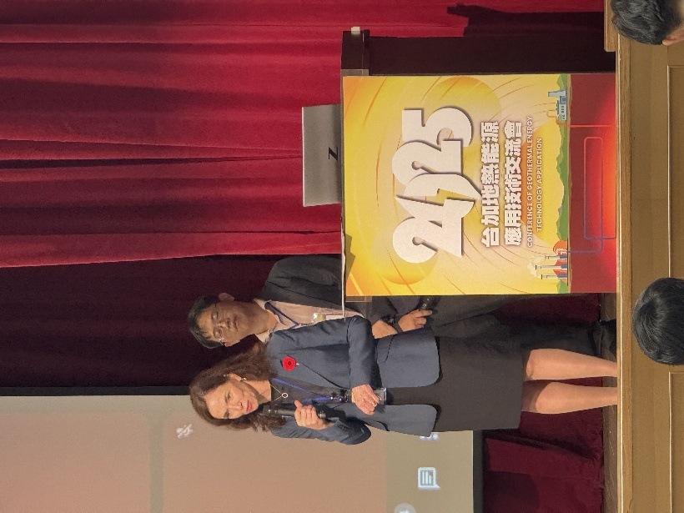

Photo 3. Executive Director Ms. Marie-Louise Hannan of the Canadian Trade Office in Taipei delivers speech

