
新聞資料NEWS LETTER

MIRDC Promotes Smart Oral Care Solutions to Guard the Oral Health of Seniors

With support from the Department of Industrial Technology, Ministry of Economic Affairs, the Metal Industries Research & Development Centre (MIRDC) unveiled its age-friendly smart oral and swallowing empowerment pavilion at the Cares Expo Taipei 2025, held from September 25 to 27 at the Taipei Nangang Exhibition Center. The pavilion showcased a comprehensive smart solution that integrates swallowing and tongue training and assessment, home-based dental cleaning, and a cloud-based oral health management system. The solution utilizes an interactive mobile app with real-time AI recognition to help seniors improve their self-directed training and oral care results at home. With more than 1,200 participants, field tests revealed an 83% improvement in oral hygiene, underscoring the potential of smart care applications.

Chieh-cheng Tai, Senior Technical Specialist of the Department of Industrial Technology, Ministry of Economic Affairs, said that data from the Health Promotion Administration of the Ministry of Health and Welfare shows that Taiwan's aging population has surpassed 4 million individuals aged 65 and older. Almost 60% of seniors suffer from periodontal disease or poor oral hygiene, while nearly 30% face swallowing difficulties due to declining oral function. These issues pose significant risks of malnutrition and disability. MIRDC created a Smart Oral Care Solution that features Auto Brush, a full-mouth sonic toothbrush; Smile Guard, a smart oral care device; a balloon-based tongue pressure sensor; and interactive tongue training games. Through home-based and digital methods, the solution helps seniors improve their oral hygiene and swallowing abilities, while integrating with the FHIR data exchange framework to form comprehensive data for various healthcare systems.

Chun-Chieh Wang, Vice President of MIRDC, stated that improving oral healthcare for seniors is a technology-driven initiative with philanthropic goals that holds significant importance for MIRDC. In the future, MIRDC plans to further enhance its solutions by integrating them with Dental Health Information Systems and SaMD platforms from BSSOTA Information Co., Ltd. to deliver more accurate diagnosis and care. Additionally, the solution incorporates ADA-certified bristle designs specifically designed for Asian dentition, along with in-house developed fluorescence imaging and gingival oximetry devices, further enhancing oral health monitoring. Under the leadership of Tzyy-Ker Sue, Director of MIRDC, demonstration projects have been successfully completed at many sites, including the community care stations of the Chiayi County Health Bureau, the Taiwan Oral Care Association (TOCA), the Multidisciplinary Swallowing Center at Kaohsiung Municipal Siaogang Hospital, community clinics, and Taiyo caregiving institutions. To date, over 1,267 seniors across five different categories of care sites have participated in the program, resulting in 1,051 documented before-and-after cases. MIRDC has also partnered with Formosa Heavy Industry Corp., Huo Na Lin Biotec Co., Ltd., U-an Co., Ltd., and Sitatech Information Services Co., Ltd., to promote smart care business models.

MIRDC is committed to expanding partnerships with industry stakeholders to effectively promote home rehabilitation programs and related products to help seniors engage in muscle strength and swallowing training at home, gathering important health data for clinical reference to ensure that seniors can eat well, chew well, and live well.

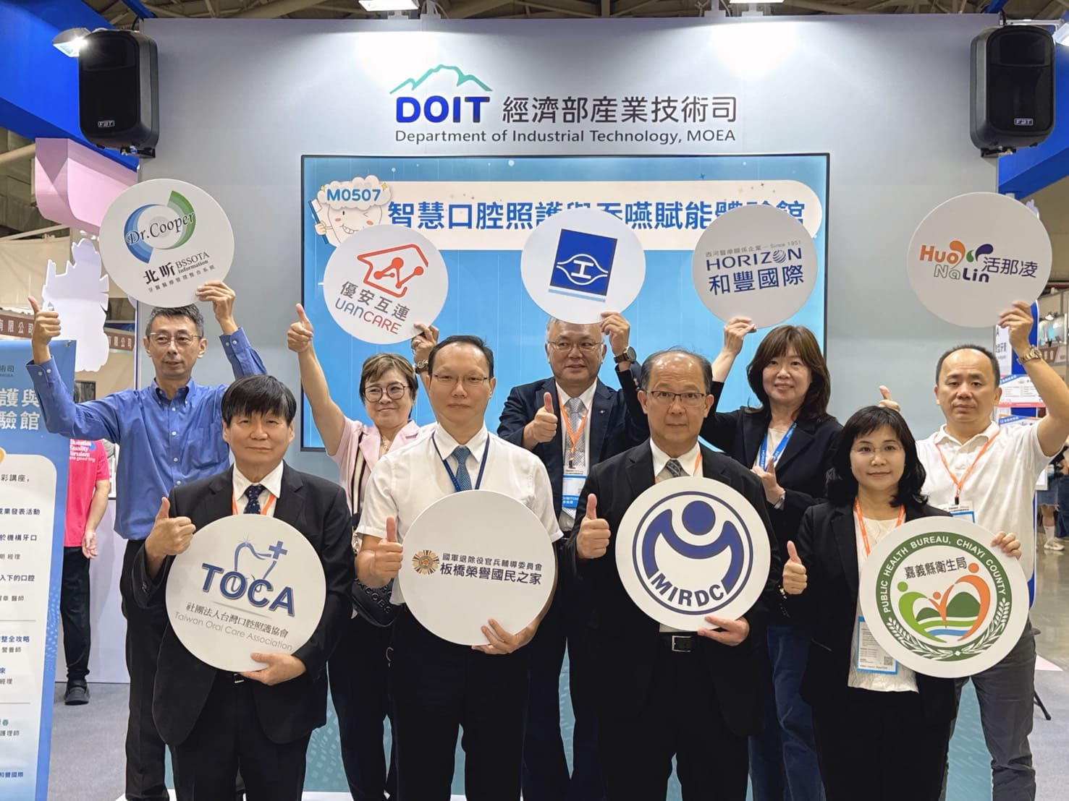

Photo 1. MIRDC’s Smart Solution for Oral Care and Swallowing Empowerment was showcased with industry and healthcare partners, highlighting the outcomes of cross-sector collaboration and field demonstrations. (Front row, from the left: Qiu-Yao Chung, Chairman of Taiwan Oral Care Association, Ru-jun Liu, Deputy Director of Banqiao Veterans Home, Veterans Affairs Council, Chun-Chieh Wang, Vice President of MIRDC, Wen-Hua Chao, Director of Chiayi County Health Bureau. Back row, from the left: Chih-yang Lai, Vice President of BSSOTA Information Co., Ltd., Hong-yi Wu, General Manager of U-an Co., Ltd., Yu-Feng Huang, Vice President of Formosa Heavy Industry Corp., Hsiang-li Lin, General Manager of Horizon Instruments Co., Ltd., Ssu-ju Chen, Chairman of Huo Na Lin Biotec Co., Ltd.)

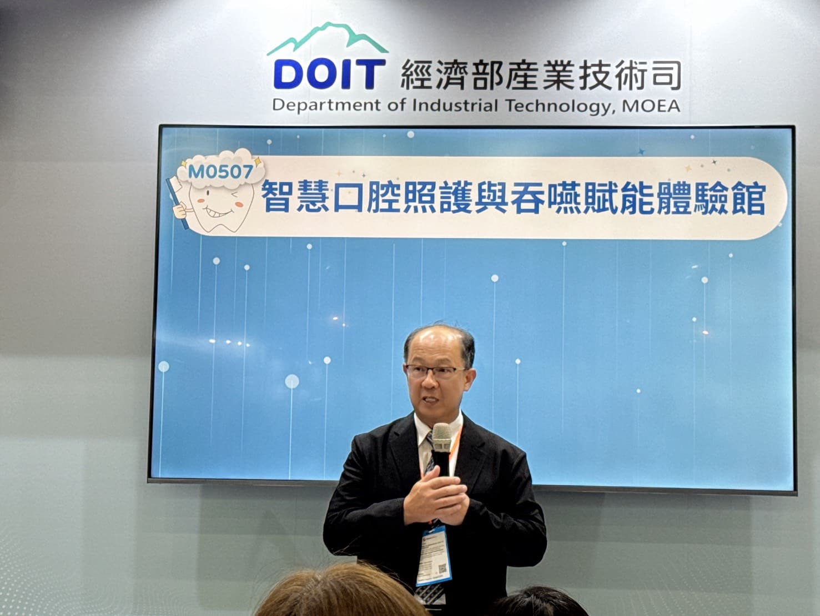

Photo 2. Chun-Chieh Wang, Vice President of MIRDC, delivered remarks at the age-friendly smart oral and swallowing empowerment pavilion.

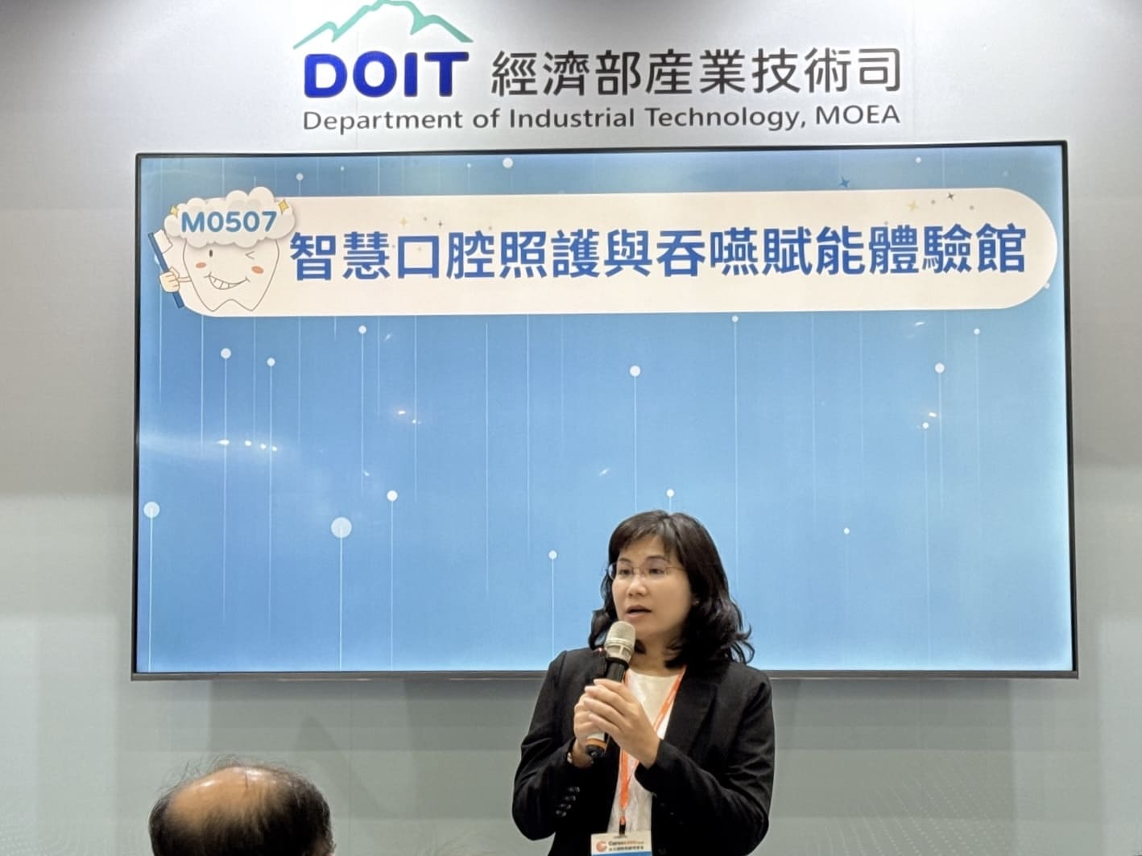

Photo 3. Wen-Hua Chao, Director of Chiayi County Health Bureau, delivered remarks at the age-friendly smart oral and swallowing empowerment pavilion.

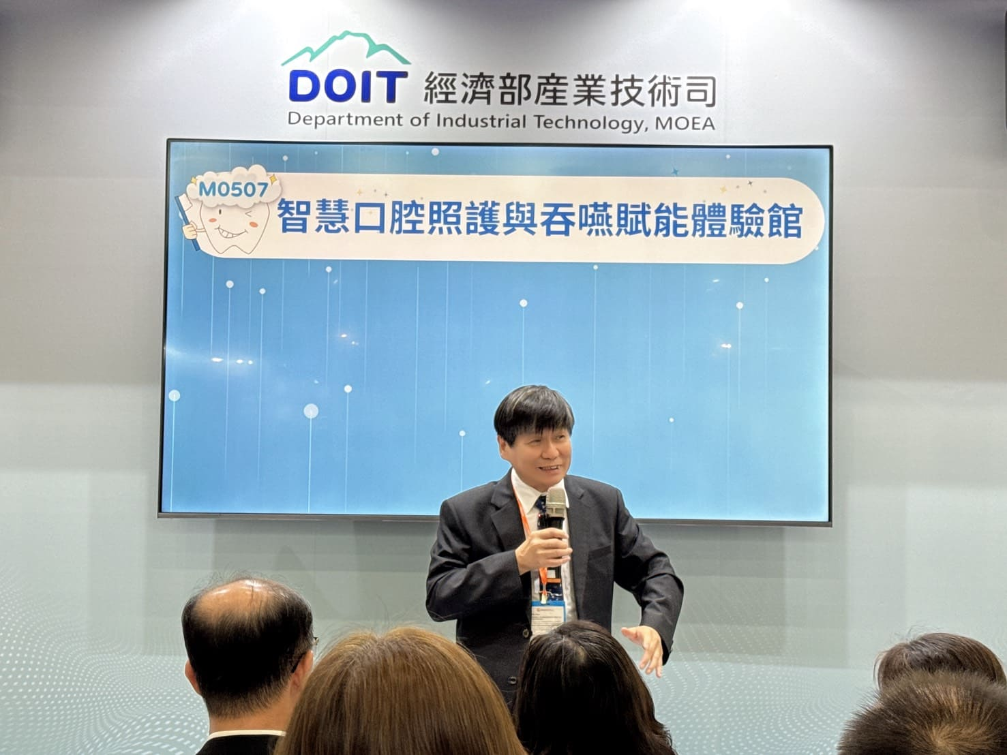

Photo 4. Qiu-Yao Chung, Chairman of Taiwan Oral Care Association, delivered remarks at the age-friendly smart oral and swallowing empowerment pavilion.

