
新聞資料NEWS LETTER
MIRDC Boosts Unmanned Aerial Vehicles Innovation, Unlocking New Opportunities for the Defense Industry

The Taipei Aerospace & Defense Technology Exhibition (TADTE) 2025 was held at Nangang Exhibition Center Hall 1 from September 18 to 20. This year’s exhibition achieved record scale, featuring over 400 exhibitors from 14 countries and more than 1,400 booths. It showcased products and technologies from the defense, aviation, space, and unmanned vehicles industries. With support from the Ministry of Economic Affairs (MOEA), the Metal Industries Research & Development Centre (MIRDC) has been dedicated to developing aerospace technologies and promoting the growth of the aerospace and unmanned vehicles industries to improve capabilities. During the exhibition, MIRDC organized two thematic seminars, inviting experts and industry representatives to share insights and discuss the latest trends to help the industry stay informed and ahead of the curve.

Chairperson Chia-Ju Liu noted that MIRDC, as an industrial think tank and advisor to the government, actively supports the planning and promotion of unmanned vehicles industry development. MIRDC focuses on developing essential unmanned vehicle modules, including airframe structures, flight control systems, and communications technologies, and ensuring industrialization of the results to help companies bring products to market faster. Under the leadership of Director General Chih-Wei Chien of MIRDC’s Aerospace Science and Technology Industry Development Department, the team successfully integrated upstream and downstream resources, fostering collaboration within the industry chain and further enhancing the global visibility and competitiveness of Taiwan’s unmanned vehicles industry.

During the exhibition, MIRDC held two featured seminars on September 19: the Aerospace Industry Future Development Trends Seminar and the Space Industry Development Trends and Applications Seminar. The aerospace seminar convened experts to discuss industry status, global aviation trends, and strategic deployment in defense aerospace and unmanned systems, providing domestic companies with essential intelligence to stay ahead of global developments. The space industry seminar centered on low-Earth orbit satellites and the development of domestically developed components. It examined domestic advancements in core technologies, the certification of components, efforts to localize production, and practical experience of international collaboration models. Representatives from the Taiwan Space Agency, academia, and industry shared success stories, helping companies close the technology gap, gain insights into future growth directions, and further strengthen Taiwan’s position within the global space industry chain.

MIRDC is dedicated to promoting cross-sector integration, technological innovation, and international linkages. By aligning policy direction with advanced research and development, and by strengthening partnerships with government agencies, academic institutions, and international industry leaders, MIRDC helps domestic companies to expand globally and supporting the industry in advancing toward independent innovation and international alignment. These initiatives are designed to keep Taiwan's aerospace and unmanned vehicle sectors competitive on a global scale, positioning the nation as a key hub for aerospace and unmanned vehicle development in Asia and delivering strong momentum for national security and economic growth.
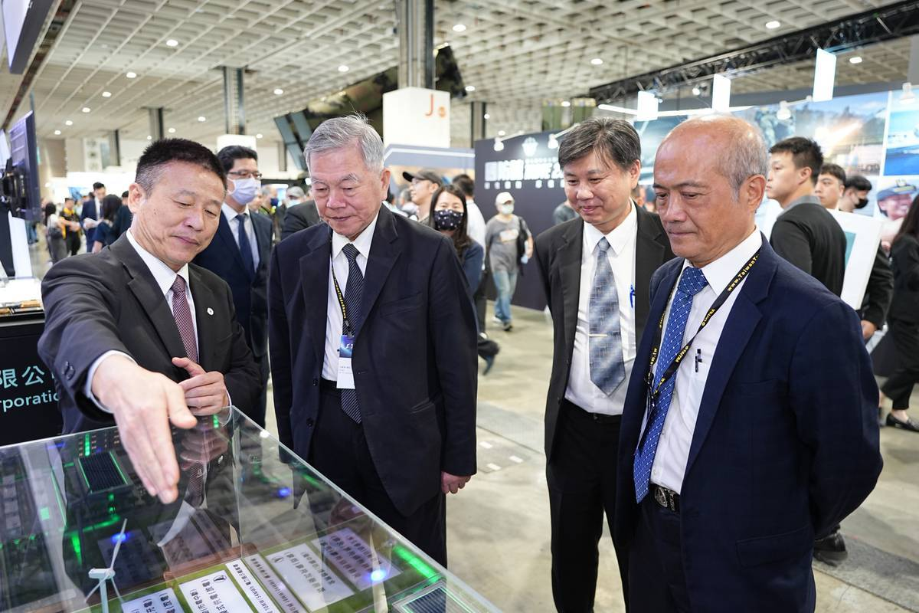

Photo 1. MIRDC is leading innovations in unmanned aerial vehicles creating new opportunities for the defense industry (first from left: Aviation Industry Development Company General Manager Chin-Pin Tsao, second from left: Senior Advisor to the President Shen Jong-chin, third from the left: MIRDC Aerospace Science and Technology Industry Development Department Director General Chih-Wei Chien)
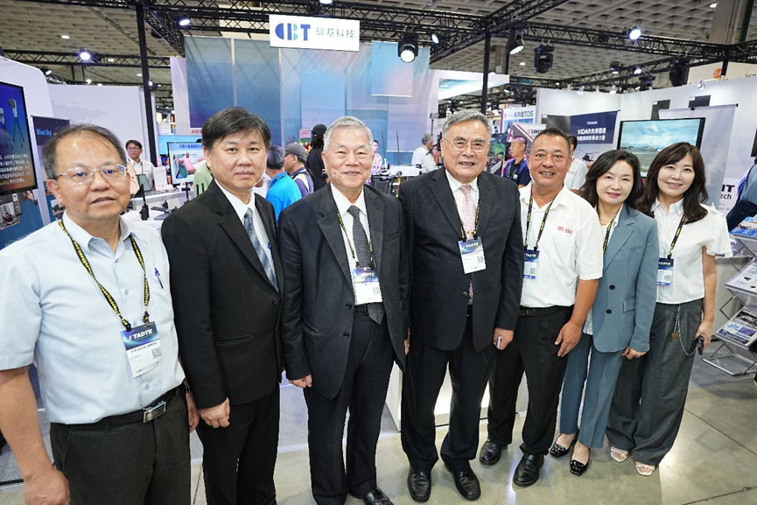

Photo 2. Group photo of guests (first from left: Ministry of Economic Affairs Industrial Development Administration Assistant Chief Wen-Tsan Lu, second from left: MIRDC Aerospace Science and Technology Industry Development Department Director General Chih-Wei Chien, third from left: Senior Advisor to the President Shen Jong-chin, Air Asia Chairman Woei-Shyan Lee)

