
新聞資料NEWS LETTER
MIRDC shows its gold strength at the 2024 Taipei Int’l Smart Mold & Die Industry Fair

Intelligent Asia, the 2024 International Intelligent Manufacturing Index Exhibition, was grandly held at the Taipei Nangang Exhibition Center (TaiNEX 2) from August 21 to 24. This year, a total of 1,200 manufacturers from around the world and nearly 4,500 booths participated in the event, covering industrial automation, robots, Smart molds, logistics and the Internet of Things, cold chain technology, additive manufacturing (3D printing), laser applications, MIRDC uses the "Mold and Smart Molding Equipment Exhibition" as the central axis to show its true strength, the latest innovative manufacturing and process technology, hoping that It can help Taiwan's mold industry obtain market opportunities for emerging applications and sustainable business opportunities.

This fair focuses on intelligent mold manufacturing, production, processing, post-processing and quality inspection. Regarding smart manufacturing and production, MIRDC has developed an aerospace-grade-AI application tool machining technology coupled with an intelligent editing system, inputting corresponding parameters to present the best parameter settings quickly. Using AI quality monitoring and real-time optimization, it can be applied to the processing of aerospace-grade components to control the processing accuracy deviation within 2% (<10um). Regarding processing, through the established vibration-assisted processing technology and customized vibration modules with different frequencies, and then introducing processing process parameter optimization and tool path compensation technology according to product development, the quality (Ra) of car lights and optical molds has been improved by 72.7 %(55nm→15nm), significantly reducing the manual polishing time by more than 50%. Regarding post-processing and quality inspection, the metal surface treatment technology established by MIRDC can develop component specification coating processes according to customer equipment needs. Regarding quality inspection, AI plastic and metal product defect identification technology can be used to identify curved and highly reflective parts. Take images of surface defects and use the defect recognition AI model to identify them in real-time.

Yung-Hsiang Lai, the President of MIRDC, stated that MIRDC has long-term played a significant role in promoting and developing the Taiwan mold and die industry technology by committing to the innovation and R&D of critical technologies such as mold processing, manufacturing process and quality optimization. A total of 26 achievements displayed at this fair on the fourth floor, TaiNEX 2; we sincerely welcome all aspects of fields to interact with us, as we aim to speed up the improvement of a higher manufacturing capability in the Taiwan mold and die industry through the integration and combination of industry, official, academics and R&D to lead the intelligent technology development.

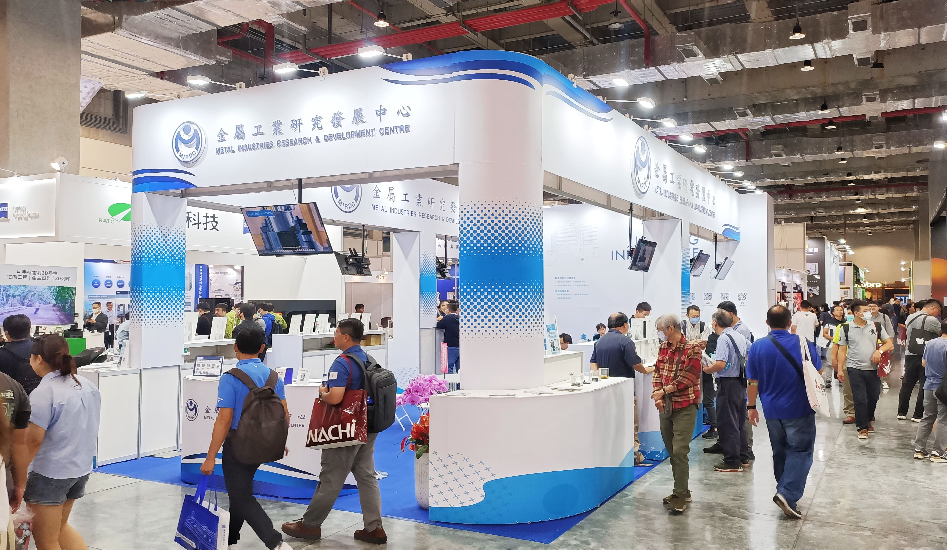

Fig1, MIRDC displayed critical developments in intelligent manufacturing, production, processing, post-processing, and quality optimization on the fourth floor of TaiNEX 2 (Booth S216).

