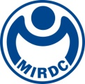
新聞資料NEWS LETTER
MIRDC Signs MOU with Powertech Labs Inc., Canada, Promoting Safety Technologies for Hydrogen Industrial Applications

Net zero carbon emission has been one of the important national policy goals, and Taiwan is about to implement “Five Strategic Initiatives of Net-zero Transformation” to tackle with 2050 net-zero challenges. Hydrogen will be one of the key energies in our country's second energy transition. To promote hydrogen industry in Taiwan, it is critical to build a comprehensive safety, inspection, and analysis technologies of hydrogen in industrial applications. With support from Department of Industrial Technology, Ministry of Economic Affairs, Metal Industries Research & Development Centre (MIRDC) signed a memorandum of understanding (MOU) with Powertech Labs Inc., the leading manufacturer and testing provider of hydrogen transportation and storage in Canada, to provide key safety testing technologies for hydrogen transportation and storage applications in Taiwan. In addition, for promoting domestic supply chains, international cooperative projects are pushed forward for researching and developing products related to hydrogen transportation and storage. More cooperation will be extended to other hydrogen industrial applications in the future.

MIRDC has an international technical cooperation with Powertech Labs Inc., Canada, and the joint development between them includes testing and analysis technologies of high-pressure hydrogen embrittlement, testing of hydrogen materials/hydrogen storage products, safety monitoring of hydrogen stations, safety testing of modular products, and analysis technologies of lifetime. In the long run, MIRDC will work with domestic industries and Canada to promote the development of metal materials in hydrogen applications and related testing technologies of composite materials and components. This cooperation symbolizes a key milestone of safety development of hydrogen applications in Taiwan, and it indicates Taiwan’s active presence in development of global hydrogen technology. MIRDC will expedite the formation of value chains in Taiwan’s hydrogen industrial applications, bringing the hydrogen industries to the international stage and assisting Taiwan in realizing its sustainable development and environmental-friendly goals.

Yung-Hsiang Lai, President of MIRDC, said that the center has actively collaborated with industry chains to build the foundation of hydrogen industrial applications in Taiwan. Currently, it has signed MOUs with 19 industry and academic units, including industries of gas, metal materials, boilers, equipment manufacturing, fittings and valves, and industry end-users of hydrogen. MIRDC will gradually increase size of this league and contribute to domestic cross-industry collaborations and international cooperation.

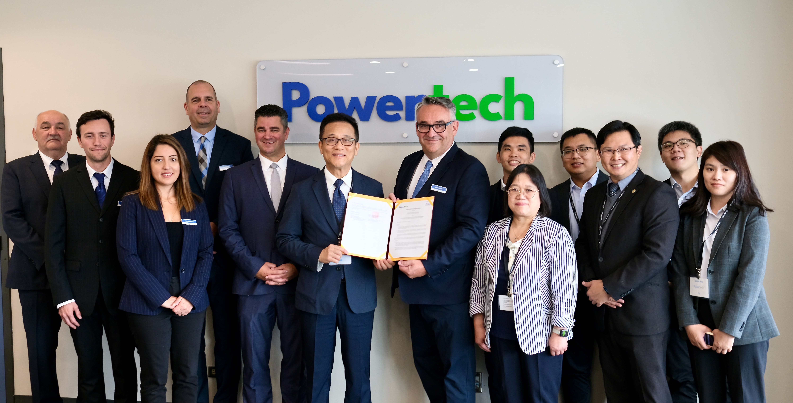
Picture 1: Group Photo of MIRDC R&D Team and Powertech R&D Team, Canada, for Signing MOU (The sixth guest from the left is Heng-Yu Lin, Director of MIRDC, and the seventh guest from the right is Pierre Poulain, CEO of Powertech.)

