
新聞資料NEWS LETTER
MIRDC jointly works with AI HAYABUSA Japan to research and develop AI technology

Artificial intelligence technology has developed rapidly in recent years, becoming an indispensable core element in various fields a worldwide. To assist the government in promoting the policy of Taiwan becoming an "Artificial Intelligence Island", accelerating the innovative application of artificial intelligence, and making the industry artificial intelligence, MIRDC the Official MOU Signing Ceremony for establishing the Artificial Intelligence System Laboratory in late May. Based on that date, the laboratory was officially unveiled, and the future industrialization of artificial intelligence was promoted by signing an intent to cooperate with Japanese AI HAYABUSA.

AI HAYABUSA was established in Hakodate shi, Japan, in March 2017, and its parent company, MIRUC OPTICAL CO., LTD. The company focuses on developing artificial intelligence algorithms based on image analysis and uses machine learning, deep learning and image processing technologies to provide multiple solutions for various industries. The company's technology has been widely used in automobile manufacturing, semiconductors, motors, metal processing, food, medical drugs and other fields; MIRDC's years of experience in industrial automation, digitalization, and intelligence have laid a solid foundation for this cooperation. In the future, MIRDC will work with AI HAYABUSA to jointly develop AI modules suitable for industrial applications, helping to seize opportunities for Taiwan's industries in the next era of competition and injecting more decisive impetus into the country's industrial upgrading and transformation. The two parties will also cooperate on artificial intelligence algorithms, machine learning, and generative AI technologies for object image analysis and develop algorithms and related application module technologies for identification, detection, and prediction of automated production lines, especially in the manufacturing industry, and automated algorithms and applications are mainly seen with greater emphasis.
Chairman of the Board, Ren Yi Lin from MIRDC, stated that Taiwan has strong AI hardware capabilities, but there is still room for improvement in software and applications. Therefore, when MIRDC and AI HAYABUSA join hands, Taiwan’s manufacturing industry would be used as a testing ground, and use the artificial intelligence system laboratory as the research and development base to jointly conduct research and development to improve the technologies of both parties, which will surely achieve the goal of resource sharing and win-win results. This cooperation between the two parties is an essential milestone in the industrialization of artificial intelligence in Taiwan and the beginning of AI technology exchanges and collaboration between the industrial circles of Taiwan and Japan. Through the joint efforts of both parties, we will open a new chapter in the development of artificial intelligence, draw a brighter blueprint for future technological innovation and industrial development, and make more remarkable contributions to Taiwan's industry.
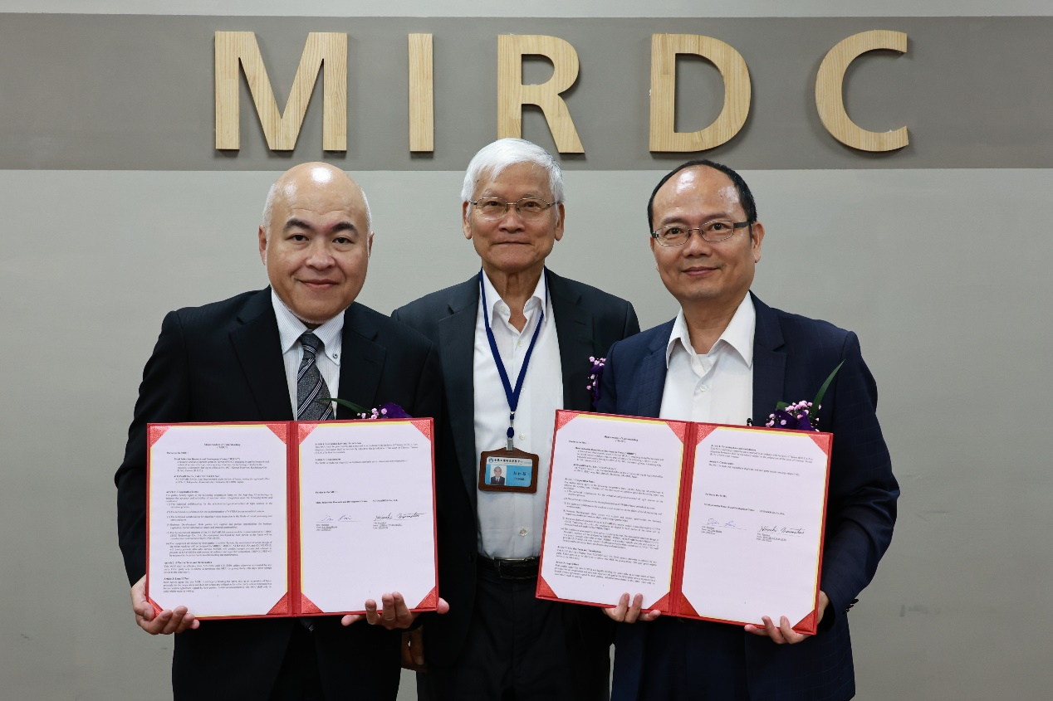
Fig1, MIRDC jointly works with AI HAYABUSA Japan to research and develop AI technology. (From left to the right are Hiroaki Muramatsu, President & Representative Director of MIRUC Optical Co., Ltd, Chairman Ren Yi Lin of MIRDC and President Yung Hsiang Lai of MIRDC)

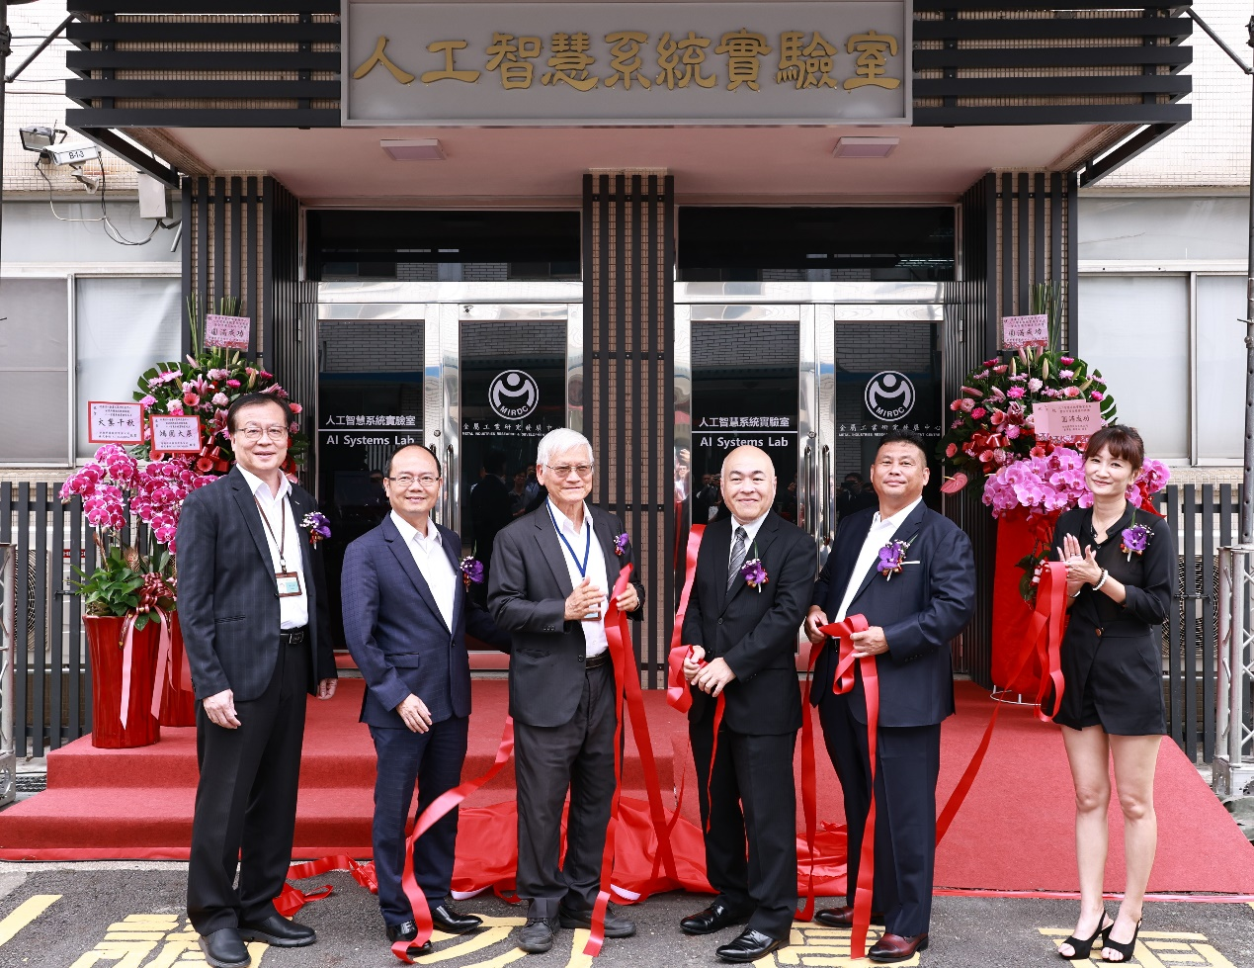
Fig2, A photo of the Official MOU Signing Ceremony for establishing the Artificial Intelligence System Laboratory. (From left to right are Vice President Lei Chuan Lin of MIRDC, President Yung Hsiang Lai of MIRDC, Chairman Ren Yi Lin of MIRDC, Hiroaki Muramatsu, President & Representative Director of MIRUC Optical Co., Ltd, Chairman Chin MU Lin of CHING CHEE Technology Co., Ltd, and Counselor Pei Ju Chen of Kaohsiung City Government

