新聞資料NEWS LETTER
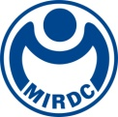
MIRDC hosts the 2023 Sino-Japanese Modern Engineering and Technology Symposium- Metal Group, Promoting the exchange of Taiwan-Japan low-carbon metal materials and process technology

On November 21, MIRDC held the "Sino-Japanese Modern Engineering and Technology Symposium - Metal Group in Innovation Value-added Center of Traditional Industry, MOEA. This year's metal group focused on the theme of "Trends in the Application and Development of Low-Carbon Metal Materials and Process Technology." Four speakers from Japan were invited to discuss and exchange ideas on topics including high-purity aluminum material purification technology, hydrogen combustion, production and transportation technology, and the application of unmanned aerial vehicles in offshore wind farms.

During the symposium, discussions were conducted from the perspectives of technological research and development, practical application, and future development, exploring potential collaboration in the application of low-carbon metal materials and process technology among industry, academia, and research experts. Many innovative research results were shared by the attending experts and scholars. Professor Tetsuya Nagasaka from Tohoku University first shared a novel solid-state electrolysis method using molten salt for upgrading aluminum waste, achieving high efficiency and low energy consumption to realize sustainable aluminum recycling. Mr. Kakuya Iwata, Executive Director of the Japan UAS Industrial Promotion Association (JUIDA), presented applications of unmanned aerial vehicles in forestry, power plant inspection, and wind turbine inspection, as well as case studies of the association's education, training, and international cooperation efforts. Furthermore, Professor Katsumi Yokomoto from Kyushu University focused on Japan's 2050 carbon neutrality plan, presenting equipment and technology for hydrogen production and storage, as well as research conducted by the Hydrogenius Research Center in experimental technology, material evaluation technology, and advanced analysis technology to ensure the safety and stability of hydrogen energy. Finally, Professor Mamoru Tanahashi from the Tokyo Institute of Technology discussed the development of hydrogen and hydrogen-oxygen gas turbine power generation systems, emphasizing the important role of hydrogen energy in achieving the goals of 2050.

Chairman Ren-Yi Lin of MIRDC stated that the "Sino-Japanese Modern Engineering and Technology Symposium" has been organized by the Chinese Institute of Engineers since 1980 and is held biennially. It has been held for 34 sessions so far, providing a platform for inviting Japanese experts and scholars to Taiwan for international academic and industrial development exchanges. In the past, MIRDC has also organized 6 specialized subgroup symposiums for the metal group, inviting 18 Japanese experts to the center for technical exchanges on metal materials and processes, promoting bilateral cooperation. It is expected that through the symposium, Taiwanese and Japanese experts and scholars will conduct international academic and industrial development exchanges and cooperation, deepen bilateral cooperation, assist the industry in addressing related technical issues, and promote the exchange and development of industrial technology.

The convener of this year's metal group, Yung-Hsiang Lai, President of MIRDC, explained Taiwan's "2050 Net Zero Emission Pathway," which provides a trajectory and action path towards net zero emissions by 2050, with hydrogen and wind energy identified as key strategic areas. In addition to being a highly promising green energy source, wind power is also a new industry that Taiwan is focusing on developing. Furthermore, recycling technology is an important part of the circular economy, as it not only enables the reuse of materials but also increases the regeneration value of metals. It is hoped that through this symposium, discussions on the application of low-carbon metal materials and process technology will contribute to achieving the goals of net zero transformation and environmental sustainability.
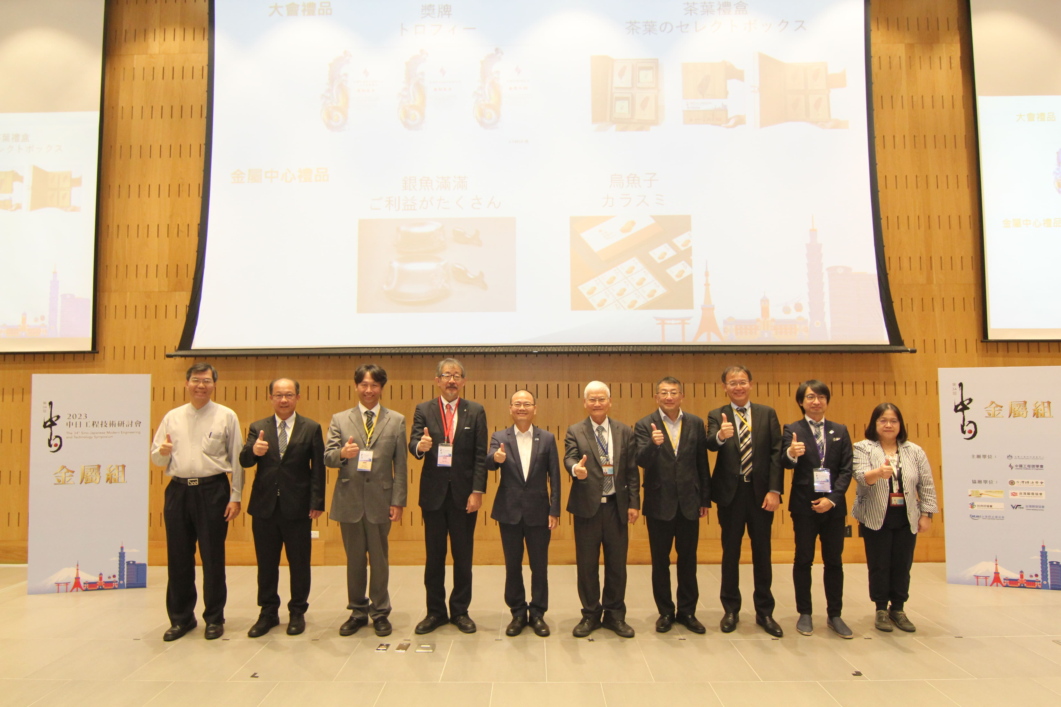

Photo 1: Group photo of symposium VIPs and speakers at the 34th Sino-Japanese Modern Engineering and Technology Symposium - Metal Group (from left to right: Director Bing-Guo Zheng of MIRDC, Vice President Chun-Chieh Wang of MIRDC, Executive Director Kakuya Iwata of the Japan UAS Industrial Promotion Association (JUIDA), Professor Tetsuya Nagasaka from Tohoku University, Yung-Hsiang Lai, President of MIRDC, Chairman Ren-Yi Lin of MIRDC, Professor Katsumi Yokomoto from Kyushu University, Mamoru Tanahashi from the Tokyo Institute of Technology, Deputy Bureau Chief Yuzhi Lin of the Japanese Branch of the Chinese Institute of Engineers, and Director Yueh-Hsiu Lee of MIRDC)

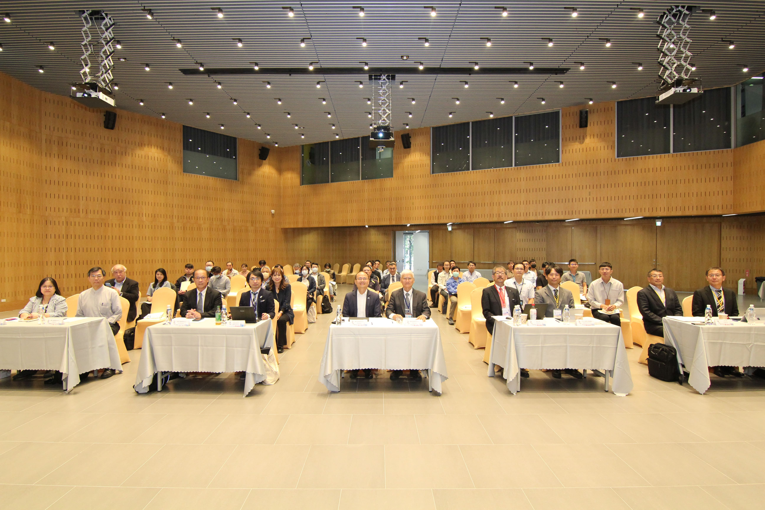

Photo 2: Group photo of the 34th Sino-Japanese Modern Engineering and Technology Symposium - Metal Group participants.

