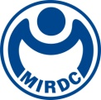
新聞資料NEWS LETTER

MIRDC and Taichung Veterans General Hospital Signed the "Memorandum of Cooperation on Intelligent Medical Clinical Trials and Field Verification" jointly promote substantive clinical exchanges and accelerate the energy of intelligent medical innovation
On the 23rd of November, Chih Lung Lin, the Vice President of MIRDC and Shih An Chen, the Superintendent of Taichung Veterans General Hospital, signed the “Memorandum of Cooperation on Intelligent Medical Clinical Trials and Field Verification”. In addition to cooperating in clinical trials and field verification in the future, the two parties have also worked on the plan of developing intelligent spine surgery assistance systems, smart detection of periodontal disease and dental caries, detection of acute exacerbation of pulmonary obstruction, language interactive therapy software, and transcranial magnetic stimulation ( rTMS), functional magnetic resonance imaging (fMRI) clinical research and speech therapy development and other vital topics to conduct in-depth cooperation and exchanges with the medical team of Taichung Veterans General Hospital to accelerate the development of Taiwan’s intelligent medical industry.

Chih Lung Lin, the Vice President of MIRDC stated that MIRDC has long been committed to technology development and research for developing metal-related industries. In the past ten years, with the support of the Department of Industrial Technology (DoIT) and MOEA, MIRDC has integrated medical talents from domestic industry, academic and R&D circles, focusing on precision medicine, development of functional implantable medical materials, smart monitoring and diagnosis, intelligent health care and other technologies. The signing of the Memorandum with Taichung Veterans General Hospital combines MIRDC's long-term brilliant medical research and development energy and Taichung Veterans General Hospital's medical clinical expertise to establish an innovative cooperation mechanism. The two parties are about to cooperate in clinical trials on the intelligent spinal minimally invasive surgical auxiliary system. In the future, they hope to expand substantial clinical exchanges with Taichung Veterans General Hospital, accelerate the innovation energy of both parties in intelligent medical care and care, and jointly develop high clinical needs and high market value intelligent medical products.
Shih An Chen, the Superintendent of Taichung Veterans General Hospital, stated that Taichung Veterans General Hospital has been committed to developing intelligent medical care and industry-university technology transfer in recent years. In addition to winning the world's best intelligence hospital for two consecutive years, this year it also competed with National Chengdu Kung University (NCKU), National Chung Hsing University (NCHU), Central Taiwan Science Park, and Southern Taiwan Science Park have established an industry-university alliance to promote clinical trials and field verification cooperation and accelerate links with the industry. Taichung Veterans General Hospital and MIRDC have strengths in the medical field and industry-university research and development. The two parties signed the Memorandum for clinical trials and field verification this time, officially launching a substantial cooperative relationship. Through previous matchmaking, 11 cases have been put into operation by the end of this year. In addition to cooperation in developing and applying innovative medical technologies, innovative medical materials, medical information platforms, etc., the real dynamic image spine surgery auxiliary system will also be launched shortly. Cooperate to conduct clinical field cooperation in general and human trials. With the collaboration between Taichung Veterans General Hospital and MIRDC, it will be able to make more valuable contributions to the development of Taiwan's biotech and medical industry.
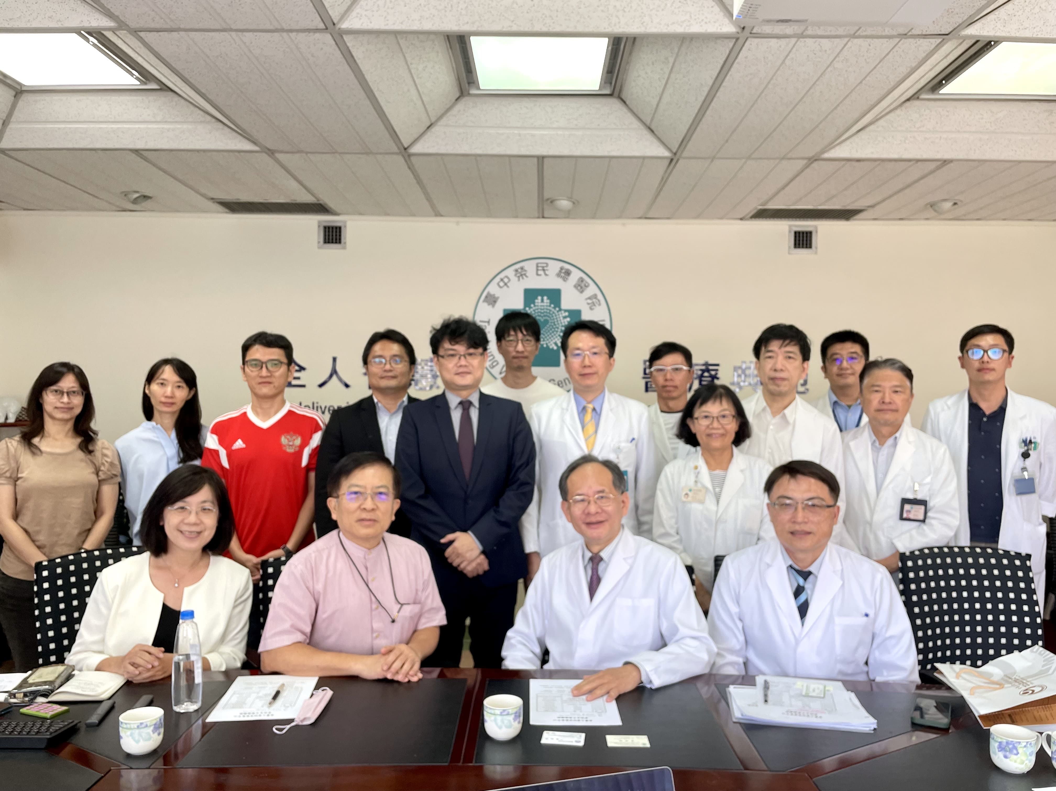

Fig1, MIRDC and Taichung Veterans General Hospital focus on Intelligent Medical Clinical Trials and Field Verification and build a long-term partnership between Chih Lung Lin, the Vice President of MIRDC (second from the left at front row) and Shih An Chen, the Superintendent of Taichung Veterans General Hospital (third from the left at front row).

